Accessibility Guide for RSPB Scotland Marwick Head
orkney@rspb.org.uk, 01856 850176, https://www.rspb.org.uk/reserves-and-events/reserves-a-z/marwick-head/
Contact for accessibility enquiries: RSPB Orkney Office
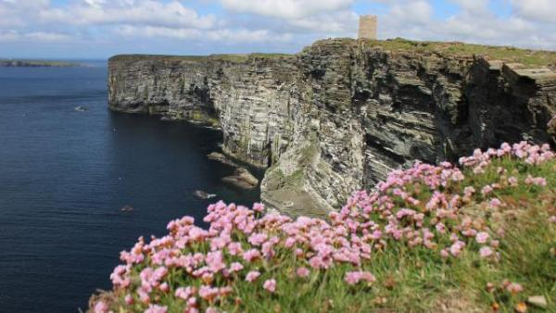

Welcome
Discover a spectacular seabird city at Marwick Head, with breathtaking views along the Orkney coastline. With a blue sky above, an azure sea, and the commotion of the seabird colony below, is there is a better place to spend a sunny June afternoon? The seacliffs are home to a bustling colony of seabirds, including kittiwakes, guillemots and razorbills, and if you're lucky you may see a puffin or a passing whale or dolphin too. Down at sea level, a low-tide lagoon called the Choin provides shelter during the winter for sea ducks, as well as a stopping off point for migrating waders. The grassy fields behind the Choin are managed for corncrake, which occasionally breed, and for the rare great yellow bumblebee.

At a Glance

Getting here
RSPB Marwick Head,
Birsay,
Orkney,
KW17 2NB

Travel by public transport
- You can get to RSPB Scotland Marwick Head by bus.
- The nearest bus stop is on the B9056 road at the junction with the road down to Marwick Bay. There is no marked bus stop - just ask the driver to let you off at the turn for Marwick Bay. The bus stop is 0.8 miles / 1.3 km from RSPB Scotland Marwick Head.
- Bus route 8S passes close to the Choin car park at the southern end of the reserve. Alight at the road end by the brown tourist sign for RSPB Marwick Head just before Marwick and there is a 0.8 mile (1.3 km) walk along a single track road to the car park at the Choin, from where the reserve can be accessed. Up to date travel information can be found at https://www.orkney.gov.uk/Service-Directory/B/Bus-Services.htm

Travel by taxi
- You can get a taxi with Orkney Cabs by calling 01856 875000. The taxi company has a wheelchair accessible vehicle.
- You can get a taxi with Craigies Taxis by calling 01856 878787.

Parking
- We have a car park. The parking is less than 50 metres from the main entrance. Parking is free.
- There is a drop-off point at the main entrance. The drop-off point has a dropped kerb.
- From the car park to the entrance, there is level access. The route is 4000mm wide, or more.
- There is a car park at the Choin at the southern end of the reserve, from which the reserve can be accessed. The surface of the car park is rough hardcore and it is situated directly beside the road. There are views of the Choin lagoon and beach from the car park.
There is an alternative smaller car park at Cumlaquoy at the northern end of the reserve, which has a rough surface. The northern end of the reserve can be accessed through a steep unsurfaced trail from this car park.
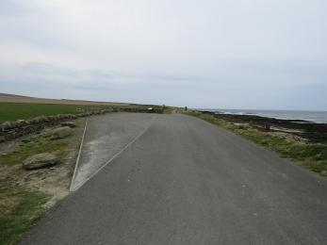
Marwick Head Choin car park
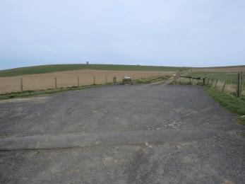
Marwick Head Cumlaquoy car park

Arrival

Path to main entrance
- From the street to the main entrance, there is level access.
- The path is 4000mm wide, or more.

Main entrance
- The main entrance has level access.
- Please note that there is no Visitor Centre and there are no buildings at the reserve. The only facilities are nature trails around the reserve. There are no staff based at the reserve.

Getting around inside

Getting around outside

Designated Walking Trail

Marwick Head Nature Trail Circular Walk
- The trail is 3800metres long. Some of the trail has a loose surface. There are two narrow kissing gates along the trail leading from the cliffs to the Cumlaquoy car park . The trail is sloped. The trail has seats.
- The nature trail around the reserve has some prolonged steep sections and is mostly unsurfaced. The path is mainly grassy with some muddy/rocky sections and there are natural steps formed by erosion and also boulders in places on the trail surface. The trail is narrow and goes close to the unprotected cliff edge in some areas. Some of the path is on a surfaced single track road. There is a bench overlooking the northern end of the Choin.
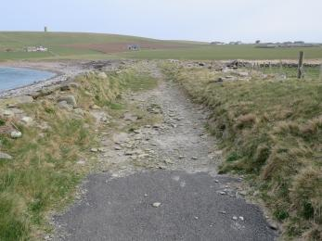
Entrance to Marwick Head Nature Trail circular walk from the Choin
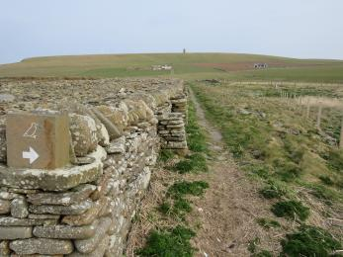
Marwick Head nature trail alongside the Choin
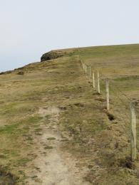
Marwick Head nature trail between the Choin and the Kitchener memorial
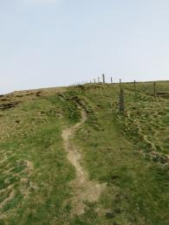
Marwick Head nature trail between the Choin and the Kitchener memorial
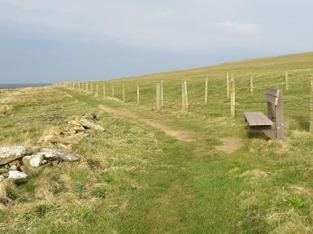
Bench overlooking the northern end of the Choin

Designated Walking Trail

Marwick Head Nature Trail - The Choin to Kitchener Memorial
- The trail is 3200metres long. Some of the trail has a loose surface. The trail is sloped. The trail has seats.
- This is a linear trail and the distance refers to the return journey. The trail has some prolonged steep sections and is mostly unsurfaced. The path is mainly grassy/stony with some muddy sections and there are natural steps formed by erosion and some boulders in places on the trail surface. The trail is narrow and goes close to the unprotected cliff edge in some areas. There is a bench overlooking the northern end of the Choin.
Entrance to Marwick Head Choin to Kitchener Memorial nature trail
Marwick Head nature trail alongside the Choin
Marwick Head nature trail between the Choin and the Kitchener memorial
Marwick Head nature trail between the Choin and the Kitchener memorial
Bench overlooking the northern end of the Choin

Designated Walking Trail

Marwick Head Nature Trail - Cumlaquoy to Marwick Cliffs
- The trail is 1200metres long. There are two narrow kissing gates along the trail leading from the cliffs to the Cumlaquoy car park . The trail is sloped.
- This is a linear trail and the distance refers to the return journey. The trail has some prolonged steep sections and is unsurfaced. The path is mainly grassy with some muddy sections and there are natural steps formed by erosion and boulders in places on the trail surface. The trail is narrow and goes close to the unprotected cliff edge at the top. The walk can be extended to reach the Kitchener Memorial by walking an additional 350m each way along the clifftop trail.
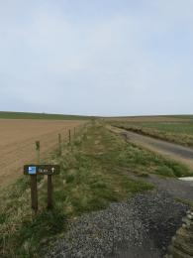
Marwick Head entrance to nature trail from the Cumlaquoy car park
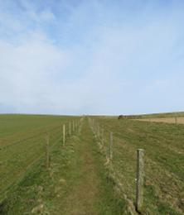
Marwick Head nature trail from Cumlaquoy to Marwick cliffs
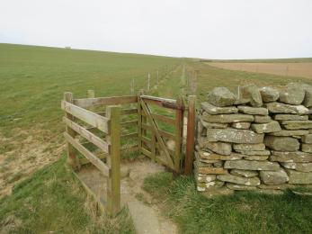
Kissing gate at southern end of path from Cumlaquoy car park to Marwick cliffs
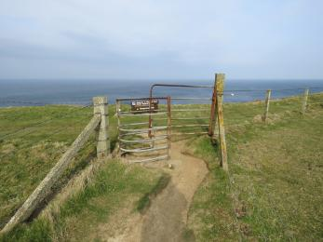
Kissing gate at northern end of path from Cumlaquoy car park to Marwick cliffs

Beach
- The beach access point is 50.00meters from the nearest car park.
- The path is 4000mm wide, or more.
- The entrance is 124000mm wide.
- The beach is next to the car park and road, but there is a natural ramp of grass and large natural boulders between the road and the main area of the beach. The upper area of the beach is made up of large stones, with sand below.
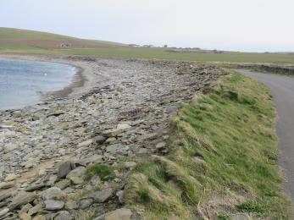
Marwick Head beach access from the Choin car park

Customer care support

Accessibility equipment
- There is no designated toilet area for assistance dogs. Any rough ground by the sides of the trail or car park can be used, but please remove any dog waste from the site.
- You can hire mobility equipment from Orkney Disability Forum by calling 01856 870340.

Guide last updated: 7 July 2022

