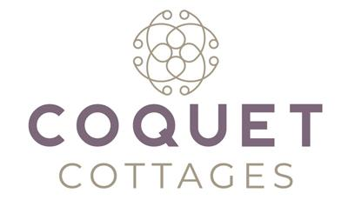
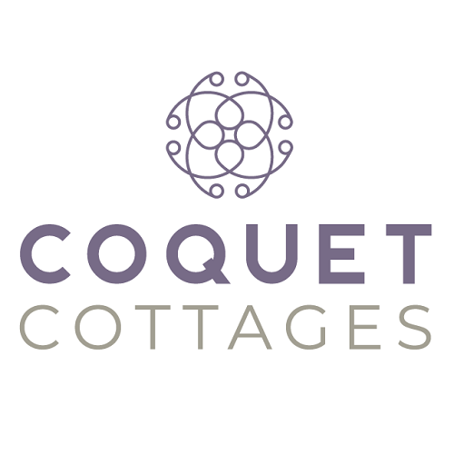

Accessibility Guide for Holburn Mill Cottage
info@coquetcottages.co.uk, 01665 710700, https://www.coquetcottages.co.uk/northumberland-holiday-cottages/holburn-mill-cottage/
Contact for accessibility enquiries: Reservations Team
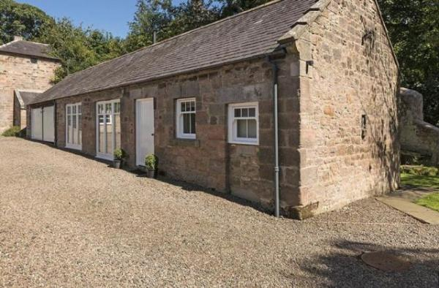

Welcome
Sleeping just 2, the cottage is all ground level with a couple of steps here and there. It was originally one of the mill buildings that has been completely refurbished into a romantic cottage for 2. Fluffy bathrobes, Smart TV, Bluetooth speaker and the wood burning stove give a perfect mix of hotel luxury with a hint of the rustic Northumbrian landscape. Holy Island is just 10 miles away and Bamburgh Village and Castle is just 12 miles away. The cottage is filled with local guide books and history about the area, so whether you choose to put your feet up or put those walking boots to good use, Holburn Mill Cottage will leave you relaxed and refreshed whatever you choose.

At a Glance

Level Access
- The main entrance has 1 step. There is no lift and no ramp.

Access with steps
- There are steps from the main entrance to:
  - Bedroom
  - Washing machine
  - Lounge
  - Garden

Hearing
- The (bedroom) TVs have subtitles.

Getting here
Holburn Mill Cottage
Lowick
TD15 2UL

Travel by public transport
- You can get to Holburn Mill Cottage by bus.
- The nearest bus stop is located in the village of Lowick approx. 4 miles / 6.4 km away. The bus stop is 4.0 miles / 6.4 km from Holburn Mill Cottage.

Travel by taxi
- You can get a taxi with Ron's Taxis by calling 01668 281281.

Parking
- We have a car park. The parking is less than 50 metres from the main entrance. Parking is free.
- There is a drop-off point at the main entrance. The drop-off point has a dropped kerb.
- From the parking to the main entrance, there is 1 step. There is no ramp and no lift. Private parking for 2 cars 50 yards from the front door, however, you can unload your belongings at the front door temporarily.

Arrival

Path to main entrance
- From the street to the main entrance, there is 1 step. There is no ramp and no lift.

Main entrance
- The main entrance has 1 steps.
- The main door is side hung and manual.

Getting around inside

Bedrooms
- All bedrooms have windows.
- Bedrooms have ceiling lights, bedside lamps, desk or table lamps and natural daylight.
- Lights are LED and energy saving. TVs have subtitles.
- All bedrooms are non-smoking.
- No bedrooms have fitted carpets.
- The bedroom nearest the main entrance has 2 steps.
- We have bathrooms with a bath and overhead shower.

Washing machine
- From the main entrance to the laundry, there is 1 step. There is no lift and no ramp.
- We have an iron and ironing board.

Self catering kitchen

Kitchen
- We have an open plan kitchen.
- From the main entrance to the kitchen, there is 1 step. There is no lift and no ramp.
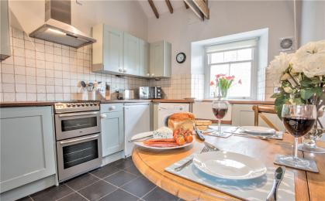
Kitchen

Lounge

Lounge
- From the main entrance to the lounge, there is 1 step. There is no lift and no ramp.
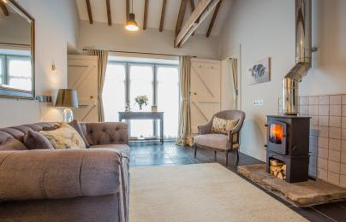
Lounge

Getting around outside

Garden
- From the main entrance to the gardens, there are 4 steps. There is no lift and no ramp.
- The pretty lawned garden is completely private from the owner’s residence and a sun trap.

Customer care support

Accessibility equipment
- For a list of more items, please go to http://www.redcross.org.uk/Where-we-work/HealthandSupport?loc=ne65+0xp&r=50&s....
- The nearest toilet area for assistance dogs is in the garden.
- You can hire mobility equipment from Red Cross Newcastle by calling 0191 2737961.

Guide last updated: 22 July 2021

