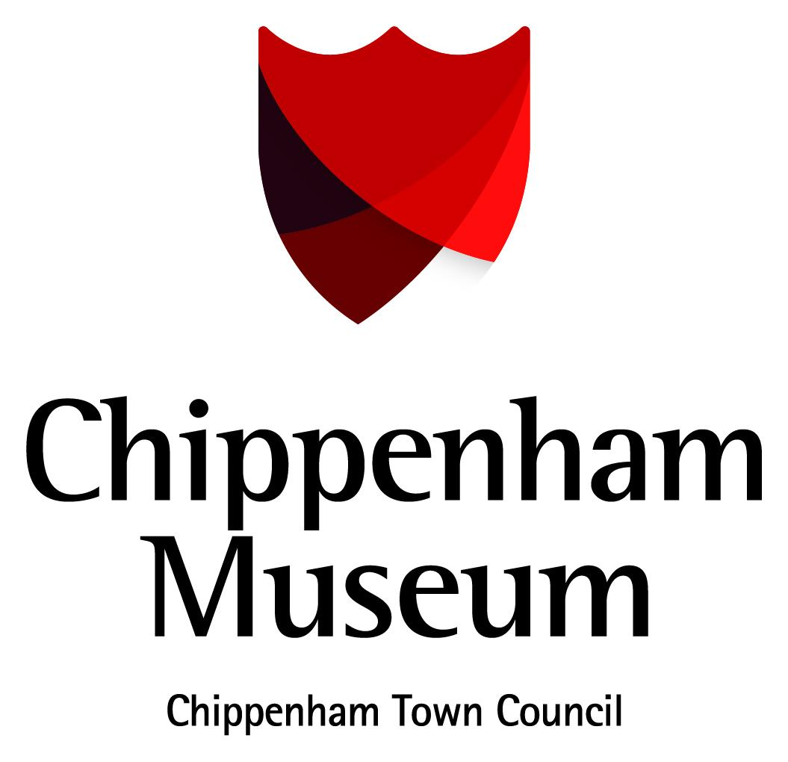

Accessibility Guide for Chippenham Museum
heritage@chippenham.gov.uk, 01249 705020, http://www.chippenham.gov.uk/chippenham-museum
Contact for accessibility enquiries: Melissa Barnett
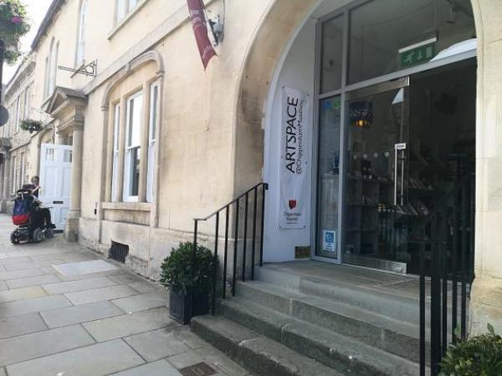

Welcome
Housed in an 18th century townhouse, Chippenham Museum tells the fascinating story of this historic market town from its prehistoric origins to the present day.
Learn about the town’s development, through its connections to river, road and rail and explore its surprising links to Alfred the Great and Isambard Kingdom Brunel.
See our regularly changing displays in our temporary exhibition gallery or take part in our varied programme of walks, talks, children’s activities and special events. Visit our museum shop selling a wide range of souvenirs, books and gifts inspired by the museum’s collections.

At a Glance

Level Access
- There is level access from the main entrance to:
  - Ground Floor Galleries
  - Upstairs Galleries
  - Education Room
  - Information Desk
  - Museum Toilets
  - Museum Shop

Hearing
- The fire alarm has flashing lights.
- We have a hearing loop in the Information Desk/Shop and Education Room.

Visual
- The walls and the doors have high colour contrast.
- Some parts of the venue have low lighting.
- We have display information in large print.
- We have information in large print.

General
- There is at least 1 public toilet for disabled visitors.

Getting here
10 Market Place
Chippenham
SN15 3HF

Travel by public transport
- You can get to Chippenham Museum by bus and train.
- We are next to the Bus Station in Chippenham. The bus stop is 0.0 miles / 0.0 km from Chippenham Museum.
- The nearest train station is Chippenham Station. The train station is 1 miles / 1.6 km from Chippenham Museum.
- The Train Station is a 10 minute walk from the museum through the town centre. Alternatively bus services Stagecoach 55 and Faresaver X 31 and X34 call in at the Train Station on their way to the Bus Station, which is next door to the museum.

Travel by taxi
- You can get a taxi with V Cars by calling 01249 656565.
- You can get a taxi with Ezy's Taxis by calling 01249 650088.

Parking
- There is a drop-off point at the main entrance. The drop-off point has a dropped kerb.
- There are a number of accesible parking locations in Chippenham Town Centre, for more details visit http://wiltshire.gov.uk/parking-chippenham

Arrival

Path to main entrance
- From the street to the main entrance, there is level access.
- The path is 1960mm wide, or more.

Main entrance
- The main entrance has level access.
- The door is 870mm wide.
- The main door is side hung and manual.
- The museum's level entrance is located to the left of the entrance with steps. There is a silver button to the right of the level entrance which can be pressed to alert the museum team to promptly open the door.
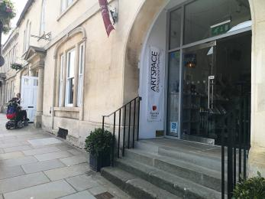
The museum's level entrance is located to the left of the steps
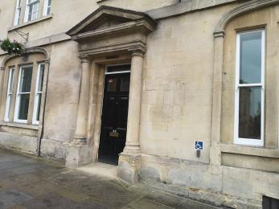
To use the level entrance please press the silver button to the right of the door.

Getting around inside

Visual Impairment - General Information
- We have high colour contrast between walls and doorframes.
- Some parts of the venue have low lighting.
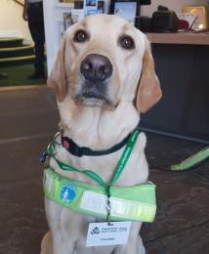
Assistance dogs are welcome at Chippenham Museum

Lift
- We have 1 lift.
- You can get a lift to all floors.

Lift to all floors
- The lift door is 800mm wide.
- The lift is 1100mm wide. The lift is 1420mm deep.
- The lift buttons have raised numbers or letters.
- The lift shows the floor number, at each floor.
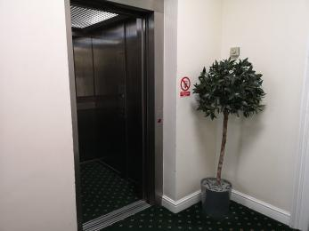
The lift at Chippenham Museum

Ticket/ information desk

Information Desk
- From the main entrance to the desk, there is level access. The route is 1100mm wide, or more.
- The door is 1100mm wide, or more.
- The desk has a low section.
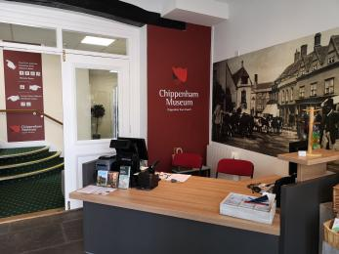
Chippenham Museum's information desk at the entrance has low access for wheelchair users and a hearing loop

Things to See and Do
- We have display information in: large print.

Ground Floor Galleries
- From the main entrance to this area, there is level access. The route is 1150mm wide, or more. The door is 1370mm wide.
- Some display information is low, for wheelchair users. There are seats.
- There are three gallery spaces on the ground floor of Chippenham Museum with level access throughout.
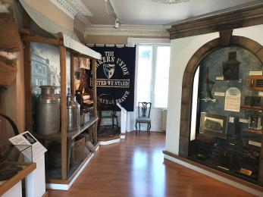
The ground floor has level access throughout.

Upstairs Galleries
- From the main entrance to this area, there is level access. There is a lift.
- From the lift to this area, the route is 1100mm wide, or more. The door is 1370mm wide.
- Some display information is low, for wheelchair users. There are seats.
- There are four gallery spaces upstairs at Chippenham Museum with level access throughout.
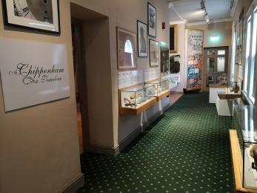
There are a number of galleries upstairs with level access throughout

Education Room
- From the main entrance to this area, there is level access. There is a lift.
- From the lift to this area, the route is 800mm wide, or more. The door is 800mm wide.
- Some display information is low, for wheelchair users. There are seats.
- There is a hearing loop.
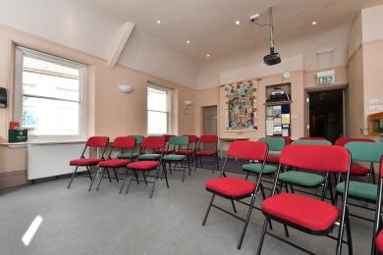
There is level access to the Education Room

Public toilet

Museum Toilets
- There is a public toilet for disabled visitors.
- From the main entrance to the public toilet, there is level access. There is a lift.
- From the lift to the public toilet, the route is 900mm wide, or more.
- The toilet door is 830mm wide.
- The direction of transfer onto the toilet is to the left.
- There is 750mm at the side of the toilet. There is 1200mm in front of the toilet. The toilet seat is 450mm high. The toilets have handrails.
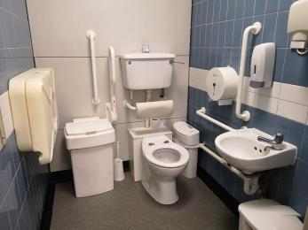
Chippenham Museum has an acccessible toilet

Shop

Museum Shop
- From the main entrance to the shop, there is level access. The route is 1100mm wide, or more. The door is 1100mm wide.
- The route through the shop is 800mm wide, or more.
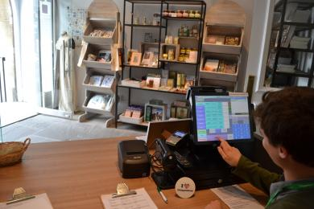
The shop at Chippenham Museum has a low level desk and friendly volunteers available to offer assistance
- From the main entrance to this area, there is level access. There is a lift.

Customer care support

Accessibility equipment
- We have a hearing loop in the Information Desk/Shop and Education Room.
- The nearest toilet area for assistance dogs is in the museum garden to the rear of the museum.

Emergency evacuation procedures
- We have emergency evacuation procedures for disabled visitors.
- The fire alarm has flashing lights.

Customer care support
- We have information in large print.

Guide last updated: 5 July 2019

