Accessibility Guide for The Old Manse
01665 710700, https://www.coquetcottages.co.uk/northumberland-holiday-cottages/the-old-manse/
Contact for accessibility enquiries: Reservations Team
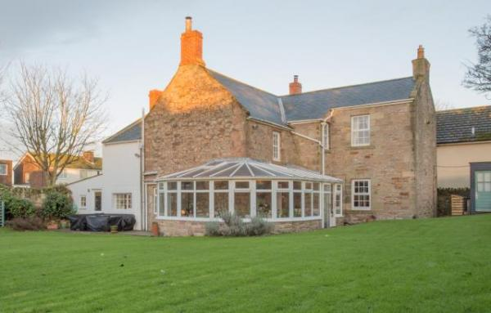

Welcome
The Old Manse is perfect for family and friends get-together’s, a comfortable base for long walks on the beach and cosy nights in front of the fire. The beautiful, well-maintained garden with its huge lawn is a wonderful feature of this old, characterful property. It’s completely enclosed, which is perfect for young children and pets to run about in. A unique feature of The Old Manse is the ‘Kota’ in the garden – an all-season BBQ house where you can enjoy family BBQ’s, or just a gathering around the cosy fire with a few drinks, all year round! The Old Manse sleeps 11 guests in 5 bedrooms and welcomes 2 dogs.

At a Glance

Level Access
- The main entrance has 1 step. There is no lift and no ramp.

Access with steps
- There are steps from the main entrance to:
  - Bedroom
  - Washing machine & tumble dryer
  - Lounge
  - Garden

Bedrooms
- We have non-allergic bedding.

Hearing
- The (bedroom) TVs have subtitles.

Getting here
The Old Manse
9 North Lane
North Sunderland
NE68 7UQ

Travel by public transport
- You can get to The Old Manse by bus.
- The nearest bus stop is located on the Main Street which is approx. 0.1 mile away. The bus stop is 0.1 miles / 0.2 km from The Old Manse.

Travel by taxi
- You can get a taxi with Park's Taxi Hire by calling 07739 802250.

Parking
- We have a car park. The parking is less than 50 metres from the main entrance. Parking is free.
- There is a drop-off point at the main entrance. The drop-off point has a dropped kerb.
- From the car park to the entrance, there is level access. The path is sloped.
- Private parking is available for 4 cars outside of The Old Manse. Additional cars can be parked on the roadside, as long as it isn’t blocking anywhere else.

Arrival

Path to main entrance
- From the street to the main entrance, there is level access.
- The path is sloped.

Main entrance
- The main entrance has 1 steps.
- The main door is side hung and manual.

Getting around inside

Bedrooms
- All bedrooms have windows.
- Bedrooms have ceiling lights, wall lights, bedside lamps, desk or table lamps and natural daylight.
- TVs have subtitles.
- All bedrooms are non-smoking.
- We have non-allergic bedding.
- All bedrooms have fitted carpets.
- The bedroom nearest the main entrance has 4 steps.
- All bedrooms are ensuite.
- We have bathrooms with a separate shower.
- We have bathrooms with a bath and overhead shower.

Washing machine & tumble dryer
- From the main entrance to the laundry, there are 2 steps. There is no lift and no ramp.
- We have an iron and ironing board.

Self catering kitchen

Kitchen
- We have a separate kitchen and dining room. From the main entrance to the kitchen, there are 2 steps. There is no lift and no ramp.
- The table and plates have high colour contrast.
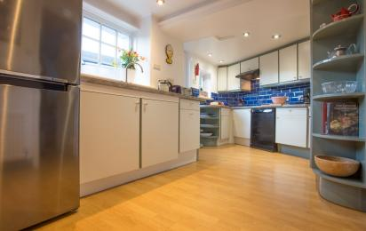
Kitchen
- From the main entrance to the dining room, there is level access.

Lounge

Lounge
- From the main entrance to the lounge, there are 2 steps. There is no lift and no ramp.
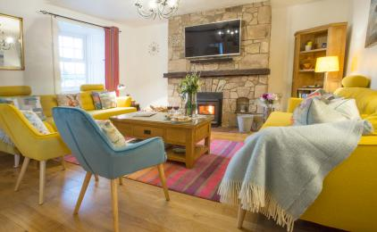
Lounge

Getting around outside

Garden
- From the main entrance to the gardens, there are 4 steps. There is no lift and no ramp.
- The large rear garden at The Old Manse is beautifully kept and is ideal for dogs and children with it being enclosed. The Kota (BBQ hut) is available all year round and is ideal in every season.
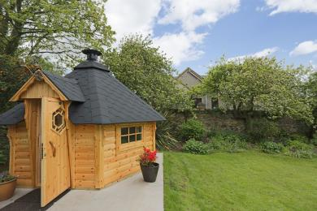
Garden

Customer care support

Accessibility equipment
- For a list of more items, please go to http://www.redcross.org.uk/Where-we-work/HealthandSupport?loc=ne65+0xp&r=50&s....
- The nearest toilet area for assistance dogs is the garden.
- You can hire mobility equipment from Red Cross Newcastle by calling 0191 2737961.

Guide last updated: 10 April 2019

