Accessibility Guide for Wentworth Holidays
grasmere-wentworth@hotmail.com, 01493728052, www.grasmere-wentworth.co.uk
Contact for accessibility enquiries: Rosemary Peers
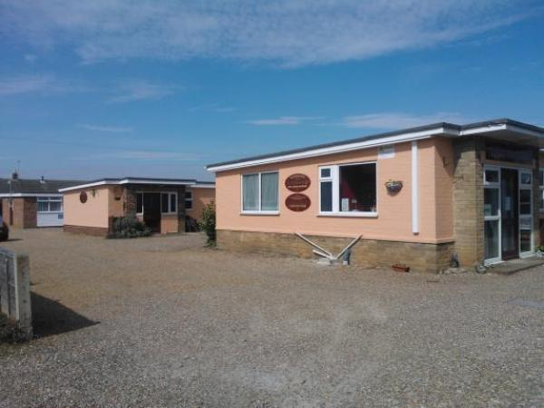

Welcome
Wentworth is a small, compact chalet site established in the 1960s and in our ownership since 1999. Most regular customers use us as a base, but the general layout does not lend itself to families who would normally spend a lot of time on-site.
All chalets are equipped with:
• Fitted lounge and bedroom heaters
• Colour TV, full-size electric cooker, microwave and toaster.
• Kitchen equipment, china and cutlery
• Bed linen and towels included. For persons staying longer than a week, a change can be provided on Fridays.
• Bedrooms and lounge are carpeted.
• We offer a free WiFi system

At a Glance

Access with steps
- There are steps from the main entrance to:
  - Wentworth Reception
  - Bedroom
  - Wentworth
  - Oliver

Bedrooms
- We have non-allergic bedding.

Hearing
- The (bedroom) TVs have subtitles.

Visual
- Glass doors and full-height windows have contrast markings.
- Some parts of the venue have low lighting.

General
- Staff are available 24 hours a day.
- We have emergency evacuation procedures for disabled visitors.

Getting here
Bultitudes Loke
Caister-On-Sea
Great Yarmouth
NR30 5DH

Travel by public transport
- You can get to Wentworth Holidays by bus and train.
- The nearest bus stop is on the main road just to the left when you exit Bultitudes loke. The bus stop is 0.1 miles / 0.2 km from Wentworth Holidays.
- The nearest train station is Great Yarmouth Train Station. The train station is 2.5 miles / 4.0 km from Wentworth Holidays.
- We advise people travelling via train to get a taxi from the train station to us.

Travel by taxi
- You can get a taxi with Albies by calling 01493331111. The taxi company has a wheelchair accessible vehicle.
- You can get a taxi with Swift by calling 01493300300. The taxi company has a wheelchair accessible vehicle.

Parking
- We have a car park. The parking is less than 50 metres from the main entrance. Parking is free.
- There is a drop-off point at the main entrance. The drop-off point has a dropped kerb.
- From the car park to the entrance, there is level access.

Arrival

Path to main entrance
- From the street to the main entrance, there is level access.

Main entrance
- The main entrance has level access.
- When you arrive, we can help carry your luggage.

Getting around inside

Visual Impairment - General Information
- We have contrast markings on all glass doors and contrast markings on all full-height windows.
- Some parts of the venue have low lighting.

Wentworth Reception
- From the main entrance to reception, there is 1 step. There is no lift and no ramp.
- You can sit down at reception.
- The reception is a very informal area and as such it does not have a check in desk.
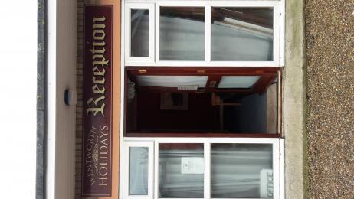
Outside view of reception.
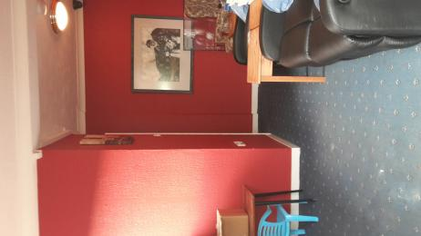
Inside reception.

Bedrooms
- All bedrooms have windows.
- Bedrooms have ceiling lights, bedside lamps and natural daylight.
- Lights are LED and energy saving. TVs have subtitles.
- All bedrooms are non-smoking.
- We have non-allergic bedding.
- All bedrooms have fitted carpets.
- The bedroom nearest the main entrance has 1 steps.
- We have bathrooms with a separate shower.
- The walls and the fittings have high colour contrast.
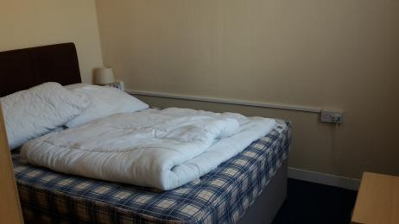
Oliver bedroom
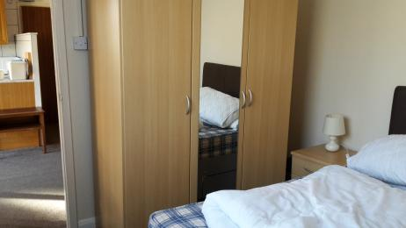
Oliver bedroom
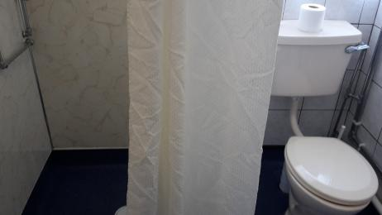
Oliver bathroom
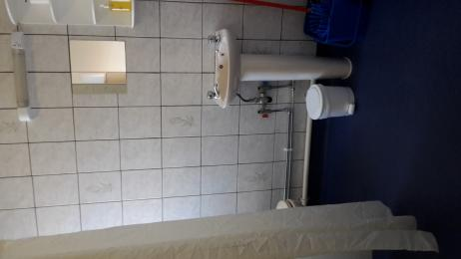
Oliver bathroom

Wentworth
- From the main entrance to the laundry, there are 2 steps. There is no lift and no ramp.
- We have an iron and ironing board. You can use the ironing board sitting down.
- The ironing board can be used from a seated position but the plug for it is raised and cannot be reached from a seated position.
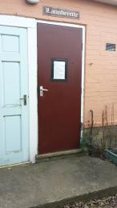
Laundry entrance.
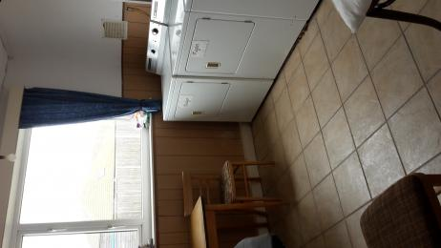
Inside laundry.
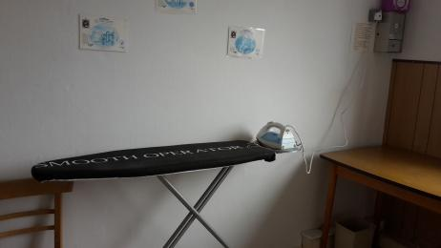
Ironing board.

Self catering kitchen

Oliver
- We have an open plan kitchen.
- From the main entrance to the kitchen, there is 1 step. There is no lift and no ramp.
- The table and plates have high colour contrast.
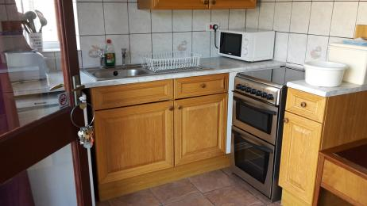
Oliver Kitchen

Lounge

Oliver
- From the main entrance to the lounge, there is 1 step. There is no lift and no ramp.
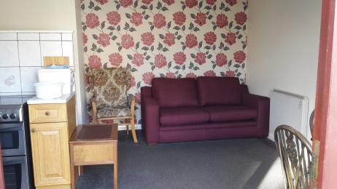
Oliver lounge.

Customer care support
- You can hire mobility equipment from Beactive Mobility by calling 01493 444 384.

Customer care support
- Staff are available 24 hours a day.

Guide last updated: 17 December 2019

