Accessibility Guide for RSPB Pulborough Brooks
pulborough.brooks@rspb.org.uk, 01798 875851, www.rspb.org.uk/pulboroughbrooks
Contact for accessibility enquiries: Anna Allum (pulborough.brooks@rspb.org.uk)
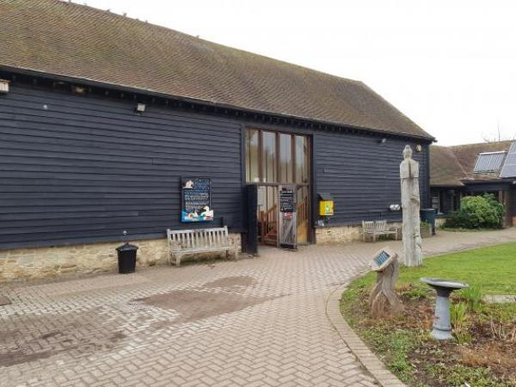

Welcome
Set within the South Downs National Park, Pulborough Brooks is one of the best homes for nature in the country. The Visitor Centre and nature reserve is open all year and boasts a great variety of habitats including wetlands, woodland, and heathland. Pulborough Brooks is a haven for a wide range of wildlife.
There are two trails on the reserve, one which explores the wetland area and the other takes in the wooded heath.
The Visitor Centre facilities offer a shop that stocks a wide range of birdcare and gifts; a café that serves main meals, snacks, cakes and hot and cold drinks. The toilets are situated in the visitor centre and includes an accessible toilet and baby changing area.

At a Glance

Level Access
- There is level access from the main entrance to:
  - Dining Table
  - Welcome area and admissions
  - Visitor Centre Toilets
  - RSPB Shop
  - Education Centre
  - Play area
  - Composting toilet
  - Additional picnic areas
- There is level access from the car park to:
  - Main Picnic area (located near to the Visitor Centre)
- The hide entrance has level access.

Hearing
- Some staff have disability awareness training.

General
- We have a complimentary ticket policy for personal assistants.
- There is at least 1 public toilet for disabled visitors.
- Some staff have disability awareness training.

Getting here
RSPB Pulborough Brooks nature reserve
Wiggonholt
Pulborough
RH20 2EL

Travel by public transport
- You can get to RSPB Pulborough Brooks by bus and train.
- The compass bus 100, from Burgess Hill to Horsham stops on the A283 at the end of the access track leading to the Visitor Centre. In the opposite direction, the stop is located on the other side of the road approximately 50 metres further along the road. The main road outside the reserve has no pavement and is uneven in places with a gradual incline. From the bus stop along the access track it is 450 m to the Visitor Centre The bus stop is 0.3 miles / 0.5 km from RSPB Pulborough Brooks.
- The nearest train station is Pulborough. The train station is 2 miles / 3.2 km from RSPB Pulborough Brooks.
- The compass bus 100 stops at Pulborough train station. Taxis are not readily available at the station. If you require an accessible taxi you may need to book this in advance.

Travel by taxi
- You can get a taxi with M J Cars by calling 01798 874321.

Parking
- We have a car park. There are accessible parking spaces. The parking is less than 50 metres from the main entrance. Parking is free.
- There is a drop-off point at the main entrance. The drop-off point has a dropped kerb.
- From the car park to the entrance, there is level access. The route is 1350mm wide, or more.
- A manual wheelchair and a self-drive electric buggy are available at the centre and can be taken out to the car park to transport visitors into the centre.
There are 5 clearly signed accessible free parking spaces situated in front of the Visitor Centre courtyard 45 metres from the Visitor Centre entrance from the furthest space.
The car park is adjacent to the Visitor Centre and a short walk to the entrance. There is no charge for parking.
The car park surface is tarmac immediately outside the Visitor Centre and loose gravel in all other places. The car park is not lit at night, but there is illumination provided by movement – activated lighting on the Visitor Centre.
There is a drop off point immediately outside the Visitor Centre courtyard, although care is needed as delivery vehicles and pedestrians use this area.
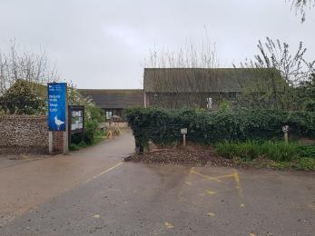
Accessible parking spaces in front of Visitor Centre courtyard

Arrival

Path to main entrance
- From the street to the main entrance, there is level access.
- The path is 1350mm wide, or more.

Main entrance
- The main entrance has level access.
- The door is 1350mm wide.
- The main door is side hung and manual.
- There are no steps between the car park and the visitor centre. The visitor centre is accessed via double doors which open outwards. The clear door opening width is 135 cm. The reception area is permanently staffed during opening hours by the RSPB team who can provide assistance if necessary.
The Visitor Centre is open 9.30am-5pm daily (the cafe closes at 4.30pm), except Christmas Eve & Christmas Day. The nature trail is open daily from sunrise to sunset, except Christmas Day.
We welcome assistance dogs in the Visitor Centre and on the nature trails. Water bowls for dogs are provided at the Visitor Centre.
All well behaved dogs are welcome on the public footpaths and on parts of the wooded heathland trail but are not permitted on the wetland nature trail (except assistance dogs).
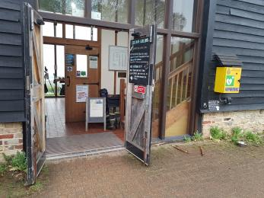
Entrance door to Visitor Centre

Getting around inside

Ticket/ information desk

Welcome area and admissions
- From the main entrance to the desk, there is level access. The route is 900mm wide, or more.
- The desk has a low section.
- A member of the RSPB team will be on hand to welcome you to the Visitor Centre. Should you need information about the nature reserve they will be happy to chat with you, provide directions and a map. If you need to purchase tickets for entrance to the nature trails they will assist you at the desk which is shared by both admissions and shop purchases.
The main entrance and information area is situated on the ground floor and the tiled floor is step free and level throughout.
The Visitor Centre is staffed by friendly RSPB staff and volunteers, who can give you information, read out any literature and provide assistance if required.
There is a lowered section of the service counter which can be used for shop purchases and for the payment of admission charges to the reserve.
A stool and chair are available within the reception area and can be provided on request.
A wheelchair can be borrowed (free of charge) for use in and around the visitor centre. This wheelchair is not suitable for use on the nature trails themselves.
Two self-drive motorised electric vehicles (pre-booking is recommended) are available for hire for use around the wetland trail. These are free to hire but donations towards their upkeep are welcomed. These vehicles can access the entirety of the wetland trail, including the viewpoints. Winpenny Hide can be accessed with the vehicles following door widening. There are turning circles and room to park the vehicles outside the other 3 hides.
Visitors are welcome to use their own wheelchair and mobility vehicles, but please note that some of the path surfaces may not be suitable for some vehicles.
Binoculars are available for hire. We also hire out bug hunting kits for families.
There are a variety of events and activities available throughout the year. We make every effort to make these events accessible, and adapt them where possible on request, however some do take in ‘off trail’ areas on the reserve which visitors with limited mobility may find difficult: please ask staff for more details of events, including accessibility.
The exit to the wetland trail is via a single door with an opening width of 80 cm. If needed the trail can be accessed via a side gate with an opening width of 90 cm. Please ask a member of the RSPB team to unlock this gate for you.
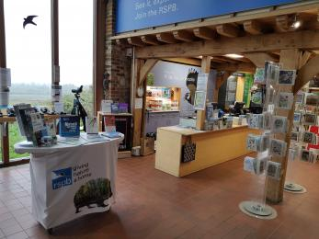
Photo of welcome area and admissions/shop desk

Things to See and Do
- We have a complimentary ticket policy for personal assistants.
- Staff and volunteers are always available to talk through nature reserve information in addition to the written guides that are available. A Television screen is used to display photographs from the reserve or wildlife videos.

Public toilet

Visitor Centre Toilets
- There is a public toilet for disabled visitors.
- From the main entrance to the public toilet, there is level access. The route is 850mm wide, or more.
- The toilet door is 850mm wide.
- The direction of transfer onto the toilet is to the front only.
- The toilet seat is 450mm high. The toilets have handrails.
- Public toilets are located in the Visitor Centre all have level access. The width of the door from Visitor Centre into WC corridor is 85 cm.
In addition to the ladies (4 cubicles) and mens (1 cubicle, 2 urinals) toilets there is a unisex accessible toilet, open to all and described below:
Door – opens outwards with 85 cm clear opening
Sign on door and wheelchair symbol
Pull handle on outside of door 95 cm above floor level
Simple lever lock on inside of door, large and easy to operate, 100 cm above floor
Light cord/switch, within reach 85 cm above floor level
Wheelchair turning room/floorspace,
Floor surface level, smooth and skid-resistant
WC height 45 cm to top of seat, additional child seat available.
Twin hinged support rail [35mm dia.] next to WC at height of 75 cm to top rail
Horizontal support rail [35mm diameter, 60 cm long] at side of WC back wall [height 70 cm to top of rail]
Wash basin on side wall, within reach, 70 cm height to top
Tap with running water, lever type easy to operate (not pressure taps)
Soap dispenser and hand drier and toilet paper holder with toilet paper, within reach to side of WC
Vertical support rail [35mm diameter, 600mm long] on side wall height 80 cm from bottom of rail
Mirror above wash basin
Sanitary waste disposal bin
Emergency alarm cord, red, within reach from floor, large pull handle
There is a baby changing table that is accessible from a seated position and folds down for use. Nappy waste disposal bin available.
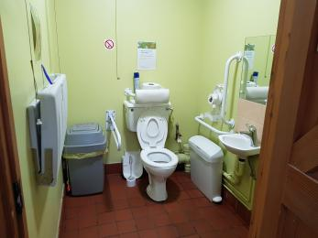
Photo of interior of accessible toilet

Shop

RSPB Shop
- From the main entrance to the shop, there is level access. The route is 1350mm wide, or more. The door is 1350mm wide.
- The route through the shop is 800mm wide, or more.
- There is a shop selling an extensive selection of bird food and bird care products, binoculars and telescopes, books, children’s products and gifts. This is located within the main Visitor Centre building.
There is level entry and no doors to enter the shop apart from those at the main entrance.
There is step free, level access throughout with a floor surface of non-slip tiles. There is sufficient aisle space to provide access through the shop, although space is limited in some places within the shop.
The area is evenly and well lit by natural lighting and overhead lights.
Most goods are within easy reach, but some goods are on high shelves. Some products (such as bags of bird food) are heavy (up to 12.75 kg) Staff are on hand to provide assistance.
Promotional or reserve-based films are played on screens, sometimes with sound and occasionally with subtitles. There is no background music.
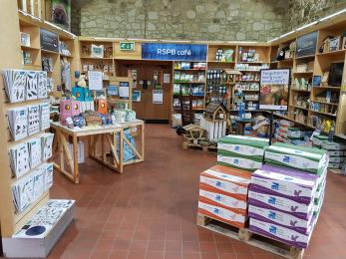
Interior of shop and entrance to cafe

Place to eat and drink

RSPB Cafe
- From the main entrance to the dining area, there is level access. The route is 800mm wide, or more. The door is 1600mm wide.
- To get to a table, there are no steps.
- The route through the dining area is 800mm wide, or more.
- There is no background music.
- The table and plates have high colour contrast.
- We cater for vegetarian, gluten free (celiacs) and vegan specific diets.
- The café is accessed via a step free level surface from the Visitor Centre and shop. Single door width is 800 mm with double door width being 1600 mm. The floor is tiled and level throughout.
There are upright chairs without arms and the clear table height is 70 cm. Children’s high chairs are also available. All seating can be moved to provide access for wheelchair users.
Lighting in all areas is natural daylight with overhead lighting used.
The outside seating is made up of benches and tables, with wheelchair spaces available under the covered area. There is a shallow gradient to reach the lower tea terrace which has additional tables
Food and drinks are ordered at the till point. Drinks and cakes are served from the till point with trays available. If assistance is needed to carry the trays then staff are available. Hot food is served to your table.
We try to source food locally and the café has been awarded ‘Bronze’ by the Soil Association. We do provide for different dietary needs, please ask a member of the catering team about ingredients if you have any food allergies.
Our day to day menu is available on all tables and specials are shown on a blackboard. Staff can assist by reading out the menu if required.
The nearest public toilet with an accessible WC is located at the other end of the visitor centre
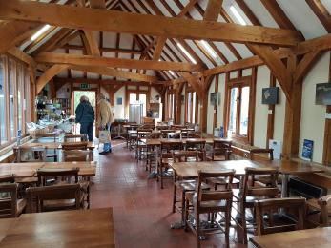
Interior of cafe

Education Centre
- From the main entrance to this area, there is level access. The route is 800mm wide, or more.
- The door is 800mm wide.
- The classroom is situated on the ground floor of the Visitor Centre with level entry from a corridor.
There is step free, level access throughout and the floor surface is non-slip.
Furniture can be re-arranged giving ample room within the classroom for a wheelchair to manoeuvre and turn. The classroom is not accessible with our electric mobility vehicles.
The area is evenly and well lit with LED lighting.

Getting around outside

Designated Walking Trail

Wetland nature trail
- The trail is 3500metres long. Some of the trail has a loose surface. There are 6 gates (all of which open in both directions). Some of these gates are heavy and assistance may be required. The trail is sloped. The trail has seats. There are bird hides along the trail.
- On the wetland trail, the stone path (with gradients) can be bumpy in places following rain. Two self-drive ‘Tramper’ mobility scooters are available (pre-booking is recommended).
The walk around the wetland trail is just over two miles (3 km) following a circular loop. From the Visitor Centre the trail has a tarmac surface for 125 metres before changing into a rolled stone path, underlain by tarmac that extends clockwise around the trail to Winpenny hide (1.2 km). The remainder of the path is stone and can be uneven and muddy in places, particularly following rain and where vehicles cross the path.
Wooden bench seats are located at intervals around the wetland trail. All have back support and some have arm rests. Benches within the hides do not have back support, although those at the rear of the hides do have the hide walls for support.
The wetland trail are clearly signposted and trail maps are available from the Visitor Centre and can be downloaded from the website.
Seasonal interpretation boards are provided along the trails. These are hand drawn and handwritten with good colour contrast. Most are easily read from a seated position. Staff and volunteers are present on the visitor routes and in the hides and may be available to provide assistance and information.
There are no stiles on the wetland trail, however there are 6 gates, some of which are heavy and where assistance may be required.
Hides:
West Mead Hide - Door opens inwards. Door width 88 cm. The hide features a bench-free low window suitable for use from a seated position. Not suitable for our mobility vehicle. There is a parking and turning space at the hide entrance.
Winpenny Hide - Winpenny hide has a double door, extending to a width of 128 cm. The second door is secured with a bolt so users may require assistance. In Winpenny hide some of the fixed seating has been removed to allow turning room to make it accessible to our mobility vehicles.
Little Hanger Hide - Door opens inwards. Door width 75 cm. The hide features a bench-free low window suitable for use from a seated position. Not suitable for our mobility vehicle. There is a parking and turning space at the hide entrance.
Nettley's Hide - Door opens inwards. Door width 75 cm. There are no bench free sections with low windows in this hide. Not suitable for our mobility vehicle. There is a parking and turning space at the hide entrance.
The pathway down to Nettley’s hide and Jupp’s View is steep in places. These are on a separate ‘offshoot’ of the main trail so the main circular loop can be completed without accessing these viewing areas.
All hides have glazed viewing flaps that are relatively easy to open and secure. All hides have fixed bench seating except in the location of the low viewing slots. There are information boards showing seasonal bird species in all hides. A childrens ‘step stool’ is available in each hide.
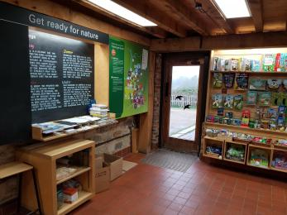
Door accessing wetland nature trail from Visitor Centre
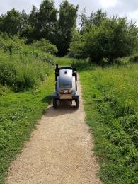
Mobility vehicle on rolled stone path
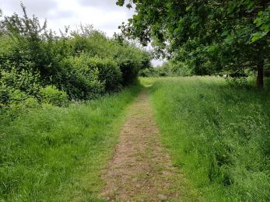
Stone path
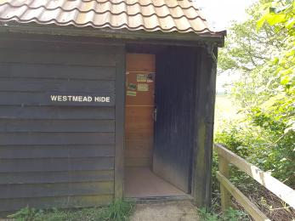
West Mead Hide - showing exterior and entrance door
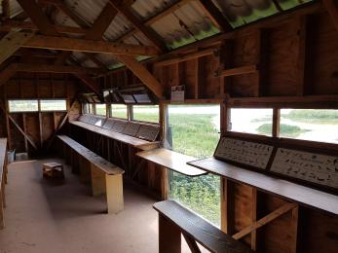
Interior of West Mead Hide

Designated Walking Trail

Wooded heathland trail
- The trail is 1850metres long. Some of the trail has a loose surface. The paths on the heathland trail are natural paths with loose sand in some areas, tree roots, wet sections and some steep gradients. The trail is sloped. The trail has seats.
- The pathways on the wooded heathland trail are all natural surfaces and have some steep gradients, a camber and a variety of loose surfaces (including sand) with some tree roots crossing paths.
This trail is not suitable for our mobility scooters.
There are a variety of pathways in this area and signage and interpretation is minimal. The ‘outer loop’ around the central area of the heath is 1850 metres, shorter loops are possible.
There are no stiles on these trails but there are a number of pedestrian gates accessing sections of the heath.
These trails are used by dogwalkers and there is a public bridleway which is used by horseriders and cyclists.

West Mead Hide (located on Wetland Trail)
- At the hide entrance, there is level access. The door is 880.00mm wide.
- There are low windows in the hide, so wheelchair users can see outside.

Winpenny Hide (located on Wetland Trail)
- At the hide entrance, there is level access. There is a permanent ramp. The door is 1280.00mm wide.
- There are low windows in the hide, so wheelchair users can see outside.

Little Hanger Hide (located on Wetland Trail)
- At the hide entrance, there is level access. The door is 750.00mm wide.
- There are low windows in the hide, so wheelchair users can see outside.

Nettley's Hide (located on Wetland Trail)
- At the hide entrance, there is level access. There is a permanent ramp. The door is 750.00mm wide.

Picnic Area

Main Picnic area (located near to the Visitor Centre)
- From the car park to the picnic area, there is level access. The path is 800mm wide, or more.
- The entrance is 800mm wide.
- Some tables have space for wheelchair users. You can bring your own food to the picnic area.
- This picnic area is adjacent to the play area and located at the start of the wetland nature trail. It is accessed via the nature trail entrance (door width 800mm) and there is a paved then tarmac path 1200mm wide. It is 68 m from the nature trail entrance to the picnic area. The tables are on a grass surface.
There are five picnic tables with space for wheelchair users and pushchairs/buggies. Sandwiches and drinks are available from tge cafe; however, visitors are free to bring their own refreshments with them.

Play area
- From the main entrance to this area, there is level access. There is a permanent ramp. The route is 800mm wide, or more. The entrance is 800mm wide.
- The play area is located close to the Visitor Centre (68m) and is accessed via a tarmac path from the nature trail entrance point. Door width is 800mm and path width 1600mm.
The adventure play area has been designed to be suitable for children of a range of ages and abilities to enable them to build their motor skills and learn how to balance, climb, swing and jump. The design also features a double width slide designed for parents/carers to use with their youngsters and a low hammock-style swing.
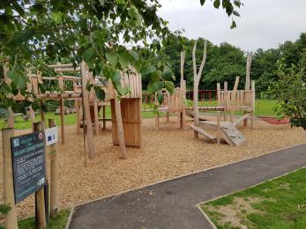
Access to play area
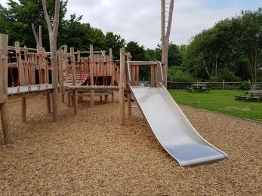
Play equipment includes a double width slide

Composting toilet
- From the main entrance to this area, there is level access. There is a permanent ramp. The route is 820mm wide, or more. The entrance is 820mm wide.
- There is an accessible composting toilet on the wetland trail on the way towards Nettley’s hide (Approximately 1000m from the Visitor Centre). There is a shallow gradient ramp up to the toilet.
(Door width 82 cm, Height of toilet seat 47 cm, Height of urinals 42 cm & 60 cm)
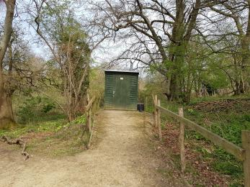
Exterior of composting toilet
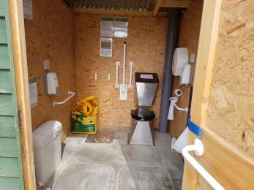
Interior of composing toilet showing toilet facilities
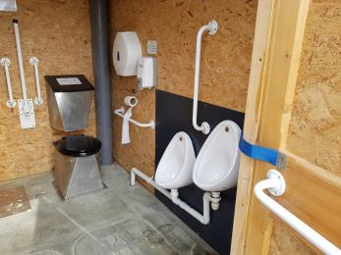
Interior of composting toilet showing urinals

Additional picnic areas
- From the main entrance to this area, there is level access. The route is 800mm wide, or more. The entrance is 800mm wide.
- Additional picnic areas
There are two picnic tables with space for wheelchair users in Fattengates courtyard (570 metres from the Visitor Centre following the accessible zig zag path). The surface of the courtyard is cement and is reasonably level. This area has an open-sided shelter (with level access) and a raised pond.
A further two picnic tables with space for wheelchair users are available on the trail towards Nettley’s hide (1000m from the Visitor Centre) and close to the accessible composting toilet. There is a gradient to reach this site and the ground is uneven in places and soft after rain.
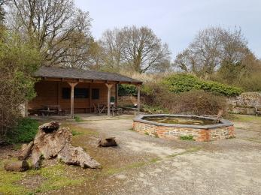
Picnic tables in Fattengates courtyard shelter

Customer care support

Accessibility equipment
- We provide wheelchairs. Wheelchairs are free.
- One manual wheelchair and is for use around the Visitor Centre, courtyard and car park only
Two self-drive mobility scooters are available for use on the nature trail. Pre-booking is recommended.
- We have an area to charge mobility scooters and battery powered wheelchairs.
- We provide our own mobility scooters. These are stored in an outside shelter in close vicinity to the Visitor Centre. Mains power is available from this point and would be made available if required.
Mobility vehicle available for use

Emergency evacuation procedures
- We have emergency evacuation procedures for disabled visitors.
- Emergency exit signs light up if fire alarm is activated. Many of the staff are trained fire wardens and will check the building on activation of the alarm to provide evacuation assistance if needed.

Customer care support
- Some staff have disability awareness training.

Guide last updated: 15 April 2019

