Accessibility Guide for Pickwell Barton Cottage
holidays@pickwellbarton.co.uk, 01271 890994 / 07811 033027, https://www.pickwellbarton.co.uk/pickwell-barton-cottage.html
Contact for accessibility enquiries: Jane Cook
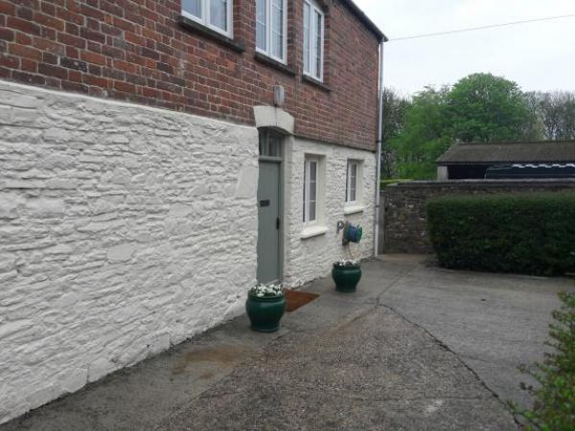

Welcome
Welcome to Pickwell Barton Cottage.
We aim to make everyone’s stay as enjoyable as possible, and we are committed to providing the best possible access we can in the property. We have described, in detail with supporting photographs, accessibility in order to give you the confidence to visit knowing that Pickwell Barton Cottage will be suitable for your requirements.
If you cannot find the information you require in this Accessibility Guide please do make contact and we will do our best to answer your questions.
We look forward to welcoming you.
Warm wishes,
Jane Cook

At a Glance

Level Access
- There is level access from the main entrance to:
  - Downstairs Bathroom
  - Downstairs Toilet

Access with steps
- There are steps from the main entrance to:
  - Bedroom
  - Lounge
  - Utility Room
  - Garden

Bedrooms
- We have non-allergic bedding.

Hearing
- Some staff have disability awareness training.

Visual
- Some parts of the venue have low lighting.

General
- Staff are available 24 hours a day.
- Some staff have disability awareness training.
- We have emergency evacuation procedures for disabled visitors.

Getting here
Pickwell Barton
Georgeham
Braunton
EX33 1LA

Parking
- We have a car park. The parking is less than 50 metres from the main entrance. Parking is free.
- There is a drop-off point at the main entrance. The drop-off point has a dropped kerb.
- From the car park to the entrance, there is level access. The route is 830mm wide, or more.
- Parking is available near the entry gate.
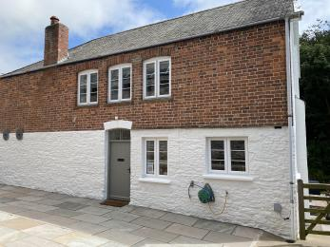
entrance to the Cottage

Arrival

Path to main entrance
- From the street to the main entrance, there is level access.

Main entrance
- The door is 770mm wide.
- The main door is side hung and manual.
- When you arrive, we can help carry your luggage.
- There is a 30mm threshold to enter the front door.
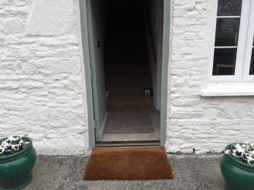
Front door

Getting around inside

Visual Impairment - General Information
- Some parts of the venue have low lighting.

Bedrooms
- All bedrooms have windows.
- Bedrooms have ceiling lights, wall lights, bedside lamps and natural daylight.
- Lights are halogen and energy saving. Some lights can be controlled independently.
- All bedrooms are non-smoking.
- We have non-allergic bedding.
- All bedrooms have fitted carpets.
- We can move the bedroom furniture, to improve accessibility.
- The bedroom nearest the main entrance has 12 steps.
- We have bathrooms with a separate shower.
- We have bathrooms with a bath and overhead shower. The walls and the fittings have high colour contrast.
- The direction of transfer onto the toilet is to the front only.
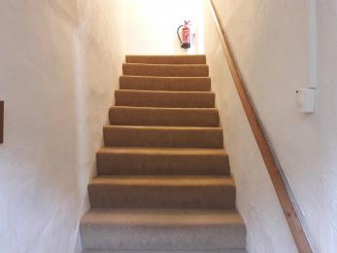
Stairs
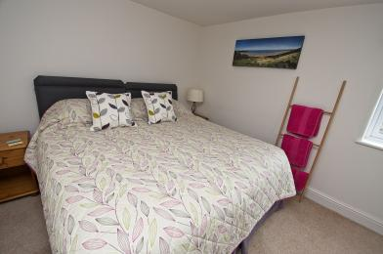
Bedroom 1 configured with super kingsize
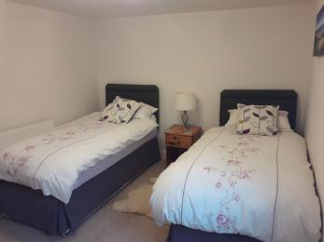
Bedroom 1 configured with two single beds
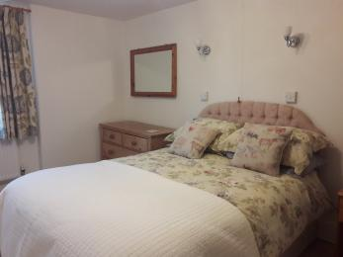
Bedroom 2 with a double bed
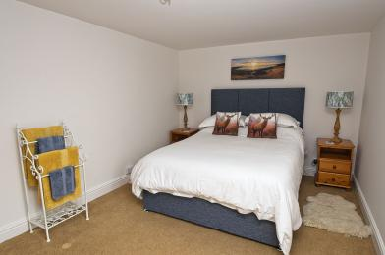
Bedroom 3 with a double bed
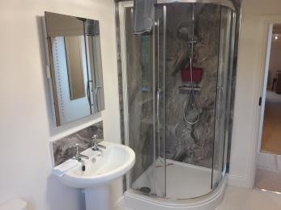
Shower room with a toilet

Self catering kitchen

Kitchen
- We have an open plan kitchen.
- From the main entrance to the kitchen, there is level access.
- The door is 770mm wide.
- The table and plates have high colour contrast.
- Height of work surface, sink and hob is 920mm.
Chairs around the kitchen table can be moved to enable wheelchair access.
The table has room for 6 places. The table height is 770mm.
High contrast table cloth available on request.
Electric oven and hob with four heat spots.
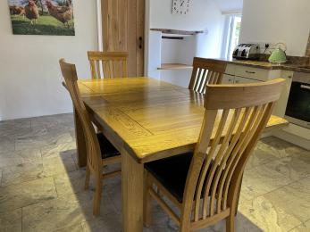
Cottage Kitchen

Lounge

Lounge
- From the main entrance to the lounge, there are 2 steps. There is no lift and no ramp.
- There is one two seater sofa - height 430mm and seat depth is 600mm.
There are three armchairs.
A 32inch SMART TV, DVD and HiFi stereo.
Wood burning fire.
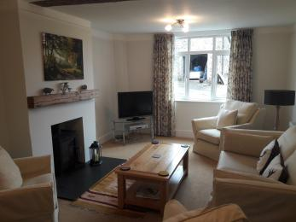
View looking in
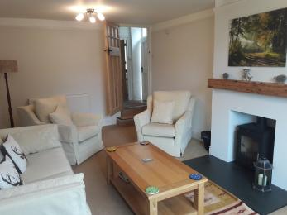
View back to lounge door

Downstairs Bathroom
- From the main entrance to this area, there is level access. The route is 700mm wide, or more.
- The bath is 5 foot. Side height is 570mm. Fitted with wall mounted shower above the bath.
Hand basin height is 840mm. Fitted with twist taps.
Toilet height is 410mm.
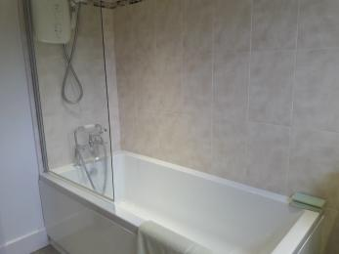
Bath
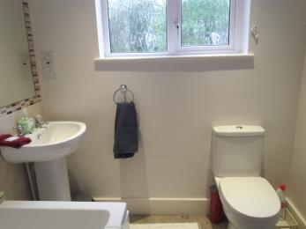
Toilet and basin

Downstairs Toilet
- From the main entrance to this area, there is level access.
- Separate toilet and hand basin.
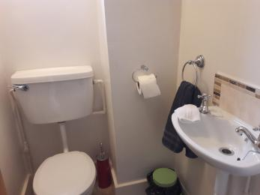
Toilet and basin

Utility Room
- From the main entrance to this area, there are 2 steps. There is no lift and no ramp.
- There is a washing machine, tumble dryer and fridge/freezer.
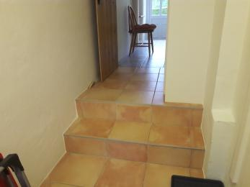
Steps in to Utility Room

Getting around outside

Garden
- From the main entrance to the gardens, there are 2 steps. There is no lift and no ramp.
- The garden can be accessed via the back door from the kitchen, with two steps inside (each 150mm) and two steps outside or by walking round the cottage from the front door. This route is step-free.
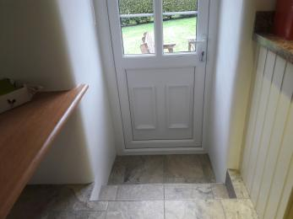
Back door exit to the garden
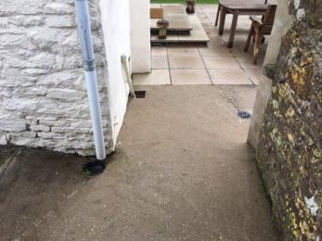
Step free route
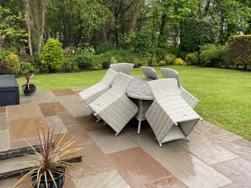
Cottage garden furniture

Customer care support

Accessibility equipment
- For a list of more items, please go to https://www.brauntonmobility.co.uk.
- Assistance dogs may use the field next to the entrance gate to Pickwell Court as a toilet area.
- You can hire mobility equipment from Braunton Mobility Centre by calling 01271 814577.

Emergency evacuation procedures
- Visitors attention is drawn to fire procedures on arrival.

Customer care support
- Some staff have disability awareness training.
- Staff are available 24 hours a day.
- Owners live in Farmhouse nearby - 75m.

Guide last updated: 10 August 2021

