Accessibility Guide for Buckenham Marshes RSPB Reserve
strumpshaw@rspb.org.uk, 01603 715191, https://www.rspb.org.uk/reserves-and-events/reserves-a-z/buckenham-marshes/
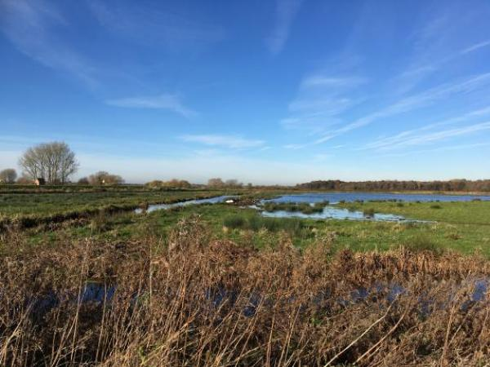

Welcome
Buckenham Marshes is a fantastic example of a managed lowland wet grassland. The Marshes are home to thousands of wildfowl in the winter months including wigeon, pink-footed geese and white-fronted geese. In the summer months, breeding waders can be seen and heard displaying as well as the muddy pools being attractive to passage waders. There is a path from the car park to the riverbank which can be followed to the east all the way to Great Yarmouth! There is also an accessible parking space right next to our viewing shelter.

At a Glance

Level Access
- The hide entrance has level access.

Getting here
Station Road
Buckenham
NR13 4HW

Travel by public transport
- You can get to Buckenham Marshes RSPB Reserve by bus and train.
- An hourly bus service from Norwich (First Bus service 16 towards Lingwood) stops on the Brundall to Strumpshaw Road at the junction of Long Lane and Stone Road (weekdays and Saturdays only - www.firstbus.co.uk/norfolk-suffolk/routes-and-maps/route-maps). The route from the bus stop to the reserve is 2.6 km along quiet country roads with no pavements. The road is fairly flat but uneven in places. The bus stop is 1.6 miles / 2.6 km from Buckenham Marshes RSPB Reserve.
- The nearest train station is Buckenham. The train station is 0 miles / 0.0 km from Buckenham Marshes RSPB Reserve.
- There is a train station next to the car park at Buckenham Marshes, however trains only stop here at weekends (www.greateranglia.co.uk/timetables - timetable no 8).
Brundall station is serviced with an hourly service throughout the week, however it is a 2.3mile (3.7km) journey.

Travel by taxi
- You can get a taxi with A2B by calling 01603 552324. The taxi company has a wheelchair accessible vehicle.
- You can get a taxi with Courtesy Taxis by calling 01603 446644. The taxi company has a wheelchair accessible vehicle.

Parking
- We have a car park. There are accessible parking spaces. Parking is free.
- There is a drop-off point at the main entrance. The drop-off point has a dropped kerb.
- From the car park to the entrance, there is level access. The route is 1300mm wide, or more.
- There are two car parks for the Buckenham reserve, the main car park is behind Buckenham station. There is one accessible parking space next to the bird hide at the top of the farm track which starts directly opposite the level crossing gates in front of Buckenham Station.
For the accessible parking follow the directions to Strumpshaw Fen - at the junction of Long Lane and Stone Road turn right into Stone Road, and immediately right again into Low Road. The entrance to Strumpshaw Fen is 900m ahead. Continue past Strumpshaw Fen 200m to a T junction. Turn Right and follow Station Road to the level crossing gates at Buckenham Station where the tarmac road terminates. Turn Right on the farm track for 700m to the hide. The accessible parking space is to the left of the hide.
The main car park can be approached via an alternative route (avoiding opening the railway crossing gates to cross the line). Follow the directions above to the T junction 200m past Strumpshaw Fen. Turn right on Low Road to a crossroads. Turn right on Stone Road and follow it to a crossroads. Turn right, continuing on Stone Road to a right turn for Station Road. Follow Station Road to the main car park behind the station on the right.
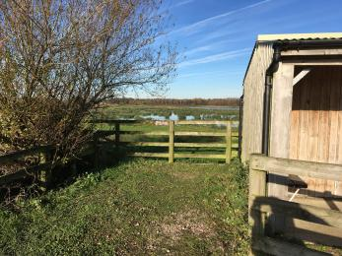
Accessible parking space next to Buckenham Hide
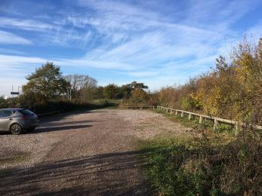
Main Car Park
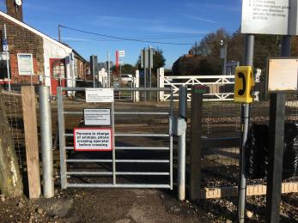
Railway gate from main car park to main trail to hide (1300mm clearance)

Arrival

Path to main entrance
- From the street to the main entrance, there is level access.
- The path is 1300mm wide, or more.

Main entrance
- The main entrance has level access.

Getting around inside

Getting around outside

Designated Walking Trail

Buckenham Track
- The trail is 1600metres long. Some of the trail has a loose surface. A gate with 1040mm clearance leads to the lower trail. The raised riverside trail is accessed via a ramp. The trail is sloped. The trail has seats. There are bird hides along the trail.
- The hide has one wheelchair accessible viewing window. There is only one seat on the reserve, overlooking the river by the accessible car park.
The first 700m of the trail follows the track from Buckenham Station to the hide/shelter. This is on a firm but uneven vehicle track, which is potholed and has large puddles in the winter.
The second section from the hide to the mill has 2 parallel tracks. A riverside walk on a raised bank and a farm track below it. The raised bank is accessed via a ramp. The farm track is accessed via a gate with 1040mm clearance. The farm track has vehicle ruts and a raised middle section. The riverside walk is grass and can be very muddy in winter. There is a small earth ramp down to the mill at the end of the trail.
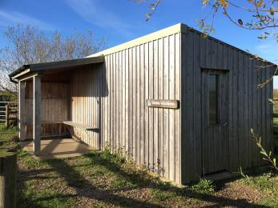
Buckenham Hide and external viewing shelter
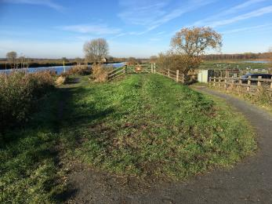
Ramp from accessible parking onto the riverbank and to accessible fishing swims
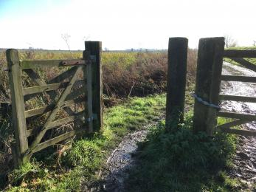
Pedestrian access gate to footpath and mill (1040mm clearance)
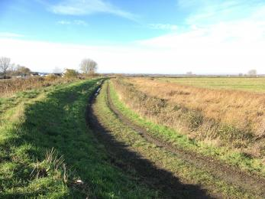
Path surface from mill towards accessible parking and Buckenham Hide
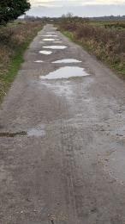
Track from Buckenham Station to Hide/Shelter
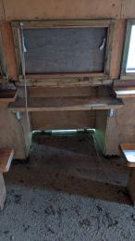
Accessible Viewing Window
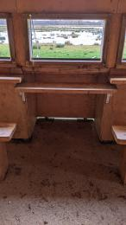
Accessible Viewing Window
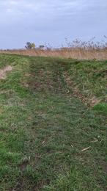
Ramp to Mill

Buckenham Hide and External Viewing Shelter
- At the hide entrance, there is level access. The door is 770.00mm wide.
- There are low windows in the hide, so wheelchair users can see outside.

Customer care support

Guide last updated: 9 March 2024

