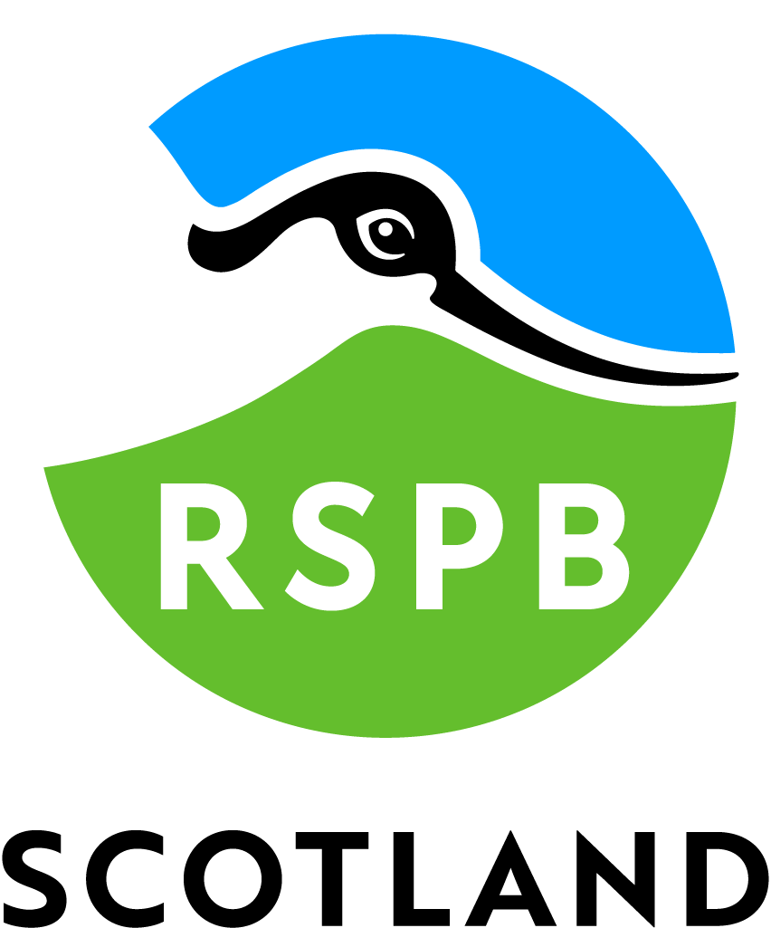

Accessibility Guide for RSPB Scotland Trumland
orkney@rspb.org.uk, 01856 850176, https://www.rspb.org.uk/reserves-and-events/reserves-a-z/trumland/
Contact for accessibility enquiries: RSPB Orkney Office
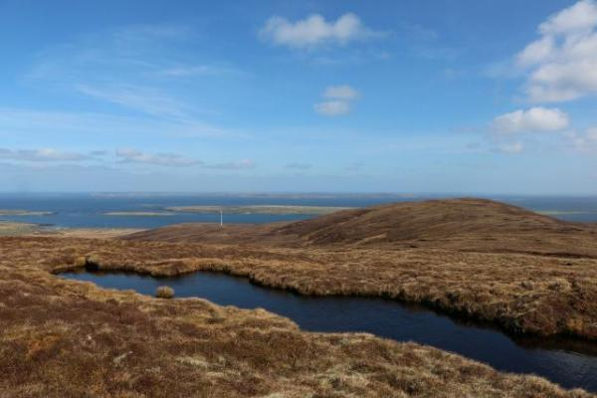

Welcome
Trumland Reserve is a beautiful mixture of blanket bog and wet heath. It is a remote location and arguably the best time to visit is during the summer months, when you should be able to see breeding red-throated divers, hen harriers, merlins and short-eared owls. The moorland is also home to Arctic and great skuas in summer. Enjoy spectacular views of the Orkney archipelago from the tops of Knitchen Hill and Blotchnie Fiold (Rousay's highest hill), but don't miss the tiny moorland wildflowers at your feet and the plaintive cries of golden plovers as you pass by.

At a Glance

Getting here
RSPB Trumland
Rousay
KW17 2PU

Travel by public transport
- You can get to RSPB Scotland Trumland by boat or ferry.
- The nearest port is Rousay Pier. The port is 0.8 miles / 1.3 km from RSPB Scotland Trumland .
- Rousay is reached by a roll on-roll off ferry, which takes both passengers and vehicles, from Tingwall on Mainland Orkney. Vehicles must be booked in adavance. Visit http://www.orkneyferries.co.uk/ for up to date travel information. From the ferry terminal, the reserve is reached by a 0.75 mile walk along single track roads. From the pier, follow the road uphill and left until you reach the T-junction at Trumland House, then head right and look for a small bridge and RSPB sign on your left after 0.4 miles.

Parking
- There is no car parking available at the reserve itself. The nearest car park is at the pier, 0.75 miles from the reserve entrance. From the pier, follow the road uphill and left until you reach the T-junction at Trumland House, then head right along the road and look for a small bridge and RSPB sign on your left after 0.4 miles.
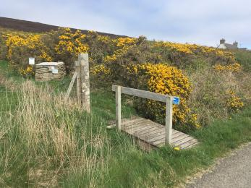
Trumland entrance photo

Arrival

Path to main entrance
- The path is sloped.

Main entrance
- Please note that there is no Visitor Centre and there are no buildings at the reserve. The only facilities are a nature trail around the reserve. There are no staff based at the reserve. There is an accessible toilet at the Rousay Heritage Centre by the pier - please contact the Orkney Islands Council on 01856 873535 for details on opening times.

Getting around inside

Getting around outside

Designated Walking Trail

Hilltop Trail
- The trail is 4850metres long. Some of the trail has a loose surface. The trail is sloped. The trail has seats.
- The path is narrow (less than 40 cm wide in sections), unsurfaced, uneven and steep in places and can be very wet and muddy. A bench is placed just off the trail three quarters of the way up Knitchen Hill. There is a wooden bridge covered in chickenwire with an unprotected drop on one side at the entrance to the reserve.
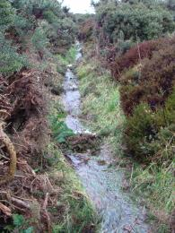
Trumland path in winter
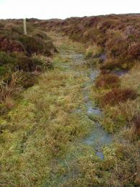
Trumland wet path in winter
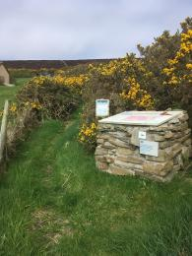
Trumland reserve entry point
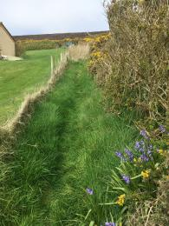
Trumland trail grassy surface
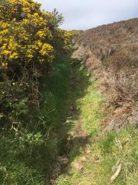
Trumland trail surface
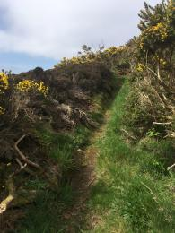
Trumland trail
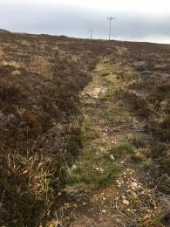
Trumland moorland trail
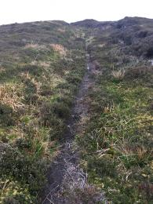
Trumland trail
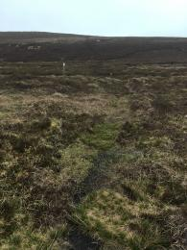
Trumland trail
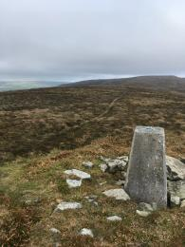
Trumland Knitchen Hill trig point
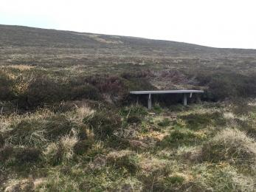
Trumland bench

Customer care support

Accessibility equipment
- There is no designated toilet area for assistance dogs. Any rough ground by the sides of the trail can be used, but please remove any dog waste from the site.
- You can hire mobility equipment from Orkney Disability Forum by calling 01856 870340.

Guide last updated: 7 July 2022

