Accessibility Guide for Nightingale Cottage
mylostkite@comcast.net, 01760 305008, www.nightingalecottage.com
Contact for accessibility enquiries: Sue Wilmot
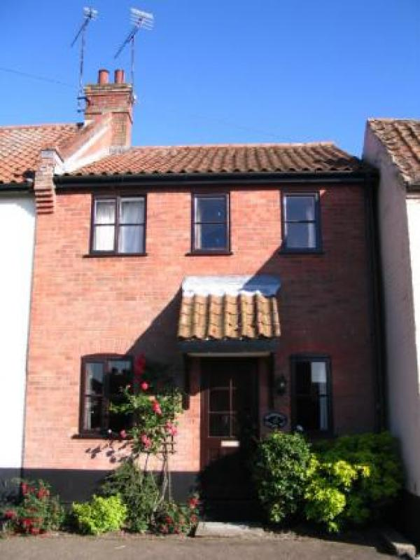

Welcome
Nightingale Cottage is a comfortable, clean and spacious three bedroom cottage, sleeping up to four people with a cot (crib) for an infant.
The living/dining room has a cosy open fire with electric heating throughout. For your entertainment here is a 27" flat screen High Definition LCD TV with built in Freeview Service and a separate Blu-Ray DVD player.
The kitchen is well equipped with electric cooker, microwave, fridge, and washer-dryer.
Upstairs you will find one double bedroom and two single bedrooms with ceiling fans.
The bathroom has extra heating and includes a bathtub and electric shower.
Enclosed courtyard garden and parking out front and in garage.

At a Glance

Level Access
- The main entrance has 3 steps. There is no lift and no ramp.
- There is level access from the main entrance to:
  - Nightingale Cottage Sitting Room

Access with steps
- There are steps from the main entrance to:
  - Bedroom
  - Courtyard garden

Bedrooms
- We have non-allergic bedding.

Hearing
- The (bedroom) TVs have subtitles.

Getting here
Nightingale Cottage, 1 Sandles Court,
Back Lane
Castle Acre, Kings Lynn
PE32 2XF

Travel by public transport
- You can get to Nightingale Cottage by bus.
- The bus stop is 200 yards from the cottage on the Massingham Road. The bus stop is 0.1 miles / 0.2 km from Nightingale Cottage.
- Buses run on weekdays from Kings Lynn and Swaffham with wider connecting services.

Travel by taxi
- You can get a taxi with Platinum Cars by calling 01760 725336.
- You can get a taxi with 2 & Fro by calling 01760 441536.

Parking
- We have a car park. The parking is less than 50 metres from the main entrance. Parking is free.
- There is a drop-off point at the main entrance. The drop-off point does not have a dropped kerb.
- From the parking to the main entrance, there are 3 steps. There is no ramp and no lift.
- There is also access from the parking area at the back of the cottage along a path, through the garden gate and in via the back door which has 2 steps into the kitchen.

Arrival

Path to main entrance
- From the street to the main entrance, there are 3 steps. There is no ramp and no lift.

Main entrance
- The door is 700mm wide.
- The main entrance has 3 steps.
- The main door is side hung and manual.

Getting around inside

Bedrooms
- All bedrooms have windows.
- Bedrooms have ceiling lights, bedside lamps and natural daylight.
- Lights are energy saving. TVs have subtitles.
- All bedrooms are non-smoking.
- We have non-allergic bedding.
- All bedrooms have fitted carpets.
- The bedroom nearest the main entrance has 13 steps.
- We have bathrooms with a bath and overhead shower. The direction of transfer onto the toilet is to the left.

Self catering kitchen

Nightingale Cottage kitchen
- We have a separate kitchen and dining room. From the main entrance to the kitchen, there is level access.
- The route is 740mm wide, or more.
- The door is 740mm wide.
- The table and plates have high colour contrast.
- From the main entrance to the dining room, there is level access.
- Dining room and sitting room are combined.
There is a hatch between the kitchen and dining area

Lounge

Nightingale Cottage Sitting Room
- From the main entrance to the lounge, there is level access.
- The main entrance provides direct access to the sitting room.

Getting around outside

Courtyard garden
- From the main entrance to the area, there are 2 steps.
- The courtyard garden can be accessed from the kitchen and from the rear of the cottage via a gate which has opening of 87cm wide.

Customer care support

Accessibility equipment
- Assistance dogs are welcome to use the courtyard garden but care must be taken to wash away any urine with water and solid waste matter disposed of correctly in sealed waste bags.
- We have an area to charge mobility scooters and battery powered wheelchairs.
- To charge a battery operated scooter or wheelchair a cable could be run through a small window in the dining room into the courtyard garden where the vehicle can be parked.
- You can hire mobility equipment from Mobility Supermarket Dereham by calling 01362 853256.

Guide last updated: 6 February 2020

