Accessibility Guide for Luxury Eco-Cabin at Bulworthy Project
hello@bulworthy.uk, 07594569441, www.bulworthy.uk/cabin
Contact for accessibility enquiries: Anna and Pete Grugeon
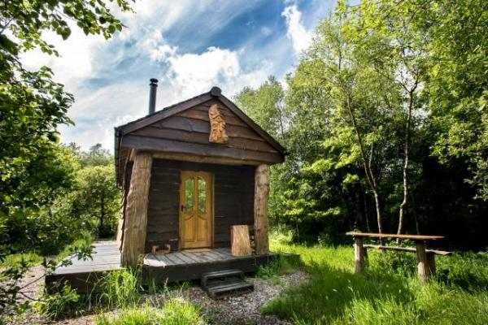

Welcome
The rustic exterior of this beautiful cabin belies the luxury within. Handmade by it's owners, it's packed with beautiful wooden features. There's a double bed an en suite and a kitchenette inside. Set in it's own private woodland glade with a barbecue and a campfire it's the perfect place for a romantic getaway for people who love the great outdoors.
Electricity for the lights, electric coolbox and usb charging points is produced by solar. Water and space is heated by a woodburning stove with a glass front so that you can watch the flickering flames.
Watch the video: Luxury Eco Cabin at Bulworthy Project

At a Glance

Level Access
- The main entrance has level access with a ramp. The ramp is permanent.
- There is level access from the main entrance to:
  - Bedroom: 1
  - The woodland glade that the cabin is set in

Bedrooms
- We have non-allergic bedding.

Level access bedrooms
- From the main entrance to the bedroom, there is level access.
- The route to the bedroom is 750mm wide, or more.
- The bedroom door is 750mm wide, or more.
- There is unobstructed floor space 1200mm by 900mm, or more.
- The bathroom has a level access shower.

Hearing
- Some staff have disability awareness training.

Visual
- The walls and the doors have high colour contrast.
- We have information in large print.

General
- Some staff have disability awareness training.

Getting here
Hensons Wood
Rackenford
Tiverton
EX16 8DL

Travel by public transport
- Unfortunately, there is no local public transport.

Travel by taxi
- You can get a taxi with Parkway Taxis by calling 01884 38899. The taxi company has a wheelchair accessible vehicle.

Parking
- We have a car park. The parking is less than 50 metres from the main entrance. Parking is free.
- There is a drop-off point at the main entrance. The drop-off point has a dropped kerb.
- From the car park to the entrance, there is level access. There is a permanent ramp.
- The route is 820mm wide, or more.
- You can park right by the ramp to the entrance.
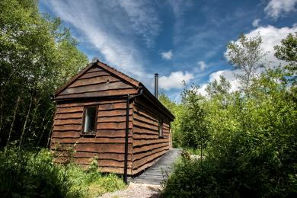
The view of the cabin from the parking space

Arrival

Path to main entrance
- From the street to the main entrance, there is level access.
- There is a permanent ramp.
- The path is 1000mm wide, or more.

Main entrance
- The main entrance has level access.
- There is a permanent ramp.
- The door is 820mm wide.
- The main door is side hung and manual.
- When you arrive, we can help carry your luggage.
- The cabin is built to be compliant with building regs on accessibility. We have a shower chair and portable grab rails for the cabin if required and we're happy to discuss accessibility needs to see if we can improve the accessibility of the cabin further.
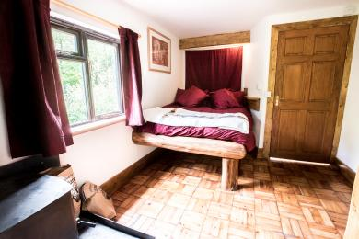
The cabin interior

Getting around inside

Visual Impairment - General Information
- We have high colour contrast between walls and doorframes.
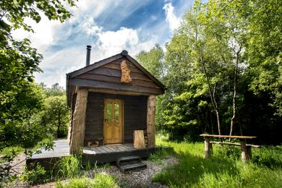
Luxury Eco Cabin

Bedrooms
- All bedrooms have windows.
- Bedrooms have ceiling lights and natural daylight.
- Lights are LED. All bedrooms are non-smoking.
- We have non-allergic bedding.
- No bedrooms have fitted carpets.
- We have wi-fi free bedrooms, for visitors with electro-sensitivity.
- There have never been any pets in the cabin, so it is safe for people who are allergic to dogs and cats.
- From the main entrance to this area, there is level access.

Accessible bedrooms

Accessible bedroom 1
- From the main entrance to the bedroom, there is level access. There is a ramp. The ramp is Permanent.
- The route to the bedroom is 820mm wide, or more. The bedroom door is 820mm wide. There is 1200mm at the side of the bed. The bed is 700mm high. There is 410mm under the bed.
- There is a low clothes rail. You can use the rail sitting down.
- The bedroom is double. The bathroom is ensuite. The bathroom door is 800mm wide.
- The bathroom has a separate shower. The shower has a seat. The shower has a handrail.
- The bathroom has a level access shower. There is a shower chair available. The level access shower has handrails.
- The direction of transfer onto the toilet is to the left. There is 650mm at the side of the toilet.
- There is 800mm in front of the toilet. The toilet seat is 430mm high.
- The basin is 830mm high. There is space under the basin, with no pedestal or boxing.
- There is a pull out sofa under then foot of the bed. This can be removed if it would be in the way of a hoist is being used.

Self catering kitchen

Kitchenette in Cabin
- We have an open plan kitchen.
- From the main entrance to the kitchen, there is level access.
- The route is 1000mm wide, or more.
- The work surface is available at a height between 650mm and 900mm.
- The hob is available at a height between 650mm and 900mm.
- The sink is available at a height between 650mm and 900mm.
- The table and plates have high colour contrast.

Getting around outside

The woodland glade that the cabin is set in
- From the main entrance to this area, there is level access. There is a permanent ramp. The route is 1000mm wide, or more. The entrance is 1000mm wide.
- The woodland glade has stone under the lawn, making it suitable for wheeelchairs when the grass is not too long. Please let us know if you use a wheelchair and we'll make sure to cut the grass before you come.

Customer care support

Accessibility equipment
- We have a shower chair and removable hand rails for the shower. Please let us know your requirements and we'll try to accommodate them.
- For a list of more items, please go to https://www.gonorthdevon.co.uk/.
- You can hire mobility equipment from Go North Devon by calling 01271 328866.

Customer care support
- Some staff have disability awareness training.
- We have information in large print.
- We have other services for people with accessibility requirements.
- We are happy to discuss requirements to see what we can accommodate.

Guide last updated: 12 March 2019

