Accessibility Guide for Pickwell Court
holidays@pickwellbarton.co.uk, 01271 890994 / 07811 033027, https://www.pickwellbarton.co.uk/pickwell-court-holiday-cottage.html
Contact for accessibility enquiries: Jane Cook
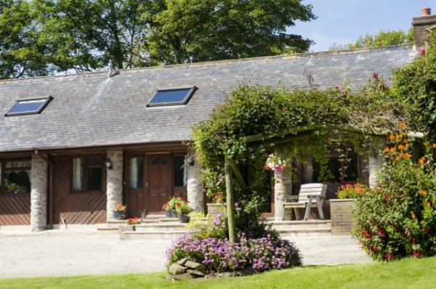

Welcome
Welcome to Pickwell Court.
We aim to make everyone’s stay as enjoyable as possible, and we are committed to providing the best possible access we can in the property. We have described, in detail with supporting photographs, accessibility in order to give you the confidence to visit knowing that Pickwell Court will be suitable for your requirements.
If you cannot find the information you require in this Accessibility Guide please do make contact and we will do our best to answer your questions.
We look forward to welcoming you.
Warm wishes,
Jane Cook

At a Glance

Level Access
- There is level access from the main entrance to:
  - Lounge
  - Ground Floor Bathroom
  - Ground Floor Shower Room
  - Terrace and Garden

Access with steps
- There are steps from the main entrance to:
  - Utility Room

Bedrooms
- We have non-allergic bedding.

Level access bedrooms
- From the main entrance to the bedroom, there is level access.
- The route to the bedroom is 750mm wide, or more.
- There is unobstructed floor space 1200mm by 900mm, or more.

Hearing
- Some staff have disability awareness training.

General
- Staff are available 24 hours a day.
- Some staff have disability awareness training.
- We have emergency evacuation procedures for disabled visitors.

Getting here
Pickwell Barton
Georgeham
Braunton
EX33 1LA

Parking
- We have a car park. The parking is less than 50 metres from the main entrance. Parking is free.
- There is a drop-off point at the main entrance. The drop-off point has a dropped kerb.
- From the car park to the entrance, there is level access. There is a permanent ramp.
- The path is sloped.
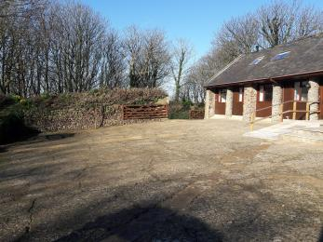
Entrance and car parking area

Arrival

Main entrance
- The main entrance has level access.
- There is a permanent ramp.
- The door is 720mm wide.
- The main door is side hung and manual.
- When you arrive, we can help carry your luggage.
- Please let us know in advance if you may require help with your luggage.
The front door entry threshold is 100mm.
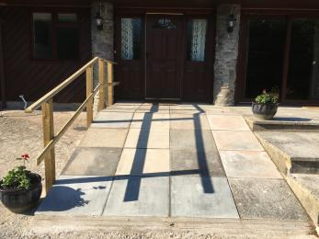
Ramp access to front door
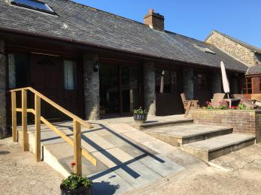
Ramp access and terrace with seating
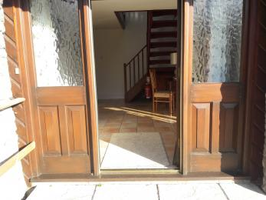
Front door entry with small threshold
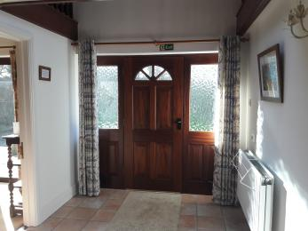
Entrance hallway
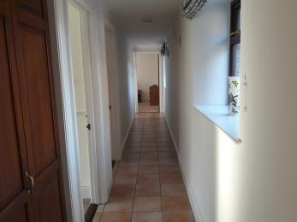
Access route to bathroom and bedrooms

Getting around inside

Bedrooms
- All bedrooms have windows.
- Bedrooms have ceiling lights, bedside lamps, spot lights and natural daylight.
- Lights are halogen and energy saving. All bedrooms are non-smoking.
- We have non-allergic bedding.
- Some bedrooms have fitted carpets.
- Non allergic bedding available on request. Property is kept pet free, unless requested for assistance dogs.
- We can move the bedroom furniture, to improve accessibility.
- From the main entrance to this area, there is level access.
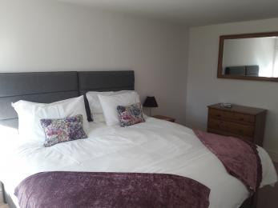
Ground floor bedroom with Super Kingsize bed
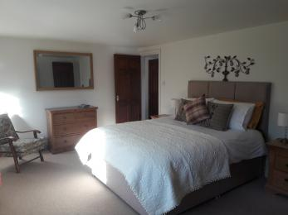
Ground floor bedroom with Kingsize bed
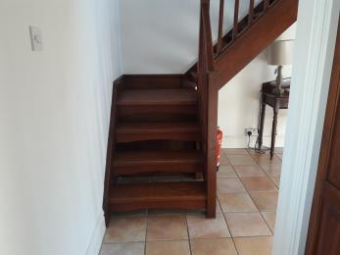
Stairs to upstairs bedroom
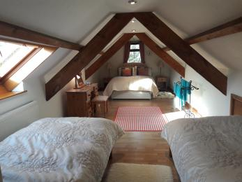
Upstairs bedroom
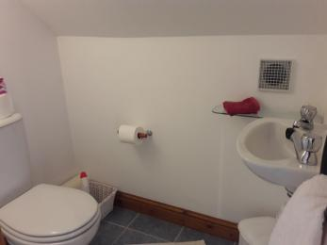
Upstairs bedroom ensuite toilet

Self catering kitchen

Kitchen
- We have an open plan kitchen.
- From the main entrance to the kitchen, there is level access.
- The door is 710mm wide.
- The table and plates have high colour contrast.
- Height of work surface, sink and hob is 920mm.
Kitchen chairs can be moved to enable wheelchair access.
Table can be extended to seat 8 places. Table height is 770mm.
High contrast table cloth is available on request.
Electric oven and hob with four heat spots.
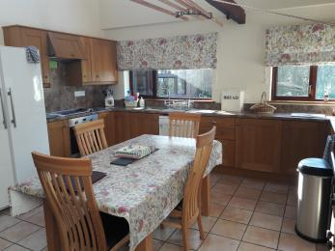
View of kitchen from lounge doorway
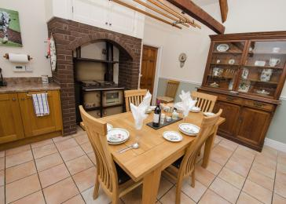
View of kitchen towards lounge doorway

Lounge

Lounge
- From the main entrance to the lounge, there is level access. The door is 710mm wide.
- Two, 2-seater soafs - seat height is 520mm.
Two arm chairs - seat heights are: 520mm and 410mm.
One large foot stool.
One low level coffee table.
Dimmable ceiling lights and several free standing lamps.
A 42inch SMART TV with sub titles available and DVD player.
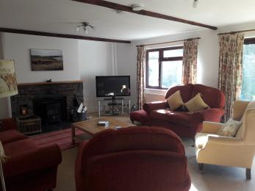
View of lounge
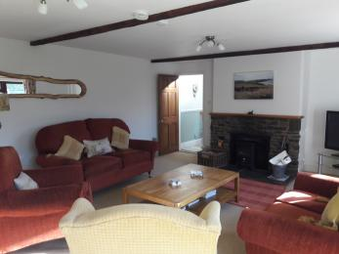
View towards kitchen doorway

Ground Floor Bathroom
- From the main entrance to this area, there is level access. The door is 710mm wide.
- Bath with wall mounted adjustable shower. Bath height is 560mm.
Toilet height is 430mm.
Wash basin height is 870mm.
Heated towel rail.
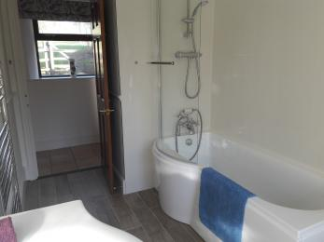
View of bathroom to doorway
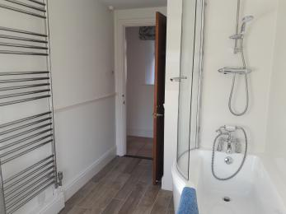
Entrance to bathroom
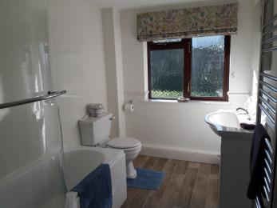
View in to the bathroom

Ground Floor Shower Room
- From the main entrance to this area, there is level access. The door is 710mm wide.
- From the main entrance to this area, there is 1 step. There is no lift and no ramp.
- The ground floor shower room is located between the kitchen and the Utility Room.
The shower in-step is 180mm.
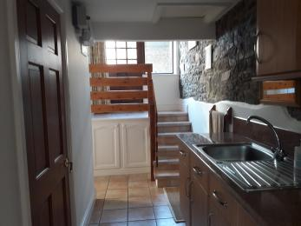
Entrance area
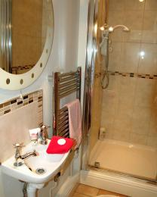
Shower with in-step
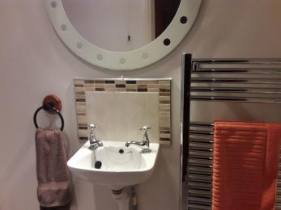
There is a small hand basin

Utility Room
- From the main entrance to this area, there is 1 step. There is no lift and no ramp.
- Access is either via back door with small threshold step or from kitchen.
Utility room contains washing machine and tumble dryer.
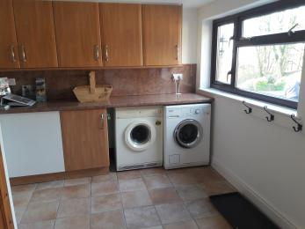
View of Utility Room
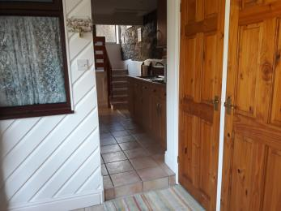
Entrance with small 120mm step

Getting around outside

Terrace and Garden
- From the main entrance to the gardens, there is level access.
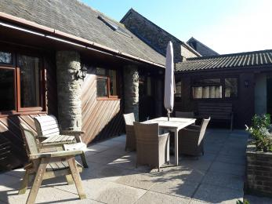
Terrace with outside table with sun umbrella and seating
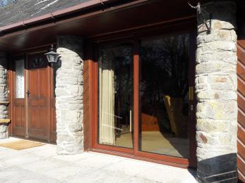
Patio doors from the lounge to the terrace
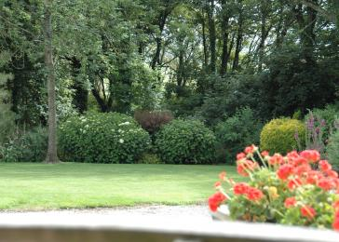
View of the garden
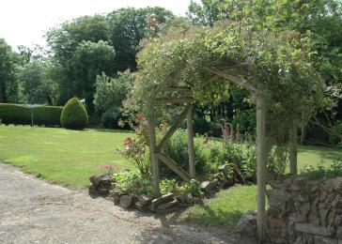
Second view of the garden

Customer care support

Accessibility equipment
- We are in the process of acquiring some accessibility equipment. Details will be posted soon.
- Assistance dogs may use the field next to the entrance gate as a toilet area.
- We have an area to charge mobility scooters and battery powered wheelchairs.
- The external power socket is available near the back door entrance to the Utility Room.
- You can hire mobility equipment from Braunton Mobility Centre by calling 01271 814577 .
- You can hire mobility equipment from Living Needs Solutions, Barnstaple by calling 01271 374600.

Emergency evacuation procedures
- Visitors attention is drawn to fire procedures on arrival.

Customer care support
- Some staff have disability awareness training.
- Staff are available 24 hours a day.
- Owners live in Farmhouse nearby - 200m.

Guide last updated: 11 August 2021

