Accessibility Guide for Swansdown
info@coquetcottages.co.uk, 01665 710700, https://www.coquetcottages.co.uk/northumberland-holiday-cottages/swansdown/
Contact for accessibility enquiries: Reservations Team
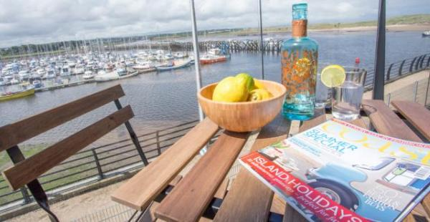

Welcome
Swansdown is a luxurious apartment at Amble harbour sleeping 4 guests in 2 bedrooms with 2 bathrooms. Situated right in the heart of the popular fishing port of Amble, Swansdown is very spacious – perfect for couples as well as a small family. Swansdown is also suitable for guests with limited mobility too, as there is a level access from the car park area, a lift to the apartment door, extra wide doorways and is completely level throughout, and although there is no provision for a wheelchair in the bathrooms, there is a walk-in shower. 1 small dog is very welcome here.

At a Glance

Level Access
- There is level access from the main entrance to:
  - Bedroom: Second Bedroom
  - Washer/dryer
  - Lounge
  - Balcony

Bedrooms
- We have non-allergic bedding.

Level access bedrooms
- From the main entrance to the bedroom, there is level access.
- The route to the bedroom is 750mm wide, or more.
- The bedroom door is 750mm wide, or more.

Hearing
- The (bedroom) TVs have subtitles.

Getting here
Swansdown
10 Coble Quay
Amble
NE65 0DJ

Travel by public transport
- You can get to Swansdown by bus.
- The nearest bus stop is located on Church Street 0.2 miles / 0.3 km away. The bus stop is 0.2 miles / 0.3 km from Swansdown.

Travel by taxi
- You can get a taxi with Phoenix Amble Taxis by calling 01665 710988.

Parking
- We have a car park. The parking is less than 50 metres from the main entrance. Parking is free.
- There is a drop-off point at the main entrance. The drop-off point has a dropped kerb.
- From the car park to the entrance, there is level access. Dedicated parking bay for 1 car in the Coble Quay car park directly underneath the apartment. Additional guest parking is nearby.

Arrival

Path to main entrance
- From the street to the main entrance, there is level access.

Main entrance
- The main entrance has level access.
- There is a lift.
- The door is 760mm wide.
- The main door is side hung and manual.
- Apartment is on the first floor.

Getting around inside

Lift
- We have 1 lift.
- You can get a lift to all floors.

There is 1 lift per apartment block which will take you to each floor within the block. From here it's a few steps to the apartment door.
- The lift says the floor number at each floor.
- The lift shows the floor number, at each floor.

Bedrooms
- All bedrooms have windows.
- Bedrooms have bedside lamps, desk or table lamps, spot lights and natural daylight.
- Lights are LED. TVs have subtitles.
- All bedrooms are non-smoking.
- We have non-allergic bedding.
- All bedrooms have fitted carpets.
- From the main entrance to this area, there is level access.

Accessible bedrooms

Accessible bedroom Second Bedroom
- The route to the bedroom is 800mm wide, or more. The bedroom door is 800mm wide. There is 1000mm at the side of the bed.

Washer/dryer
- From the main entrance to the laundry, there is level access. There is a lift.
- The door is 750mm wide.
- We have an iron and ironing board.

Self catering kitchen

Kitchen
- We have an open plan kitchen.
- From the main entrance to the kitchen, there is level access.
- There is a lift. The route is 800mm wide, or more.
- The door is 760mm wide.
- The table and plates have high colour contrast.
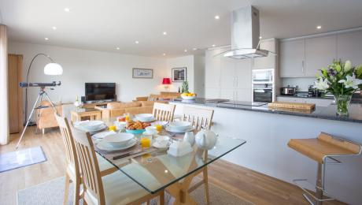
Kitchen/diner

Lounge

Lounge
- From the main entrance to the lounge, there is level access. There is a lift. The route is 800mm wide, or more. The door is 760mm wide.
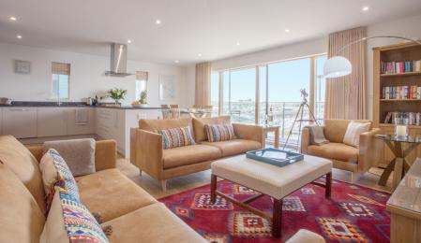
Lounge

Getting around outside

Terrace

Balcony
- From the main entrance to this area, there is level access. There is a lift.
- The entrance is 750mm wide.
- To get to a table, there are no steps.
- The balcony off the lounge is as wide as the sliding doors and has a table with chairs. It overlooks the marina and is west facing providing a gorgeous view particularly at sunset. It’s also sheltered from the direct sea wind.
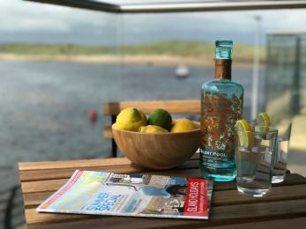
Balcony
- From the main entrance to this area, there is level access. There is a lift.

Customer care support

Accessibility equipment
- For a list of more items, please go to http://www.redcross.org.uk/Where-we-work/HealthandSupport?loc=ne65+0xp&r=50&s....
- As the apartment is on the first floor, the nearest toilet area for assistance dogs is at the marina braid, which is approx. 200 meters from the entrance door to the apartment building.
- You can hire mobility equipment from Red Cross Newcastle by calling 0191 2737961.

Guide last updated: 27 November 2019

