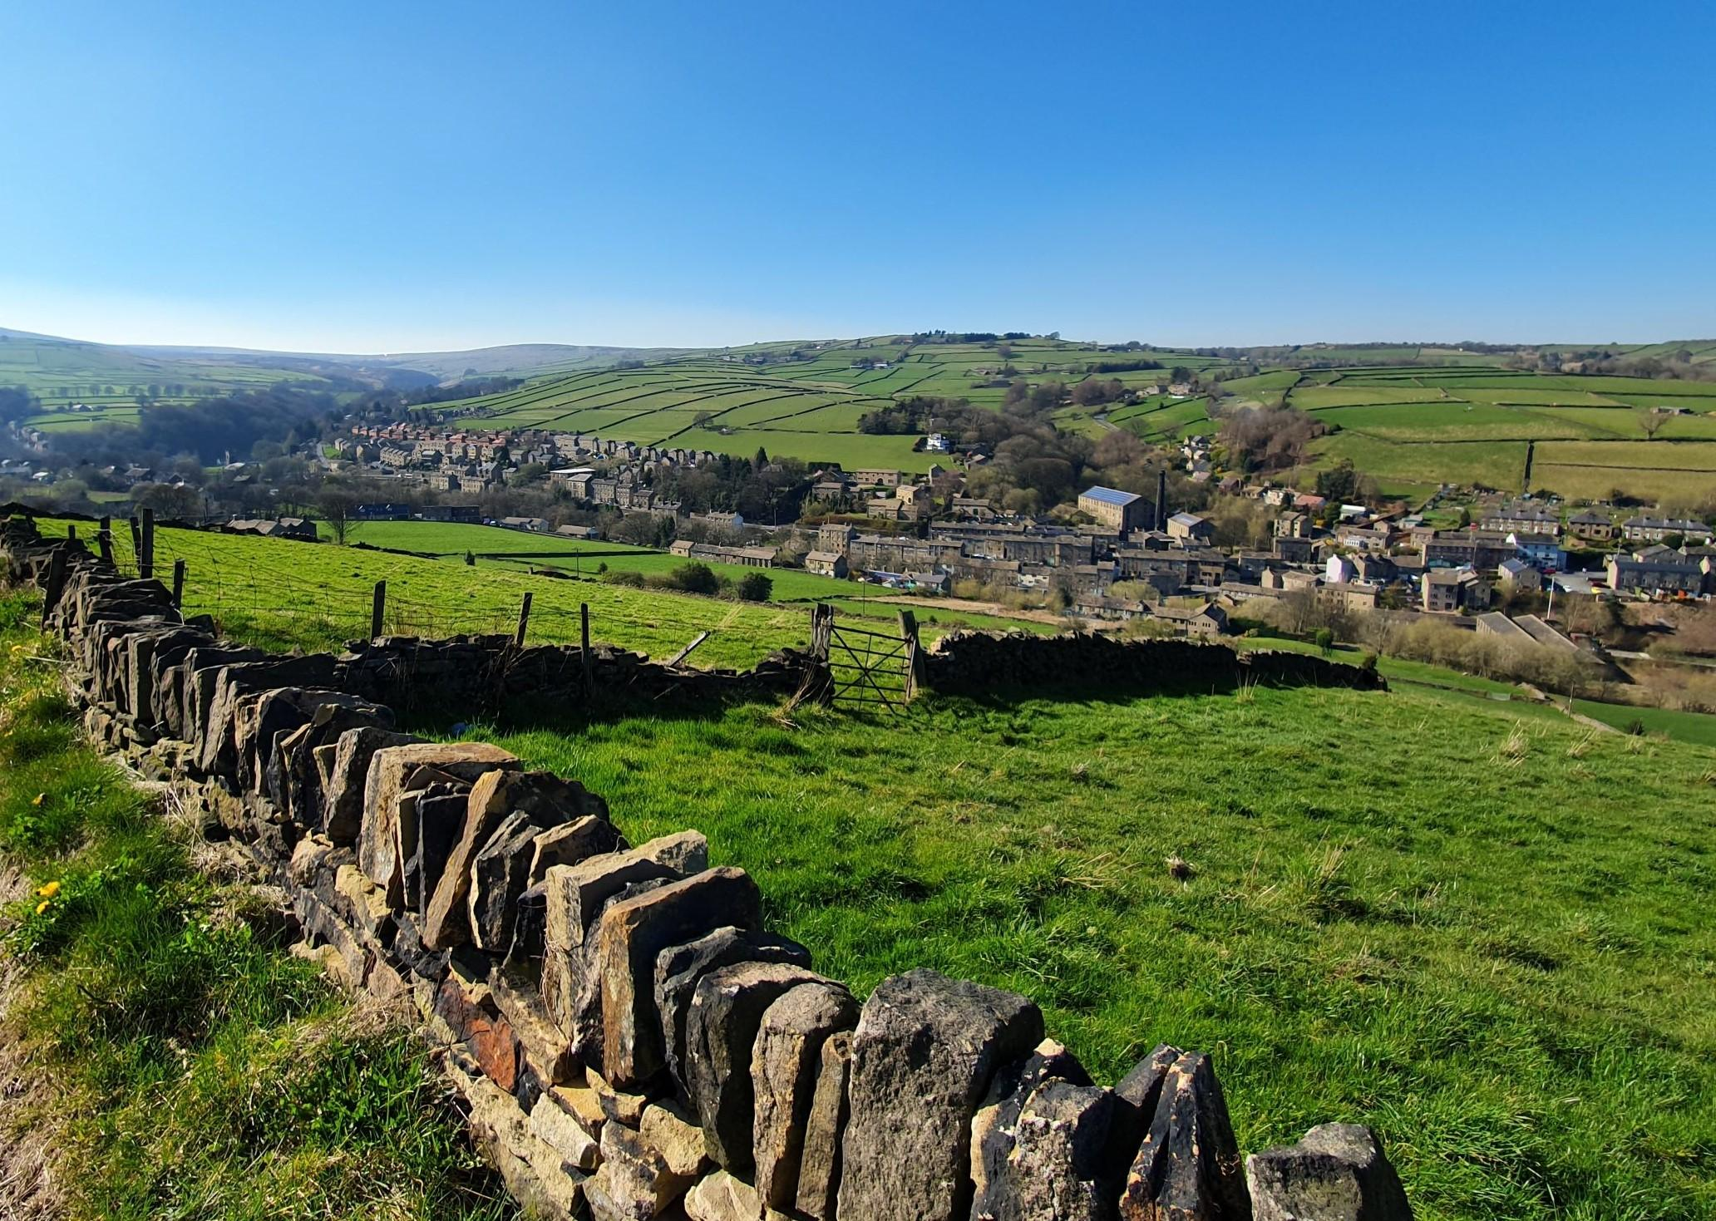
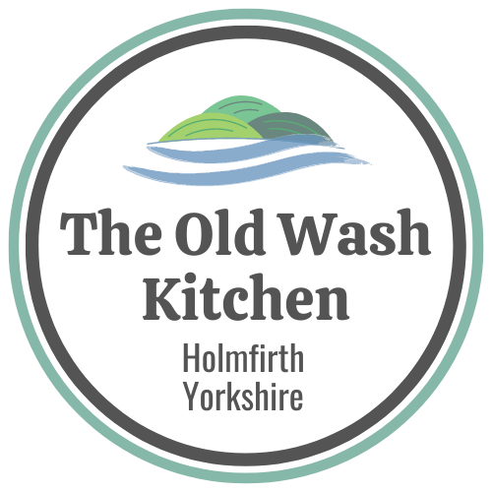

Accessibility Guide for The Old Wash Kitchen
theoldwashkitchen@outlook.com, 07305 997167, www.theoldwashkitchen.co.uk
Contact for accessibility enquiries: Claire Harpin
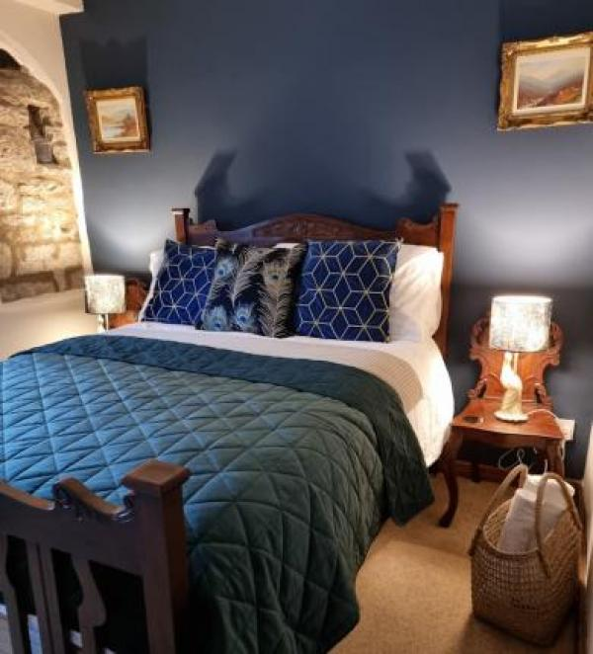

Welcome
The Old Wash Kitchen, Holmfirth, Yorkshire. A Cosy, quirky cottage for 4, set in scenic countryside on the edge of the Peak district and Yorkshire Pennines. The Old Wash Kitchen nestles in the heart of the village of Hinchliffe Mill at the foot of Holme Moss, a location with views made famous in the hit comedy series, 'The Last of The Summer Wine'. It sits in a conservation area with characteristic stone cottages centred around a 19th century woollen mill and the river Holme which can be heard babbling by. The cottage is surrounded by rolling green hills and open countryside but has the benefit of local shops and dog friendly pubs within walking distance.

At a Glance

Level Access
- The main entrance has 13 steps and a handrail. There is no lift and no ramp.

Access with steps
- There are steps from the main entrance to:
  - Bedroom
  - Lounge
  - Outdoor seating area

Bedrooms
- We have non-allergic bedding.

Hearing
- Some (bedroom) TVs have subtitles.

Getting here
Old Road
Holmbridge
Holmfirth
HD9 2NU

Travel by public transport
- You can get to The Old Wash Kitchen by bus and train.
- The bus stop for buses going to Huddersfield and linking with the bus and rail services is 150 yards away from the door and a local minibus which goes to Holmfirth and surrounding villages is 20 yards from the back door on a lane passing the cottage. . The bus stop is 0.1 miles / 0.2 km from The Old Wash Kitchen.
- The nearest train station is Brockholes. The train station is 3.7 miles / 6.0 km from The Old Wash Kitchen.
- The Nearest railway station is Brockholes less than 4 miles away, however, Huddersfield railway station is only 8 miles away and links with most main line services.

Travel by taxi
- You can get a taxi with Holmfirth Cars by calling 01484 683500.

Parking
- We have a car park. The parking is less than 50 metres from the main entrance. Parking is free.
- The cottage has 2 entrances, one is down a flight of stone steps and the other is at the rear of the cottage and is on road level but has a raised threshold of around 5 cms. From the parking to the main entrance, there are 13 steps. There is no ramp and no lift.

Arrival

Path to main entrance
- From the street to the main entrance, there are 13 steps. There is no ramp and no lift.
- The path is sloped.

Main entrance
- The door is 762mm wide.
- The main entrance has 13 steps.
- This entrance has a handrail.
- The main door is side hung and manual.

Getting around inside

Bedrooms
- All bedrooms have windows.
- Bedrooms have ceiling lights, bedside lamps and natural daylight.
- Lights are LED. Some TVs have subtitles.
- All bedrooms are non-smoking.
- We have non-allergic bedding.
- All bedrooms have fitted carpets.
- The bedroom nearest the main entrance has 1 steps.
- We have bathrooms with a separate shower.
- We have bathrooms with a bath.
- The bath has a handrail. The direction of transfer onto the toilet is to the front only.

Self catering kitchen

Kitchen Dining room
- We have an open plan kitchen.
- From the main entrance to the kitchen, there is 1 step. There is no lift and no ramp.

Lounge

Lounge
- From the main entrance to the lounge, there is 1 step. There is no lift and no ramp.

Getting around outside

Outdoor seating area
- From the main entrance to the area, there is 1 step.

Customer care support

Guide last updated: 6 March 2024

