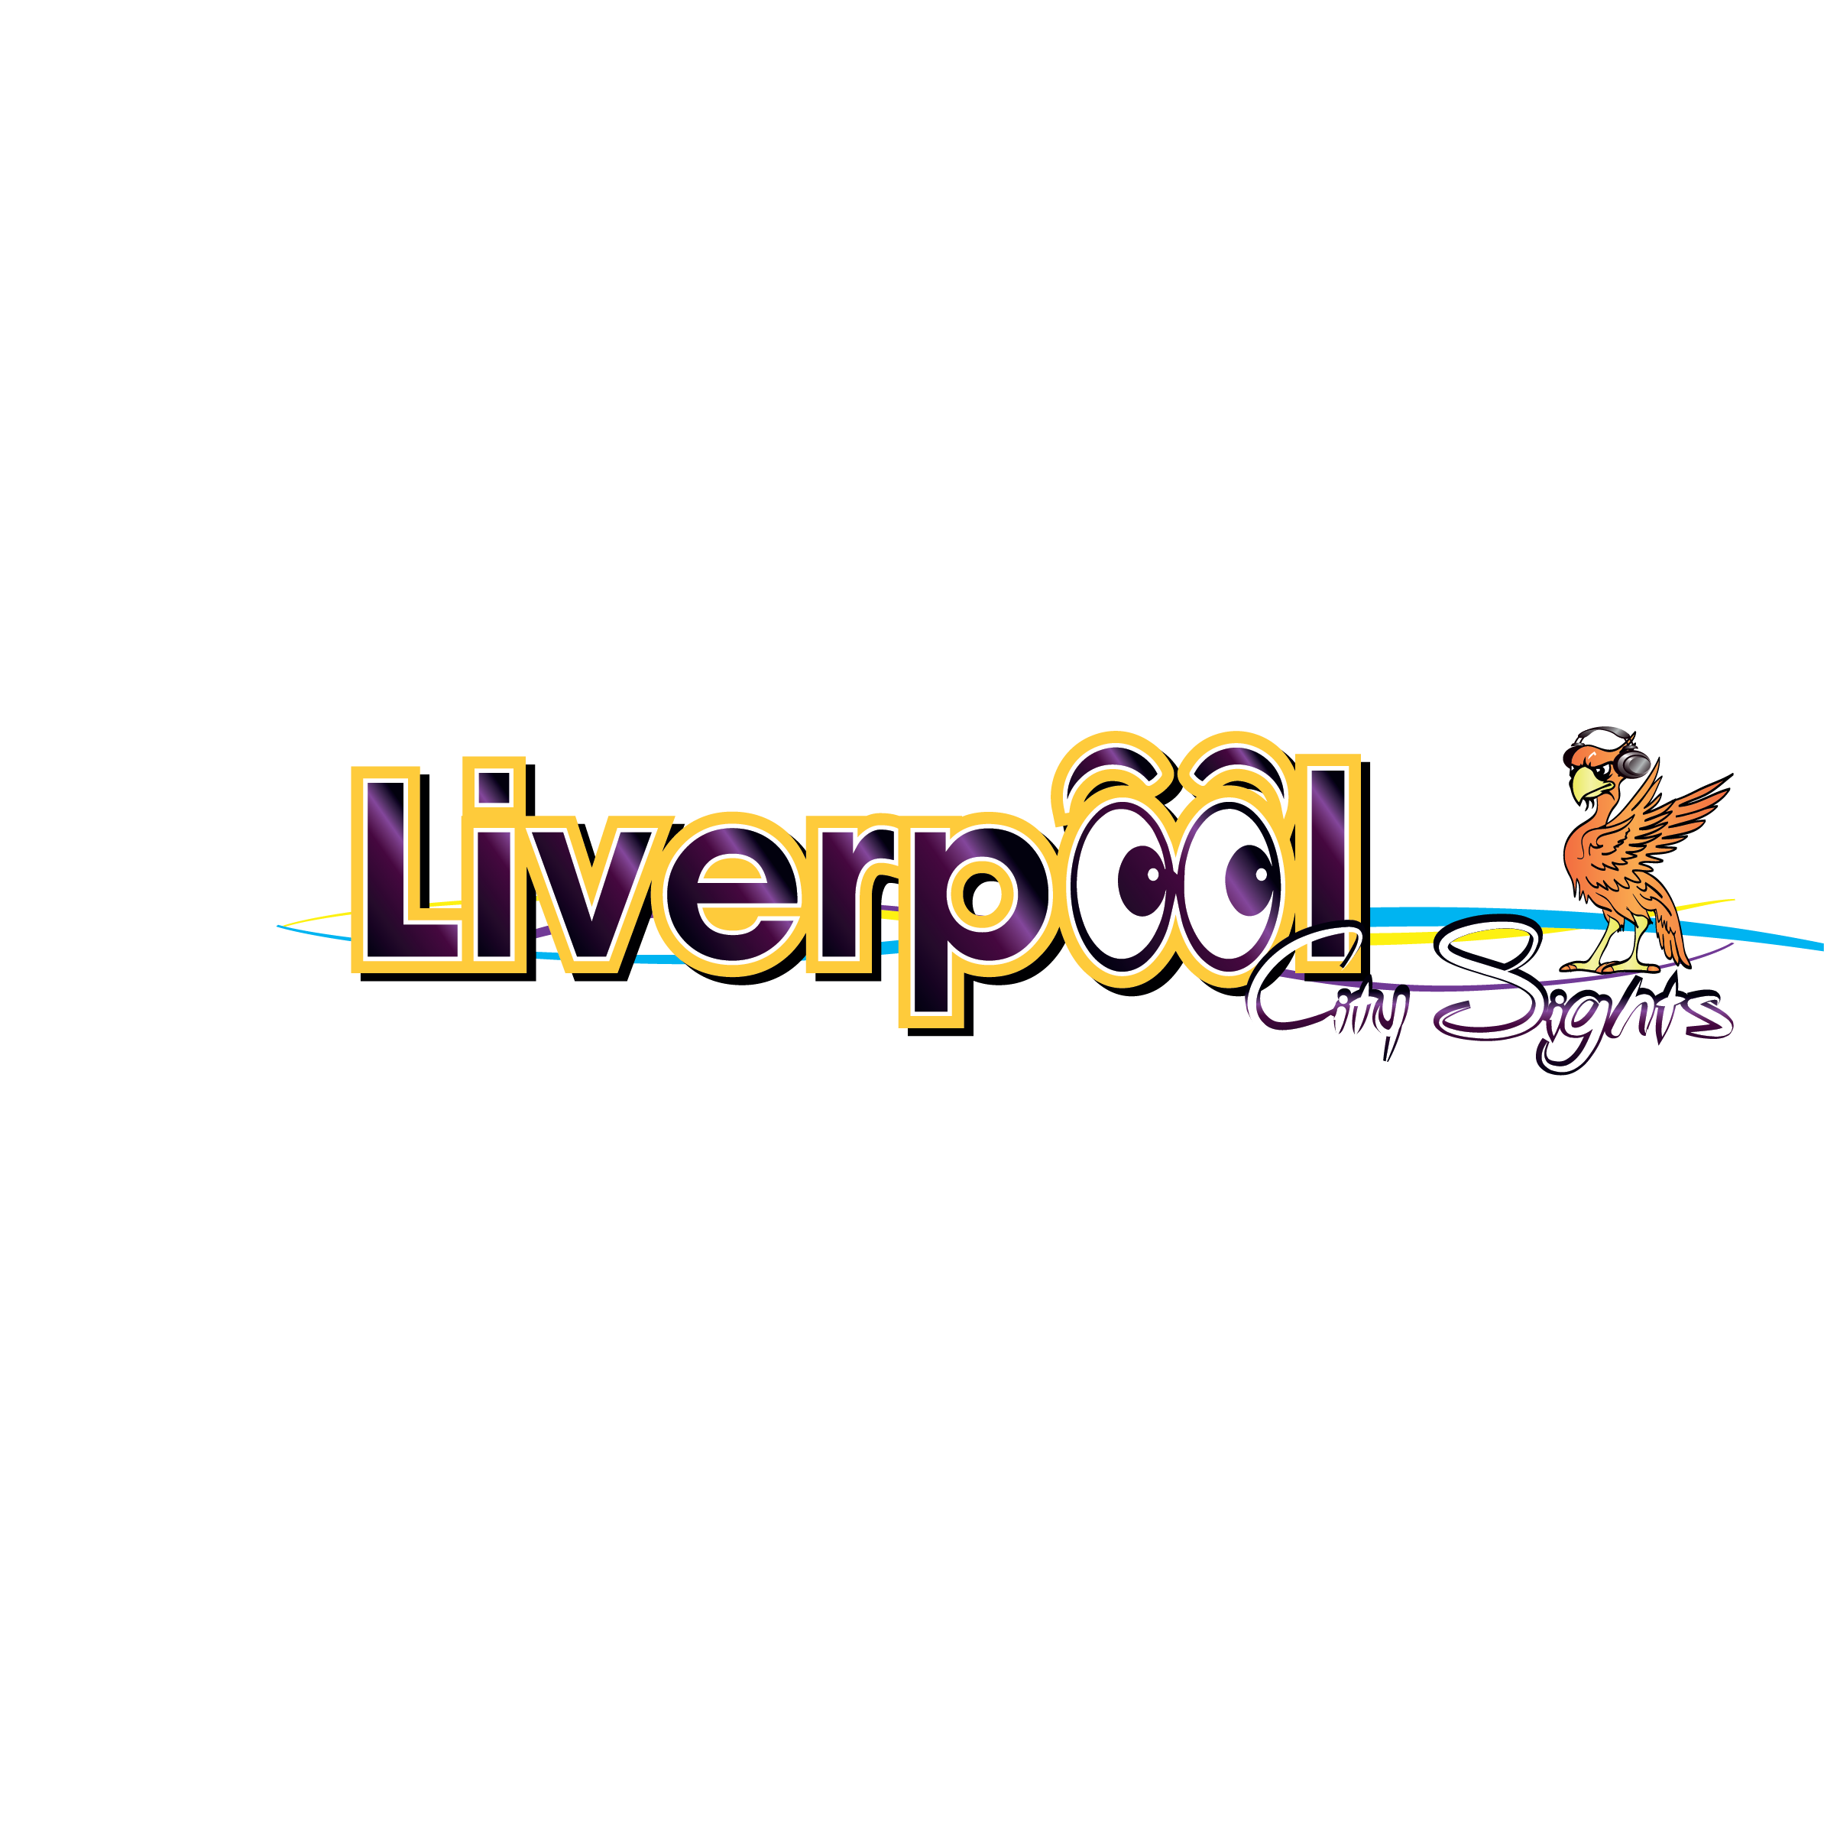

Accessibility Guide for Liverpool City Sights
admin@liverpoolcitysights.com, 0151 298 1253, www.liverpoolcitysights.com
Contact for accessibility enquiries: Chloe Egan
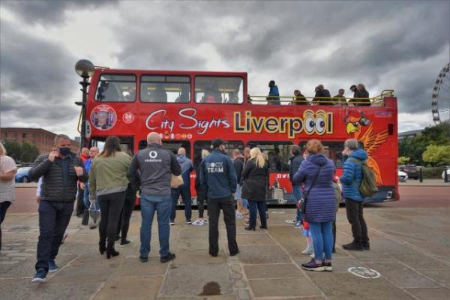

Welcome
BLUE ROUTE - City & Beatles Tour
This is a live guided City and Beatles tour, including 48hr use of the Hop On Hop Off Red Route. You will see all the city’s historic sights, including our two magnifcent Cathedrals. We make two stops - Penny Lane and Strawberry Field, where you can alight the bus for a photo opportunity. Voted Best Bus Tour In The World.
RED ROUTE - City Tour
This is a 24hr ticket, Hop-On, Hop-Off, Multilingual City tour of Liverpool. You will see historical landmarks and attractions including The Royal Albert Dock, the Cavern Club, the World Museum, The Philharmonic Dining Rooms, China Town and much more.

At a Glance

Level Access
- There is level access from the main entrance to:
  - Open Top Bus Downstairs area
  - Tour Buses Ticketing Hut
  - Royal Albert Dock, Gower Street

Access with steps
- There are steps from the main entrance to:
  - Open Top Bus Upstairs area

Hearing
- Some staff have Next Generation Text and disability awareness training.

Visual
- Glass doors have contrast markings.
- The walls and the doors have high colour contrast.
- We have display information in audio and large print.
- We have information in audio, large print and other.

General
- We have a concessionary rate for disabled visitors.
- Some staff have disability awareness training.

Getting here
Royal Albert Dock
Gower Street
Liverpool
L3 4AS

Travel by public transport
- You can get to Liverpool City Sights by bus, train and boat or ferry.
- The Liverpool ONE bus station is opposite the Royal Albert Dock. The National Express coach station is situated at the Liverpool ONE bus station. The bus stop is 0.5 miles / 0.8 km from Liverpool City Sights.
- The nearest train station is James Street. The train station is 0.5 miles / 0.8 km from Liverpool City Sights.
- The nearest port is Liverpool . The port is 0.6 miles / 1.0 km from Liverpool City Sights.
- 12 minute walk from Pier Head - Mersey Ferry/Cruise Terminal to Bus Stop 1 Gower Street in the Royal Albert Dock
2 minute walk from Pier Head - Mersey Ferry/Cruise Terminal to Bus Stop 2 Canada Boulevard

Travel by taxi
- You can get a taxi with DELTA by calling 0151 922 7373. The taxi company has a wheelchair accessible vehicle.
- You can get a taxi with Hackney Taxi by calling 0151 708 7080. The taxi company has a wheelchair accessible vehicle.

Parking
- There is parking near the venue. There are accessible parking spaces. The parking is less than 50 metres from the main entrance. Parking is not free.
- There is a drop-off point at the main entrance. The drop-off point has a dropped kerb.
- From the car park to the entrance, there is level access. The route is 1828mm wide, or more.

Arrival

Path to main entrance
- From the street to the main entrance, there is level access.
- The path is 1828mm wide, or more.

Main entrance
- The main entrance has level access.
- The venue to purchase tickets from is an outdoor ticketing hub, accessible from all angles via the pavement on Gower Street.

Getting around inside

Visual Impairment - General Information
- We have contrast markings on all glass doors and high colour contrast between walls and doorframes.

Ticket/ information desk

Tour Buses Ticketing Hut
- From the main entrance to the desk, there is level access. The desk has a low section.

Things to See and Do
- We have a concessionary rate for disabled visitors.
- We have performances with: audio-described.
- We have display information in: audio and large print.

Open Top Bus Downstairs area
- From the main entrance to this area, there is level access. There is a permanent ramp. The route is 900mm wide, or more. The door is 900mm wide.
- Some display information is low, for wheelchair users. There are seats.

Open Top Bus Upstairs area
- From the main entrance to this area, there are 9 steps. There is no lift and no ramp.
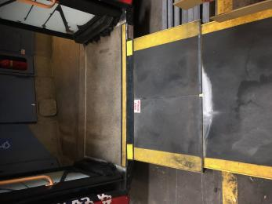
Ramp on to bus
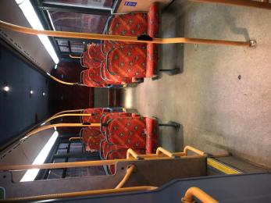
Bus gangway
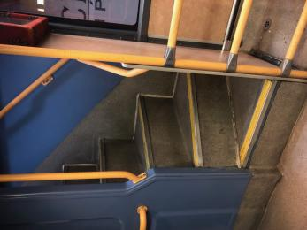
Steps up to top of bus
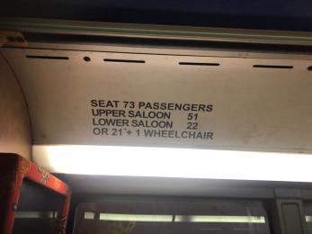
Wheelchair capacity
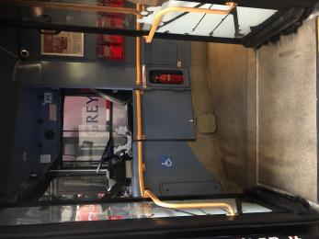
Bus Entrance
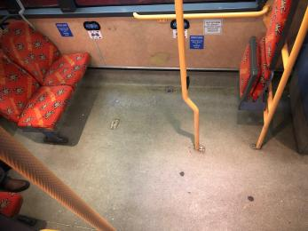
Wheelchair area
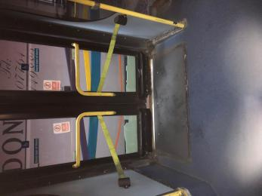
Bus side entrance
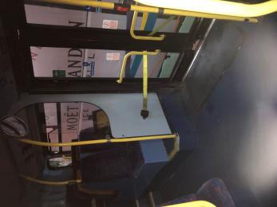
Wheelchair access
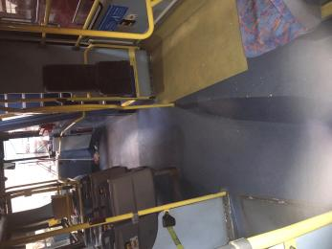
Wheelchair area

Getting around outside

Royal Albert Dock, Gower Street
- From the main entrance to this area, there is level access. There is a permanent ramp.

Customer care support

Accessibility equipment
- For a list of more items, please go to https://www.localsolutions.org.uk/north-west-services/shopmobility/44-shopmob....
- The nearest grass areas for guide dogs from stop 1 is Chavasse Park Liverpool One which is 0.4miles The nearest grass areas for guide dogs from stop 2 is Pier Head which is 10 metres from bus entrance
- You can hire mobility equipment from Local Solutions by calling 0151 709 5245 or 0151 707 0877.

Emergency evacuation procedures
- We have emergency evacuation procedures for disabled visitors.
- Wheelchair users are evacuated in a safe and orderly manner via access doors

Customer care support
- Some staff have disability awareness training.
- Some staff have Next Generation Text training.
- We have information in audio, large print .
- Easy Read

Guide last updated: 18 May 2023

