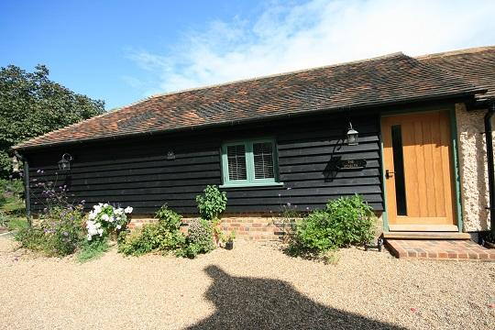

Accessibility Guide for Canterbury Cottages The Stables
annejolin2007@btinternet.com, 01227720724, www.canterbury-cottages.co.uk
Contact for accessibility enquiries: Anne Jolin
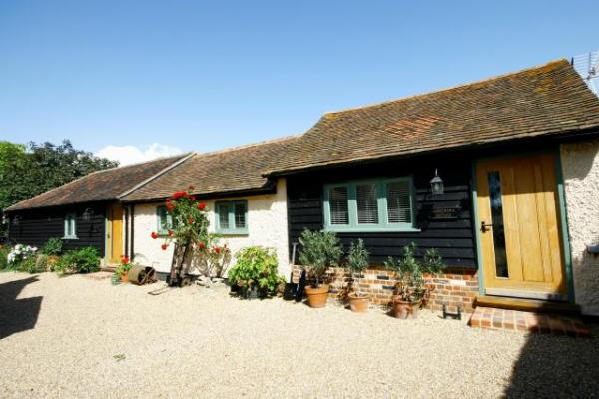

Welcome
The Stables is set in a gravelled courtyard, with one step and thrshold to access the property. Although car parking is at the top of the drive, for pick up and drop off, cars can come down to the entrance. The front door is wide enough for a wheelchair. Once inside, the floors are all level, with open access to the bedroom. The bathroom has a large walk-in shower, with a grabrail and non-slip mat.

At a Glance

Level Access
- The main entrance has 1 step. There is no lift and no ramp.
- There is level access from the main entrance to:
  - The Stables lounge

Access with steps
- There are steps from the main entrance to:
  - The Stables
  - The Stables

Bedrooms
- We have non-allergic bedding.

Level access bedrooms
- From the main entrance to the bedroom, there is level access.

Hearing
- The (bedroom) TVs have subtitles.
- All staff have disability awareness training.

General
- Staff are available 24 hours a day.
- All staff have disability awareness training.
- We have emergency evacuation procedures for disabled visitors.

Getting here
Shatterling House
Shatterling
Canterbury
CT3 1JP

Travel by public transport
- You can get to Canterbury Cottages The Stables by bus, train and boat or ferry.
- Nearest bus stop 50 metres from cottages The bus stop is 0.0 miles / 0.0 km from Canterbury Cottages The Stables.
- The nearest train station is Sandwich/Bekesbourne. The train station is 4 miles / 6.4 km from Canterbury Cottages The Stables.
- The nearest port is Dover. The port is 10 miles / 16.1 km from Canterbury Cottages The Stables.
- buses run every 20 minutes linking the cottages to Canterbury, Sandwich and Deal

Travel by taxi
- You can get a taxi with GreenLight Taxis by calling 01227722222 and 07722004679. The taxi company has a wheelchair accessible vehicle.
- We have a transfer service for visitors. We can pick up from a nearby railway station

Parking
- We have a car park. The parking is less than 50 metres from the main entrance. Parking is free.
- There is a drop-off point at the main entrance. The drop-off point has a dropped kerb.
- From the parking to the main entrance, there is 1 step. There is no ramp and no lift. shingle driveway all on one level
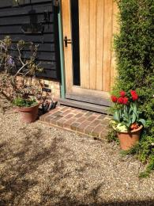
https://www.accessibilityguides.org/sites/default/files/IMG_3099.JPG

Arrival

Path to main entrance
- From the street to the main entrance, there is level access.
- There is a permanent ramp.
- The path is 3700mm wide, or more.

Main entrance
- The door is 940mm wide.
- The main entrance has 1 steps.
- The main door is side hung and manual.
- When you arrive, we can help carry your luggage.
https://www.accessibilityguides.org/sites/default/files/IMG_3099_0.JPG

Getting around inside

Bedrooms
- All bedrooms have windows.
- Bedrooms have ceiling lights, bedside lamps and natural daylight.
- Lights are LED and energy saving. TVs have subtitles.
- All bedrooms are non-smoking.
- We have non-allergic bedding.
- No bedrooms have fitted carpets.
- There are wooden blinds on most windows, with floor length curtains at the French doors. Mats & rugs can be removed if necessary
- We can move the bedroom furniture, to improve accessibility.
- From the main entrance to this area, there is level access.
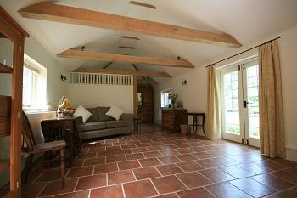
https://www.accessibilityguides.org/sites/default/files/IMG_6112_1.JPG

Self catering kitchen

The Stables kitchen
- We have a separate kitchen and dining room. From the main entrance to the kitchen, there is level access.
- The route is 2020mm wide, or more.
- The door is 260mm wide.
- The work surface is available at a height between 650mm and 900mm.
- The hob is available at a height between 650mm and 900mm.
- The sink is available at a height between 650mm and 900mm.
- The oven is available at a height between 650mm and 900mm.
- The table and plates have high colour contrast.
- From the main entrance to the dining room, there is level access. The route is 2020mm wide, or more.
- Main entrance opens into a large sitting room/dining room, with doors off to the bathroom and kitchen
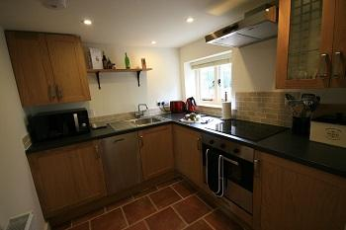
https://www.accessibilityguides.org/sites/default/files/IMG_6142.JPG

Lounge

The Stables lounge
- From the main entrance to the lounge, there is level access. The route is 2020mm wide, or more.
- Open plan
https://www.accessibilityguides.org/sites/default/files/IMG_6112_1_0.JPG

Getting around outside

The Stables
- From the main entrance to the gardens, there is 1 step. There is no lift and no ramp.
- There are French Doors to the garden and terrace, with one step down from the building
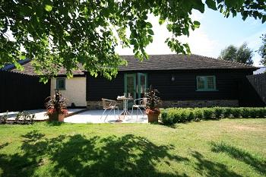
https://www.accessibilityguides.org/sites/default/files/IMG_6089_0.JPG

Terrace

The Stables
- To get to a table, there are no steps.
- From the main entrance to the terrace, there is 1 step.
- one step from the French doors in lounge down to terrace and garden furniture
https://www.accessibilityguides.org/sites/default/files/IMG_6089.JPG

Customer care support

Accessibility equipment
- For a list of more items, please go to https://dealmobility.co.uk/.
- I'm sorry, I can't find that information
- We have an area to charge mobility scooters and battery powered wheelchairs.
- Can be plugged in outside if weather is fine, or in barn if not.
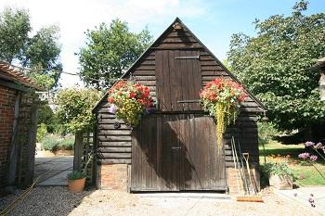
https://www.accessibilityguides.org/sites/default/files/IMG_6098.JPG
- You can hire mobility equipment from Deal Mobility by calling 01304369184.

Emergency evacuation procedures
- We have emergency evacuation procedures for disabled visitors.

Customer care support
- All staff have disability awareness training.
- Staff are available 24 hours a day.
- We live on site

Guide last updated: 18 January 2019

