Accessibility Guide for Holy Vale Farmhouse
enquiries@sibleysonscilly.com, 01720 422431, https://sibleysonscilly.co.uk
Contact for accessibility enquiries: Gail Sibley
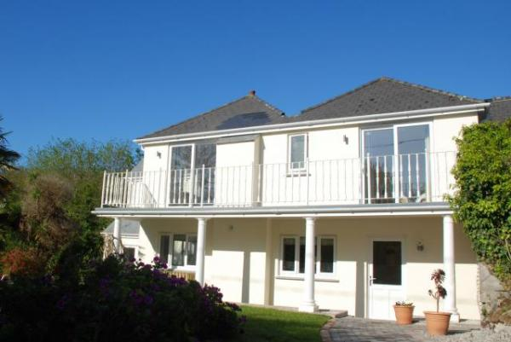

Welcome
Holy Vale Farmhouse offers beautifully-appointed accommodation of the highest quality, complete with private garden and terrace - perfect for BBQ and al fresco dining after a day on the beach.
Sleeping 8 people in two double and two twin bedrooms, the farmhouse has a large, open-plan kitchen/ dining room with separate lounge and is popular with larger families, or two families sharing.
Holy Vale is a beautiful valley in the heart of St Marys, and the farmhouse is surrounded by vineyards. Holy Vale Farmhouse really does have all the ingredients for a perfect holiday on Scilly - perfectly located for some of the best walks on St Marys!

At a Glance

Level Access
- The main entrance has 2 steps. There is no lift and no ramp.

Access with steps
- There are steps from the main entrance to:
  - Bedroom
  - Patio area

Bedrooms
- We have non-allergic bedding.

Hearing
- The (bedroom) TVs have subtitles.

General
- Staff are available 24 hours a day.
- We have emergency evacuation procedures for disabled visitors.

Getting here
Holy Vale
St Mary's
Isles of Scilly
TR21 0NH

Travel by public transport
- Sail from Penzance or fly direct from Land's End, Newquay or Exeter Airports. National and European connections available from Newquay and Exeter. If you require travel assistance please contact: 01736 334220, customerservices@islesofscilly-travel.co.uk

Travel by taxi
- You can get a taxi with Buzza Bus by calling 01872 266886. The taxi company has a wheelchair accessible vehicle.
- You can get a taxi with Toots Taxi by calling 01720 422142.
- You can get a taxi with DJ Cabs by calling 01720 423775.
- Each Skybus flight is met by a transfer taxi at St Mary's Airport. If arriving by boat, taxis can be booked for quayside collection.

Parking
- There is a drop-off point at the main entrance. The drop-off point does not have a dropped kerb.

Arrival

Path to main entrance
- From the street to the main entrance, there are 3 steps. There is no ramp and no lift.
- The path is sloped.

Main entrance
- The door is 760mm wide.
- The main entrance has 2 steps.
- The main door is side hung and manual.
- If arriving from the airport, Skybus shuttle service providers will help unload bags from the bus. If arriving by boat, you can arrange for your luggage to be delivered from the quay to door for a small fee. Please call Island Carriers on 01720 422662 to arrange.
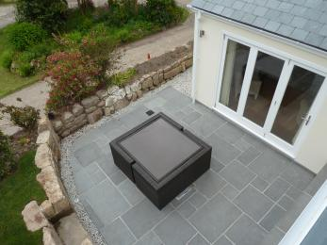
Holy Vale Patio area

Getting around inside

Bedrooms
- All bedrooms have windows.
- Bedrooms have ceiling lights, bedside lamps and natural daylight.
- Lights are LED, energy saving and traditional filament. Some lights can be controlled independently.
- TVs have subtitles.
- All bedrooms are non-smoking.
- We have non-allergic bedding.
- All bedrooms have fitted carpets.
- The bedroom nearest the main entrance has 14 steps.
- We have bathrooms with a separate shower.
- We have bathrooms with a bath.
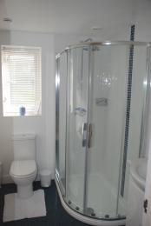
Holy Vale Shower
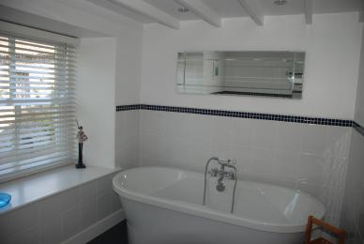
Holy Vale Bath
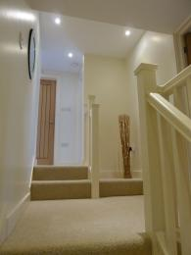
Holy Vale Steps

Self catering kitchen
- We have a separate kitchen and dining room. From the main entrance to the kitchen, there is level access.
- The route is 760mm wide, or more.
- The work surface is available at a height between 650mm and 900mm.
- The hob is available at a height between 650mm and 900mm.
- The sink is available at a height between 650mm and 900mm.
- The oven is available at a height between 650mm and 900mm.
- From the main entrance to the dining room, there are 2 steps. There is no lift and no ramp.
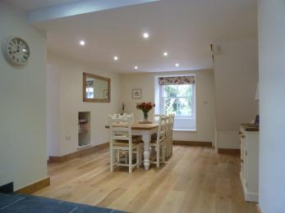
Holy Vale Dining

Lounge
- The route is 760mm wide, or more. From the main entrance to the lounge, there are 3 steps. There is no lift and no ramp.
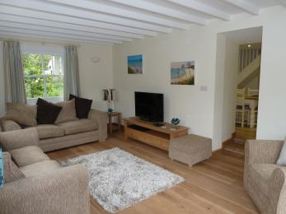
Holy Vale Lounge

Getting around outside

Patio area
- From the main entrance to the area, there are 5 steps.
- Holy Vale Farmhouse is accessed downhill via short steep approach. From the gate a block paved path gently slopes down 2 steps to the front door. From this point there is level access around the front of the property with 3 steps down to the paved patio area. The garden is gently sloping, laid to lawn.

Customer care support

Accessibility equipment
- Wheelchairs, walkers and electric golf buggies can be hired locally.
- For a list of more items, please go to https://www.visitislesofscilly.com/about/practical-info/tourist-information-c....

Customer care support
- Staff are available 24 hours a day.
- Sibley's Island Homes provides an out of hours emergency phone number in all its self-catering properties.

Guide last updated: 1 June 2020

