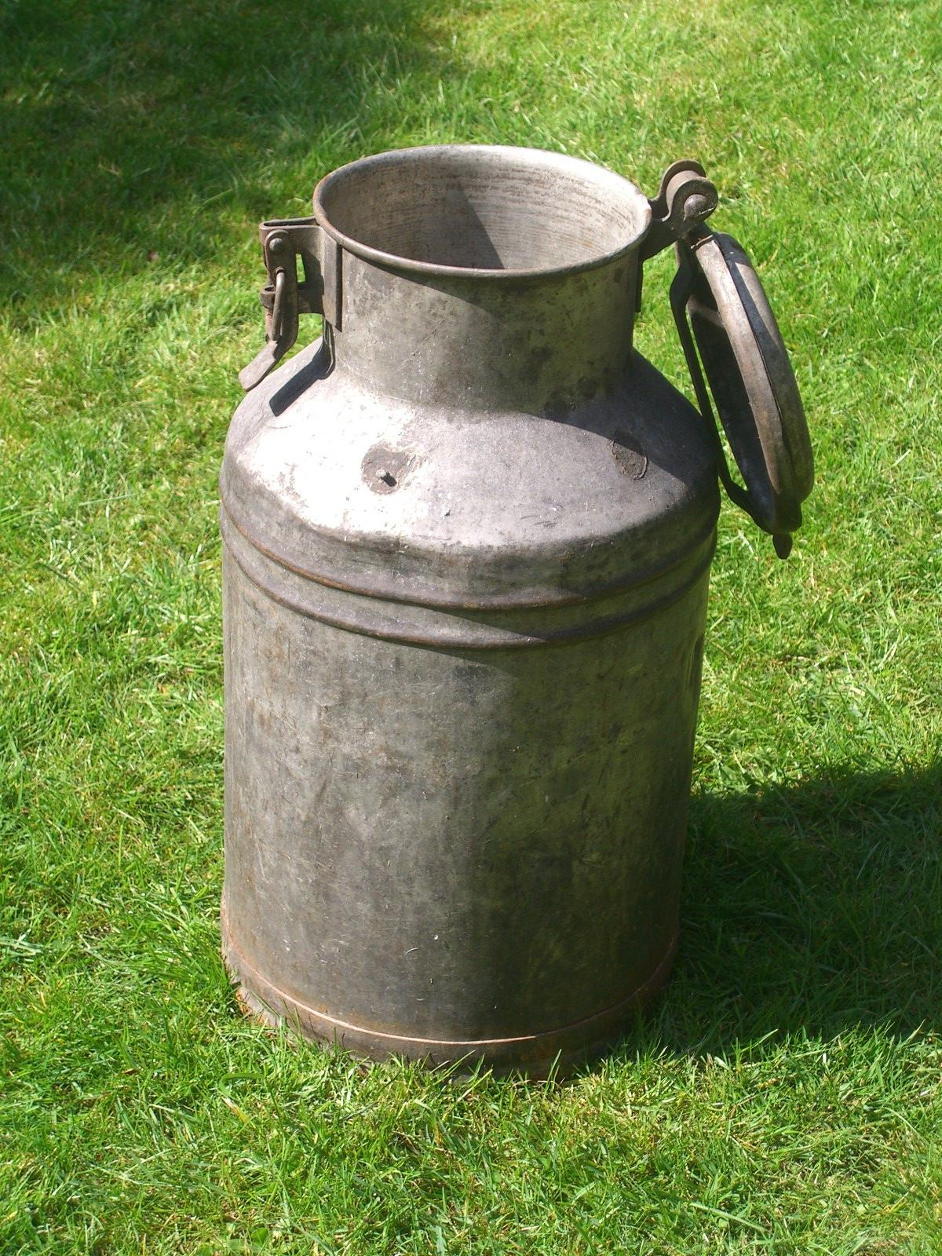

Accessibility Guide for Dairy House, Newton upon Rawcliffe
dairyhousenorthyorks@gmail.com, 01284 763568 - to speak to the owners, www.dairyhousenorthyorks.co.uk
Contact for accessibility enquiries: Mrs Mary Pennock (owner) 01284 763568
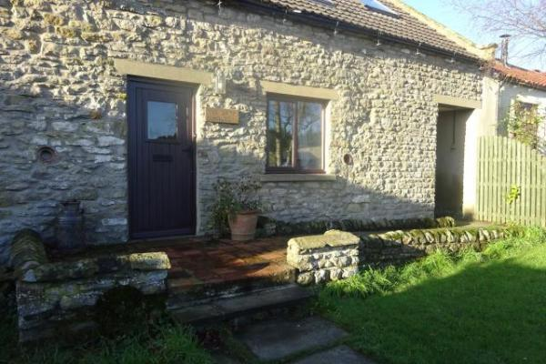

Welcome
Dairy House sleeps 6. It has 3 bedrooms, 2 bathrooms and sitting room with a dramatic gallery. It is set in the typical, yet unspoilt moorland village of Newton, a cluster of stone farms and cottages in the splendour of the North.Yorks Moors National Park. The cottage has a unique character, combining original rustic features, modern technology and comfort. With its massive oak beams and thick walls it is warm and cosy in winter yet cool in summer.

At a Glance

Level Access
- The main entrance has level access with a ramp. The ramp is permanent.
- There is level access from the main entrance to:
  - There is a laundry room in the cottage
  - Dairy House
  - Shower room & toilet
  - Dairy House - open plan

Bedrooms
- We have non-allergic bedding.

Level access bedrooms
- From the main entrance to the bedroom, there is level access.
- The route to the bedroom is 750mm wide, or more.

Hearing
- Some (bedroom) TVs have subtitles.

Visual
- Some parts of the venue have low lighting.

Getting here
Dairy House
4, Manor Farm Courtyard
Newton upon Rawcliffe, Nr Pickering
YO18 8QA

Travel by public transport
- Satnav/GPS YO18 8QA Public transport is very limited, so a car is really exential, see website for directions

Parking
- There is parking near the venue. There are accessible parking spaces. The parking is less than 50 metres from the main entrance. Parking is free.
- The designated car park/ drop off point is about 35 metres from teh front door From the car park to the entrance, there is level access. There is a permanent ramp.
- The path is sloped.
- The route is 1mm wide, or more.
- The ramp outrside the cottage to the front door has a slight slope
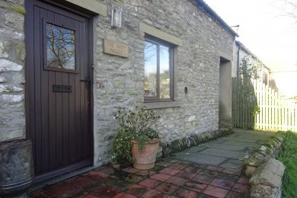
slightly sloping ramp to front door
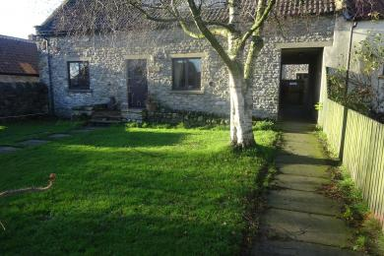
Path from car park to front door approx. 35 metres.

Arrival

Path to main entrance
- From the street to the main entrance, there is level access.
- There is a permanent ramp.
- The path is 1mm wide, or more.

Main entrance
- The main entrance has level access.
- There is a permanent ramp.
- The door is 750mm wide.
- The main door is side hung and manual.

Getting around inside

Visual Impairment - General Information
- Some parts of the venue have low lighting.

Bedrooms
- All bedrooms have windows.
- Bedrooms have ceiling lights and bedside lamps.
- Lights are energy saving. Some TVs have subtitles.
- All bedrooms are non-smoking.
- We have non-allergic bedding.
- All bedrooms have fitted carpets.
- We can move the bedroom furniture, to improve accessibility.
- From the main entrance to this area, there is level access.
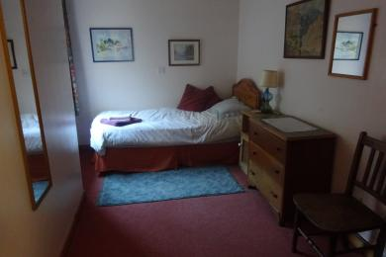
Single downstairs bedroom

There is a laundry room in the cottage
- From the main entrance to the laundry, there is level access. The route is 850mm wide, or more. The door is 700mm wide.
- We have an iron and ironing board.

Self catering kitchen

Dairy House
- We have an open plan kitchen.
- From the main entrance to the kitchen, there is level access.
- The route is 850mm wide, or more.
- The door is 700mm wide.
- The work surface is available at a height between 650mm and 900mm.
- The hob is available at a height between 650mm and 900mm.
- The sink is available at a height between 650mm and 900mm.
- The oven is available at a height between 650mm and 900mm.
- See website www.diryhousenorthyorks.co.uk

Lounge

Dairy House
- From the main entrance to the lounge, there is level access. The route is 850mm wide, or more. The door is 700mm wide.

Shower room & toilet
- From the main entrance to this area, there is level access. The route is 850mm wide, or more.
- The door is 700mm wide.
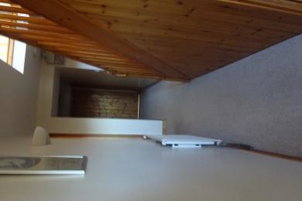
corridor from front door to all other downstairs rooms

Getting around outside

Dairy House - open plan
- From the main entrance to the gardens, there is level access.
- There is a permanent ramp.
- The route is sloped. The route is 300mm wide, or more.
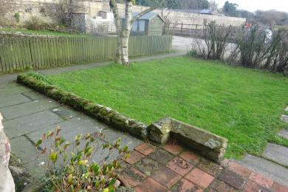
view of garden from front door

Customer care support

Emergency evacuation procedures
- We have emergency evacuation procedures for disabled visitors.
- The back door opens outwards with no lock from the inside.

Guide last updated: 18 January 2019

