Accessibility Guide for Swan House
info@swanhousehastings.co.uk, 01424 430014, www.swanhousehastings.co.uk
Contact for accessibility enquiries: Brendan McDonagh
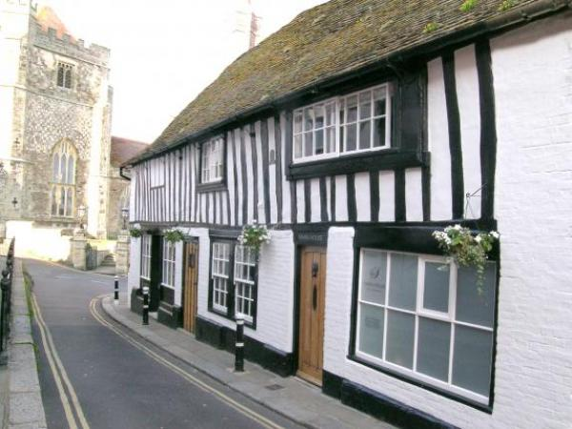

Welcome
Swan House is an award-winning, five star guest house in the heart of Hastings Old Town. Dating back to 1490, our interior has been sympathetically restored to an extremely high standard, providing luxury and style in abundance. Our individually decorated rooms delight visitors, complemented by our spacious guest lounge and patio garden, where guests enjoy breakfast.
We are fortunate to have a ground floor ensuite bedroom, although not wheelchair accessible, requiires no stairs to access, therefore, perfect for those with mobility difficulties.
The travel and interior design press love Swan House. Come and discover why!
Watch the video: Swan House

At a Glance

Level Access
- There is level access from the main entrance to:
  - Dining Table
  - Soft seating area
  - Patio

Bedrooms
- We have non-allergic bedding.

Level access bedrooms
- From the main entrance to the bedroom, there is level access.

Hearing
- The (bedroom) TVs have subtitles.
- Some staff have disability awareness training.

Visual
- Glass doors have contrast markings.
- Some parts of the venue have low lighting.
- The menu is in audio and large print.
- We have information in large print.

General
- Staff are available 24 hours a day.
- Some staff have disability awareness training.
- We have emergency evacuation procedures for disabled visitors.

Getting here
Swan House
1 Hill Street
HASTINGS
TN34 3HU

Travel by public transport
- You can get to Swan House by bus and train.
- The nearest bus stop is 50 metres away on Hastings seafront near the High Street. There is a slight incline to Swan House from the High Street. The bus stop is 0.0 miles / 0.0 km from Swan House.
- The nearest train station is Hastings. The train station is 0 miles / 0.0 km from Swan House.
- Buses and a taxi rank outside Hastings train station. A taxi direct to Swan House costs @£5.

Travel by taxi
- We have a transfer service for visitors. Always happy to transport visitors short distances around town and to the train station, time permitting.

Parking
- There is parking near the venue. The parking is less than 50 metres from the main entrance. Parking is free.
- There is a drop-off point at the main entrance. The drop-off point has a dropped kerb.
- From the car park to the entrance, there is level access. The route is 600mm wide, or more.
- Hill Street is on a narrow road of two way traffic, part pedestrianised. Access is straightforward and the drop off point is metres from the Swan House entrance
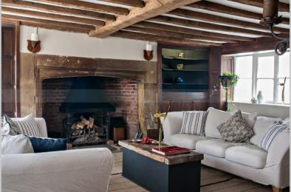
Image of the lounge entrance to Swan House

Arrival

Path to main entrance
- From the street to the main entrance, there is level access.
- The path is 600mm wide, or more.

Main entrance
- The main entrance has level access.
- The door is 800mm wide.
- The main door is side hung and manual.
- Main door entrance accessed by one key to open and close shut on entering.
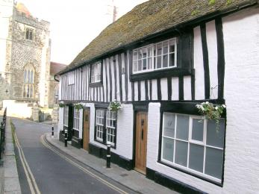
Exterior including main entrance

Getting around inside

Visual Impairment - General Information
- We have contrast markings on all glass doors.
- Some parts of the venue have low lighting.

Bedrooms
- All bedrooms have windows.
- Bedrooms have ceiling lights, wall lights, floor standing lights, bedside lamps and natural daylight.
- Lights are LED. TVs have subtitles.
- All bedrooms are non-smoking.
- We have non-allergic bedding.
- No bedrooms have fitted carpets.
- Blankets and hollow fibre bedding can be provided for those who have allergies to feather bedding
- We can move the bedroom furniture, to improve accessibility.
- From the main entrance to this area, there is level access.
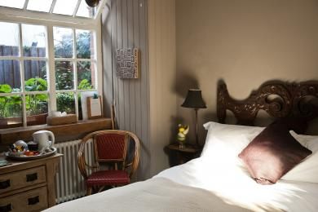
Internal view of the ground floor Garden room

Place to eat and drink

Guest lounge
- From the main entrance to the dining area, there is level access. The route is 800mm wide, or more. The door is 800mm wide.
- To get to a table, there are no steps.
- The menu is offered in audio and large print.
- There is background music sometimes.
- We cater for sugar free (diabetic), vegetarian, gluten free (celiacs), lactose free (dairy free), nut free, low fat, low potassium, low sodium, no gastric content, high fibre and vegan specific diets.
- We endeavour to cater for all dietary requirements where possible
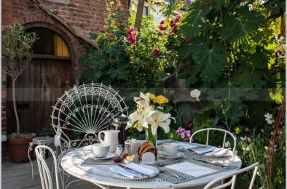
Alfresco breakfast dining at Swan House

Soft seating area
- From the main entrance to this area, there is level access. The route is 800mm wide, or more.
- Guest lounge area with soft seating used for enjoying coffee and tea on arrival
Soft seating area of the guest lounge

Getting around outside

Patio
- From the main entrance to this area, there is level access. The route is 800mm wide, or more. The entrance is 800mm wide.
- Access to the patio courtyard area where guests enjoy breakfast alfresco
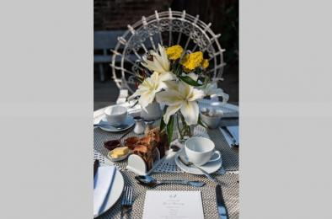
Breakfast table set up for alfresco dining

Customer care support

Accessibility equipment
- Shopping centre nearby provide wheelchairs for hire
- For a list of more items, please go to https://www.priorymeadow.com/centre-information/services/.
- The nearest toilet area for assistance dogs is 10 metres from Swan House
- We have an area to charge mobility scooters and battery powered wheelchairs.
- On the driveway adjacent to Swan House or in the guest lounge
- You can hire mobility equipment from Shopmobility by calling 01424 447847.

Emergency evacuation procedures
- We have emergency evacuation procedures for disabled visitors.

Customer care support
- Some staff have disability awareness training.
- We have information in large print.
- Staff are available 24 hours a day.
- Owner lives on the premises

Guide last updated: 18 January 2019

