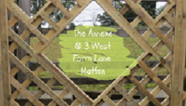

Accessibility Guide for Matfen Annexe
sheilalake01@icloud.com, 07808989000,
Contact for accessibility enquiries: Sheila Lake
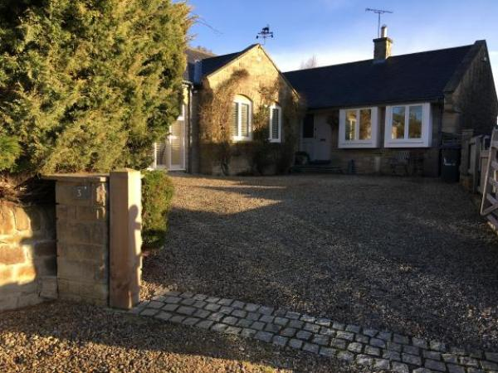

Welcome
Fully self-contained beautifully presented Annexe in the centre of the beautiful unspoilt village of Matfen. Sleeps 2 in either twin beds or super king, good sized ensuite shower room and living room with kitchen area. Enclosed private outside space to relax in the summer.

At a Glance

Level Access
- The main entrance has 2 steps. There is no lift and no ramp.

Access with steps
- There are steps from the main entrance to:
  - Bedroom
  - Living area
  - Rear patio

Bedrooms
- We have non-allergic bedding.

Hearing
- The (bedroom) TVs have subtitles.

Getting here
3 West Farm Lane
Matfen
NE20 0QZ

Travel by public transport
- You can get to Matfen Annexe by bus.
- The nearest bus stop is in the village by the Black Bull Pub. The bus stop is 0.1 miles / 0.2 km from Matfen Annexe.

Travel by taxi
- You can get a taxi with Tyne Valley Cabs by calling 07946 401722.

Parking
- We have a car park. The parking is less than 50 metres from the main entrance. Parking is free.
- You can be dropped off on the driveway at the front of the property, the main entrance is at the rear. From the parking to the main entrance, there is 1 step. There is no ramp and no lift.
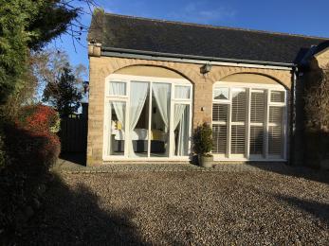
Entrance is via a path at the left hand side of the Annexe

Arrival

Path to main entrance
- From the street to the main entrance, there is 1 step. There is no ramp and no lift.
- The path is sloped.

Main entrance
- The door is 800mm wide.
- The main entrance has 2 steps.
- The main door is side hung and manual.
- When you arrive, we can help carry your luggage.
- As long a prearranged and we are home.
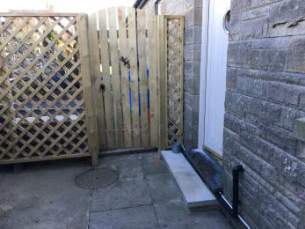
2 steps in and one on the other side of the door.

Getting around inside

Visual Impairment - General Information
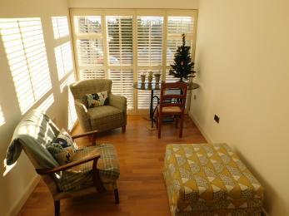
Good lighting

Bedrooms
- All bedrooms have windows.
- Bedrooms have wall lights, spot lights and natural daylight.
- Lights are LED. TVs have subtitles.
- All bedrooms are non-smoking.
- We have non-allergic bedding.
- No bedrooms have fitted carpets.
- We have wi-fi free bedrooms, for visitors with electro-sensitivity.
- We can move the bedroom furniture, to improve accessibility.
- The bedroom nearest the main entrance has 2 steps.
- All bedrooms are ensuite.
- We have bathrooms with a separate shower.
- The direction of transfer onto the toilet is to the left.
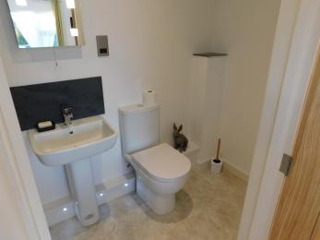
Bathroom

Self catering kitchen

Main
- We have an open plan kitchen.
- From the main entrance to the kitchen, there is 1 step. There is no lift and no ramp.
- The work surface is available with clear underspace and available at a height between 650mm and 900mm.
- The table and plates have high colour contrast.
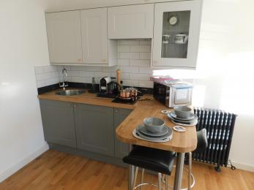
Kitchen area

Lounge

Living area
- From the main entrance to the lounge, there is 1 step. There is no lift and no ramp.
Living area

Getting around outside

Rear patio
- From the main entrance to the area, there is 1 step.
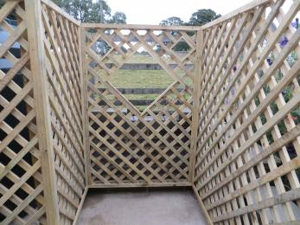
Outside area

Customer care support

Accessibility equipment
- For a list of more items, please go to http://www.disabilitynorth.org.uk/dn-exhibitors/north-east-mobility-solutions....
- Front driveway
- You can hire mobility equipment from Disability North by calling 01289 331055.

Guide last updated: 21 January 2019

