Accessibility Guide for The Hideaway
enquiries@sibleysonscilly.com, 01720 422431, https://sibleysonscilly.co.uk/Holidays/RentalDetail?UnitTypeID=42&occupancy=2
Contact for accessibility enquiries: Gail Sibley
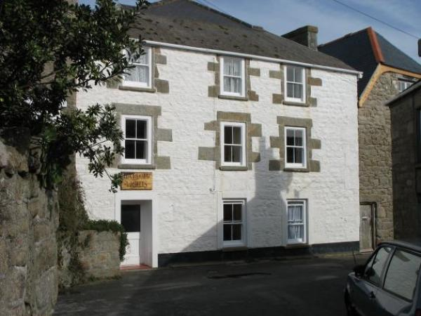

Welcome
The Hideaway is an endearing and well-equipped ground floor apartment for 2 people. It is perfectly situated in the centre of Hugh Town, a short flat walk to all amenities and the harbour, with direct beach access.
The accommodation comprises twin bedroom with ensuite shower room, and open plan lounge, kitchen, diner. Being so central and with no stairs to negotiate, this property lends itself well to out of season visits to both couples, friends or the single traveller alike.

At a Glance

Bedrooms
- We have non-allergic bedding.

Level access bedrooms
- From the main entrance to the bedroom, there is level access.

Visual
- Glass doors have contrast markings.

General
- Staff are available 24 hours a day.
- We have emergency evacuation procedures for disabled visitors.

Getting here
5 Harbour Lights,
Thorofare
St Mary's
TR21 0LN

Travel by public transport
- Sail from Penzance or fly direct from Land's End, Newquay or Exeter Airports. National and European connections available from Newquay and Exeter. If you require travel assistance please contact: 01736 334220, customerservices@islesofscilly-travel.co.uk

Travel by taxi
- You can get a taxi with Buzza Bus by calling 01872 266886. The taxi company has a wheelchair accessible vehicle.
- You can get a taxi with DJ Cabs by calling 01720 423775.
- You can get a taxi with Toots Taxi by calling 01720 422142.
- Each Skybus flight is met by a transfer taxi at St Mary's Airport. If arriving by boat, taxis can be booked for quayside collection.

Parking
- There is a drop-off point at the main entrance. The drop-off point has a dropped kerb.
- The street outside Harbour Lights has no kerb.

Arrival

Path to main entrance
- From the street to the main entrance, there is level access.
- The path is 1000mm wide, or more.

Main entrance
- The main entrance has level access.
- The door is 660mm wide.
- The main door is side hung and manual.
- If arriving from the airport, Skybus shuttle service providers will help unload bags from the bus. If arriving by boat you can arrange for your luggage to be delivered from the quay to to door for a small fee. Please call Island Carriers on 01720 422662 to arrange.

Getting around inside

Visual Impairment - General Information
- We have contrast markings on all glass doors.

Bedrooms
- All bedrooms have windows.
- Bedrooms have ceiling lights, bedside lamps and natural daylight.
- Lights are halogen and LED. Some lights can be controlled independently.
- All bedrooms are non-smoking.
- We have non-allergic bedding.
- All bedrooms have fitted carpets.
- This property has never had pets in it.
- From the main entrance to this area, there is level access.

Customer care support

Accessibility equipment
- Wheelchairs, walkers and electric golf buggies can be hired locally. information available through the Tourist Information Centre.
- For a list of more items, please go to https://www.visitislesofscilly.com/about/practical-info/tourist-information-c....

Customer care support
- Staff are available 24 hours a day.
- Sibley's Island Homes provides an out of hours emergency phone number in all of it's self catering properties.

Guide last updated: 13 June 2019

