Accessibility Guide for Fire Station Cottage
matthew@coopercottages.com, 01877 384331, https://coopercottages.com/fire-station-cottage/
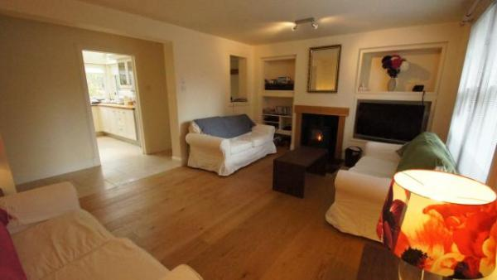

Welcome
Fire Station Cottage is situated in the village of Comrie. It has three upstairs bedrooms (double, twin and single). There is a downstairs bathroom with shower and toilet and upstairs family bathroom. Downstairs there is a kitchen, separate dining room, and lounge.

At a Glance

Level Access
- There is level access from the main entrance to:
  - Dining Room

Access with steps
- There are steps from the main entrance to:
  - Bedroom

Hearing
- The (bedroom) TVs have subtitles.

Getting here
Fire Station Cottage
Comrie
PH6 2LN

Parking
- We have a car park. The parking is less than 50 metres from the main entrance. Parking is free.
- There is a drop-off point at the main entrance. The drop-off point has a dropped kerb.
- From the car park to the entrance, there is level access.

Arrival

Path to main entrance
- From the street to the main entrance, there is level access.

Main entrance
- The main entrance has level access.
- The main door is side hung and manual.
- Access to the property is through the rear door with level access.

Getting around inside

Bedrooms
- All bedrooms have windows.
- Bedrooms have ceiling lights, bedside lamps and natural daylight.
- TVs have subtitles.
- All bedrooms are non-smoking.
- The bedroom nearest the main entrance has 20 steps.
- We have bathrooms with a separate shower.

Self catering kitchen
- We have a separate kitchen and dining room. From the main entrance to the kitchen, there is level access.
- The table and plates have high colour contrast.
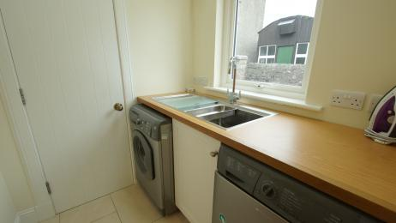
Fire Station Cottage Comrie kitchen
- From the main entrance to the dining room, there is level access.

Lounge
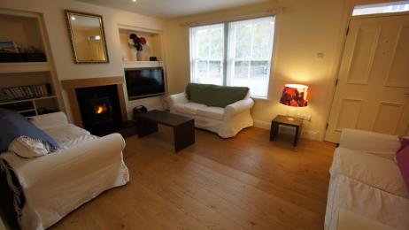
Fire Station Cottage Comrie lounge
- From the main entrance to the lounge, there is level access.

Dining Room
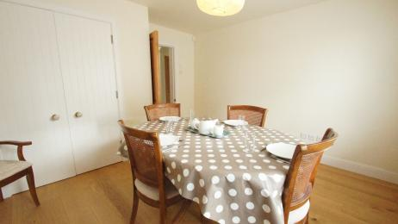
Fire Station Cottage Comrie dining room
- From the main entrance to this area, there is level access.

Customer care support

Accessibility equipment
- We have an area to charge mobility scooters and battery powered wheelchairs.
- Mains power sockets downstairs

Emergency evacuation procedures
- Exits would be through either the front or rear door of the property.

Guide last updated: 18 January 2019

