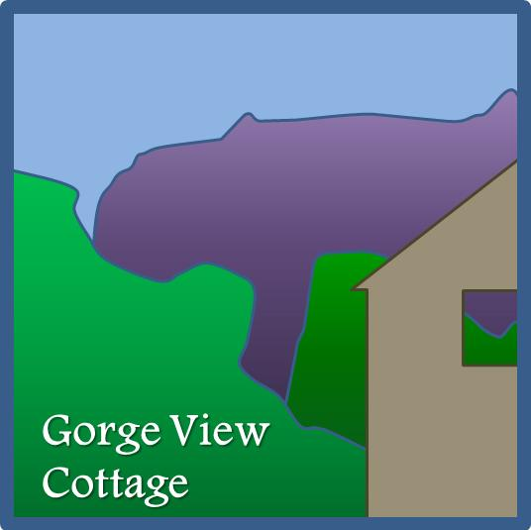

Accessibility Guide for Gorge View Cottage
info@gorgeviewcottage.co.uk, 01934 744727, www.gorgeviewcottage.co.uk
Contact for accessibility enquiries: Huw and Mary Robson
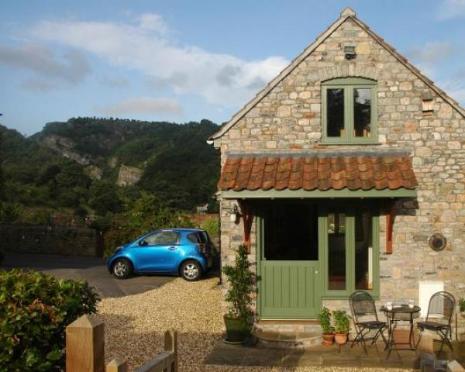

Welcome
Gorge View Cottage is an award-winning sustainable four-star (gold) self-catering holiday cottage for two, nestling in the foothills of the Mendip Hills Area of Outstanding Natural Beauty. It was recently fully renovated to exacting environmental standards whilst maintaining its natural charm. For anyone needing a gentle break the Cottage has it all; a haven for walkers and cyclists and yet just a couple of minutes to the gorge, pubs and restaurants.

At a Glance

Level Access
- The main entrance has 2 steps. There is no lift and no ramp.
- There is level access from the main entrance to:
  - Lounge
  - Drive and garden

Access with steps
- There are steps from the main entrance to:
  - Bedroom

Bedrooms
- We have non-allergic bedding.

Hearing
- The (bedroom) TVs have subtitles.

Visual
- Some parts of the venue have low lighting.

Getting here
Gorge View
Birch Hill
Cheddar
Somerset
BS27 3JN

Travel by public transport
- You can get to Gorge View Cottage by bus.
- Tweentown bus stop in Cheddar is where the main services stop including the First Bus 126 service between Wells and Weston-Super-Mare. The bus stop is 0.2 miles / 0.3 km from Gorge View Cottage.
- From the bus stop head towards the Riverside Inn and bear left at the mnini-roundabout in front of the pub. Turn immediately left again and up Birch Hill (with the Cheddar Fish Bar on your right). Up the short steep rise and the narrow lane lftannes out. Gorge View is the second larger house on the left, and the cottage shares the drive with the main house.
The shortest route includes a short steep section of narrow lane. A slightly longer route via West Lynne avoids this.

Parking
- We have a car park. The parking is less than 50 metres from the main entrance. Parking is free.
- There is a drop-off point at the main entrance. The drop-off point has a dropped kerb.
- From the parking to the main entrance, there is 1 step. There is no ramp and no lift. Parking on the drive can be directly by the cottage front door. At this point the drive is a gravel surface. There is a single step up to the front door (under a covered porch with light), and the a step over the door threshold.
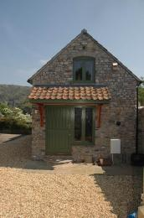
Gorge View Cottage parking and front door

Arrival

Path to main entrance
- From the street to the main entrance, there is 1 step. There is no ramp and no lift.

Main entrance
- The door is 970mm wide.
- The main entrance has 2 steps.
- The main door is side hung and manual.
- When you arrive, we can help carry your luggage.
Cottage entrance: parking by the front door. Two steps to threshold.

Getting around inside

Visual Impairment - General Information
- Some parts of the venue have low lighting.
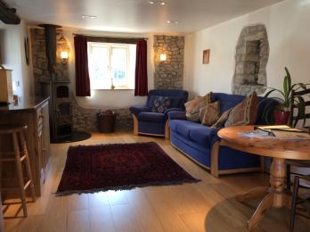
Downstairs (living/kitchen/diner)

Bedrooms
- All bedrooms have windows.
- Bedrooms have ceiling lights, wall lights, bedside lamps, desk or table lamps, spot lights and natural daylight.
- Lights are LED. TVs have subtitles.
- All bedrooms are non-smoking.
- We have non-allergic bedding.
- No bedrooms have fitted carpets.
- We have wi-fi free bedrooms, for visitors with electro-sensitivity.
- The bedroom nearest the main entrance has 9 steps.
- All bedrooms are ensuite.
- We have bathrooms with a separate shower.

Self catering kitchen

Kitchen
- We have an open plan kitchen.
- From the main entrance to the kitchen, there is level access.
- The route is 3000mm wide, or more.
- The work surface is available at a height between 650mm and 900mm.
- The hob is available at a height between 650mm and 900mm.
- The sink is available at a height between 650mm and 900mm.
- The table and plates have high colour contrast.
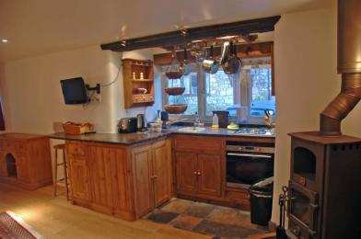
Kitchen seen from lounge

Lounge

Lounge
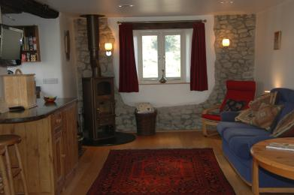
Lounge seen from hall area
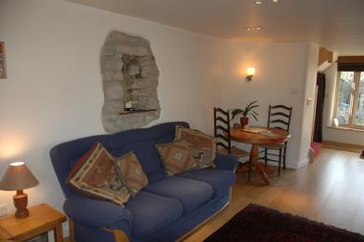
Lounge/dining seen from kitchen
- From the main entrance to the lounge, there is level access. The route is 3000mm wide, or more.

Getting around outside

Drive and garden
- From the main entrance to this area, there is level access. The route is 2000mm wide, or more. The entrance is 1000mm wide.
- The drive is gravelled and tarmaced nearer the hosue and road entrance. The garden which is level and open to guersts is mostly laid to grass between flower and vegatables, with some smaller paths mulched. This is a working garden and care is needed.

Customer care support

Accessibility equipment
- For a list of more items, please go to https://www.gorgeviewcottage.co.uk/access.html.
- The nearest area would be the garden - three meters from the front door through double gates. Dog mess would need to be bagged.
- We have an area to charge mobility scooters and battery powered wheelchairs.
- The cottage has an outdoor socket near the front door, but this would not be covered or secure.
- You can hire mobility equipment from Dalesway Mobility, RETAIL UNIT, CARLTON STREET CAR PARK, WESTON-SUPER MARE, SOMERSET, BS23 1UA by calling 01934 642002.

Customer care support
- Proprietors normally available in main house next door (across drive) - but 24/7 availability cannot be guaranteed.

Guide last updated: 18 January 2019

