Accessibility Guide for Bempton Beach House
bemptonholidays@wilfward.org.uk, 08456 050371, www.bemptonholidays.co.uk
Contact for accessibility enquiries: Janette Dillon
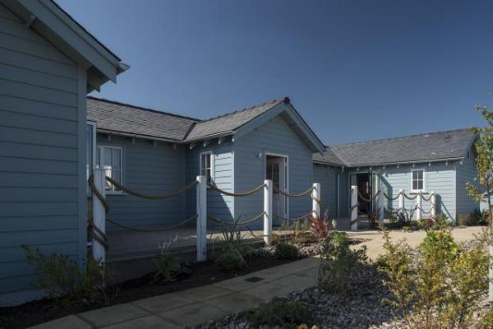

Welcome
The beach house is a self-catering house at The Bay, Filey with four bedrooms accommodating up to 7 guests. Two of the bedrooms have electric profiling beds, ceiling tracking and hoist leading to an en-suite wet room with height adjustable shower table and shower chair. There is also a mobile hoist and a rise recliner in the lounge area. The ground floor kitchen, dining and lounge are open plan for ease of access. The lounge and dining area have bi fold doors leading to decking and a private garden.

At a Glance

Level Access
- There is level access from the main entrance to:
  - Bedroom: Bedroom 1 and Bedroom 2
  - Separate utility room with washing machine tumble drier and ironing table and iron
  - house garden

Bedrooms
- We have non-allergic bedding.
- There is a ceiling tracked hoist.
- We have a portable hoist.

Level access bedrooms
- From the main entrance to the bedroom, there is level access.
- The route to the bedroom is 750mm wide, or more.
- The bedroom door is 750mm wide, or more.
- There is unobstructed floor space 1200mm by 900mm, or more.
- The bathroom has a level access shower.

Hearing
- The (bedroom) TVs have subtitles.
- All staff have disability awareness training. Some staff have BSL training

General
- Staff are available 24 hours a day.
- All staff have disability awareness training.
- We have emergency evacuation procedures for disabled visitors.

Getting here
2a Blue Anchor Road, Moor Road
Moor Road
Filey
North Yorkshire
YO14 9GQ

Parking
- We have a car park. Parking is free.
- There is a drop-off point at the main entrance. The drop-off point has a dropped kerb.
- From the car park to the entrance, there is level access. The route is 1330mm wide, or more.
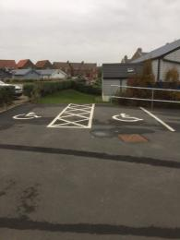
Two disabled parking bays

Arrival

Path to main entrance
- From the street to the main entrance, there is level access.
- The path is 1330mm wide, or more.

Main entrance
- The main entrance has level access.
- The door is 840mm wide.
- The main door is side hung and manual.
- When you arrive, we can help carry your luggage.
- We offer visitors a meet and greet service on arrival
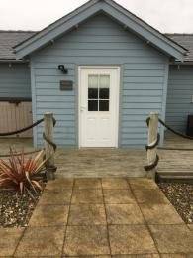
Level pathway leading to entrance door of beach house

Getting around inside

Bedrooms
- All bedrooms have windows.
- Bedrooms have ceiling lights, bedside lamps and natural daylight.
- Lights are halogen and traditional filament. TVs have subtitles.
- All bedrooms are non-smoking.
- We have non-allergic bedding.
- Some bedrooms have fitted carpets.
- We can move the bedroom furniture, to improve accessibility.
- We have bed blocks.
- We have a portable hoist.
- From the main entrance to this area, there is level access.

Accessible bedrooms

Accessible bedroom Bedroom 1 and Bedroom 2
- The route to the bedroom is 805mm wide, or more. The bedroom door is 805mm wide. There is 1260mm at the side of the bed. The bed is 560mm high. There is 430mm under the bed.
- There is a low clothes rail. You can use the rail sitting down.
- There is a ceiling tracked hoist.
- The bedroom is single. The bathroom is ensuite. The bathroom door is 1120mm wide.
- The bathroom has a separate shower. The shower has a seat. The bathroom has a bath with an overhead shower. The bathroom has a level access shower. There is a shower chair available. The toilets have handrails. The direction of transfer onto the toilet is to the right. There is 260mm at the side of the toilet.
- There is 2030mm in front of the toilet. The toilet seat is 450mm high.
- The basin is 660mm high. The taps are lever operated. There is space under the basin, with no pedestal or boxing.
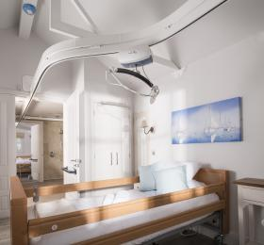
Electric profiling bed with overhead hoist and ceiling tracking
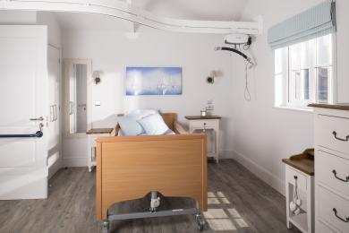
Electric profiling bed
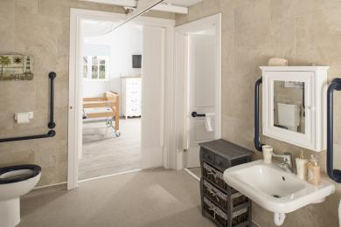
Ensuite shower room with ceiling track and hoist
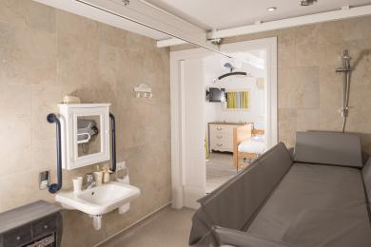
Ceiling tracking and hoist to height adjustable shower table

Separate utility room with washing machine tumble drier and ironing table and iron
- From the main entrance to the laundry, there is level access. The route is 810mm wide, or more. The door is 810mm wide.
- We have an iron and ironing board. You can use the ironing board sitting down.

Self catering kitchen
- We have an open plan kitchen.
- From the main entrance to the kitchen, there is level access.
- The route is 840mm wide, or more.
- The work surface is available with clear underspace and available at a height between 650mm and 900mm.
- The hob is available with clear underspace and available at a height between 650mm and 900mm.
- The sink is available with clear underspace and available at a height between 650mm and 900mm.
- The oven is available at a height between 650mm and 900mm.
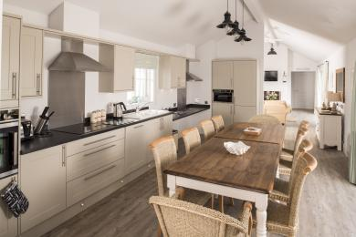
Open plan kitchen dining area with dining table seating 8

Lounge
- From the main entrance to the lounge, there is level access. The route is 840mm wide, or more. The door is 840mm wide.
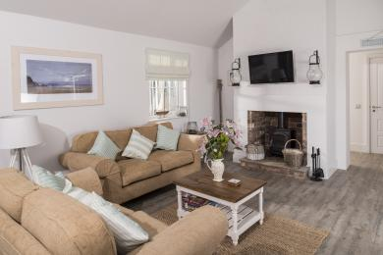
Open plan lounge with two three seater sofas and riser recliner

Getting around outside

house garden
- From the main entrance to the gardens, there is level access.
- The route is 840mm wide, or more.
- There is level access from the open plan lounge and dining area with bi fold doors and from all four bedrooms with patio doors to the decking that surrounds the house with patio furniture
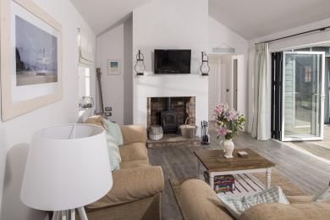
lounge with bi fold doors open leading to decking at the back of the house

Customer care support

Accessibility equipment
- Electric profiling beds, ceiling tracking and overhead hoists from bedrooms to ensuite shower rooms, height adjustable shower bed, shower chair, electric riser recliner and mobile hoist
- We have an area to charge mobility scooters and battery powered wheelchairs.
- Mobility Scooter or wheelchair can be charted in the entrance hall

Customer care support
- All staff have disability awareness training.
- Some staff have BSL training.
- Staff are available 24 hours a day.
- We have an emergency on-call system where a manager in the Trust can be contacted 24 hours a day, 7 days a week in the event of an emergency

Guide last updated: 18 January 2019

