Accessibility Guide for Trentham Gardens
enquiry@trentham.co.uk, 01782657341, http://www.trentham.co.uk/
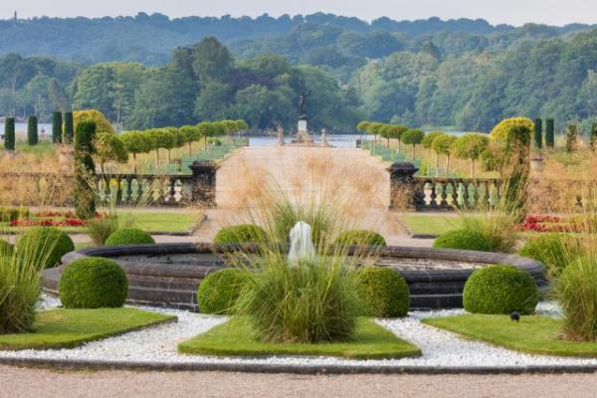

Welcome
The Trentham Estate is home to the award-winning Trentham Gardens featuring The Italian Garden by Tom Stuart-Smith, and the Floral Labyrinth and Rivers of Grass by Piet Oudolf and vast wildflower and woodland meadow plantings by Nigel Dunnett. A fascinating wire fairy sculpture trail, fab childrens adventure playground with the UK's first barefoot walk, a family-friendly maze, mile-long Capability Brown lake with seasonal boat and train trips. Trentham Monkey Forest and Trentham Shopping Village with 50 shops and 14 cafes and restaurants can also be found at The Trentham Estate. You'll find something for everyone here.
Watch the video: More to Explore

At a Glance

Level Access
- The main entrance has level access with a ramp. The ramp is permanent.
- There is level access from the main entrance to:
  - Italian Garden Tearooms
  - Lakeside Cafe
  - Dining Table
  - Capability Brown Centre
  - Visitor Centre/Gardens Entrance
  - South Entrance via Lakeside Cafe
  - Visitor Centre (Garden Entrance) Toilets
  - Shopping Village Toilets
  - Shopping Villages Changing Places Toilet
  - Italian Garden Tearooms Toilets
  - South Entrance Toilets
  - Italian Gardens
  - Upper Flower Garden
  - Show Gardens
  - Rivers of Grass
  - Floral Labyrinth
  - Adventure Play Area, Barefoot Walk and Hide and Speak Maze
- We have a viewing area for wheelchair users.

Hearing
- We have a hearing loop in Visitor Centre (at the Gardens Entrance).

Visual
- Glass doors and full-height windows have contrast markings.
- The walls and the doors have high colour contrast.
- We have display information in large print.
- We have information in large print.

General
- We have a concessionary rate for disabled visitors.
- We have a complimentary ticket policy for personal assistants.
- There is at least 1 public toilet for disabled visitors.At least one toilet is a Changing Places toilet.

Getting here
Trentham Gardens
Stone Road
Trentham
ST4 8AX

Travel by public transport
- You can get to Trentham Gardens by bus and train.
- The nearest bus stop is located in the car park at the North Entrance beside the Shopping Village. Please call our Visitor Centre for up to date bus schedules. The bus stop is 0.0 miles / 0.0 km from Trentham Gardens.
- The nearest train station is Stoke on Trent Railway Station. The train station is 4 miles / 6.4 km from Trentham Gardens.

Travel by taxi
- You can get a taxi with Castle Cars by calling 01782631119. The taxi company has a wheelchair accessible vehicle.
- You can get a taxi with Roseville Taxis (Private Taxis) by calling 01782613245. The taxi company has a wheelchair accessible vehicle.
- Please contact our Visitor Centre for enquiries regarding transport options.

Parking
- We have a car park. There are accessible parking spaces. Parking is free.
- There is a drop-off point at the main entrance. The drop-off point has a dropped kerb.
- From the car park to the entrance, there is level access. There is a permanent ramp.
- The route is 2000mm wide, or more.

Arrival

Path to main entrance
- From the street to the main entrance, there is level access.
- There is a permanent ramp.
- The path is 2000mm wide, or more.

Main entrance
- The main entrance has level access.
- There is a permanent ramp.
- The door is 980mm wide.
- The main door is side hung and automatic.
- The main door is sliding and automatic.

Getting around inside

Visual Impairment - General Information
- We have contrast markings on all glass doors, contrast markings on all full-height windows and high colour contrast between walls and doorframes.

Ticket/ information desk

Visitor Centre/Gardens Entrance
- From the main entrance to the desk, there is level access. The route is 980mm wide, or more.
- The door is 980mm wide, or more.
- The desk has a low section.

Ticket/ information desk

South Entrance via Lakeside Cafe
- From the main entrance to the desk, there is level access. There is a permanent ramp. The route is 200mm wide, or more.

Things to See and Do
- We have a concessionary rate for disabled visitors.
- We have a complimentary ticket policy for personal assistants.
- We have display information in: large print.

Capability Brown Centre
- From the main entrance to this area, there is level access. There is a permanent ramp. The route is 1750mm wide, or more. The door is 1480mm wide.
- Some display information is low, for wheelchair users. There are seats.
- This venue is mainly used by pre-booked groups e.g. schools and workshops. It may also be used to host some events throughout the year. Please enquire at the Visitor Centre if you would like more information about access to the Capability Brown Centre.

Spectator/ Audience viewing areas
- There are stewards to help disabled visitors.
- We have a viewing area for wheelchair users.

Amphitheatre
- From the main entrance to the viewing area, there is level access. There is a permanent ramp. The route is 1750.00 wide, or more. Personal assistants and friends can sit with wheelchair users.
- Wheelchair users can sit with their own fans.
- Stewards can bring food and drink to wheelchair users.
- The Amphitheatre is used for events throughout the year including our Hot Summer Saturday Concerts, and Brass Band events throughout the summer. Please visit our What's On page on our website where you can find out more about our events.
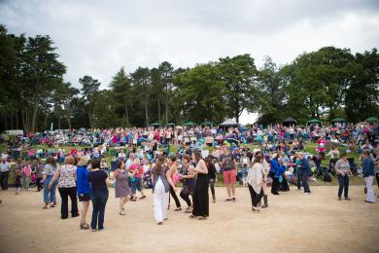
Amphitheatre

Public toilet

Visitor Centre (Garden Entrance) Toilets
- There is a public toilet for disabled visitors.
- From the main entrance to the public toilet, there is level access. There is a permanent ramp.
- The route is 1070mm wide, or more.
- The toilet door is 1070mm wide.
- The direction of transfer onto the toilet is to the left.
- There is 1300mm at the side of the toilet. There is 1400mm in front of the toilet. The toilet seat is 500mm high. The toilets have handrails.

Public toilet

Shopping Village Toilets
- There is a public toilet for disabled visitors.
- From the main entrance to the public toilet, there is level access. There is a permanent ramp.
- The route is 1300mm wide, or more.
- The toilet door is 1000mm wide.
- The direction of transfer onto the toilet is to the right.
- There is 1490mm at the side of the toilet. There is 900mm in front of the toilet. The toilet seat is 50mm high. The toilets have handrails.

Public toilet

Shopping Villages Changing Places Toilet
- There is a public toilet for disabled visitors.
- The toilet is a Changing Places toilet.
- You need a RADAR key to open the public toilet.
- From the main entrance to the public toilet, there is level access. There is a permanent ramp.
- The route is 2400mm wide, or more.
- The toilet door is 100mm wide.
- The direction of transfer onto the toilet is to the left and right.
- There is 3170mm in front of the toilet. The toilet seat is 50mm high. The toilets have handrails.
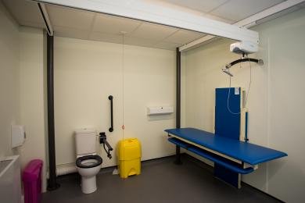
Changing Places Facility

Public toilet

Italian Garden Tearooms Toilets
- There is a public toilet for disabled visitors.
- From the main entrance to the public toilet, there is level access. There is a permanent ramp.
- The route is 1750mm wide, or more.
- The toilet door is 875mm wide.
- The direction of transfer onto the toilet is to the left.
- There is 1240mm at the side of the toilet. There is 1500mm in front of the toilet. The toilet seat is 500mm high. The toilets have handrails.

Public toilet

South Entrance Toilets
- There is a public toilet for disabled visitors.
- From the main entrance to the public toilet, there is level access. There is a permanent ramp.
- The route is 1750mm wide, or more.
- The direction of transfer onto the toilet is to the front only.
- The toilet seat is 500mm high.

Place to eat and drink

Italian Garden Tearooms
- From the main entrance to the dining area, there is level access. There is a permanent ramp. The route is 1750mm wide, or more. To get to a table, there are no steps.
- The route through the dining area is 800mm wide, or more.
- There is background music.
- The table and plates have high colour contrast.
- We cater for vegetarian, gluten free (celiacs), lactose free (dairy free), nut free and vegan specific diets.
- Please telephone our Visitor Centre if you would like more information regarding dietary requirements.
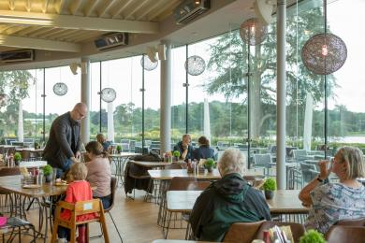
Italian Garden Tearoom

Place to eat and drink

Lakeside Cafe
- From the main entrance to the dining area, there is level access. There is a permanent ramp. The route is 1750mm wide, or more. To get to a table, there are no steps.
- The route through the dining area is 800mm wide, or more.
- There is background music.
- The table and plates have high colour contrast.
- We cater for vegetarian, gluten free (celiacs), lactose free (dairy free) and vegan specific diets.
- Please telephone our Visitor Centre if you would like more information regarding dietary requirements.

Getting around outside

Italian Gardens
- From the main entrance to the gardens, there is level access.
- There is a permanent ramp.
- The route is sloped. The route is 1750mm wide, or more.
- Access to the Italian Garden is via slopes to the lower beds. Access to the Rose Trellis and Upper Flower garden can be made without use of slopes. An accessible route map is available from our website and Visitor Centre which details our recommended routes to avoid slopes and uneven pathways.
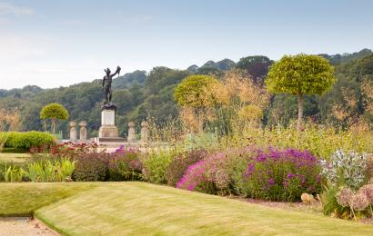
Italian Garden
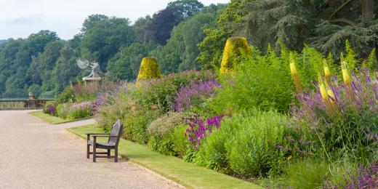
Italian Garden

Upper Flower Garden
- From the main entrance to the gardens, there is level access.
- There is a permanent ramp.
- The route is sloped. The route is 1750mm wide, or more.
- Access to the Upper Flower Garden can be made through multiple routes, including through the Italian Garden, or Eastern Pleasure Gardens (Rivers of Grass and Floral Labyrinth). Due to the historic nature of the Estate, some routes do include steps, however more accessible routes are available. Please ask at the Visitor Centre, or visit our website for our recommended, accessible routes map.
Access to the Church Flats area where the Viewing Platform is located is via a set of stone steps.
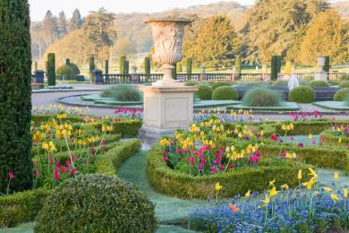
Upper Flower Garden

Show Gardens
- From the main entrance to the gardens, there is level access.
- There is a permanent ramp.
- The route is sloped. The route is 1750mm wide, or more.
- The Show Gardens are located in the Western Pleasure Gardens with close access to the Adventure Play Area, Italian Garden Tearooms, Barefoot Walk and Maze. This area features nine small Show Gardens with a main pathway leading through each of these, including a wooden bridge. This pathway is at least 1500mm wide. Access within each Garden may be limited, with path widths varying e.g. in our Potager Garden where the path width is 700mm.
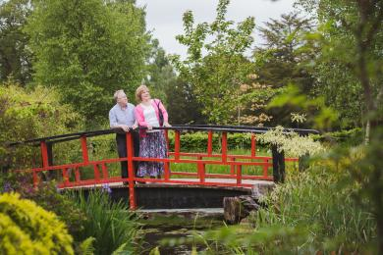
Show Garden

Rivers of Grass
- From the main entrance to the gardens, there is level access.
- There is a permanent ramp.
- The route is 1750mm wide, or more.
- The Rivers of Grass is the first area of Gardens that you will encounter as you enter over the bridge at the Visitor Centre. There is a wide, even pathway leading around the perimeter of this area, with mown grass pathways leading through the Garden. A range of benches are available in this area.
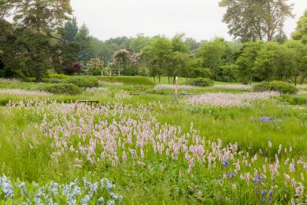
Rivers of Grass

Floral Labyrinth
- From the main entrance to the gardens, there is level access.
- There is a permanent ramp.
- The route is sloped. The route is 1750mm wide, or more.
- The Floral Labyrinth is located adjacent to the Rivers of Grass and Italian Garden. Access can be made via the main pathway which leads from the Visitor Centre, or via the Italian Garden. This area of the Garden features meandering pathways through the perennial planting beds. This area features some grass pathways and lawn areas, plus some picnic benches and seating. In the North corner of the Garden, there is a wide wooden Loveseat enclosed within a hornbeam dome.
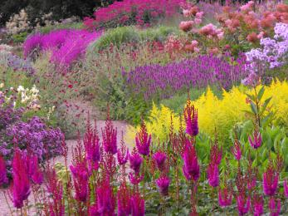
Floral Labyrinth

Designated Walking Trail

Lakeside Walks
- The trail is 3300metres long. The trail has a hard surface. The trail is sloped. The trail has seats.
- Pathways around the Lakeside Walks are comprised of a layer of compressed gravel, providing a smooth, even surface. We ensure that these are maintained to be wheelchair and pushchair friendly. Where we have varied gradients due to the historic povenance of the garden alternative paths are signposted, a map with our recommended accessible routes is available from the website or our Visitor Centre.
There is a slope on the East Side of the Lake close to the South Entrance which leads down to our Weir Cascade, a wooden footbridge is installed to allow access across this.

Adventure Play Area, Barefoot Walk and Hide and Speak Maze
- From the main entrance to this area, there is level access. There is a permanent ramp. The route is 1750mm wide, or more. The entrance is 3400mm wide.
- The Adventure Play Area features a range of play equipment to suit all ages. Access via the main pathways is made over compressed gravel paths, boardwalks and paving. Accessible play equipment is featured, including a nest swing and table top sand play suitable for use by wheelchair users.
Access to the Barefoot Walk is made from the Play Area. Please visit our website for more information regarding this activity and its availability.
The Hide and Speak Maze is made up of a series of Hornbeam hedges and compressed gravel pathways leading to a spiral path that leads around the outside of a tall grass mound.
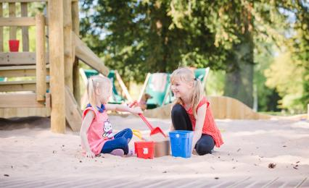
Sandplay

Customer care support

Accessibility equipment
- We provide wheelchairs. Wheelchairs are free.
- We have a hearing loop in Visitor Centre (at the Gardens Entrance).
- For a list of more items, please go to https://trentham.co.uk/plan-your-visit/accessibility-of-trentham-estate/.
- As an outdoor-based, dog friendly attraction there are no specific, designated areas for assistance dogs.

Emergency evacuation procedures
- We have emergency evacuation procedures for disabled visitors.

Customer care support
- We have information in large print.
- Visitor Information is available in large print formats from the Visitor Centre, and copies are available to view and print from our wesbite.

Guide last updated: 23 February 2023

