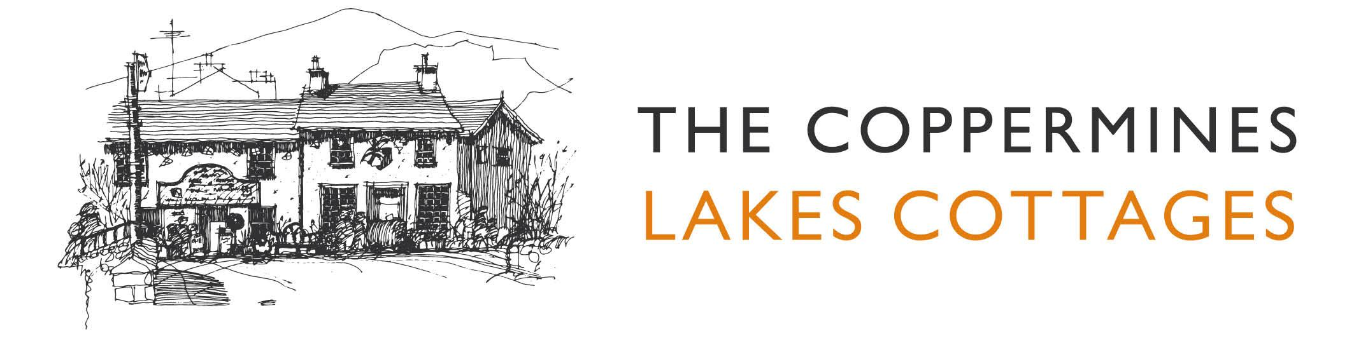

Accessibility Guide for Vine Tree Cottage
info@coppermines.co.uk, 015394 41765, www.coppermines.co.uk
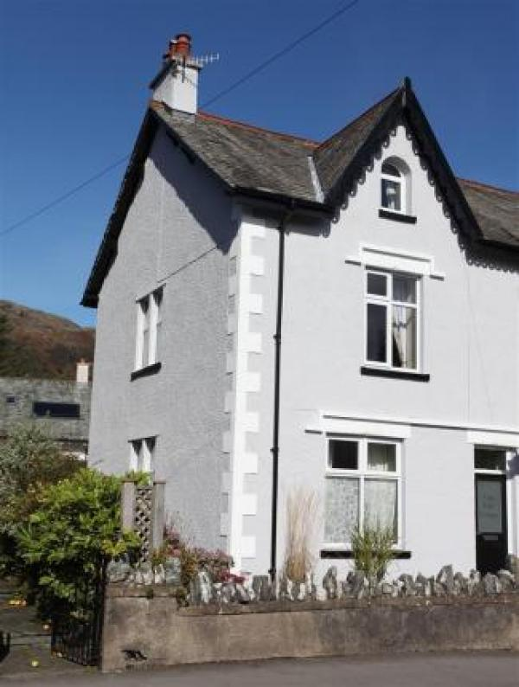

Welcome
At the Coppermines Lakes Cottages we want to make everyone's stay as enjoyable as possible. We aim to accurately describe our facilities and services to give you the confidence to book the right cottage for your specific requirements.

At a Glance

Level Access
- The main entrance has 1 step. There is no lift and no ramp.
- There is level access from the main entrance to:
  - Vine Tree Cottage Lounge
  - Utility Room and Downstair W.C.
  - Rear paved garden

Visual
- We have information in large print.

Getting here
Vine Tree Cottage
Tilberthwaite Avenue
Coniston
Cumbria
LA21 8ED

Travel by public transport
- You can get to Vine Tree Cottage by bus.
- The X12 bus from Barrow and the 505 bus from Windermere both stop at The Crown in the centre of Coniston. Southlakeland Bus Timetables available at http://www.cumbria.gov.uk/buses. The bus stop is 0.1 miles / 0.2 km from Vine Tree Cottage.

Travel by taxi
- You can get a taxi with Bluebird Tours by calling 07814 728390.

Parking
- We have a car park. The parking is less than 50 metres from the main entrance. There is a drop-off point at the main entrance. The drop-off point has a dropped kerb.
- From the car park to the entrance, there is level access. Parking is to the rear of the cottage. Entrance is gained via the back door

Arrival

Path to main entrance
- From the street to the main entrance, there is level access.

Main entrance
- The main entrance has 1 steps.
- The main door is side hung and manual.
- 1 step over threshold

Getting around inside

Bedrooms
- All bedrooms have windows.
- Bedrooms have ceiling lights, bedside lamps and natural daylight.
- All bedrooms are non-smoking.
- All bedrooms have fitted carpets.
- We have bathrooms with a separate shower.
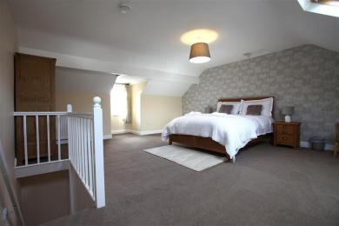
Vine Tree Second Floor Bedroom
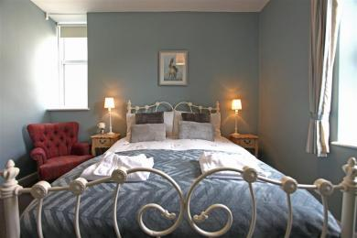
Vine Tree 1st Floor Bedroom
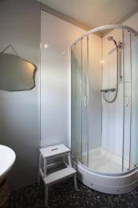
Vine Tree Shower Room

Self catering kitchen

Vine Tree Kitchen
- We have an open plan kitchen.
- From the main entrance to the kitchen, there is level access.
- The work surface is available at a height between 650mm and 900mm.
- The hob is available at a height between 650mm and 900mm.
- The sink is available at a height between 650mm and 900mm.
- The oven is available at a height between 650mm and 900mm.
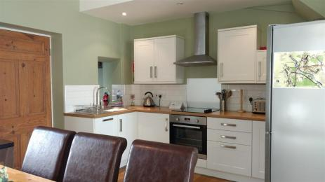
Vine Tree Cottage Kitchen
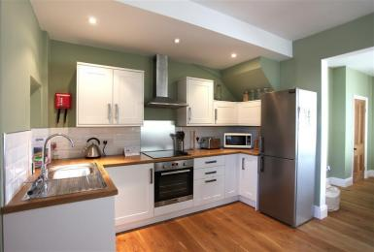
Vine Tree Kitchen

Lounge

Vine Tree Cottage Lounge
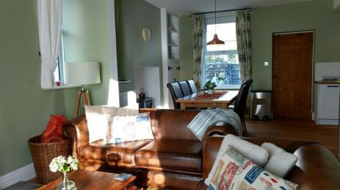
Vine Tree Cottage Lounge / Dining Area
- From the main entrance to the lounge, there is level access.

Utility Room and Downstair W.C.
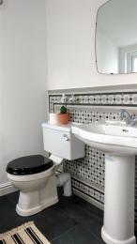
Vine Tree Downstairs W.C.
- From the main entrance to this area, there is level access.

Getting around outside

Rear paved garden
- From the main entrance to this area, there is level access.

Customer care support

Accessibility equipment
- For a list of more items, please go to http://www.southlakesmobilityshop.co.uk/.
- The nearest RADAR toilet is at the Coniston Tourist information Centre.
- We have an area to charge mobility scooters and battery powered wheelchairs.
- You can hire mobility equipment from South Lakes Mobility in Ulverston or Kendal by calling 01229 585 009. Wheelchairs may be able to be hired from Coniston Care Scheme by calling 015394 41868.

Customer care support
- We have information in large print.

Guide last updated: 4 June 2019

