Accessibility Guide for Sherwood Forest Visitor Centre
sherwoodforest@rspb.org.uk, 01623 677321, visitsherwood.co.uk
Contact for accessibility enquiries: Rob James
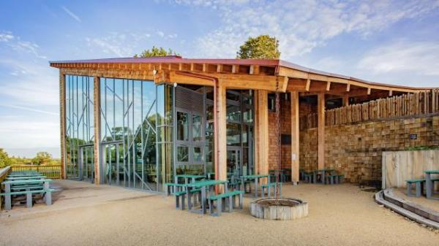

Welcome
Welcome to Sherwood Forest
A landmark thousands of years in the making, alive with nature, history and folklore, and its all yours to explore, from its ancient oaks and legendary characters, to the work of the RSPB, protecting the forest today. Play, discover and leave with tales of your own, inspired by 420 hectares of beautiful, precious, unique woodland.

At a Glance

Level Access
- There is level access from the main entrance to:
  - Dining Table
  - Retail
  - Catering
  - Welcome
  - Accessible Toilet 1
  - Accessible Toilet 2
  - Changing Places
  - Shop
  - Play area
- There is level access from the car park to:
  - Amphitheatre

Hearing
- The fire alarm has flashing lights.
- We have a hearing loop in Visitor centre shop.
- Some staff have BSL training.

Visual
- Glass doors have contrast markings.
- The walls and the doors have high colour contrast.
- The menu is in Written format on table tops and large screens behind the order point. Please ask a member of staff if you require assistance..

General
- We have a complimentary ticket policy for personal assistants.
- There is at least 1 public toilet for disabled visitors.At least one toilet is a Changing Places toilet.

Getting here
Sherwood Forest Visitor Centre
Forest Corner
Edwinstowe
Nottinghamshire
NG21 9RN

Travel by public transport
- You can get to Sherwood Forest Visitor Centre by bus and train.
- The Sherwood Arrow service runs hourly from Victoria bus station in Nottingham and stops outside the visitor centre. The direct journey takes around an hour. For up to date information check here www.bustimes.org The nearest train station is Shirebrook. The train station is 6 miles / 9.7 km from Sherwood Forest Visitor Centre.
- The nearest train stations are at Shirebrook (6 miles) Mansfield Woodhouse (6.5 miles) and Mansfield (7 miles). These are all served by the Robin Hood line, operated by East Midlands Trains and you can find timetables here www.eastmidlandstrains.co.uk

Travel by taxi
- You can get a taxi with ACE-ABC Taxis by calling 01623 654321.
- You can get a taxi with G Cars Taxi Service Mansfield by calling 07426 777079.

Parking
- We have a car park. There are accessible parking spaces. Parking is not free.
- There is a drop-off point at the main entrance. The drop-off point has a dropped kerb.
- From the car park to the entrance, there is level access. The main car park is across the road from the visitor centre and a distance of approximately 300 metres from the visitor centre main entrance. Accessible parking is available next to the visitor centre with level access to the main entrance.
Parking costs £5 for non-members, and is chargeable for anything up to a full day, including for blue badge holders. Parking is free for RSPB members.
During the Robin Hood Festival, a special event parking fee applies to everyone attending.
A Pay by Phone option is now available for parking in addition to cash payments.
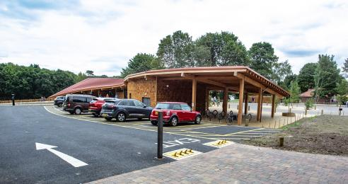
Accessible car park

Arrival

Path to main entrance
- From the street to the main entrance, there is level access.
- The path is 2200mm wide, or more.
- The path is sloped.

Main entrance
- The main entrance has level access.
- There is a lift.
- The door is 2000mm wide.
- The main door is sliding and automatic.
- Please note, there is level access from the accessible car park, next to the visitor centre, but not from the main visitor car park across the road.
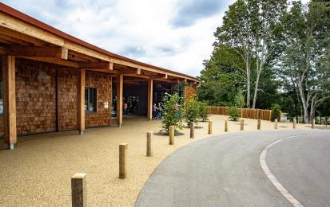
Visitor Centre main entrance

Getting around inside

Visual Impairment - General Information
- We have contrast markings on all glass doors and high colour contrast between walls and doorframes.

Lift
- We have 1 lift.
- You can get a lift to all floors.

Lifts to all floors
- The lift door is 1300mm wide.
- The lift is 2100mm wide. The lift is 1590mm deep.
- The lift says the floor number at each floor.
- The lift buttons have raised numbers or letters.
- The lift shows the floor number, at each floor.
- The Visitor Centre lift is currently out of order and we are working closely with specialists to repair it. We realise that this will be a barrier for some of our visitors which will affect moving between the two floors of the building and accessing our shop, café, toilets and Changing Places facility. We sincerely apologise for the inconvenience that is caused by it not being in operation. A mobility scooter is available to hire and there is a sloped pathway linking the accessible car park to the amphitheatre area and the entrance to the Visitor Centre café. We recommend calling us on 01623 677321 or emailing sherwoodforest@rspb.org.uk if you plan to visit Sherwood and have questions about access to our building and its facilities. There is more information about our facilities at https://www.visitsherwood.co.uk/at-the-visitor-centre/facilities-and-changing-places/

Ticket/ information desk

Welcome
- From the main entrance to the desk, there is level access. The door is 2000mm wide, or more.
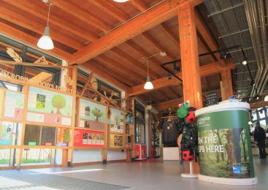
Welcome area

Things to See and Do
- We have a complimentary ticket policy for personal assistants.

Retail
- From the main entrance to this area, there is level access. The door is 2000mm wide.
- Some display information is low, for wheelchair users. There is a hearing loop.
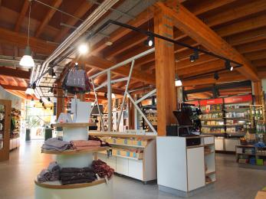
Sherwood Forest Shop

Catering
- From the main entrance to this area, there is level access. There is a permanent ramp. There is a lift.
- From the lift to this area, the route is 1160mm wide, or more. Some display information is low, for wheelchair users. There are seats.
- There is a hearing loop.
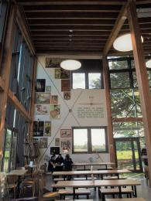
Sherwood Forest Cafe

Public toilet

Accessible Toilet 1
- There is a public toilet for disabled visitors.
- From the main entrance to the public toilet, there is level access. There is a permanent ramp.
- There is a lift.
- From the lift to the public toilet, the route is 1400mm wide, or more.
- The toilet door is 920mm wide.
- The direction of transfer onto the toilet is to the front only.
- There is 1580mm in front of the toilet. The toilet seat is 490mm high. The toilets have handrails.

Public toilet

Accessible Toilet 2
- There is a public toilet for disabled visitors.
- From the main entrance to the public toilet, there is level access. There is a permanent ramp.
- There is a lift.
- The toilet door is 920mm wide.
- The direction of transfer onto the toilet is to the left.
- There is 1100mm at the side of the toilet. There is 1400mm in front of the toilet. The toilet seat is 490mm high. The toilets have handrails.

Public toilet

Changing Places
- There is a public toilet for disabled visitors.
- The toilet is a Changing Places toilet.
- From the main entrance to the public toilet, there is level access. There is a permanent ramp.
- There is a lift.
- From the lift to the public toilet, the route is 1400mm wide, or more.
- The toilet door is 920mm wide.
- The direction of transfer onto the toilet is to the left and right.
- There is 1340mm at the side of the toilet. There is 3270mm in front of the toilet. The toilet seat is 490mm high. The toilets have handrails.
- Our Changing Places facility includes a hoist, shower, toilet and changing facilities for the comfort of our visitors and their carers.
Please request the key from a member of staff before use.

Shop

Shop
- From the main entrance to the shop, there is level access. The route is 1160mm wide, or more. The door is 2000mm wide.
- The route through the shop is 800mm wide, or more.

Place to eat and drink

Cafe
- From the main entrance to the dining area, there is level access. There is a permanent ramp. There is a lift. From the lift to dining area, the route is 1160mm wide, or more. To get to a table, there are no steps.
- Written format on table tops and large screens behind the order point. Please ask a member of staff if you require assistance.
- The route through the dining area is 800mm wide, or more.
- There is background music sometimes.
- We cater for vegetarian, gluten free (celiacs), lactose free (dairy free) and vegan specific diets.

Getting around outside

Designated Walking Trail

Major Oak Trail
- The trail is 2400metres long. Some of the trail has a loose surface. The trail is sloped. The trail has seats.

Designated Walking Trail

Greenwood Trail
- The trail is 3200metres long. Some of the trail has a loose surface. The trail is sloped.

Designated Walking Trail

Wildwood Trail
- The trail is 6400metres long. Some of the trail has a loose surface. The Wildwood Trail is a rough woodland trail with kissing gates throughout. The trail is sloped.

Picnic Area

Amphitheatre
- From the car park to the picnic area, there is level access. There is a permanent ramp. The path is 2000mm wide, or more.
- Some tables have space for wheelchair users. You can bring your own food to the picnic area.
- Level access is from the accessible, rather than main, car park.

Play area
- From the main entrance to this area, there is level access. There is a permanent ramp. The route is 2000mm wide, or more.

Customer care support

Accessibility equipment
- We have a hearing loop in Visitor centre shop.
- Changing Places facility
Mobility Scooter (£3 per hour)
- For a list of more items, please go to https://www.visitsherwood.co.uk/at-the-visitor-centre/facilities-and-changing....
- Assistance dogs allowed throughout the visitor centre and therefore able to access toilets.
- We have an area to charge mobility scooters and battery powered wheelchairs.
- Please ask a member of staff for assistance.

Emergency evacuation procedures
- We have emergency evacuation procedures for disabled visitors.
- The fire alarm has flashing lights.

Customer care support
- Some staff have BSL training.

Guide last updated: 16 December 2023

