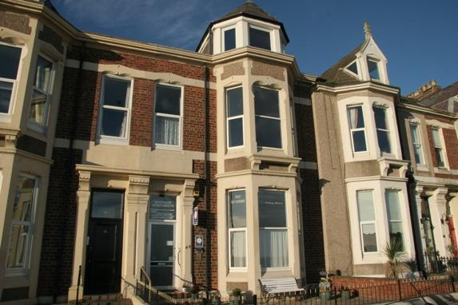

Accessibility Guide for Seafront Apartments
stay@seafront.info, 07977203379, www.seafront.info
Contact for accessibility enquiries: Andrew Webb
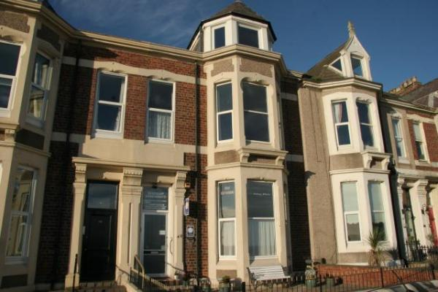

Welcome
Accessibility guide for Seafront Apartments
stay@seafront.info. 07977203379 www.seafront.info
Contact for accessibility enquiries: Andrew Webb
Welcome
At Seafront Apartments we want to make everyone's stay as enjoyable as possible, and are committed to providing suitable access for all our guests, whatever their individual needs. We aim to accurately describe our facilities and services to give you the confidence to book the right apartment for your specific requirements.
All our apartments are rated 4 star by VisitEngland.

At a Glance

Level Access
- The main entrance has 3 steps and a handrail. There is no lift and no ramp.
- There is level access from the main entrance to:
  - Apartment 1A lounge
  - Hall
  - Back yard

Access with steps
- There are steps from the main entrance to:
  - Laundry room
  - Front terrace

Bedrooms
- We have non-allergic bedding.

Level access bedrooms
- From the main entrance to the bedroom, there is level access.
- There is unobstructed floor space 1200mm by 900mm, or more.

Hearing
- The (bedroom) TVs have subtitles.
- Some staff have disability awareness training.

General
- Some staff have disability awareness training.

Getting here
46 Beverley Terrace
Cullercoats
North Shields
Tyne & Wear
NE30 4NU

Travel by public transport
- You can get to Seafront Apartments by bus, metro and boat or ferry.
- The nearest bus stop is 50 metres away The bus stop is 0.0 miles / 0.0 km from Seafront Apartments.
- The nearest underground station is Cullercoats. The underground station is 0.2 miles / 0.3 km from Seafront Apartments.
- The nearest port is Newcastle. The port is 5 miles / 8.1 km from Seafront Apartments.

Travel by taxi
- You can get a taxi with East Coast by calling 01912530777.

Parking
- There is a drop-off point at the main entrance. The drop-off point does not have a dropped kerb.
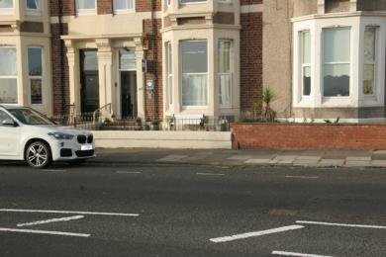
Parking spaces are available on the road directly infront of the apartments. We supply a parking permit for each apartment.

Arrival

Path to main entrance
- From the street to the main entrance, there are 3 steps. There is no ramp and no lift.

Main entrance
- The door is 845mm wide.
- The main entrance has 3 steps.
- This entrance has a handrail.
- The main door is side hung and manual.
- The other entrance door is 695.00mm wide.
- Back lane
- When you arrive, we can help carry your luggage.
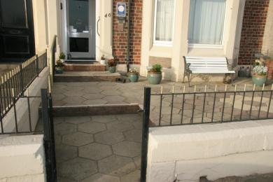
Front entrance showing 3 steps
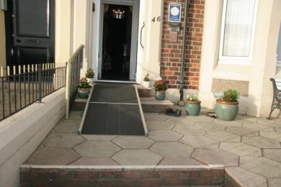
Portable ramp covers 2 of the 3 steps at the front entrance
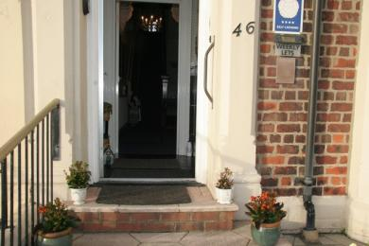
Front door outer door 845mm wide, inner door 810mm
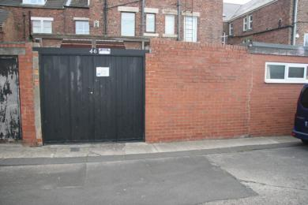
Rear entrance through gates from back lane
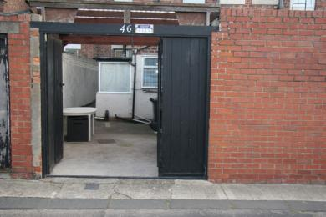
Rear entrance into back yard, gates 1670mm wide
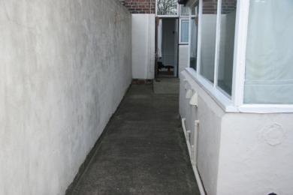
Back yard walkway 1290mm wide
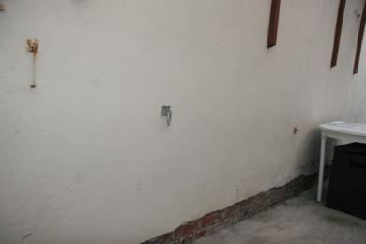
Back yard security points on wall for padlocking mobility scooter
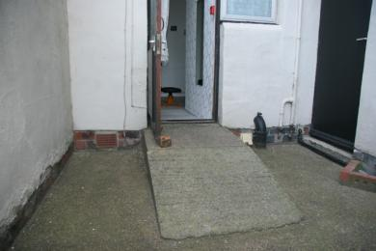
apartment 1A back door entrance with ramp 1000mm long,, 910 wide, 230 high, platform 920 x685 door w 695
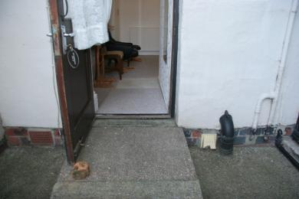
apartment 1A back door threshold outside 70mm, inside 55mm, ramp inside 1200mm long x 740 W x 110 high, inside wall W 1100

Getting around inside

Bedrooms
- All bedrooms have windows.
- Bedrooms have ceiling lights, wall lights, bedside lamps and natural daylight.
- Lights are LED. TVs have subtitles.
- All bedrooms are non-smoking.
- We have non-allergic bedding.
- Some bedrooms have fitted carpets.
- We have wi-fi free bedrooms, for visitors with electro-sensitivity.
- We can move the bedroom furniture, to improve accessibility.
- We have bed blocks.
- From the main entrance to this area, there is level access.
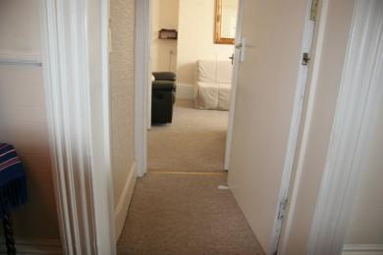
Entrance from hall into apartment 1A, outer door 830mm W, inner door 765mm, narrowest point 700mm

Laundry room
- From the main entrance to the laundry, there are 2 steps. There is no lift and no ramp.
- We have an iron and ironing board. You can use the ironing board sitting down.

Self catering kitchen

Apartment 1A kitchen
- We have an open plan kitchen.
- From the main entrance to the kitchen, there is level access.
- The route is 3000mm wide, or more.
- The door is 3000mm wide.
- The table and plates have high colour contrast.

Lounge

Apartment 1A lounge
- From the main entrance to the lounge, there is level access. The route is 700mm wide, or more. The door is 700mm wide.
Entrance from hall into apartment 1A, outer door 830mm W, inner door 765mm, narrowest point 700mm

Hall
- From the main entrance to this area, there is level access. The route is 810mm wide, or more.
- The door is 810mm wide.
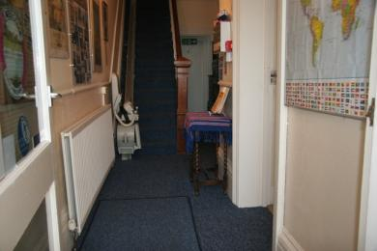
Hall width 1185

Getting around outside

Terrace

Front terrace
- To get to a table, there are 2steps steps.
- From the main entrance to the terrace, there are 2 steps.
Portable ramp covers 3 steps onto the front terrace

Back yard
- From the main entrance to this area, there is level access. There is a portable ramp. The route is 695mm wide, or more. The entrance is 695mm wide.
- From the main entrance to the area, there is 1 step.
Rear entrance into back yard, gates 1670mm wide
Back yard walkway 1290mm wide
apartment 1A threshold outside 70mm, inside 55mm, ramp inside 1200mm long x 740 W x 110 high, inside wall W 1100
apartment 1A back door entrance with ramp 1000mm long,, 910 wide, 230 high, platform 920 x685 door w 695

Customer care support

Accessibility equipment
- We provide wheelchairs. Wheelchairs are free.
- Walking aid on wheels, toilet frame, bath bench, seat for inbath with shower over, toilet support arm
- 100 metres, across the road to the right on the grass
- We have an area to charge mobility scooters and battery powered wheelchairs.
- In the back yard
Back yard security points on wall for padlocking mobility scooter
- You can hire mobility equipment from Travelability by calling 01912512444.

Emergency evacuation procedures
- We have emergency evacuation procedures for disabled visitors.

Customer care support
- Some staff have disability awareness training.

Guide last updated: 18 January 2019

