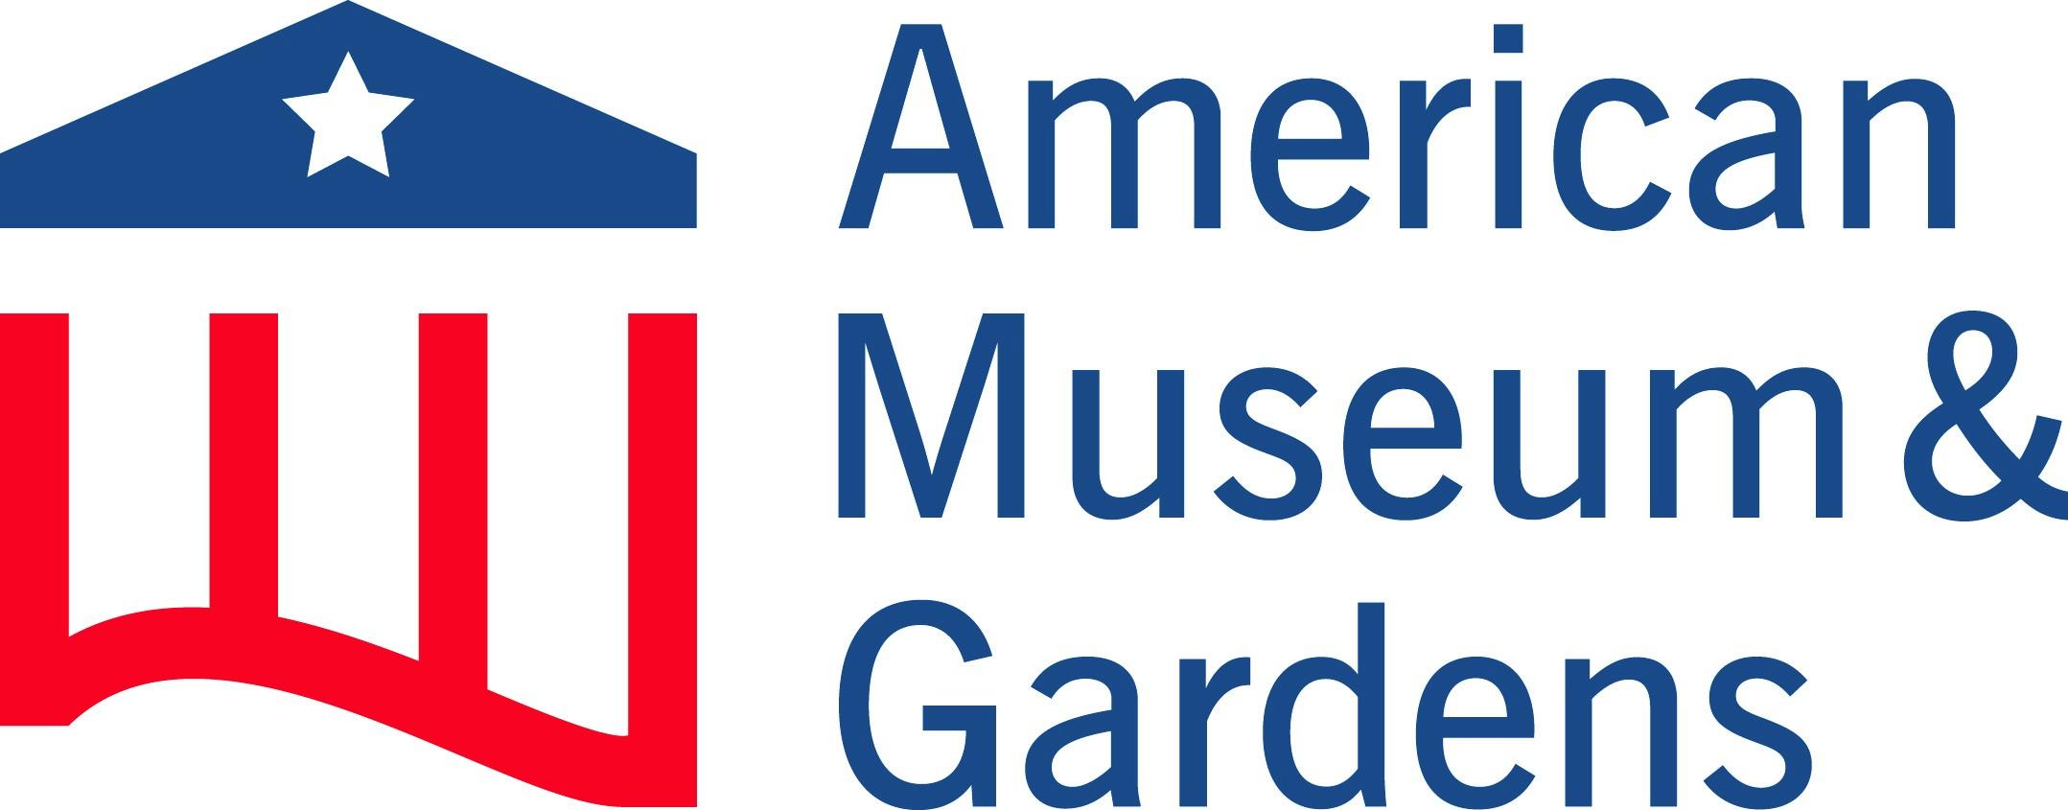

Accessibility Guide for American Museum & Gardens
reception@americanmuseum.org, 01225 460503, https://americanmuseum.org/
Contact for accessibility enquiries: Armani Lawlor
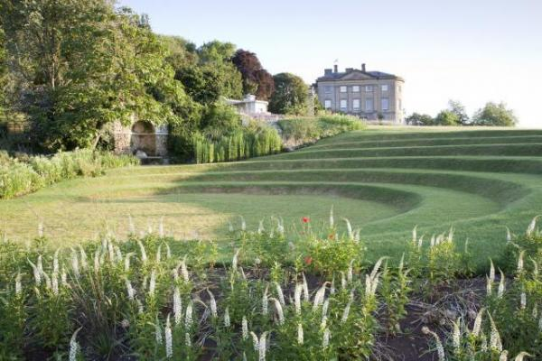

Welcome
With its remarkable collection of folk, decorative arts and cultural objects, the American Museum & Gardens showcases the diverse and complex nature of American traditions. The only museum of Americana outside of the United States, it was founded to bring American history and cultures to the people of Britain and Europe.
Located in an area of outstanding natural beauty, the 30 acres surrounding the house have been developed with formal gardens incuding a replica of George Washington’s garden at Mount Vernon, a children's play area and parklands.

Watch the video: Claverton Manor and Garden

At a Glance

Level Access
- The main entrance has level access with a ramp. The ramp is permanent.
- There is level access from the main entrance to:
  - New American Garden
  - Manor House
  - Ticket Office
  - Exhibition Gallery Toilets
  - Coach House Toilets
  - The Garden Café
  - Exhibition
  - New American Garden
  - Mount Vernon Garden
  - Terrace
  - Childrens Garden
- There is level access from the car park to:

Access with steps
- There are steps from the main entrance to:
  - Garden Café Toilets

Hearing
- We have a hearing loop in Ticket Office and Garden Café and Gallery Shop .
- Some staff have disability awareness training.

Visual
- We have information in large print.

General
- We have a complimentary ticket policy for personal assistants.
- There is at least 1 public toilet for disabled visitors.At least one toilet is a Changing Places toilet.
- Some staff have disability awareness training.

Getting here
Claverton Manor
Bath
BA2 7BD

Travel by public transport
- You can get to American Museum & Gardens by bus.
- The nearest bus stop is at the University of Bath. The walk from the stop to the Museum will take around 15 minutes via the road or woodland path. There is no footpath adjacent to the road for half of the distance. The woodland path is not a hard surface and can be slippery. There is a steep gradient near the entrance to the Museum. The bus stop is 1.0 miles / 1.6 km from American Museum & Gardens.

Travel by taxi
- You can get a taxi with V Cars Bath by calling 01225464646. The taxi company has a wheelchair accessible vehicle.

Parking
- We have a car park. There are accessible parking spaces. Parking is free.
- There is a drop-off point at the main entrance. The drop-off point has a dropped kerb.
- From the car park to the entrance, there is level access. There is a permanent ramp.
- The path is sloped.
- The route is 2100mm wide, or more.

Arrival

Path to main entrance
- From the street to the main entrance, there is level access.
- The path is sloped.

Main entrance
- The main entrance has level access.
- There is a permanent ramp.
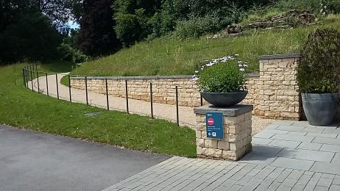
Accessible path from the car park to the Ticket Office and museum entrance

Getting around inside

Lift
- We have 2 lifts.
- You can get a lift to all floors.

Manor House lift
- The lift says the floor number at each floor.
- The lift shows the floor number, at each floor.

Ticket/ information desk

Ticket Office
- From the main entrance to the desk, there is level access. There is a permanent ramp. The route is 1000mm wide, or more.
- The door is 1000mm wide, or more.
- The desk has a low section.
- Please only one person at one time in the ticket office. The counter has a clear perspex screen in place. To access the accessible path into the garden you will need to exit the ticket office and enter through the side gate. Otherwise the one way system in place leads out on to steps down into the garden.
There is a hearing loop in the Ticket Office.
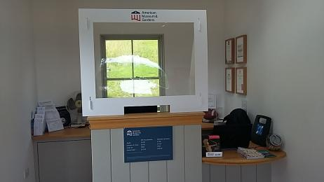
Ticket Office Desk

Things to See and Do
- We have a complimentary ticket policy for personal assistants.

New American Garden
- From the main entrance to this area, there is level access. There is a permanent ramp. From the lift to this area, the route is 800mm wide, or more. Some display information is low, for wheelchair users. There are seats.

Manor House
- From the main entrance to this area, there is level access. There is a permanent ramp. Some display information is low, for wheelchair users. There are seats.
- There is a hearing loop.
- Some videos have subtitles.
- All 3 floors of the Manor House are accessible by using the lift.
Wheelchairs are available on request.
There is ample seating throughout the Manor House.

Spectator/ Audience viewing areas
- There are stewards to help disabled visitors.

Public toilet

Garden Café Toilets
- From the main entrance to the public toilet, there is 1 step. There is no lift and no ramp.
- The public toilets by the Garden Cafe do have a step to get into them.
Wheelchair accessible toilets are located in the Exhibition Gallery building and in the Coach House.
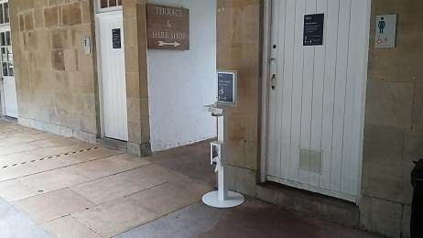
Garden Cafe Toilets

Public toilet

Exhibition Gallery Toilets
- There is a public toilet for disabled visitors.
- From the main entrance to the public toilet, there is level access. There is a permanent ramp.
- The route is 700mm wide, or more.
- The toilet door is 700mm wide.
- The direction of transfer onto the toilet is to the right.
- The toilets have handrails.
- The Gallery Toilets are currently closed until we are allowed to reopen the Exhibition gallery, subject to Goverment Covid-19 Guidance.
Alternative toilets, including accessible toilets and baby-changing facilities, are available at the Coach house (See below)
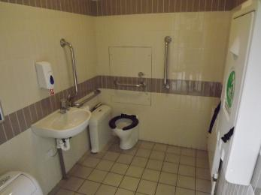
Exhibition Gallery Wheelchair Accessible Toilet

Public toilet

Coach House Toilets
- There is a public toilet for disabled visitors.
- The toilet is a Changing Places toilet.
- From the main entrance to the public toilet, there is level access. There is a permanent ramp.
- The route is 850mm wide, or more.
- The toilet door is 1050mm wide.
- The direction of transfer onto the toilet is to the left.
- The toilets have handrails.
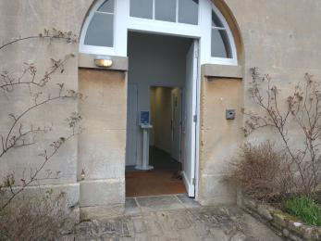
Coach House Entrance
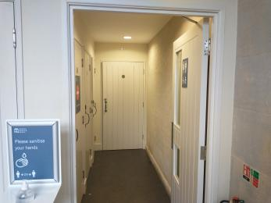
Coach House Interior

The Garden Café
- From the main entrance to this area, there is level access. The route is 800mm wide, or more.
- The door is 800mm wide.
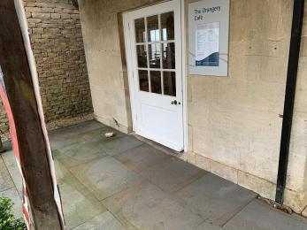
Entrance to the Garden Café

Exhibition
- From the main entrance to this area, there is level access. There is a permanent ramp.
- The temporary museum exhibition space is currently unavailable due to Government Covid-19 Guidence.
The exhibition currently has a one-way system in place, with moveable barriers to accomodate accessibilty.

Getting around outside

New American Garden
- From the main entrance to the gardens, there is level access.
- There is a lift. The route is sloped. The route is 1300mm wide, or more.
- We have a Tramper as part of our partnership with the Countryside Mobility Scheme which can be hired by visitors to access the gardens.
Manual wheelchairs are also available.
To book in advance please email: reception@americanmuseum.org or call 01225 460503.
- Watch the video: Tramper
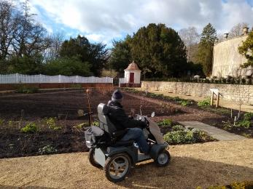
Tramper
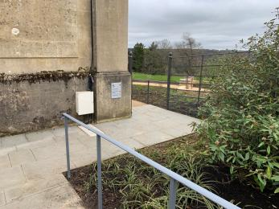
Step free access to New American Garden near the Ticket Office

Mount Vernon Garden
- From the main entrance to the gardens, there is level access.
- The route is sloped. The route is 1300mm wide, or more.
- A resin bonded gravel sloped path provides access to the Mount Vernon Garden from the New American Garden.
The level access route into the Mount Vernon Garden from the Garden Cafe is via a grassed and resin bonded gravel path. The grassed section may be inaccessible after heavy rain due to waterlogging.
There are 20 stone steps down into Mount Vernon Garden from the New American Garden.
- Watch the video: New American Garden & Mount Vernon Launch
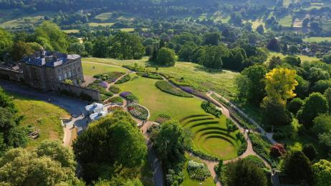
Aerial View of Claverton Manor and Gardens

Picnic Area
- From the car park to the picnic area, there is level access. The path is 1300mm wide, or more.
- You can bring your own food to the picnic area.

Terrace
- From the main entrance to this area, there is level access.
- The Terrace at the edge of the New American Garden and next to the Garden Cafe is the main outdoor seating area for visitors, especially for customers of the Garden Cafe.
It has a stone flag floor with multiple tables and chairs. Dog water bowls are provided in this area.
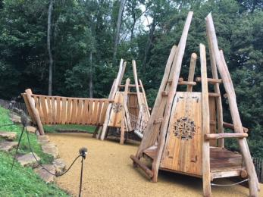
The Pyramid Structure

Childrens Garden
- From the main entrance to this area, there is level access.
- There is level access around the Childrens Garden
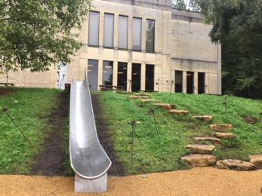
The slide and Rock Scramble
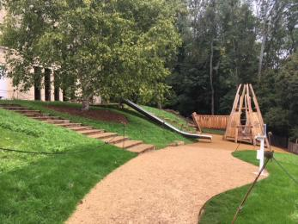
The path towards the slide and pyramid structure
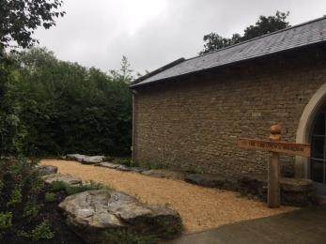
The Accessible path leading to the Children's Garden

Customer care support

Accessibility equipment
- We provide wheelchairs. Wheelchairs are free.
- We have a hearing loop in Ticket Office and Garden Café and Gallery Shop .
- We can provide three manual wheelchairs, subject to availability. Please ask at the Ticket Office on arrival.
- For a list of more items, please go to https://americanmuseum.org/visiting-us/accessibility/.
- The nearest toilet area for assistance dogs is located within the New American Garden.
- You can hire mobility equipment from Mobiloo by calling 03000301255.

Emergency evacuation procedures
- We have emergency evacuation procedures for disabled visitors.

Customer care support
- Some staff have disability awareness training.
- We have information in large print.

Guide last updated: 17 October 2022

