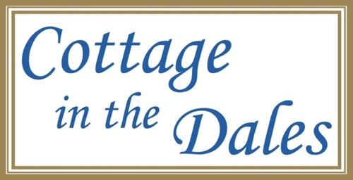

Accessibility Guide for Inglenook Cottage
stay@cottageinthedales.co.uk, 01969 662766, www.cottageinthedales.co.uk
Contact for accessibility enquiries: Diane Howarth
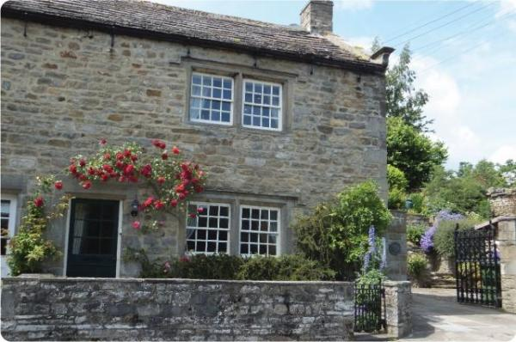

Welcome
Awarded Best in Yorkshire 2016 & Best in England 2017. Discover the endless beautiful scenery & 'Distinctly Dales' experiences based from a luxury Grade II listed cottage in the heart of the Yorkshire Dales Natinal Park. The 3 award-winning cottages each have their own appeal as individual as you. We pride ourselves on delivering a 'luxury 5 star experience, without the inconvenience of other guests'! Just like a top hotel, nothing is too much trouble & no detail overlooked; warmly lit fire, premium toiletries, best local produce. Our aim is to ensure you feel at home, whether you are coming for the first time or returning for the tenth. Our pleasure is to ensure yours.

At a Glance

Level Access
- The main entrance has 3 steps and a handrail. There is no lift and no ramp.

Access with steps
- There are steps from the main entrance to:
  - Bedroom
  - Inglenook Cottage lounge
  - Lower patio area
  - Garden & Upper Patio

Bedrooms
- We have non-allergic bedding.
- We have a portable hoist.

Hearing
- The fire alarm has a vibrating pillow pad and flashing lights.
- The (bedroom) TVs have subtitles.
- We have a hearing loop in Portable induction hearing loop can be used throughout the cottage and can be taken out and about during your stay. .
- Some staff have disability awareness training.

Visual
- The walls and the doors have high colour contrast.

General
The accommodation is rated by the National Accessible Scheme as suitable for:
- Older and less mobile guests
- Guests with hearing loss
- Visually impaired guests
- Staff are available 24 hours a day.
- Some staff have disability awareness training.
- We have emergency evacuation procedures for disabled visitors.

Getting here
Back Nook
West Burton
Leyburn
North Yorkshire
DL8 4JU

Travel by public transport
- You can get to Inglenook Cottage by bus.
- Inglenook Cottage is in West Burton, Wensleydale, a small village in the heart of the Yorkshire Dales National Park. Being so rural, there is a limited bus service which runs between Leyburn and Hawes a few times each time, and stops just 100m from Inglenook Cottage, just outside the village shop, on the same side of the road. All visitors arrive, and travel around, by car, as there is no real other option. The bus stop is 0.0 miles / 0.0 km from Inglenook Cottage.

Travel by taxi
- You can get a taxi with Hello Coopers by calling 01677 424252 or 01609 772295. The taxi company has a wheelchair accessible vehicle.
- You can get a taxi with Hello Coopers by calling 01677 424252 or 01609 772295. The taxi company has a wheelchair accessible vehicle.
Wheelchair accessible taxis are available from http://www.hellocoopers.co.uk

Parking
- We have a car park. There are accessible parking spaces. The parking is less than 50 metres from the main entrance. Parking is free.
- There is a drop-off point at the main entrance. The drop-off point has a dropped kerb.
- From the car park to the entrance, there is level access. The path is sloped.
- The route is 2000mm wide, or more.
- The private parking for Inglenook Cottage is in a secure courtyard adjacent to the gable end of the cottage with room either side of the car to easily get out of the car and walk up the slight slope to the rear door of the cottage or 10m out to the front of the cottage.
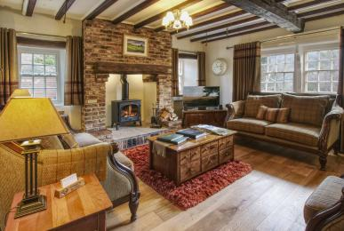
Inglenook Cottage, West Burton - lounge
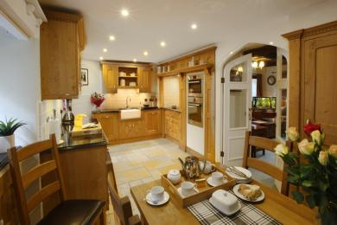
Inglenook Cottage, West Burton - kitchen
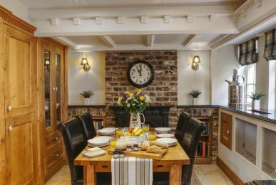
Inglenook Cottage, West Burton - dining area
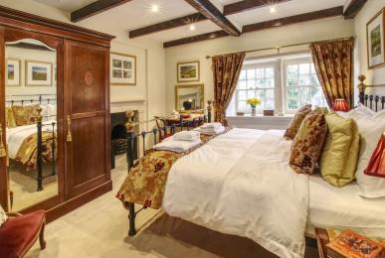
Inglenook Cottage, West Burton - master bedroom
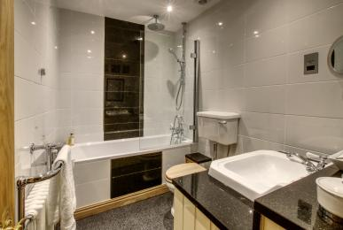
Inglenook Cottage, West Burton - bathroom
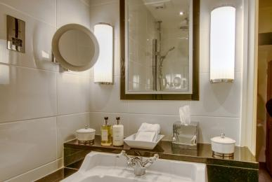
Inglenook Cottage, West Burton - bathroom sink area

Arrival

Path to main entrance
- From the street to the main entrance, there is level access.
- The path is 1500mm wide, or more.
- The path is sloped.

Main entrance
- The door is 900mm wide.
- The main entrance has 3 steps.
- This entrance has a handrail.
- The main door is side hung and manual.
- When you arrive, we can help carry your luggage.
- Most visitors use the rear door to access the cottage as it is immediately accessibe from the courtyard. The rear door opens outwards. There is a threshold step which immediately goes down 3 steps. A rail is available on the right hand side for guess to use which is accessible before starting to go down the steps.

Getting around inside

Visual Impairment - General Information
- We have high colour contrast between walls and doorframes.

Bedrooms
- All bedrooms have windows.
- Bedrooms have ceiling lights, bedside lamps and natural daylight.
- Lights are LED. TVs have subtitles.
- All bedrooms are non-smoking.
- We have non-allergic bedding.
- All bedrooms have fitted carpets.
- Guests may request, free of charge, non-allergenic bedlinen, which includes duvets and pillows and bedlinen which has been washed in non-bio washing powder. We guarantee no dogs have ever entered the cottage. Ecover cleaning products provided too.
- We can move the bedroom furniture, to improve accessibility.
- We have bed blocks.
- We have a portable hoist.
- The bedroom nearest the main entrance has 12 steps.
- We have bathrooms with a bath and overhead shower. The shower has a handrail.
- The toilets have handrails.
- The walls and the fittings have high colour contrast.
Inglenook Cottage - master bedroom

Self catering kitchen

Inglenook Cottage kitchen
- We have an open plan kitchen.
- From the main entrance to the kitchen, there are 3 steps. There is no lift and no ramp.
- The work surface is available at a height between 650mm and 900mm.
- The hob is available at a height between 650mm and 900mm.
- The sink is available at a height between 650mm and 900mm.
- The oven is available at a height between 650mm and 900mm.
- The table and plates have high colour contrast.
Inglenook Cottage, West Burton - kitchen
Inglenook Cottage, West Burton - dining area

Lounge

Inglenook Cottage lounge
- From the main entrance to the lounge, there are 3 steps. There is no lift and no ramp.
- There are 3 steps down from the rear entrance into the kitchen then a level area throughout the ground floor, which is a limestone floor in the kitchen and solid oak in the lounge and front hallway. There is also access from the front of the house up one step into the front hallway and then level access into the lounge.
Inglenook Cottage - lounge

Getting around outside

Lower patio area
- From the main entrance to the area, there are 4 steps.
- There are 4 steps from the courtyard up to the lower patio area, which is suitable for breakfast during the summer.

Garden & Upper Patio
- From the main entrance to the area, there are 12 steps.
- There are 12 steps, relatively steep upward to the elevated garden and upper patio. These steps are quite deep and there is no handrail, but a wall on either side to aid progression.

Customer care support

Accessibility equipment
- We provide wheelchairs. Wheelchairs are free.
- We have a hearing loop in Portable induction hearing loop can be used throughout the cottage and can be taken out and about during your stay. .
- A full list of accessible equipment is shown on our website and also available, on request, in our 'Accessible Luxury' brochure, which lists the equipment and shows the pictures too.
- For a list of more items, please go to https://www.cottageinthedales.co.uk/holiday-cottages/39/Accessibility.
- Assistance dogs are fully supported at our fully accessible cottage - The Dairy. The same support can be provided at Inglenook Cottage (which is unsuitable for wheelchairs). The nearest toilet area for assistance dogs is located in the courtyard adjacent to the house about 10 metres from the main entrance.
- We have an area to charge mobility scooters and battery powered wheelchairs.
- There is a chargine point in the courtyard which is secure but not covered.
- You can hire mobility equipment from Change Mobility in Harrogate by calling 01423 500666.

Emergency evacuation procedures
- We have emergency evacuation procedures for disabled visitors.
- The fire alarm has a vibrating pillow pad.
- The fire alarm has flashing lights.

Customer care support
- Some staff have disability awareness training.
- Staff are available 24 hours a day.
- The owners live in the next village, just 1 mile away. The caretaker lives on the edge of the village almost a mile away.
- We have other services for people with accessibility requirements.
- Full details are on our websit eon the accessibility page > https://www.cottageinthedales.co.uk/holiday-cottages/39/Accessibility
and also hardcopy by requesting a copy of our 'Accessible Luxury' brochure to be sent in the post to you.

Guide last updated: 18 January 2019

