Accessibility Guide for The Quarterdeck
enquiries@purbeckholidays.co.uk, 07976360139, www.purbeckholidays.co.uk
Contact for accessibility enquiries: Chris and Shona Radford
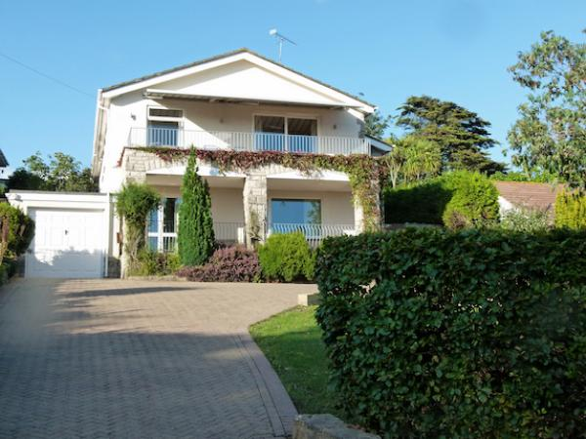

Welcome
The Quarterdeck is a spacious, modern family house, just 400m from Swanage beach, with views over the town and Swanage Bay. You will find the beach, shops and pubs are all nearby, while the immediate environment is quiet and green. The house is finished in a light, bright, modern and simple style. We have three double bedrooms plus a quad room, three bathrooms, and a large garden.
The house is built on a slope where the first floor at the front becomes the ground floor at the back, and living space is on the first floor. You can avoid steps to the first floor by walking up an external slope. Please see the floor plans included in the arrivals section of this guide for more detail.
Watch the video: Welcome to The Quarterdeck

At a Glance

Level Access
- The main entrance has 8 steps and a handrail. There is no lift and no ramp.
- There is level access from the main entrance to:
  - Hallway and stairs
  - Garden

Access with steps
- There are steps from the main entrance to:
  - Bedroom
  - Living room
  - Utility room

Bedrooms
- We have non-allergic bedding.

Getting here
26 Walrond Road
SWANAGE
BH19 1PD

Travel by public transport
- You can get to The Quarterdeck by bus.
- The main bus station terminus is beside Swanage Railway Station in Station Rd, Swanage BH19 1HB. There is also a request stop at Sandpit Field, 9 Shore Rd, Swanage BH19 1LA The bus stop is 0.5 miles / 0.8 km from The Quarterdeck.
- It's 0.5 miles from the bus terminus and slightly closer (0.4 miles) from the Sandpit Field request stop. The walk is uphill.

Travel by taxi
- You can get a taxi with Swanage Associated Taxis by calling 01929 421122 and 01929 425350. The taxi company has a wheelchair accessible vehicle.
- Trains to London and the North of England stop at Wareham which is 15 miles away and is connected by bus or taxi. There are very few taxis at Wareham so call Swanage Associated Taxis on 01929 421122 to pre-book.

Parking
- We have a car park. The parking is less than 50 metres from the main entrance. Parking is free.
- There is a drop-off point at the main entrance. The drop-off point has a dropped kerb.
- From the parking to the main entrance, there are 8 steps. There is no ramp and no lift.
- There is parking for 4 cars on a block-paving drive in front of the house. A car can be driven to within 4 metres of the bottom of the steps to the front door. The driveway starts at a slope angle of 10 degrees and then flattens off closer to the house. Note that the house is built on a slope and there are few truly level surfaces on the front driveway.
There are 8 steps (each is 155cm wide and 15cm high) from the driveway up to the front door. There is a handrail and a front door light with PIR sensor but there is no lighting on the driveway. You can also enter the house directly into the living areas without using the steps by going up a slope of approximately 10-15 degrees at the side of the house.

Arrival

Path to main entrance
- From the street to the main entrance, there are 8 steps. There is no ramp and no lift.
- The path is sloped.

Main entrance
- The door is 800mm wide.
- The main entrance has 8 steps.
- This entrance has a handrail.
- The main door is side hung and manual.
- Access without steps to the upper floor (living areas, master bedroom and 4th bedroom/games room) is available by going up a 15 degree slope to the right hand side of the house.
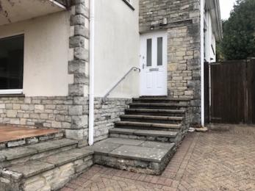
Eight steps leading up to front door with handrail on wall
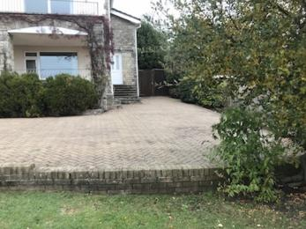
Parking space for four cars outside the front door on block paving
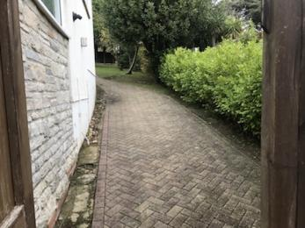
Access to the house back entrance avoiding steps up a slope on block paving
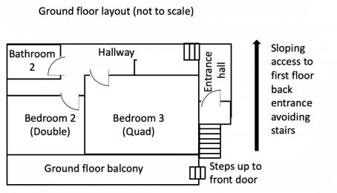
Layout of ground floor and external route to enter the house without steps. Not to scale
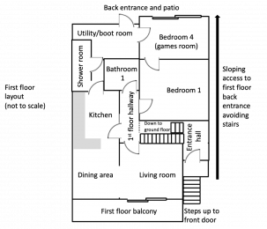
Layout of first floor and external route to enter the house without steps. Not to scale

Getting around inside

Bedrooms
- All bedrooms have windows.
- Bedrooms have ceiling lights, wall lights, bedside lamps and natural daylight.
- Lights are LED and energy saving. All bedrooms are non-smoking.
- We have non-allergic bedding.
- Some bedrooms have fitted carpets.
- The bedroom nearest the main entrance has 4 steps.
- We have bathrooms with a separate shower.
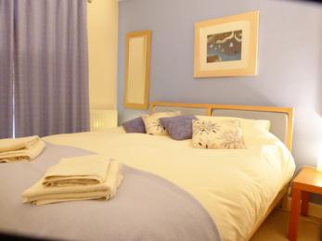
ground floor double bedroom showing kingsize bed
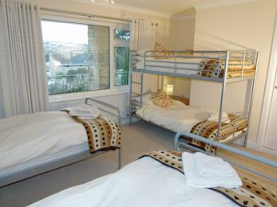
Ground floor quad bedroom with two single beds and one bunk bed suitable for adults
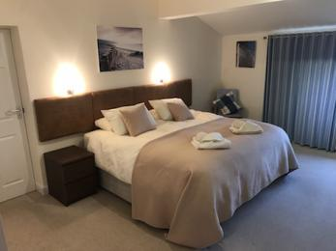
First floor double with super kingsize bed
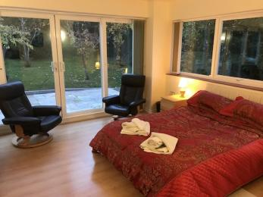
4th bedroom showing double bed, two easy chairs and patio doors
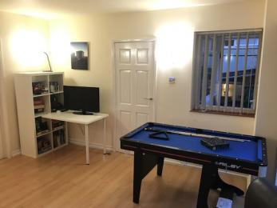
Pool table, TV and games selection in 4th bedroom
- We have bathrooms with a bath and overhead shower.

Self catering kitchen

The kitchen
- We have an open plan kitchen.
- From the main entrance to the kitchen, there are 12 steps. There is no lift and no ramp.
- The oven is available at a height between 650mm and 900mm.
- The table and plates have high colour contrast.
- Access without steps to the upper floor (all living areas, master bedroom and 4th bedroom/games room) is available by going up a 15-degree slope to the right-hand side of the house.
The kitchen is open plan with the dining room and is accessed from upstairs landing through a door with 770mm clearance. There are double aspect windows and lots of natural light.. The area is well lit with 12*50W halogen and 2 wall lights.
Kitchen area
- Worktop height 93cm
- Oven door is drop down - lowest oven shelf is 65cm above floor.
- Flooring is high grade laminate wood effect surface.
- Large (90cm wide) American style double-door fridge and freezer.
- Ceramic cooking hob (93cm high) uses touch sensitive controls.
- Waste bin and recycling bins are freestanding in the kitchen.
- Sink is 1.5 bowl type with draining area and single lever controlled mixer tap.
- Waste disposal unit in the sink with switch at 300mm above floor level.
Dining area
- Dining table is extendable 220/260cm long*100cm wide *75cm high. There is 650mm clearance under the table top.
- 10 high back leather dining chairs (all moveable).
- 750mm clearance to move around the dining table.
- Dining area opens out to the living room.
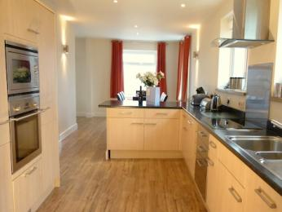
view of kitchen showing sink, oven and work surfaces through to open plan dining room
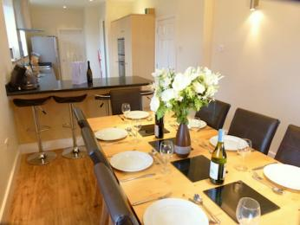
View from dining room to kitchen showing table laid for 10

Lounge

Living room
- From the main entrance to the lounge, there are 12 steps. There is no lift and no ramp.
- Access without steps to the upper floor (all living areas, master bedroom and 4th bedroom/games room) is available by going up a 15-degree slope to the right-hand side of the house.
The room is accessed from upstairs landing through a door with 770mm clearance, and has open plan access onto the dining area (see kitchen/dining area notes).
- Flooring is laminate wood effect with large rug.
- Freeview TV, DVD, Video with remote controls.
- 3 triple seat leather sofas (seat height 400mm).
- Patio door access to balcony (1000mm opening, 80mm threshhold).
- Triple aspect windows with views to town, hills and Swanage bay.
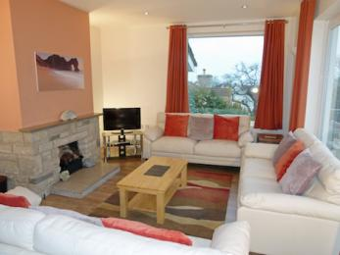
Living room with three 3-seater sofas and coffee tables

Utility room
- From the main entrance to this area, there are 12 steps. There is no lift and no ramp.
- Access without steps to the upper floor (living areas, utility room, master bedroom and 4th bedroom/games room) is available by going up a 15-degree slope to the right-hand side of the house.
- The utility room has a washing machine and tumble dryer. (The dryer is on a shelf directly above the washing machine, with controls at 1760mm height), a clothes drying rack, and a large cupboard containing ironing board and iron and cleaning equipment.
- Utility room is well lit with 4 * 50W halogen bulbs.
- The door between the kitchen and utility room has 670mm clearance.

Bathrooms and shower room
- Access without steps to the upper floor bathroom and shower room is available by going up a 15-degree slope to the right-hand side of the house.
There are two bathrooms and a shower room. All bathrooms and WCs are shared
First-floor bathroom is 2200*1800mm and the floor space after fittings is 1500*1400mm:
- Door width 780mm.
- The toilet seat is 460mm above the floor.
- The washbasin is 840mm high.
- The bath has an electric shower over and shower screen. Bath rim height is 600mm.
- 100% tiled surfaces.
- Heated towel rail.
- Underfloor heating.
Ground floor bathroom is 1900*1600mm and the floor space after fittings 1200*1200mm:
- Door width 620mm.
- The toilet seat is 460mm above the floor.
- the washbasin is 840mm high.
- The bath has an electric shower over and shower screen. Bath rim height is 600mm.
- 100% tiled surfaces.
- Heated towel rail.
- Underfloor heating.
Shower room with WC reached from first-floor utility room with 670mm access door and restricted space:
- The access door opens outwards into the utility room.
- The shower room is 2800mm long and 700mm wide, with 350mm width clearance at the narrowest point between the basin and radiator.
- The room contains a large walk-in shower (950mm by 800mm) with a 70mm rim height step to get in. There is also a washbasin and toilet.
- Although the shower is large, the space overall is quite tight. The toilet in the upstairs bathroom is easier to access.
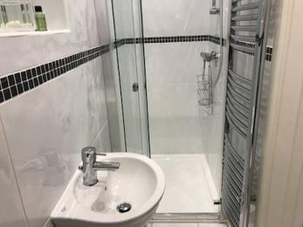
First floor shower room showing shower and distance between basin and radiator
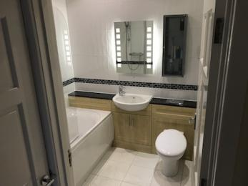
First floor bathroom showing power shower over bath
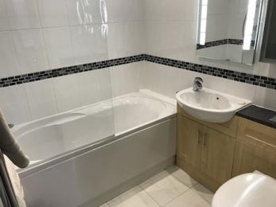
Ground floor bathroom showing power shower over bath

Hallway and stairs
- From the main entrance to this area, there is level access. The route is 1500mm wide, or more.
- The front door opens into entrance hall (3000mm* 1400mm). From here you can go:
- 12 steps up (each one 840*160*260mm) with handrail to first floor where all the living space is situated.
- 5 stairs down (each one 900*160*260mm) with no handrail to the ground floor where there are two bedrooms and a bathroom.
- There are no steps or obstacles in moving between rooms on the same floor level, but there is a 70mm high threshold whenever you step outside.
First floor layout
- The first-floor landing is 4500mm *1050mm and leads directly to the living room, dining room, kitchen, bathroom, and main bedroom.
- The utility room is on the same floor and reached through the kitchen. Access to the back garden it through the utility room.
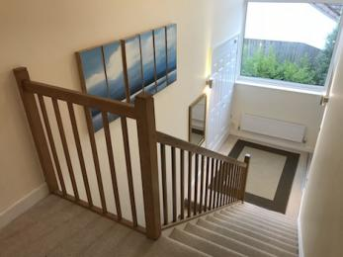
View from first floor showing 12 stairs down to main hallway and further 4 steps to ground floor

Getting around outside

Garden
- From the main entrance to this area, there is level access. The entrance is 830mm wide.
- The rear garden has a large level patio area reached from the utility room or games room, with three steps up from the patio to the garden beyond.
There is a large garden on a sloping site (the slope is approximately 10-15 degrees). There are lots of natural features such as trees, bushes, paving slabs, steps etc.
The rear garden has gates which can be closed to prevent toddlers escaping to the front. But please note it is a natural garden with natural hazards for toddlers.
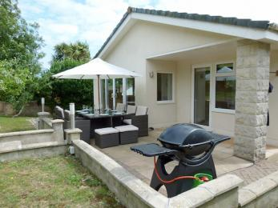
Rear patio with gas barbecue and patio table with 6 chairs and 4 stools

Customer care support

Accessibility equipment
- Information folder in the house is printed in 10 font Arial text.
Light switches are all at 140cm off the floor
There is good mobile phone reception, and a landline phone where you can make local calls and receive calls. The phone number at the house is 01929 423 504
The beach is 300m away, downhill from the house. There is disabled permit parking on the seafront.
- You can hire mobility equipment from Purbeck Mobility (purbeckmobility.com) by calling 01929 552623.

Guide last updated: 18 October 2019

