Accessibility Guide for Delamere Forest
delamere@forestryengland.uk, 0300 067 4340, https://www.forestryengland.uk/delamere-forest
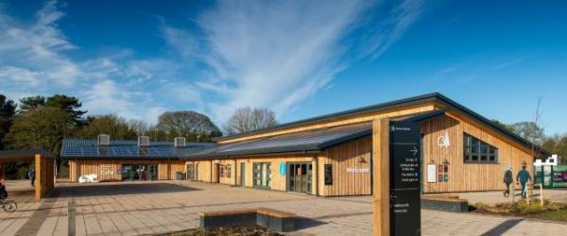

Welcome
Delamere Forest is a place to let off steam, explore nature and find peace in the heart of Cheshire's largest forest.
Accessible by its very own train station, you’ll find plenty of gentle, easy-going trails for all abilities, views across to the seven surrounding counties from the top of Old Pale, orienteering courses as well as plenty of peace and quiet to watch the wildlife by Blakemere Moss.
If you'd rather get up into the tree canopy, head up high on a Treetop Adventure at Go Ape, who also offer Segway tours, too! Or hire bikes at the Delamere Forest Bike Hire to explore the trails on wheels. And be sure to check out Delamere Forest Cafe for a well-deserved rest and a range of food and drink.

At a Glance

Level Access
- There is level access from the main entrance to:
  - Dining Table
  - Delamere Forest Visitor Welcome
  - Visitor Centre Toilets
  - Delamere Forest Bike Hire
  - Access to Go Ape cabin

Hearing
- The fire alarm has flashing lights.
- We have a hearing loop in Delamere Forest Visitor Welcome.

Visual
- Glass doors and full-height windows have contrast markings.

Getting here
Delamere Forest
Northwich
CW8 2HZ

Travel by public transport
- You can get to Delamere Forest by train.
- The nearest train station is Delamere. The train station is 0.5 miles / 0.8 km from Delamere Forest.
- Delamere railway station is on the mid-Cheshire line between Manchester and Chester.

Travel by taxi
- You can get a taxi with Club Class (Northwich) by calling 01606 46666.

Parking
- We have a car park. There are accessible parking spaces. Parking is not free.
- There is a drop-off point at the main entrance. The drop-off point has a dropped kerb.
- From the car park to the entrance, there is level access. The route is 2400mm wide, or more.

Arrival

Path to main entrance
- From the street to the main entrance, there is level access.
- The path is 2400mm wide, or more.

Main entrance
- The main entrance has level access.
- The door is 2200mm wide.
- The main door is side hung and manual.
- The main door is side hung and automatic.
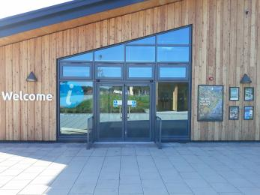
Main entrance

Getting around inside

Visual Impairment - General Information
- We have contrast markings on all glass doors and contrast markings on all full-height windows.

Ticket/ information desk

Delamere Forest Visitor Welcome
- From the main entrance to the desk, there is level access. The desk has a low section.

Public toilet

Visitor Centre Toilets
- There is a public toilet for disabled visitors.
- The toilet is a Changing Places toilet.
- From the main entrance to the public toilet, there is level access. The route is 2400mm wide, or more.
- The toilet door is 1800mm wide.
- The direction of transfer onto the toilet is to the right.
- There is 1100mm at the side of the toilet. There is 2300mm in front of the toilet. The toilet seat is 450mm high. The toilets have handrails.
- The toilet is around 80m from the car park
The toilet is fitted with an emergency cord which hangs from the ceiling to the floor. This is located next to the toilet.
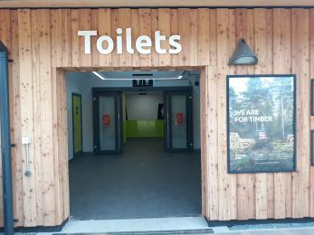
Main Entrance
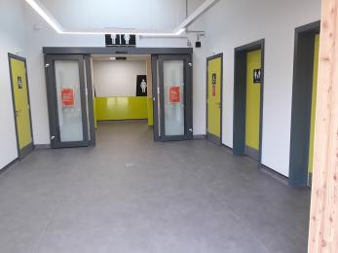
Lobby Area
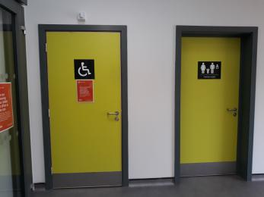
Accessible toilet door
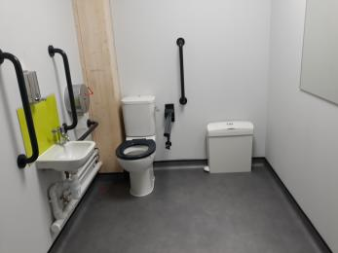
Accessible toilet
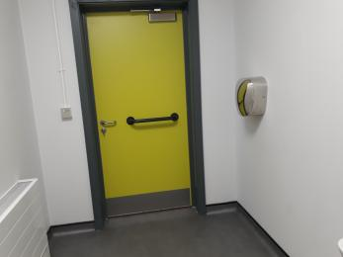
Accessible toilet

Place to eat and drink

Delamere Forest Cafe
- From the main entrance to the dining area, there is level access. The route is 2400mm wide, or more. The door is 1700mm wide.
- To get to a table, there are no steps.
- If you need table service, staff can help you.
- The route through the dining area is 800mm wide, or more.
- There is background music sometimes.
- We cater for sugar free (diabetic), vegetarian, gluten free (celiacs), lactose free (dairy free) and low fat specific diets.

Delamere Forest Bike Hire
- From the main entrance to this area, there is level access. The route is 2400mm wide, or more.
- The door is 800mm wide.
- There is an decline to access the Bike Hire along a tar spray and chip surfaced path.
Large changing room.
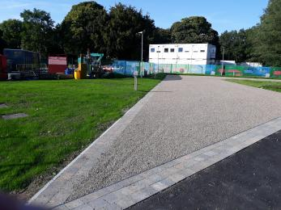
Access path from car park
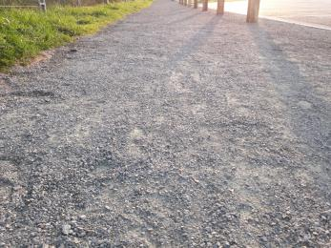
Example tar spray and chip
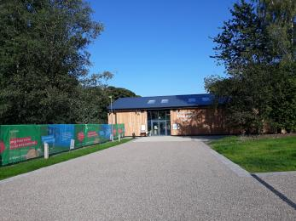
Access path to Cycle Hire

Getting around outside

Designated Walking Trail
- The trail has a hard surface. The trail is sloped. The trail has seats.
- Waymarked trails within Delamere Forest are generally flat and even with no stiles or steps.
There are some inclines/declines throughout the forest.
The surface is generally a compact hardcore surface of stone and MOT. Some trails get leaf-littered during winter months and wet/muddy during periods of rain.

Picnic Area

Throughout the Forest including some with picnic benches
- Some tables have space for wheelchair users. You can bring your own food to the picnic area.
- A number of picnic benches are located around the Visitor Centre, several of which have space for wheelchair use.
There are also a number of benches and picnic benches throughout the forest.

Access to Go Ape cabin
- From the main entrance to this area, there is level access.
- The Go Ape cabin is approximately 420m from the accessible parking spaces. There is a variety of different terrain including tarmac, tar spray and chip and stone paths. There are some inclines and declines inlcuding a railway bridge crossing. You need to walk a short distance along a quiet access road.
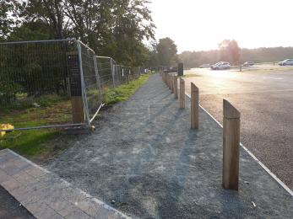
Tar spray and chip path along car park
Example tar spray and chip surfacing
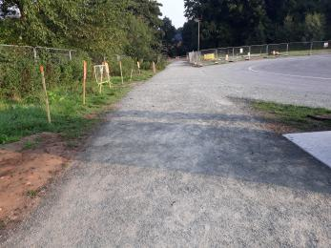
Tar spray and chip path leading to access road
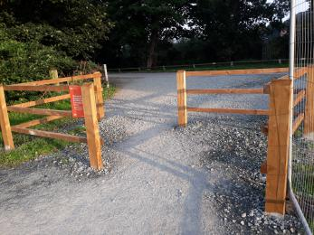
Chicane crossing to access road
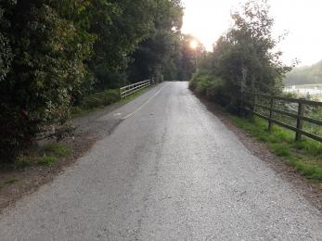
Incline along access road
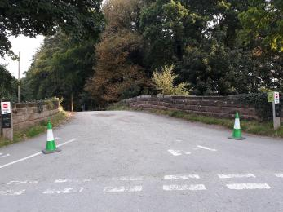
Railway bridge crossing
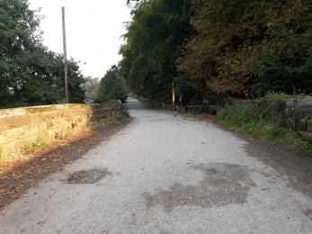
Railway bridge crossing
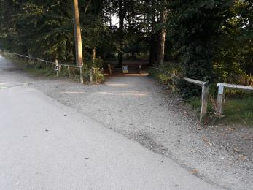
Start of stone surfaced path
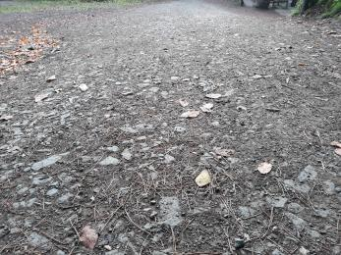
Example stone surface path
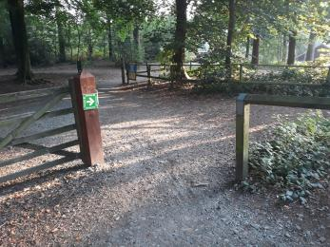
Access alongside gate
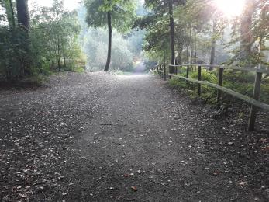
Stone surface path
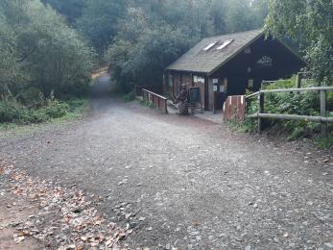
Decline to Go Ape cabin
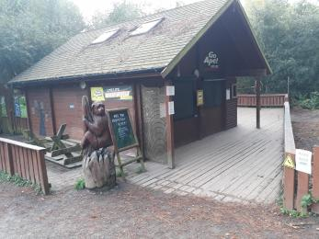
Access to Go Ape cabin

Customer care support

Accessibility equipment
- We have a hearing loop in Delamere Forest Visitor Welcome.

Emergency evacuation procedures
- We have emergency evacuation procedures for disabled visitors.
- The fire alarm has flashing lights.

Guide last updated: 5 July 2023

