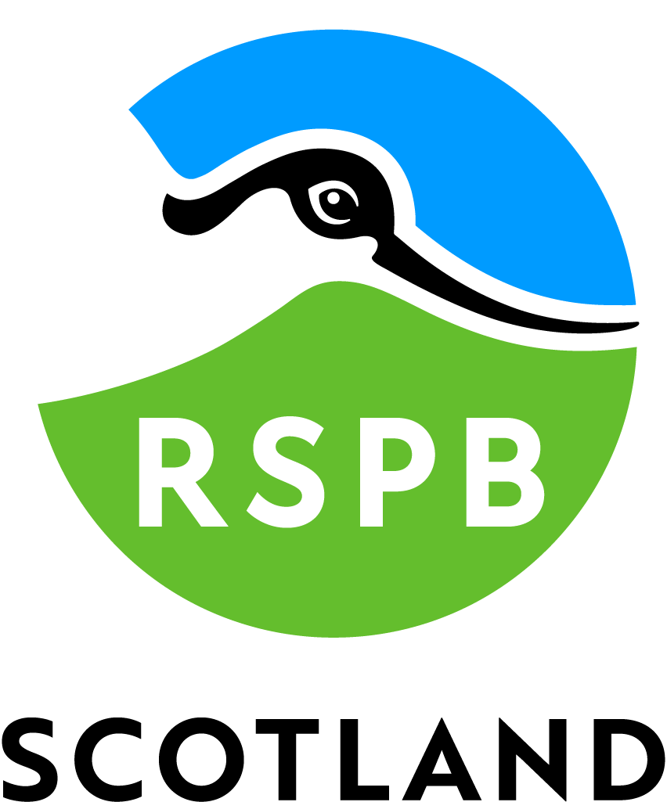

Accessibility Guide for RSPB Scotland Mersehead
mersehead@rspb.org.uk, 01384 780 579, https://www.rspb.org.uk/reserves-and-events/reserves-a-z/mersehead/
Contact for accessibility enquiries: Call 01387 780 579 and ask for a member of staff who will help you with your enquiry.
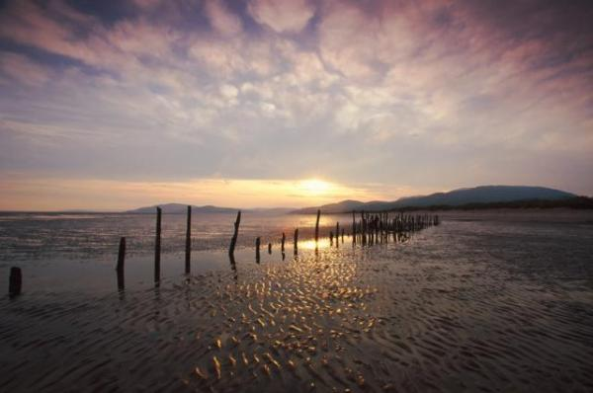

Welcome
Mersehead is a real Solway gem in Dumfries & Galloway, situated 18 miles from Dumfries. This working farm boasts a wide variety of habitats in breath-taking surroundings, with wild barnacle geese in autumn/winter and lapwings and natterjacks toads in the spring/summer. It's a stunning example of freshwater wetland habitats, set beside wide expanses of intertidal sand and mudflats, woodland, saltmarsh, farmland and a fabulous beach. A great place for wheelchair access, to wetland hides and towards the beach (just beyond sand dunes).
Read more at https://www.rspb.org.uk/reserves-and-events/reserves-a-z/mersehead/#XG65...
Watch the video: A short film about disabled access at the RSPB's Mersehead

At a Glance

Level Access
- There is level access from the main entrance to:
  - Dining Table
  - Visitor Centre Information Desk
  - Visitor Toilets
  - Two Bird Hides
  - Sulwath Garden
- There is level access from the car park to:
  - Beach
  - Car Park Picnic Area
- The hide entrance has level access.

General
- There is at least 1 public toilet for disabled visitors.

Getting here
RSPB Mersehead
Southwick
Dumfries
DG2 8AH

Travel by public transport
- You can get to RSPB Scotland Mersehead by bus and train.
- The nearest bus stop is at Caulkerbush (Southwick) approximately 1 mile from the visitor centre. Bus 372 Dumfries-Dalbeattie approximately every two hours. Visit the Dumfries & Galloway website for timetable information http://www.dumgal.gov.uk/timetableswebsite The bus stop is 1.0 miles / 1.6 km from RSPB Scotland Mersehead.
- The nearest train station is Dumfries. The train station is 17 miles / 27.4 km from RSPB Scotland Mersehead.
- There are regular trains to Dumfries, however to continue to the reserve on public transport a bus and short walk will be required.

Travel by taxi
- We have a transfer service for visitors. Wheelchair users can use the transfer service.

Parking
- We have a car park. There are accessible parking spaces. The parking is less than 50 metres from the main entrance. Parking is not free.
- There is a drop-off point at the main entrance. The drop-off point does not have a dropped kerb.
- From the car park to the entrance, there is level access. The route is 3000mm wide, or more.
- There is no car park fee for RSPB Memebers
Non-RSPB member costs are £3 per car to park
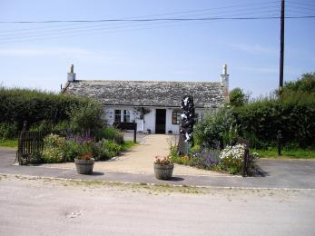
View from the carpark to the Visitor Centre

Arrival

Path to main entrance
- From the street to the main entrance, there is level access.
- The path is 3000mm wide, or more.

Main entrance
- The door is 762mm wide.
- The main entrance has 0 steps.
- The main door is side hung and manual.
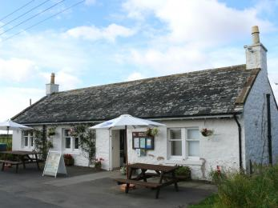
View of visitor centre entrance

Getting around inside

Ticket/ information desk

Visitor Centre Information Desk
- From the main entrance to the desk, there is level access. The route is 3000mm wide, or more.
- Desk is low enough to interface with wheelchair users

Public toilet

Visitor Toilets
- There is a public toilet for disabled visitors.
- From the main entrance to the public toilet, there is level access. The route is 762mm wide, or more.
- The toilet door is 962mm wide.
- The direction of transfer onto the toilet is to the right.
- There is 1500mm at the side of the toilet. There is 1500mm in front of the toilet. The toilets have handrails.
- Disabled toilet has been built to meet standards required under UK Equality Act

Place to eat and drink

Cafe Lite
- From the main entrance to the dining area, there is level access. The route is 1500mm wide, or more. The door is 1500mm wide.
- To get to a table, there are no steps.
- The dining area is self-service. If you need table service, staff can help you.
- The route through the dining area is 800mm wide, or more.
- There is no background music.
- The table and plates have high colour contrast.
- The self-service cafe area only offers a very limited range of packaged snacks, hot drinks and free tap water.

Two Bird Hides
- From the main entrance to this area, there is level access. There is a permanent ramp. The route is 762mm wide, or more.
- The door is 800mm wide.
- Two hides with step-free, ramped access on Wetland Trail.
Blue Badge parking bays 400 m from hides

Getting around outside

Designated Walking Trail

Wetland Trail
- The trail is 3600metres long. The trail has a hard surface. The trail is sloped. The trail has seats. There are bird hides along the trail.

Designated Walking Trail

Coastal Trail
- The trail is 5000metres long. Some of the trail has a loose surface. Trail follows 1000m of shoreline of essentially soft sand and crosses two points of sand-dunes. A further 1600m follows a rout along an earth/grass path and farm track, not accessible by standard wheelchairs. The trail is sloped.
- Access to the beach area is passable by wheelchair (on clockwise route of this circular trail) but crossing the sand-dune threshold would be difficult by wheelchair iff unassisted. The solid surfaced path stops short of sand-dunes but beyonmd this point consists of softer sand.

Bruaich Hide
- At the hide entrance, there is level access. The door is 800.00mm wide.
- There are low windows in the hide, so wheelchair users can see outside.

Meida Hide
- At the hide entrance, there is level access. There is a permanent ramp. The door is 800.00mm wide.
- There are low windows in the hide, so wheelchair users can see outside.

Beach
- The beach access point is 500.00meters from the nearest car park.
- From the nearest car park to the beach, there is level access. The path is 3000mm wide, or more.
- The entrance is 3000mm wide.
- Access to the beach area is passable by wheelchair but crossing the sand-dune threshold would be difficult by wheelchair iff unassisted. The solid surfaced path stops short of sand-dunes but beyonmd this point consists of softer sand.

Picnic Area

Car Park Picnic Area
- From the car park to the picnic area, there is level access. The path is 5000mm wide, or more.
- The entrance is 5000mm wide.
- Some tables have space for wheelchair users. You can bring your own food to the picnic area.
- A single wheelchair friendly picnic table is available and two more picnic tables (non-wheelchair compliant)

Sulwath Garden
- From the main entrance to this area, there is level access. There is a permanent ramp. The route is 1500mm wide, or more. The entrance is 1500mm wide.
- Beyond the gate into garden area, there are no further gates but a series of grass mowed paths which may be difficult to access by wheelchair, without assistance.

Customer care support

Guide last updated: 20 December 2022

