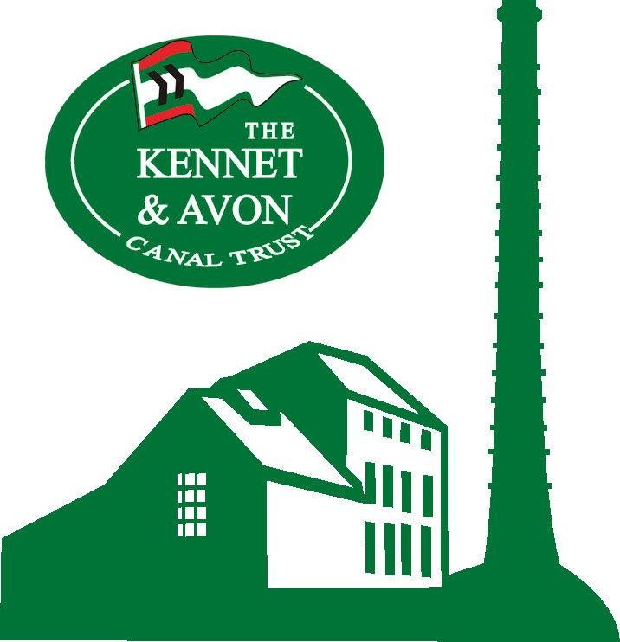

Accessibility Guide for Crofton Beam Engines
crofton@katrust.org.uk, 01672 870300, www.croftonbeamengines.org
Contact for accessibility enquiries: Pam Weeks
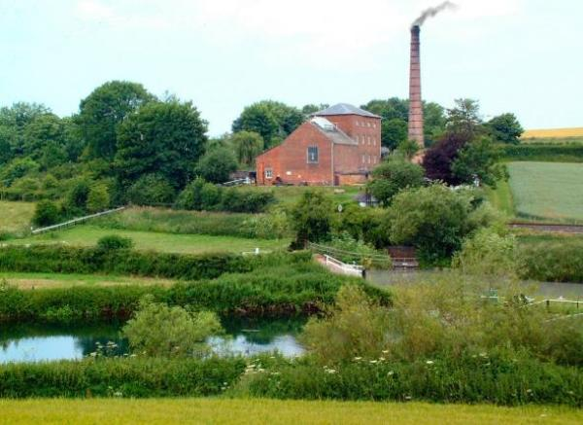

Welcome
Grade 1 listed industrial heritage visitor attraction open to the public April to October, Crofton Pumping Station was built in 1807-9 to supply water to the highest point of the Kennet & Avon Canal. It has recently undergone Heritage Lottery Fund supported conservation and visitor facility improvement work and is the home of the oldest working steam engine in the world still in its original location and capable of performing its original task. A triumph of the Volunteer Preservation movement, the Trust bought the redundant pumping station for preservation in 1968 and by 1971 both engines had been restored to full working order. Car Park. Toilets.
Watch the video: Introduction to Crofton Beam Engines - Phil Harding

At a Glance

Level Access
- The main entrance has level access with a ramp. The ramp is permanent.
- There is level access from the main entrance to:
  - Boiler House
  - Boiler House Admissions Desk
  - Accessible Toilets
  - Crofton Grounds
  - Grounds and Picnic Area

Access with steps
- There are steps from the car park to:
Old Smithy Picnic Area

General
- We have a complimentary ticket policy for personal assistants.
- There is at least 1 public toilet for disabled visitors.
- Some staff have disability awareness training.

Getting here
Crofton
Marlborough
SN8 3DW

Travel by public transport
- You can get to Crofton Beam Engines by train.
- The nearest train station is Bedwyn. The train station is 1.5 miles / 2.4 km from Crofton Beam Engines.
- Bedwyn Station approx 1.5 miles away, access from there by either road or the canal towpath (the towpath may not be suitable for those with mobility access needs)

Parking
- We have a car park. There are accessible parking spaces. The parking is less than 50 metres from the main entrance. Parking is not free.
- There is a drop-off point at the main entrance. The drop-off point has a dropped kerb.
- From the car park to the entrance, there is level access. There is a permanent ramp.
- The path is sloped.
- The route is 1000mm wide, or more.
- Car park has two designated accessible spaces. Access to the main entrance is across the road to the main gate and down the slope to the Engine House. The gradient of the slope may not be suitable for some wheelchair users and / or their companions / carers. Please call for more information if required. There is also a second entrance from the canal towpath via a flight of 30 external steps; this not suitable for wheelchair users.
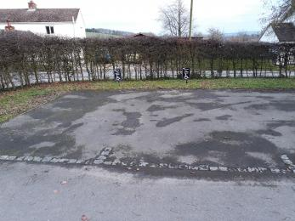
Accessible Parking Spaces
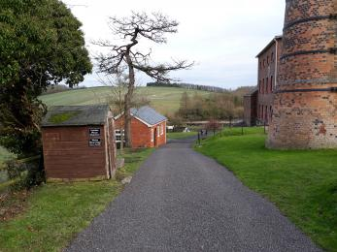
Main Path down to Entrance

Arrival

Path to main entrance
- From the street to the main entrance, there is level access.
- There is a permanent ramp.
- The path is 1000mm wide, or more.
- The path is sloped.

Main entrance
- The main entrance has level access.
- There is a permanent ramp.
- The door is 1300mm wide.
- Entry is through doors at the Boiler House. There is step-free access from the car park, but down a slope that may not be suitable for some wheelchair users, their carers, and those of limited mobility. Entry is level through to the Boiler House.
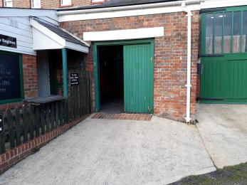
Boiler House Entrance

Getting around inside

Ticket/ information desk

Boiler House Admissions Desk
- From the main entrance to the desk, there is level access.

Things to See and Do
- We have a complimentary ticket policy for personal assistants.

Boiler House
- From the main entrance to this area, there is level access. Some display information is low, for wheelchair users.
- The Ground Floor Boiler House is accessible to wheelchair users and there is step free access. There is no step-free access to two uppermost levels in the Engine House.

Public toilet

Accessible Toilets
- There is a public toilet for disabled visitors.
- From the main entrance to the public toilet, there is level access. The direction of transfer onto the toilet is to the right.
- There is 2000mm at the side of the toilet. There is 2000mm in front of the toilet. The toilet seat is 500mm high. The toilets have handrails.
- Fully accessible unisex toilet newly opened August 2018 to full accessible standards.
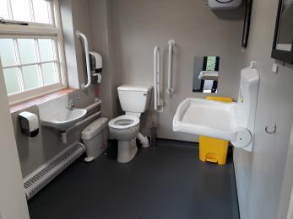
Unisex Accessible Toilet

Getting around outside

Crofton Grounds
- From the main entrance to the gardens, there is level access.
- The route is sloped. The route is 2000mm wide, or more.
- Various parts of the grounds are accessible but some of the lawned areas are on slopes and assistance may be needed.

Picnic Area

Old Smithy Picnic Area
- From the car park to the picnic area, there are 10 steps. There is no lift and no ramp.
- You can bring your own food to the picnic area.
- Picnic area is accessible to wheelchair users with assistance, the ground slopes in parts.

Grounds and Picnic Area
- From the main entrance to this area, there is level access.
- There is access to the grounds and picnic area but this does involve a slope from the entrance and then a slope over grass. These may not be suitable for wheelchair users, those with visual impairments or mobility difficulties.

Customer care support

Emergency evacuation procedures
- We have emergency evacuation procedures for disabled visitors.

Customer care support
- Some staff have disability awareness training.
- We have other services for people with accessibility requirements.
- Modern unisex accessible toilet with baby changing.
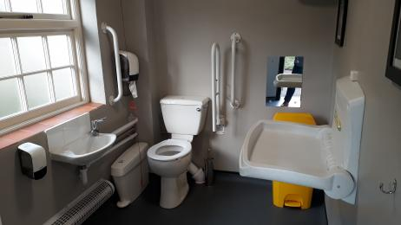
Accessible toilet and baby change

Guide last updated: 2 June 2022

