Accessibility Guide for Fern Cottage
enquiries@durhamcottages.com, 0191 372 1810 , www.durhamcottages.com
Contact for accessibility enquiries: Carol Woods
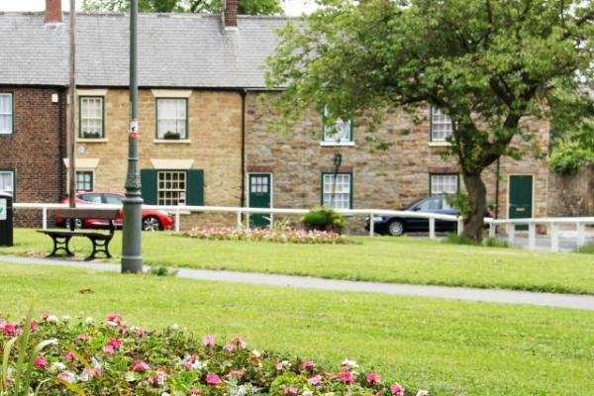

Welcome
Fern Cottage is a grade11 listed building, located on Gilesgate Green in Durham City. It is a well equipped self catering cottage suitable for 2 people. It is within 10 minutes walking distance of Durham City Centre. There are good local amenities, including a pub, supermarket, hairdresses, takeaway and 24hr garage all within a few minutes walk.
The cottage is arranged on two floors with a lounge/diner and kitchen on the ground floor and a bedroom, bathroom and small landing upstiars
Free WiFi is available

At a Glance

Level Access
- The main entrance has 1 step. There is no lift and no ramp.

Access with steps
- There are steps from the main entrance to:
  - Bedroom
  - Fern Cottage lounge
  - Fern Cottage Courtyard

Bedrooms
- We have non-allergic bedding.

Hearing
- The (bedroom) TVs have subtitles.
- Some staff have disability awareness training.

General
- Some staff have disability awareness training.

Getting here
129 Gilesgate
Durham
Durham County
DH1 1QG

Travel by public transport
- You can get to Fern Cottage by bus and train.
- There is a bus stop on both sides of Gilesgate Green, approximately 250 meters from the cottage There is a regular bus service into Durham City Centre The bus stop is 0.1 miles / 0.2 km from Fern Cottage.
- The nearest train station is Durham. The train station is 1.3 miles / 2.1 km from Fern Cottage.
- It is about 25 minutes walk from Durham Station, but as Durham is a very hilly place this can be difficult with luggage, it is better to get a taxi. There is a taxi rank at the station and so you can usually get a taxi there.

Travel by taxi
- You can get a taxi with Pratts Taxis by calling 0191 466 1003. The taxi company has a wheelchair accessible vehicle.
- You can get a taxi with Sherburn Taxis by calling 0191 372 3388. The taxi company has a wheelchair accessible vehicle.

Parking
- There is parking near the venue. The parking is less than 50 metres from the main entrance. Parking is free.
- There is a drop-off point at the main entrance. The drop-off point does not have a dropped kerb.
- From the parking to the main entrance, there is 1 step. There is no ramp and no lift. There is a low curb from the road to the pavement.
Fern Cottage is in a Parking Permit area and we will provide you with a permit for the duration of your stay
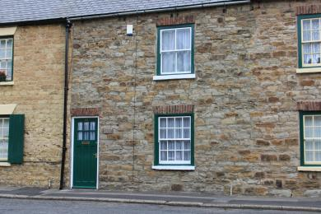
Fern Cottage entrance

Arrival

Path to main entrance
- From the street to the main entrance, there is level access.
- The path is 900mm wide, or more.

Main entrance
- The door is 800mm wide.
- The main entrance has 1 steps.
- The main door is side hung and manual.
- When you arrive, we can help carry your luggage.

Getting around inside

Bedrooms
- All bedrooms have windows.
- Bedrooms have ceiling lights, bedside lamps and natural daylight.
- Lights are LED and energy saving. TVs have subtitles.
- All bedrooms are non-smoking.
- We have non-allergic bedding.
- All bedrooms have fitted carpets.
- We can move the bedroom furniture, to improve accessibility.
- The bedroom nearest the main entrance has 12 steps.
- We have bathrooms with a bath and overhead shower. The shower has a handrail.
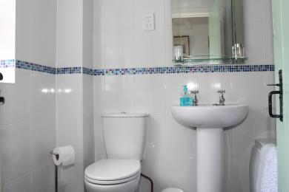
Fern Cottage bathroom
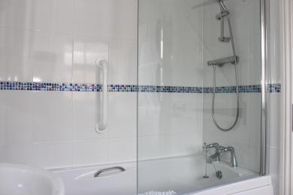
Fern Cottage bathroom
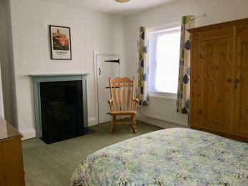
Fern Cottage bedroom
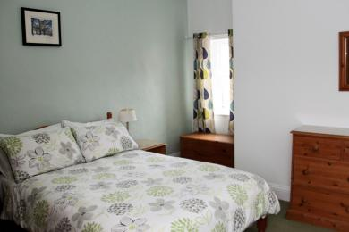
Fern Cottage bedroom

Self catering kitchen

Fern Cottage kitchen
- We have a separate kitchen and dining room. From the main entrance to the kitchen, there is level access.
- The route is 700mm wide, or more.
- The door is 700mm wide.
- The work surface is available at a height between 650mm and 900mm.
- The hob is available at a height between 650mm and 900mm.
- The sink is available at a height between 650mm and 900mm.
- The oven is available at a height between 650mm and 900mm.
- The table and plates have high colour contrast.
- From the main entrance to the dining room, there is level access. The route is 800mm wide, or more. The door is 700mm wide.
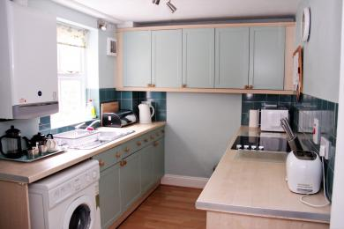
Fern Cottage kitchen

Lounge

Fern Cottage lounge
- From the main entrance to the lounge, there is 1 step. There is no lift and no ramp.
- Small step down on entrance to the house
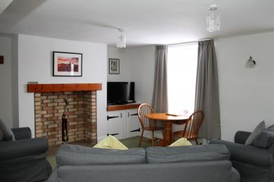
Fern Cottage lounge

Fern Cottage Courtyard
- From the main entrance to this area, there is 1 step. There is no lift and no ramp.
- Step down from back door into courtyard
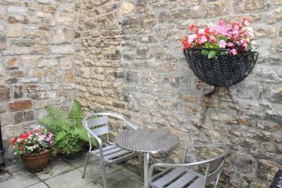
Fern Cottage courtyard

Getting around outside

Terrace

Fern Cottage Courtyard
- To get to a table, there are 1steps steps.
- It is only possible to access the courtyard via the back door of the property

Customer care support
- You can hire mobility equipment from Shopmobility Durham by calling 0191 386 8556.

Customer care support
- Some staff have disability awareness training.

Guide last updated: 16 December 2020

