Accessibility Guide for Abbots Court
01929 448638, https://www.abbots-court.co.uk
Contact for accessibility enquiries: Niki Barfoot
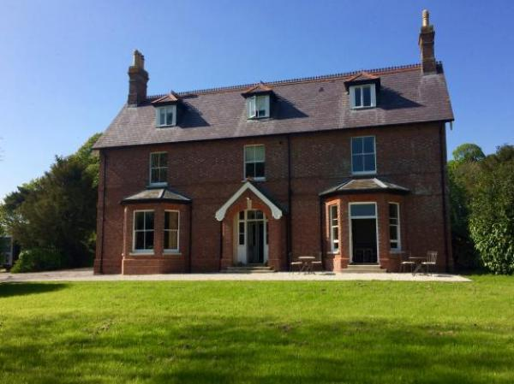

Welcome
Abbots Court is a perfect location for a relaxing short break, nestled in the heart of the Dorset countryside.
We want to make everyone’s stay as enjoyable as possible and we hope to provide suitable access for all our guests. We aim to accurately describe our facilities and services to give you the confidence to book with us and have an enjoyable stay.
Comfortable and elegant with country-chic décor, the uniquely designed rooms provide perfect views of the local countryside.

At a Glance

Level Access
- The main entrance has 3 steps. There is no lift and no ramp.
- There is level access from the main entrance to:
  - Bedroom: Old Spot
  - Dining Table
  - Abbots Court Lounge
  - Abbots Court Bar
  - Abbots Court WC
  - Abbots Court bar
  - Abbots Court Terrace

Bedrooms
- We have non-allergic bedding.

Level access bedrooms
- From the main entrance to the bedroom, there is level access.
- The route to the bedroom is 750mm wide, or more.
- The bedroom door is 750mm wide, or more.
- There is unobstructed floor space 1200mm by 900mm, or more.
- The bathroom has a level access shower.

Hearing
- The (bedroom) TVs have subtitles.
- Some staff have disability awareness training.

Visual
- The walls and the doors have high colour contrast.
- We have information in large print.

General
- Staff are available 24 hours a day.
- Some staff have disability awareness training.
- We have emergency evacuation procedures for disabled visitors.

Getting here
East Street
Winterborne Kingston
Blandford Forum
Dorset
DT11 9BH

Travel by public transport
- You can get to Abbots Court by bus.
- You can get to Abbots Court by bus. There are bus stops situated in the village with daytime services. Winterborne Kingston village hall for trips to Dorchester on the 187 bus route. Winterborne Kingston war memorial for trips to Blandford on the 187 bus route. The bus stop is 1.5 miles / 2.4 km from Abbots Court.
- Timetables can be viewed on Travelinesw.com or please ask our team for a timetable on arrival. The nearest train station is at Wareham.

Travel by taxi
- You can get a taxi with Kens Cabs Blandford by calling 01258 456136. The taxi company has a wheelchair accessible vehicle.

Parking
- We have a car park. There are accessible parking spaces. The parking is less than 50 metres from the main entrance. Parking is free.
- There is a drop-off point at the main entrance. The drop-off point has a dropped kerb.
- From the car park to the entrance, there is level access. There are several entrances to Abbots Court. The front door of the building has three steps.
One entrances is without steps and has only a threshold stone that is less than 10cm, a mat or board can be placed at this entrance to ease use.
There is accessible parking next to this entrance and additional wooden boarding can be placed over gravel to access this entrance.
From this entrance the there is level acces to the bar, restaurant, lounge, public WC and to the ground floor bedroom called 'Old Spot'.
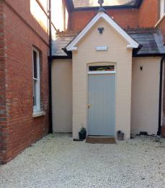
Abbots Court alternative main entrance
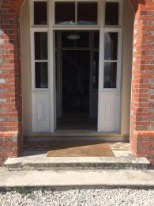
Abbots Court front door has 3 steps (an alternative main entrance is available)

Arrival

Path to main entrance
- From the street to the main entrance, there is level access.

Main entrance
- The main entrance has 3 steps.
- The main door is side hung and manual.
- The other entrance door is 840.00mm wide.
- An additional entrance is situated next the ground floor bedroom called 'Old Spot'.
- Guests can park next to this entrance for access through one level access doorway main entrance. The exterior ground cover is gravel (boards to cover the gravel are available to assist with firm ground access to this entrance).
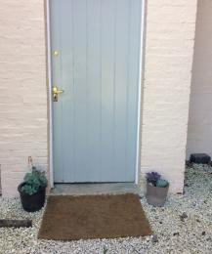
Threshold of entrance situated next to ground floor bedroom Old Spot

Getting around inside

Visual Impairment - General Information
- We have high colour contrast between walls and doorframes.

Bedrooms
- All bedrooms have windows.
- Bedrooms have ceiling lights, wall lights, bedside lamps and natural daylight.
- TVs have subtitles.
- All bedrooms are non-smoking.
- We have non-allergic bedding.
- All bedrooms have fitted carpets.
- We can move the bedroom furniture, to improve accessibility.
- From the main entrance to this area, there is level access.

Accessible bedrooms

Accessible bedroom Old Spot
- The bedroom door is 790mm wide. There is 1500mm at the side of the bed. The bed is 610mm high. The bedroom is double. The bathroom is ensuite. The bathroom door is 760mm wide.
- The bathroom has a separate shower. The bathroom has a level access shower. The direction of transfer onto the toilet is to the left and right. There is 620mm in front of the toilet. The toilet seat is 460mm high.
- The basin is 840mm high. There is no space under the basin.
- The bathroom has an emergency call system.
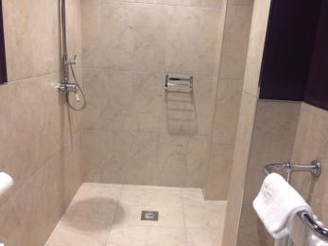
Old Spot shower room
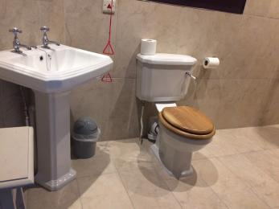
Old Spot shower room
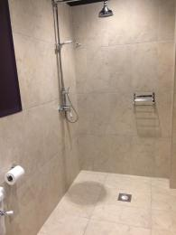
Old Spot shower room
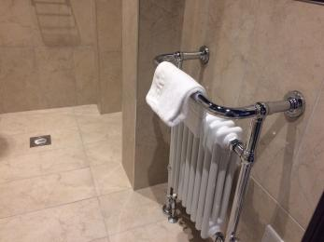
Old Spot shower room
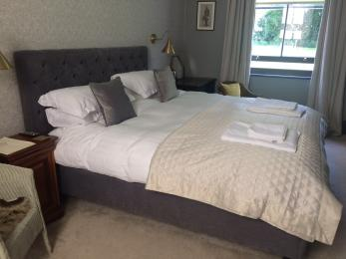
Old Spot ground floor bedroom
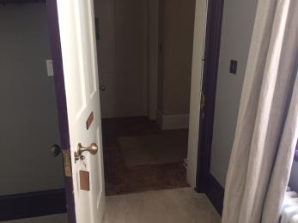
Old Spot ground floor bedroom entrance

Lounge

Abbots Court Lounge
- From the main entrance to the lounge, there is level access. The door is 870mm wide.
- There is a route from one of the main entrances that provides level access to the lounge.
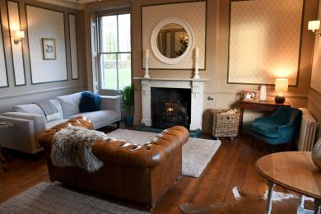
Abbots Court lounge
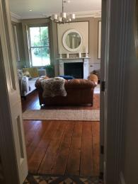
Lounge doorway

Bar

Abbots Court Bar
- From the main entrance to the bar, there is level access. The door is 840mm wide.
- There is a main entrance that provides level access to the bar.

Public toilet

Abbots Court WC
- From the main entrance to the public toilet, there is level access.

Place to eat and drink

Abbots Court Restaurant
- From the main entrance to the dining area, there is level access. To get to a table, there are no steps.
- The route through the dining area is 800mm wide, or more.
- There is background music.
- We cater for sugar free (diabetic), vegetarian, gluten free (celiacs), lactose free (dairy free), nut free, low fat, low sodium, high fibre and vegan specific diets.
- Please let us know at least 48 hours in advance of specific dietry requirements. Our chefs are happy to discuss this with you.
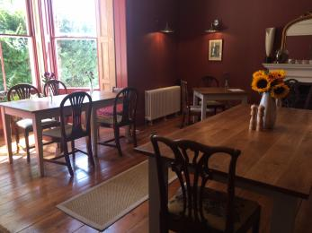
Abbots Court dining room
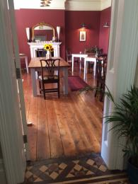
Abbots Court dining room door

Abbots Court bar
- From the main entrance to this area, there is level access. The door is 840mm wide.
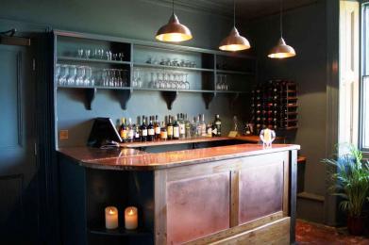
Abbots Court bar
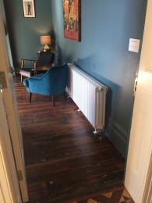
Abbots Court bar door

Getting around outside

Abbots Court Grounds and Walled Garden
- The grounds and walled garden have paths covered with gravel. Some parts of the garden are grassed and may have uneven surfaces.

Terrace

Abbots Court Terrace
- From the main entrance to this area, there is level access. To get to a table, there are no steps.
- There are tables and chairs on the terrace and the and the terrace can be accessed either by the main entrance (3 steps) or via an alternative entrance located on the other side of the building. The terrace has a gravel surface.

Customer care support

Accessibility equipment
- For a list of more items, please go to http://www.purbeckmobility.com.
- There are plentiful green spaces surrounding the farmhouse that assistance dogs are able to access.
- We have an area to charge mobility scooters and battery powered wheelchairs.
- You can hire mobility equipment from Purbeck Mobility Centre by calling 01929 552623.

Emergency evacuation procedures
- We have emergency evacuation procedures for disabled visitors.
- Should you require special assistance to evacuate the building in the event of the fire alarm sounding. Please make us aware upon booking or arrival so we can arrange for appropriate fire evacuation assistance to suit your needs.

Customer care support
- Some staff have disability awareness training.
- We have information in large print.
- Staff are available 24 hours a day.
- We have other services for people with accessibility requirements.
- A copy of the Accessible Purbeck Guide is available to read or download for information on things to see and do in the area.

Guide last updated: 18 January 2019

