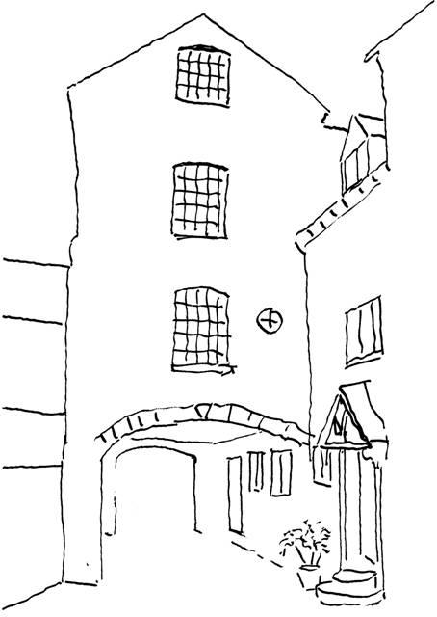

Accessibility Guide for Puddle Cottage
tredingtonmill@btinternet.com, 01608 664626, https://tredingtonmill.co.uk
Contact for accessibility enquiries: Jonathan and Sally Ward
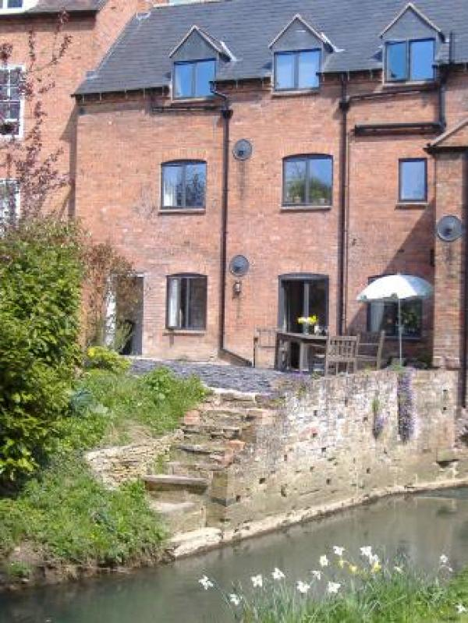

Welcome
Puddle Cottage is a terraced cottage set in the village of Tredington, Warwickshire. It is part of an 18th Century mill building and is in a conservation area. There is a parking area for one car and a garden at the rear of the house. We aim to meet the needs of all of our guests, however, due to the nature of the property this can make access for guests with limited mobility difficult and the house is unsuitable for wheelchair users.

At a Glance

Level Access
- The main entrance has 3 steps. There is no lift and no ramp.
- There is level access from the main entrance to:
  - Puddle Cottage Living Room

Bedrooms
- We have non-allergic bedding.

Hearing
- The (bedroom) TVs have subtitles.

Getting here
The Mill
Tredington
Shipston-on-Stour
Warwickshire
CV36 4NQ

Travel by public transport
- You can get to Puddle Cottage by bus.
- It is located in Tredington. They are mostly local buses, so getting here by bus would be a slow process. The bus stop is 0.3 miles / 0.5 km from Puddle Cottage.

Travel by taxi
- You can get a taxi with Shipston Taxis by calling 01608 661592.

Parking
- We have a car park. The parking is less than 50 metres from the main entrance. Parking is free.
- There is a drop-off point at the main entrance. The drop-off point has a dropped kerb.
- From the car park to the entrance, there is level access. The route is 3000mm wide, or more.
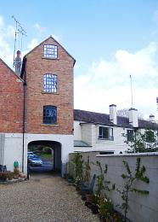
Access from parking area
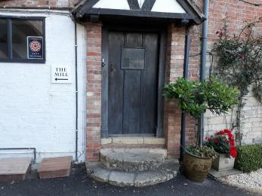
Main access from street

Arrival

Path to main entrance
- From the street to the main entrance, there is level access.
- The path is 3000mm wide, or more.

Main entrance
- The door is 740mm wide.
- The main entrance has 3 steps.
- The main door is side hung and manual.
- When you arrive, we can help carry your luggage.
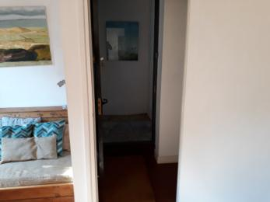
Door to living room with front door beyond

Getting around inside

Bedrooms
- All bedrooms have windows.
- Bedrooms have ceiling lights, bedside lamps and desk or table lamps.
- Lights are halogen, LED and energy saving. Some lights can be controlled independently.
- TVs have subtitles.
- All bedrooms are non-smoking.
- We have non-allergic bedding.
- Some bedrooms have fitted carpets.
- We have bathrooms with a separate shower.
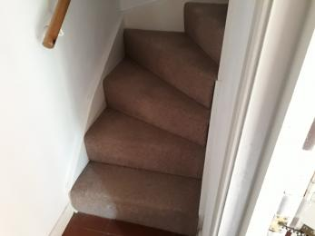
Staircase to first floor
- We have bathrooms with a bath and overhead shower.

Self catering kitchen

Puddle Cottage Kitchen
- We have an open plan kitchen.
- From the main entrance to the kitchen, there is level access.
- The route is 740mm wide, or more.
- The work surface is available at a height between 650mm and 900mm.
- The hob is available at a height between 650mm and 900mm.
- The sink is available at a height between 650mm and 900mm.
- The oven is available at a height between 650mm and 900mm.
- The table and plates have high colour contrast.

Lounge

Puddle Cottage Living Room
- From the main entrance to the lounge, there is level access.

Getting around outside

Terrace

Puddle Cottage Terrace
- To get to a table, there are 2steps steps.

Customer care support

Accessibility equipment
- We are not aware of such a facility
- You can hire mobility equipment from Shopmobility by calling 01789 414534.

Guide last updated: 19 March 2019

