Accessibility Guide for Kilbrannan Guest House
01493 850383,

Welcome
Gary & Julie welcome you to Kilbrannan Guest House. A 5 bedroom accommodation in the heart of Great Yarmouth.
All rooms are en-suite and an outstanding breakfast is included in the price.
Located within a 2 minute walk from the beach and a 5 minute walk from the town our home is perfect to explore most attractions, restaurants and bars easily on foot.

At a Glance

Level Access
- The main entrance has 1 step and a handrail. There is no lift and no ramp.
- There is level access from the main entrance to:
  - Dining Table

Access with steps
- There are steps from the main entrance to:
  - Bedroom
  - The patio

Bedrooms
- We have non-allergic bedding.

Hearing
- The (bedroom) TVs have subtitles.

Visual
- The menu is in The menu is also available in picture format..

General
- Staff are available 24 hours a day.
- We have emergency evacuation procedures for disabled visitors.

Getting here
14 Trafalgar Road
Great Yarmouth
Norfolk
NR302LD

Travel by public transport
- You can get to Kilbrannan Guest House by bus and train.
- The nearest bus stop is located in the town centre. A short walk along Trafalgar Road then through St. George's Park. The bus stops are just beyond the park exit The bus stop is 0.3 miles / 0.5 km from Kilbrannan Guest House.
- The nearest train station is Great Yarmouth Train Station. The train station is 1.2 miles / 1.9 km from Kilbrannan Guest House.
- By arrangement we can offer a free pick up service to and from the train station

Travel by taxi
- You can get a taxi with Anglia Taxis by calling 01493 855855.
- We have a transfer service for visitors. We only have a saloon car with no facility for a wheel chair

Parking
- There is parking near the venue. The parking is less than 50 metres from the main entrance. Parking is free.
- There is a drop-off point at the main entrance. The drop-off point does not have a dropped kerb.
- From the parking to the main entrance, there are 3 steps. There is no ramp and no lift.
- We have space for 1 or 2 vehicles on the side of the house and all othe parking is based within street bays for which we provide permits free of charge.

Arrival

Path to main entrance
- From the street to the main entrance, there is 1 step. There is no ramp and no lift.

Main entrance
- The door is 840mm wide.
- The main entrance has 1 steps.
- This entrance has a handrail.
- The main door is side hung and manual.
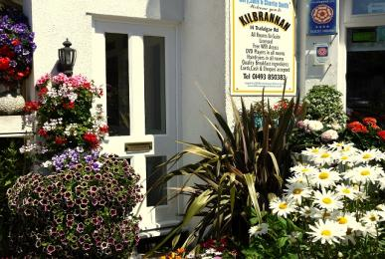
Front door with step. Grab handle is to the left

Getting around inside

Bedrooms
- All bedrooms have windows.
- Bedrooms have ceiling lights, wall lights, bedside lamps and natural daylight.
- Lights are LED, energy saving and traditional filament. TVs have subtitles.
- All bedrooms are non-smoking.
- We have non-allergic bedding.
- All bedrooms have fitted carpets.
- We can move the bedroom furniture, to improve accessibility.
- The bedroom nearest the main entrance has 11 steps.
- All bedrooms are ensuite.
- We have bathrooms with a separate shower.
- Some showers have a handrail.
- We have bathrooms with a bath and overhead shower. The shower has a handrail.
- We have bathrooms with a bath.
- The bath has a handrail. Some toilets have handrails.
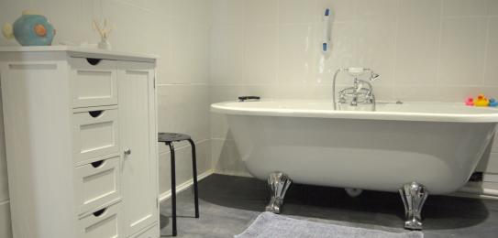
Roll top bath
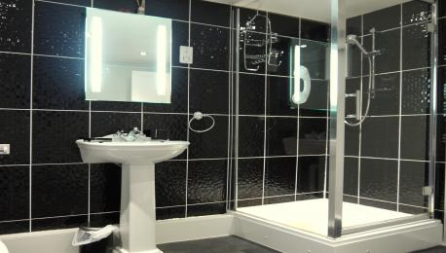
Separate walk in shower

Place to eat and drink

The dining room
- From the main entrance to the dining area, there is level access. The route is 950mm wide, or more. The door is 800mm wide.
- To get to a table, there are no steps.
- The menu is also available in picture format.
- If you need table service, staff can help you.
- There is background music.
- The table and plates have high colour contrast.
- We cater for sugar free (diabetic), vegetarian, gluten free (celiacs), lactose free (dairy free), nut free, low fat, low potassium, low sodium, no gastric content, high fibre, vegan, kosher and halal specific diets.
- Everything is cooked fresh and to order. We are happy to cater for all diets providing we are informed beforehand so that we can make sure we have the correct ingredients.
Example breakfast items
Example breakfast items 2

Getting around outside

Smoking

The patio
- From the main entrance to the smoking area, there is 1 step.
- We provide chairs and tables for all to use on the patio area. There is an ashtray located in the area
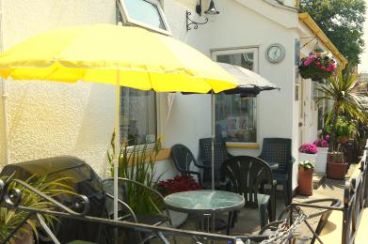
The patio area is on the side of the house close to the main entrance.

Customer care support

Accessibility equipment
- We have a large print information pack
- Assistance dogs can use the green across the road as a toilet area.
- We have an area to charge mobility scooters and battery powered wheelchairs.
- We have an area in the house where a battery can be charged and also an outside power point for fixed batteries. A mobility scooter can be covered and stored within the patio area.
- You can hire mobility equipment from Be Active by calling 01493 444348.

Emergency evacuation procedures
- We have a current fire alarm system which is professionally maintained regularly. Evacuation procedures are in place for all guests but we don't have procedures for the safe exit of disabled visitors. We also don't currently have emergency call systems with vibrating pads or flashing lights.

Customer care support
- Staff are available 24 hours a day.
- Gary and Julie both live in the house and are available at all times either in person or via a contact number.
- We have other services for people with accessibility requirements.
- We can provide transport to and from all local attractions via pre arrangement..

Guide last updated: 18 January 2019

