Accessibility Guide for West View B&B
enquiries@west-view.co.uk, 01507327209, www.west-view.co.uk
Contact for accessibility enquiries: Richard Nicholson
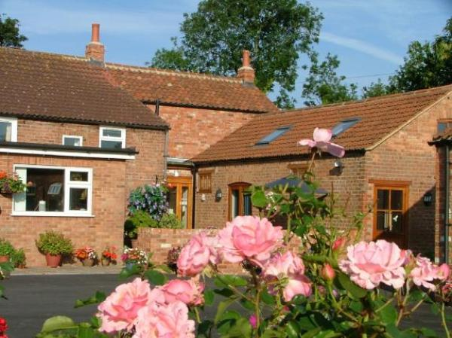

Welcome

At a Glance

Level Access
- There is level access from the main entrance to:
  - Dining Table
  - Patio

Visual
- Some parts of the venue have low lighting.

General
- Staff are available 24 hours a day.
- We have emergency evacuation procedures for disabled visitors.

Getting here
South View Lane
South Cockerington
Louth
Lincolnshire
LN11 7ED

Parking
- We have a car park. The parking is less than 50 metres from the main entrance. Parking is free.
- There is a drop-off point at the main entrance. The drop-off point has a dropped kerb.
- From the car park to the entrance, there is level access. The route is 1200mm wide, or more.
- We have a transport service, to take visitors from the car park to the main entrance. Our transport service is wheelchair accessible.

Arrival

Path to main entrance
- From the street to the main entrance, there is level access.
- The path is 1200mm wide, or more.

Main entrance
- The main entrance has level access.
- The door is 800mm wide.
- The main door is side hung and manual.

Getting around inside

Visual Impairment - General Information
- Some parts of the venue have low lighting.

Place to eat and drink

Conservatory
- From the main entrance to the dining area, there is level access. The route is 800mm wide, or more. The door is 800mm wide.
- To get to a table, there are no steps.
- The route through the dining area is 800mm wide, or more.
- There is background music sometimes.
- We cater for sugar free (diabetic), vegetarian, gluten free (celiacs), lactose free (dairy free), nut free, high fibre and vegan specific diets.

Getting around outside

Patio
- From the main entrance to this area, there is level access. The route is 1200mm wide, or more. The entrance is 800mm wide.

Customer care support
- You can hire mobility equipment from Seacroft Mobility by calling 01507 473500.

Customer care support
- Staff are available 24 hours a day.

Guide last updated: 18 January 2019

