Accessibility Guide for Watts Gallery - Artists' Village
info@wattsgallery.org.uk, 01483 810235, https://www.wattsgallery.org.uk/
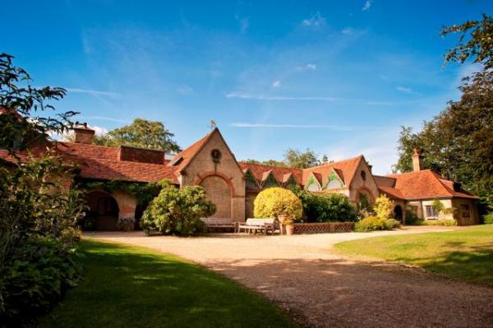

Welcome
Watts Gallery - Artists' Village is a unique Arts & Crafts gem nestled in the Surrey Hills.
Please get in touch if you require any further information about specific access or need help planning your visit.

At a Glance

Level Access
- There is level access from the main entrance to:
  - Dining Table
  - Main Gallery
  - Watts Studios
  - Visitor Centre Information Desk
  - Watts Studios Information Desk
  - Gallery Toilets
  - The Tea Shop Toilets
  - Watts Studios Toilets - Entrance
  - Watts Studios Toilets - Back of Building
  - The Shop

Access with steps
- There are steps from the main entrance to:
  - Watts Contemporary Gallery

Hearing
- Some staff have Next Generation Text and disability awareness training.

Visual
- We have information in large print.

General
- We have a complimentary ticket policy for personal assistants.
- There is at least 1 public toilet for disabled visitors.
- Some staff have disability awareness training.

Getting here
Watts Gallery - Artists' Village
Down Lane
Compton
Surrey
GU3 1DQ

Travel by public transport
- You can get to Watts Gallery - Artists' Village by bus.
- The 46 bus runs from Guildford town centre directly to the Artists' Village (bus stop Compton - Watts Gallery) once an hour between 9am and 6pm, Mondays to Saturdays. The bus stop is 0.00 miles / 62.8 km from Watts Gallery - Artists'.0; Village.

Travel by taxi
- You can get a taxi with Speedwell Taxis by calling 01483 423333. The taxi company has a wheelchair accessible vehicle.
- You can get a taxi with Paul Edwards Taxis by calling 01483 422138.

Parking
- We have a car park. There are accessible parking spaces. The parking is less than 50 metres from the main entrance. Parking is free.
- There is a drop-off point at the main entrance. The drop-off point does not have a dropped kerb.
- From the car park to the entrance, there is level access. There is an additional car park located at Watts Studios, with designated accessible parking and level access.

Arrival

Path to main entrance
- From the street to the main entrance, there is level access.
- The path is sloped.

Main entrance
- The main entrance has level access.
- The door is 840mm wide.
- The main door is side hung and manual.
- There is an additional entrance to the Visitor Centre towards the front gate of the site. It is 1185mm wide.

Getting around inside

Lift
- We have 3 lifts.
- You can get a lift to some floors.

Lift to Temporary Exhibition Space and Sculpture Gallery
- The lift door is 1010mm wide.
- The lift is 990mm wide. The lift is 1420mm deep.
- The lift says the floor number at each floor.
- The lift buttons have raised numbers or letters.
- The lift shows the floor number, at each floor.

Lift to De Morgan Collection
- The lift is a platform lift.
- The lift door is 1010mm wide.
- The lift is 1410mm wide. The lift is 1100mm deep.
- The lift buttons have raised numbers or letters.

Lift in Watts Studios
- The lift is a platform lift.
- The lift door is 995mm wide.
- The lift is 1140mm wide. The lift is 1360mm deep.

Ticket/ information desk

Visitor Centre Information Desk
- From the main entrance to the desk, there is level access. The route is 840mm wide, or more.
- The door is 840mm wide, or more.
- The desk has a low section.

Ticket/ information desk

Watts Studios Information Desk
- From the main entrance to the desk, there is level access. The route is 1370mm wide, or more.
- The door is 1370mm wide, or more.

Things to See and Do
- We have a complimentary ticket policy for personal assistants.

Main Gallery
- From the main entrance to this area, there is level access. The route is 815mm wide, or more. The door is 815mm wide.
- Some display information is low, for wheelchair users. There are seats.
- Videos have subtitles.

Watts Studios
- From the main entrance to this area, there is level access. The route is 915mm wide, or more. The door is 915mm wide.
- Some display information is low, for wheelchair users. There are seats.
- Watts Studios is approximately 0.3 miles away from the Visitor Centre, with level access between the two buildings. There is also an additional car park at Watts Studios that includes designated accessible parking.

Watts Contemporary Gallery
- From the main entrance to this area, there are 14 steps. There is no lift and no ramp.
- Some display information is low, for wheelchair users.

Watts Chapel
- Some display information is low, for wheelchair users.

Public toilet

Gallery Toilets
- There is a public toilet for disabled visitors.
- From the main entrance to the public toilet, there is level access. The route is 815mm wide, or more.
- The toilet door is 940mm wide.
- There is 1600mm in front of the toilet. The toilet seat is 460mm high. The toilets have handrails.

Public toilet

The Tea Shop Toilets
- There is a public toilet for disabled visitors.
- From the main entrance to the public toilet, there is level access. The route is 940mm wide, or more.
- The toilet door is 940mm wide.
- There is 1570mm in front of the toilet. The toilet seat is 470mm high. The toilets have handrails.

Public toilet

Watts Studios Toilets - Entrance
- There is a public toilet for disabled visitors.
- From the main entrance to the public toilet, there is level access. The route is 915mm wide, or more.
- The toilet door is 915mm wide.
- There is 1630mm in front of the toilet. The toilet seat is 480mm high. The toilets have handrails.

Public toilet

Watts Studios Toilets - Back of Building
- There is a public toilet for disabled visitors.
- From the main entrance to the public toilet, there is level access. The route is 930mm wide, or more.
- The toilet door is 930mm wide.
- There is 1590mm in front of the toilet. The toilet seat is 480mm high. The toilets have handrails.

Shop

The Shop
- From the main entrance to the shop, there is level access. The route is 840mm wide, or more. The door is 840mm wide.
- The route through the shop is 800mm wide, or more.

Place to eat and drink

The Tea Shop
- From the main entrance to the dining area, there is level access. The route is 850mm wide, or more. The door is 850mm wide.
- To get to a table, there are no steps.
- The route through the dining area is 800mm wide, or more.
- There is no background music.
- The table and plates have high colour contrast.

Customer care support

Accessibility equipment
- We provide wheelchairs. Wheelchairs are free.
- Please ring ahead if you require a wheelchair, as numbers are limited.

Customer care support
- Some staff have disability awareness training.
- Some staff have Next Generation Text training.
- We have information in large print.

Guide last updated: 18 January 2019

