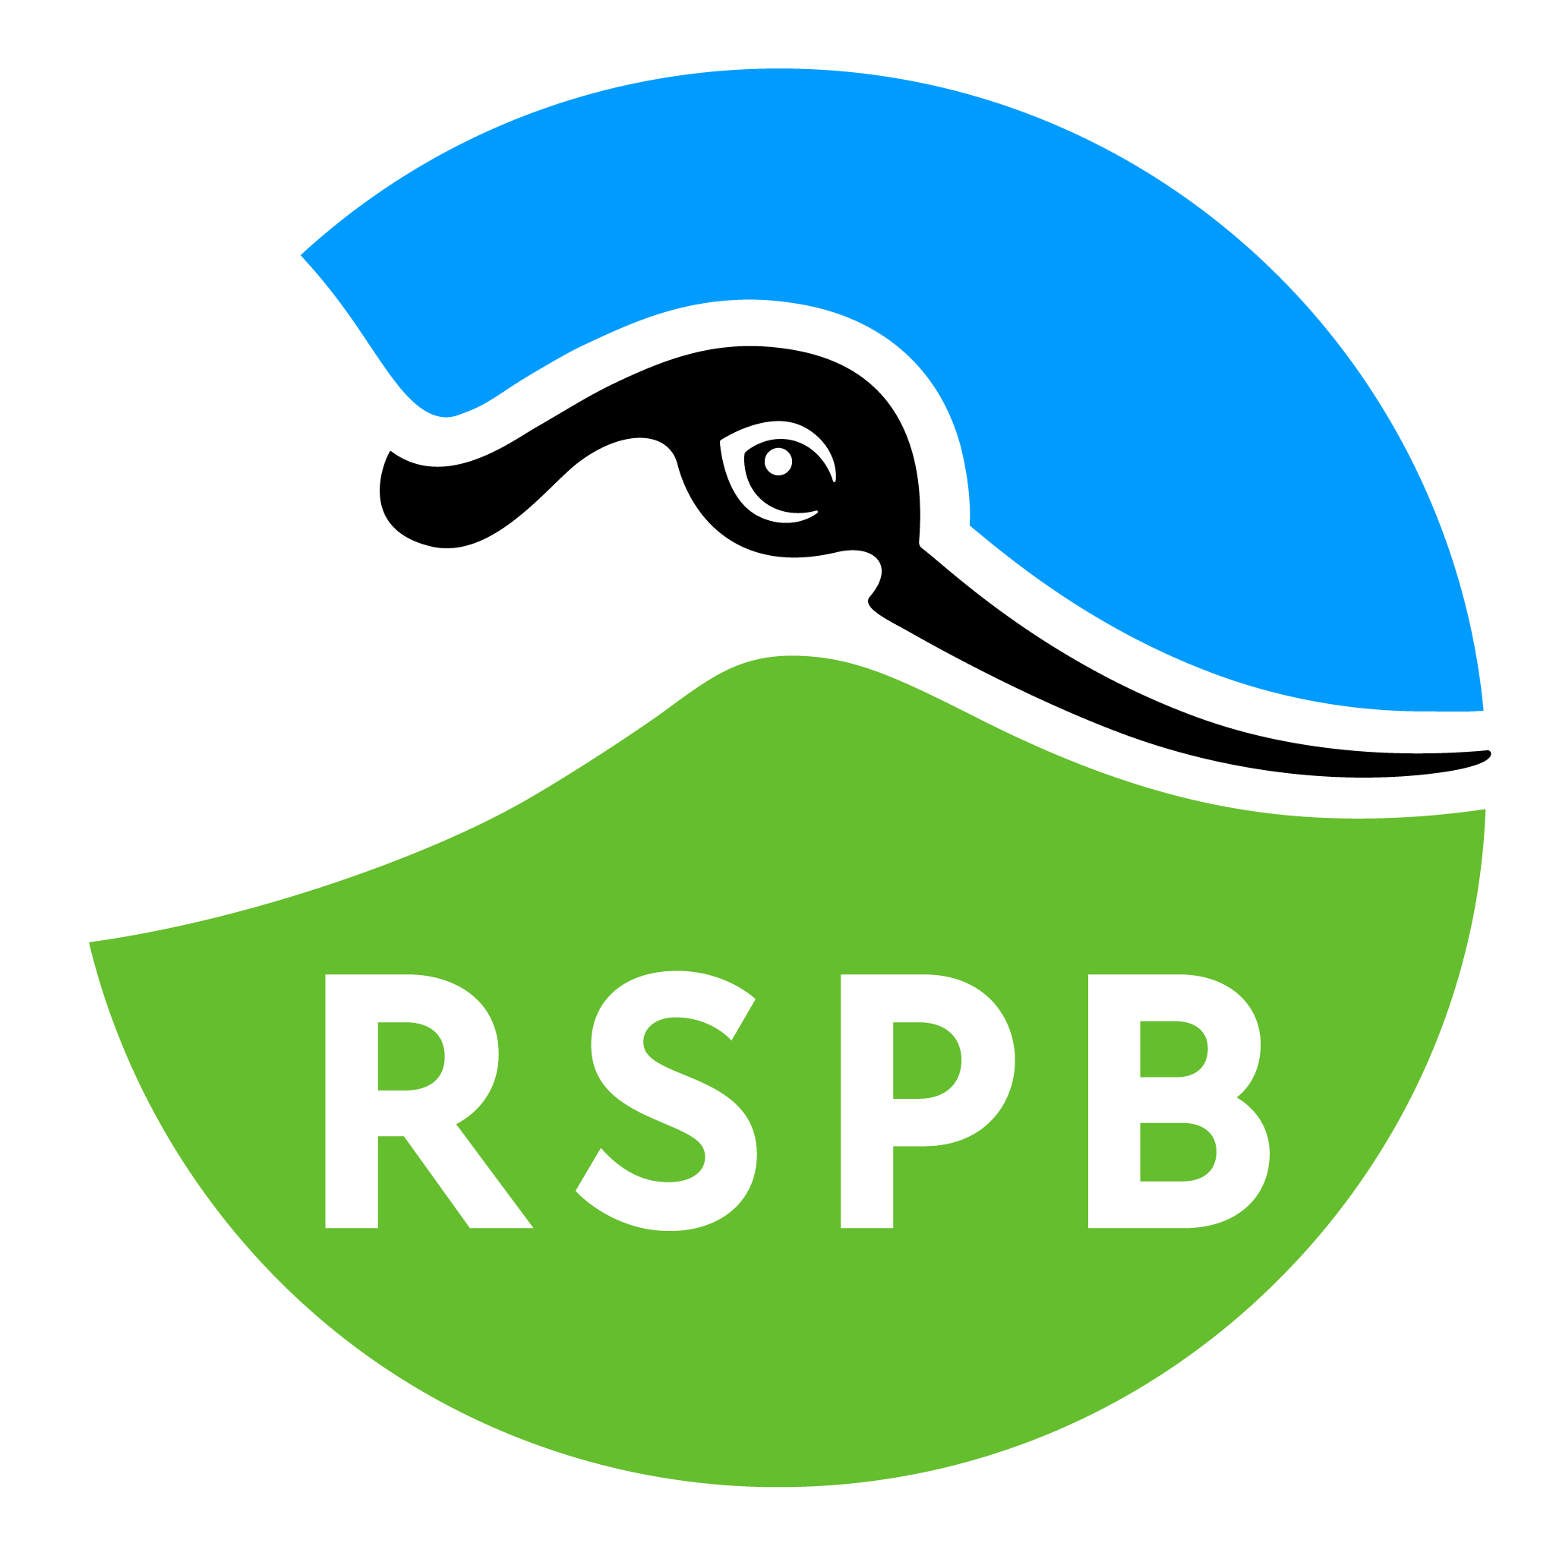

Accessibility Guide for RSPB Greylake
greylake@rspb.org.uk, 01458252805, https://www.rspb.org.uk/reserves-and-events/reserves-a-z/greylake/
Contact for accessibility enquiries: Abbie Thorne
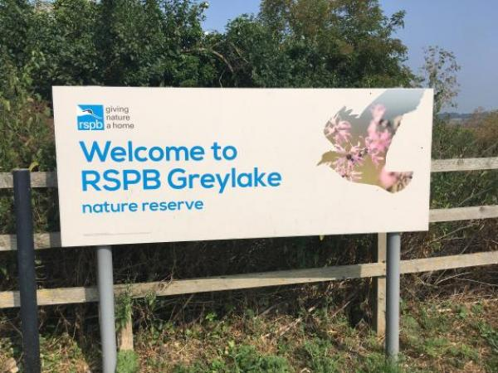

Welcome
RSPB Greylake, located in the heart of the Somerset Levels and Moors, is an exciting place to explore. See lapwing, redshank and snipe nesting in spring and vast flocks of ducks and waders, being hunted by birds of prey in winter.
Our easy access trail provides level, hard standing surface access to parts of the reserve and hides, giving a fantastic opportunity to get up close to the wildlife at Greylake. This circular walk is just under half a mile long (700 metres) suitable for wheelchairs and pushchairs, easy to follow and has benches along the way to soak up the atmosphere.
There are no toilet or refreshment facilities availiable at this reserve. This reserve is unstaffed.

At a Glance

Level Access
- There is level access from the main entrance to:
  - Entrance
- The hide entrance has level access.

Visual
- Some parts of the venue have low lighting.

Getting here
RSPB Greylake,
A361
nr Bridgwater
TA7 9BP

Travel by public transport
- You can get to RSPB Greylake by bus.
- Take the route 29 bus from Taunton or Glastonbury. The nearest bus stop is in Othery at the London Inn or in Greinton at the phone box (both are 2 miles / 3.2 km from the reserve). Walking to Greylake from here is not recommended due to fast traffic and lack of a pavement. A request to stop at the reserve could be made. The bus stop is 2.0 miles / 3.2 km from RSPB Greylake.

Parking
- We have a car park. There are accessible parking spaces. The parking is less than 50 metres from the main entrance. Parking is free.
- While there is not a formal drop off point some of the car parking spaces can act as such. From the car park to the entrance, there is level access. The route is 1100mm wide, or more.
- The car park is directly connected to the main entrance of the reserve. Access to the entrance of the reserve from the car park is across a level wooden bridge (1100 mm at narrowest point). After crossing this bridge there is a hard standing path and then a wooden gate (1600 mm at narrowest point with a trobone latch) to pass through to access the reserve.
Only assistance dogs are permitted on the reserve.
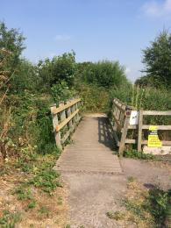
Wooden bridge which connect the car park to the entrance of the reserve at RSPB Greylake

Arrival

Path to main entrance
- From the street to the main entrance, there is level access.
- The path is 1100mm wide, or more.

Main entrance
- The main entrance has level access.
- Main entrance to the reserve is on a hardstanding path through a wooden gate with a trombone latch.
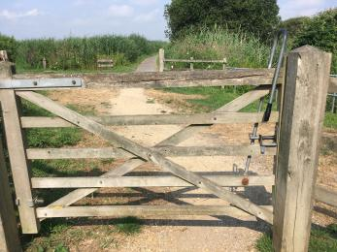
Entrance to RSPB Greylake - hard standing path through a wooden gate with a trombone latch

Getting around inside

Visual Impairment - General Information
- Some parts of the venue have low lighting.

Entrance
- From the main entrance to this area, there is level access. There is a permanent ramp. The route is 1100mm wide, or more.
- The door is 1100mm wide.
- There is no indoor entrance to RSPB Greylake. For the purposes of this guide the reserve entrance is considered the picnic area between the car park and the gate to to the reserve. The doorway listed above is the wooden bridge connecting the car park to the picnic area and wider reserve. At its narrowest this bridge is 1100 mm.
Further detail on the picnic area can be found under the getting around outside section.
There is a view point on the left hand side of the car park which gives a view over part of the reeds. This can be accessed by ramp (1:16 gradient) or a flight of 10 wooden steps. The ramp has a grass surface which has grown over plastic matting. There is a wooden hand rail on both sides of the stairs and a hand rail on one side of the ramp (the right hand side when going up and the left hand side when going down).
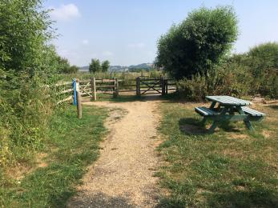
Photo from 2019. The picnic area at the entrance of RSPB Greylake. There is no indoor entrance to RSPB Greylake.
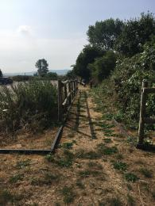
Photo taken from top of view point looking down the ramp.
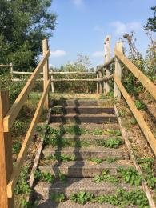
Photo taken at bottom of stairs to view point.

Getting around outside

Designated Walking Trail

Easy Access Trail
- The trail is 700metres long. The trail has a hard surface. There are 4 gates along the Easy Access Loop. There is 1 gate at the entrance, 1 gate at the exit and 1 gate on each side of where the trail crosses the drove road. These gates have trombone latch. The trail has seats. There are bird hides along the trail.
- The Easy Access train is a hardstanding trail with a compacted stone surface. The Easy Access Trail meanders alongside ditches and ponds which means that there is access to open water in some places. Reeds and other vegetation grow along the waters edge and obsure it in places.
There is a wooden floating pond platform part way around the path (see photos). There is an edgeboard but no railings around the edge of this platform. The top of the wooden ramp connecting the platform to the path is not flush. The ramp slopes down towards the platform away from the path. As the platform is floating on the water it creates a wobbly walking surface. There is a wooden bench in the centre of the platform with a back but no sides.
There are a few passing places around the Easy Access trail.
There are four benches with sides but no backs dotted around the Easy Access trail. These benches range in height from 37 cm to 51 cm high.
The path crosses the private drove road that runs through the centre of the reserve. A gate with a trombone latch is on either side of the drove road. This private drove road is used by farm machinery and other vehicles. A couple of times a year this drove is also used to move cattle.
Lookout Hide:
There is a raised threshold on the door entrance. There are 4 benches, no back or sides, which are fixed in place and 2 benches, no back or sides, which are moveable. To secure the windows open they need to be opened inwards and lifted up, then secured by placing the chain over a hook.
Treehouse Hide:
The first half of the wooden boardwalk to the hide has a raised lip on either side and the second half has railing on one side and willow screening on the other. There is chicken wire over the surface of the boardwalks. There can be overhanging vegetation in this area. This hide is closed on 3 sides and open at the back. There are 3 moveable benches with no back or sides in this hide. To secure the windows open they need to be opened inwards and raised up and secured by placing the chain over a hook.
Please note a live electric fence which forms part of the predator defences in the area near the hides. It can not be easily reached when staying on the boardwalk.
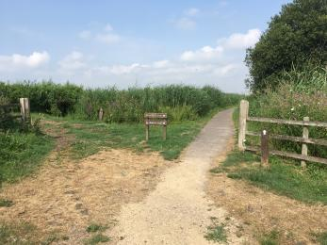
Hardstanding, compact stone, path of Easy Access Trail
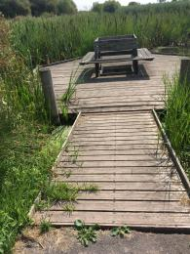
Wooden Pond Platform part way around Easy Access Trail. Access is 109 cm at the narrowest part.
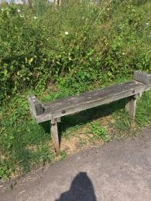
Example of benches on Easy Access Trail - sides no back. These benches range in height from 37 cm to 51 cm high.
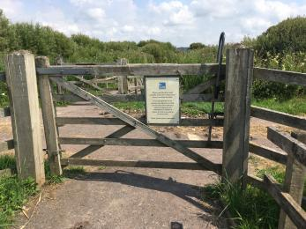
One of the gates crossing the drove on the Easy Access Trail with trombone latch.
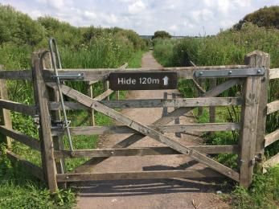
One of the gates crossing the drove on the Easy Access Trail with trombone latch.
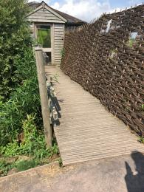
Access route to Lookout and Treetop Hides. Access is 114 cm at the narrowest part of the path.
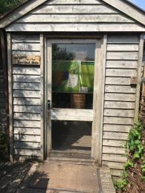
Entrance door to Lookout Hide. Note slight lip at bottom of doorway. Door is 100 cm wide.
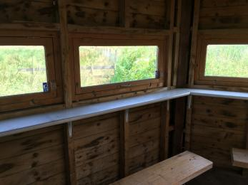
Inside of Lookout Hide showing windows and part of one of the fixed benches
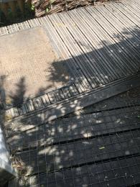
Lip outside of Lookout Hide where boardwalk to Treetop Hide joins
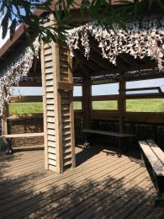
Inside of Treetop Hide
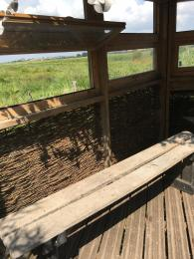
One of the benches in Treetop hide - no back or sides.
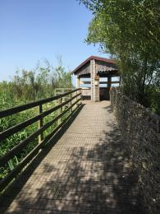
Boardwalk to the Treetop Hide

Designated Walking Trail

Reedbed Loop
- The trail is 800metres long. Some of the trail has a loose surface. There is a gateway at entrance of reserve with hand pull latch. The trail has seats.
- The Reedbed loop is an uneven, undulating, grass path on peat. The path can be muddy and slippery after wet weather and during the winter which can also cause holes to form in the path. Woodchip has been put down on the surface of the path in some areas.
There are wooden benches dotted around the reedbed loop. These benches range in height from 53 cm - 63 cm. The benches do not have backs or sides.
[Currently Closed] There is a narrow willow screen at the heart of the reedbed on the Reedbed Loop. There is encroaching vegetation on the grass path to this screen. The distance between the bench and the screen is 54 cm. The top of the shelf is 100 cm from the ground. The fixed bench in the screen has a back but no arms. This screen is currently closed.
Another willow screen can be found at the end of an additional there and back grass path of 1,000 meters off of the Reedbed Loop. This screen has 3 benches with no backs or sides. The benches are fixed in place. The benches are 48 cm high. There is a gap of 41 cm between the benches and the screen at the narrowest part. There is no shade in this area. There are no benches on the path to the screen.
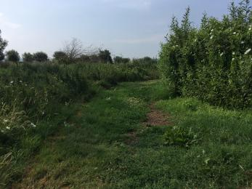
Grass path of Reedbed Loop
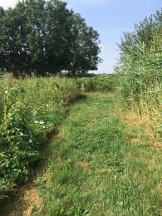
Grass path of Reedbed Loop
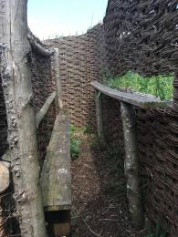
Screen at heart of the reedbeds on Reedbed Loop [Currently closed]
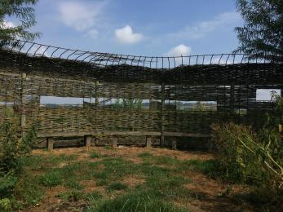
Willow Screen on there and back of the Reedbed Loop

Lookout Hide
- At the hide entrance, there is level access. There is a permanent ramp. The door is 700.00mm wide.

Treehouse Hide
- At the hide entrance, there is level access. There is a permanent ramp. The door is 1000.00mm wide.

Picnic Area
- There are 2 picnic benches in the picnic area. 1 bench has an overhang on the table ends to allow use by wheel users. The bench is situated in a grass area just off of the main hard standing path.
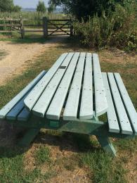
Close up of bench with table overhang for use by wheel users.
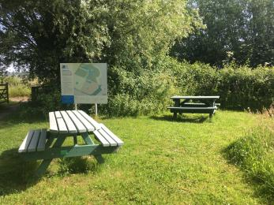
Two benches on the grass of the picnic area. In background site map can be seen in front of a tree and hedges.

Customer care support

Accessibility equipment
- None
- Assistance dogs are able to use the grass areas as a toilet area. Please clean up and remove dog mess. No dog bins are provided on site.
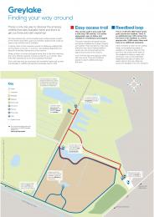
Greylake Trail Guide showing routes. Visit https://www.rspb.org.uk/reserves-and-events/reserves-a-z/greylake/ to download a copy

Guide last updated: 5 August 2022

