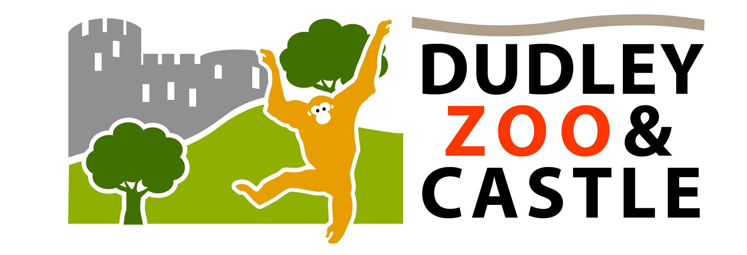

Accessibility Guide for Dudley Zoo & Castle
admin@dudleyzoo.org.uk, 01384 215313, www.dudleyzoo.org.uk
Contact for accessibility enquiries: Andrea Hales
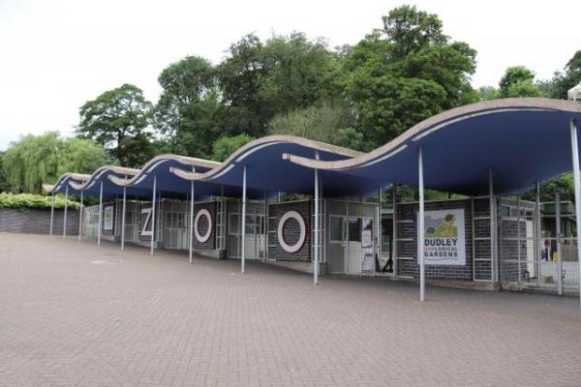

Welcome
DZC is unique… a home to more than 1300 animals, and has nigh on 200 species, including some of the rarest creatures on Planet Earth.
Hundreds of exotic and endangered animals inhabit an ancient wooded hillside, with a rich geological history, around the ruins of the 11th century Dudley Castle and share a site with the world’s largest single collection of Modernist Tecton structures – and the country’s only vintage chairlift!

At a Glance

Level Access
- The main entrance has level access with a ramp. The ramp is permanent.
- There is level access from the main entrance to:
  - Dining Table
  - Retail Shop
  - Ticket Desk
  - Courtyard Cafe
  - Entrance Toilets
  - Courtyard Toilets
  - Queen Mary Restaurant Disabled Toilet
  - Lorikeet Lookout toilets
- There is level access from the car park to:
  - Castle Courtyard

Hearing
- We have a hearing loop in Reception and Shop.
- Some staff have disability awareness training.

Visual
- Glass doors have contrast markings.
- Some parts of the venue have low lighting.

General
- We have a concessionary rate for disabled visitors.
- We have a complimentary ticket policy for personal assistants.
- There is at least 1 public toilet for disabled visitors.At least one toilet is a Changing Places toilet.
- Some staff have disability awareness training.

Getting here
Castle Hill
Dudley
DY1 4QF

Travel by public transport
- You can get to Dudley Zoo & Castle by bus and train.
- Dudley Bus Station is 2 minutes walk from the zoo entrance. The bus stop is 0.5 miles / 0.8 km from Dudley Zoo & Castle.
- The nearest train station is Dudley Port Train Station. The train station is 3 miles / 4.8 km from Dudley Zoo & Castle.
- Situated on the A461 (Castle Hill) 3 miles from M5 Junction 2. If you are travelling using a SATNAV then please use postcode DY1 4SQ.
Access to the car park is via Tipton Road (driving down Tipton Road towards Black Country Living Museum from Castlegate Island, turn left at the traffic lights). Car park is barrier operated and £3.50 per token to exit.
Frequent bus service to Dudley from Dudley Port station.

Travel by taxi
- You can get a taxi with ABC Taxis by calling 01384 515151.

Parking
- We have a car park. There are accessible parking spaces. The parking is less than 50 metres from the main entrance. Parking is not free.
- There is a drop-off point at the main entrance. The drop-off point has a dropped kerb.
- From the car park to the entrance, there is level access. There is a permanent ramp.
- The path is sloped.
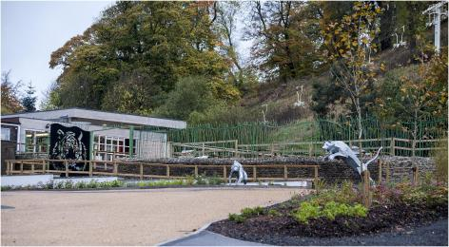
Main Entrance from Car park
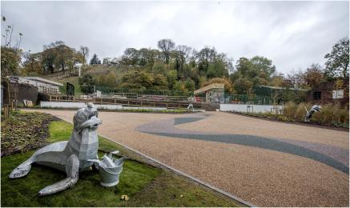
Main Entrance from Car park

Arrival

Path to main entrance
- From the street to the main entrance, there is level access.
- The path is sloped.

Main entrance
- The main entrance has level access.
- There is a permanent ramp.
- The main door is sliding and automatic.
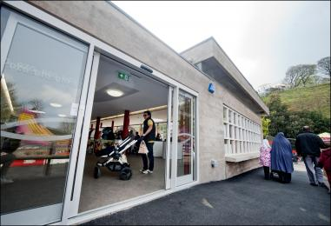
Main Entrance

Getting around inside

Visual Impairment - General Information
- We have contrast markings on all glass doors.
- Some parts of the venue have low lighting.
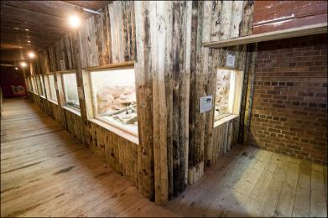
Reptile House
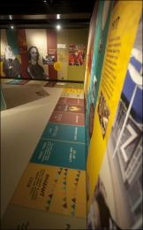
Castle Creatures

Ticket/ information desk

Ticket Desk
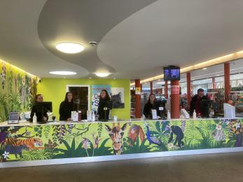
Entrance
- From the main entrance to the desk, there is level access.

Things to See and Do
- We have a concessionary rate for disabled visitors.
- We have a complimentary ticket policy for personal assistants.

Retail Shop
- From the main entrance to this area, there is level access. There is a permanent ramp. Some display information is low, for wheelchair users. There is a hearing loop.
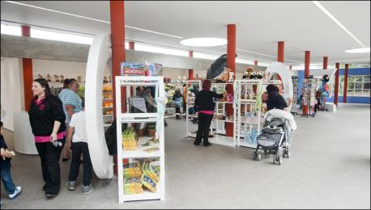
Safari Gift Shop

Bar

Courtyard Cafe
- From the main entrance to the bar, there is level access.
- The courtyard cafe is situated inside the Castle Courtyard grounds at the top of the Zoo. Although there are no steps, the access to this area is hilly and steep in parts.
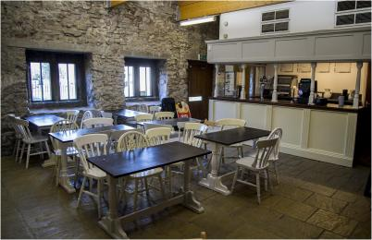
Courtyard Cafe

Public toilet

Entrance Toilets
- There is a public toilet for disabled visitors.
- From the main entrance to the public toilet, there is level access. The route is 914mm wide, or more.
- The toilet door is 914mm wide.
- The direction of transfer onto the toilet is to the right.
- The toilets have handrails.
- We now have a Changing Places toilet located at Lorikeet Lookout. A radar key will be required to access it.
Alternatively, there is another Changing Places toilet located a 7 minute walk away at Dudley Town Centre, 256 Castle Street, Dudley. Alternatively, Dudley Archive and Local History Centre, is also just a 10 minute walk from our main entrance at the end of our car park. Changing Places opening times: Mon - Fri 9 am - 5 pm, Sat 10 - 4.30 pm, closed on Sundays.

Public toilet

Courtyard Toilets
- There is a public toilet for disabled visitors.
- From the main entrance to the public toilet, there is level access. There is a permanent ramp.
- The toilet door is 762mm wide.
- The direction of transfer onto the toilet is to the right.
- The toilets have handrails.
- Not accessible for mobility scooters.
We now have a Changing Places toilet located at Lorikeet Lookout. A radar key will be required to access it.
Alternatively, there is another Changing Places toilet located a 7 minute walk away at Dudley Town Centre, 256 Castle Street, Dudley. Alternatively, Dudley Archive and Local History Centre, is also just a 10 minute walk from our main entrance at the end of our car park. Changing Places opening times: Mon - Fri 9 am - 5 pm, Sat 10 - 4.30 pm, closed on Sundays.

Public toilet

Queen Mary Restaurant Disabled Toilet
- There is a public toilet for disabled visitors.
- From the main entrance to the public toilet, there is level access. The toilet door is 900mm wide.
- The direction of transfer onto the toilet is to the front only.
- The toilets have handrails.
- Also nappy changing cubicle.
We now have a Changing Places toilet located at Lorikeet Lookout. A radar key will be required to access it.
Alternatively, there is another Changing Places toilet located a 7 minute walk away at Dudley Town Centre, 256 Castle Street, Dudley. Alternatively, Dudley Archive and Local History Centre, is also just a 10 minute walk from our main entrance at the end of our car park. Changing Places opening times: Mon - Fri 9 am - 5 pm, Sat 10 - 4.30 pm, closed on Sundays.

Public toilet

Lorikeet Lookout toilets
- There is a public toilet for disabled visitors.
- The toilet is a Changing Places toilet.
- You need a RADAR key to open the public toilet.
- From the main entrance to the public toilet, there is level access. There is a permanent ramp.
- The route is 1040mm wide, or more.
- The toilet door is 1040mm wide.
- The direction of transfer onto the toilet is to the left.
- There is 1900mm at the side of the toilet. There is 1900mm in front of the toilet. The toilet seat is 500mm high. The toilets have handrails.
- We now have a Changing Places toilet located at Lorikeet Lookout. A radar key will be required to access it. The Changing Places facility includes hoist, shower, changing bed, privacy screen, emergency cord, sink with hand rails and mirror and coat hooks.
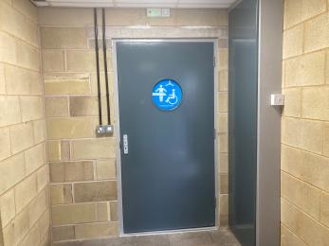
Changing Places toilet entrance
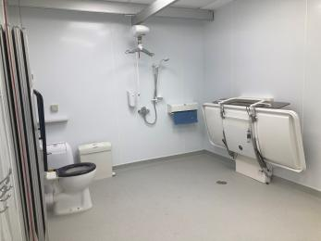
Changing places interior
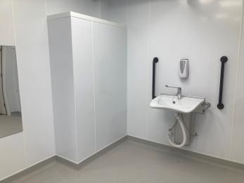
Changing places interior

Place to eat and drink

Queen Mary Restaurant
- To get to a table, there are no steps.
- The dining area is self-service. The route through the dining area is 800mm wide, or more.
- There is no background music.
- We cater for sugar free (diabetic), vegetarian, gluten free (celiacs), lactose free (dairy free), nut free and vegan specific diets.
- The Queen Mary Restaurant is situated outside the Castle Courtyard grounds at the top of the Zoo. Although there are no steps, the access to this area is hilly and steep in parts.
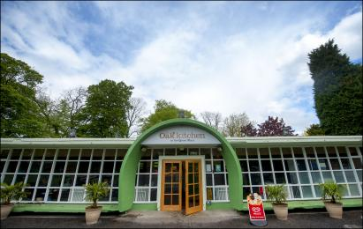
Queen Mary Restaurant
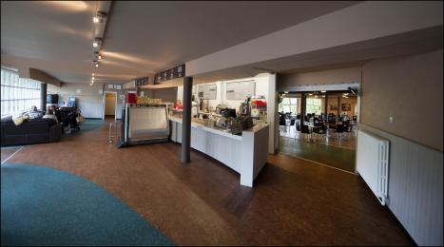
Queen Mary Restaurant
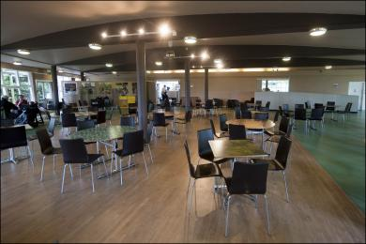
Queen Mary Restaurant

Go Wild Theatre
- The Go Wild! Theatre is accessible just outside the Castle Courtyard grounds at the top of the Zoo. Although there are no steps, the access to this area is hilly and steep in parts.
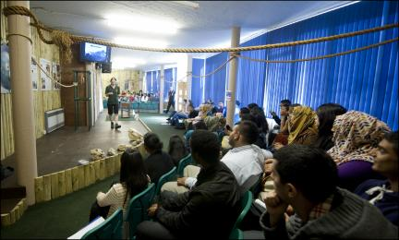
Go Wild Theatre

Getting around outside

Zoo grounds
- The route is sloped.
- The garden areas are situated all around the Zoo. Although there are no steps, the access is hilly and steep in parts.
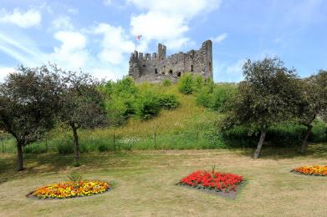
Gardens

Picnic Area

Castle Courtyard
- From the car park to the picnic area, there is level access. Some tables have space for wheelchair users. You can bring your own food to the picnic area.
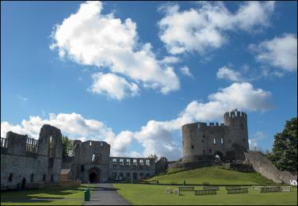
Castle Courtyard

Customer care support

Accessibility equipment
- We provide wheelchairs. Wheelchairs are free.
- We have a hearing loop in Reception and Shop.
- Electric Mobility Scooters £12 to hire with a £20 refundable deposit.
Manual wheelchairs free of charge with a £10 refundable deposit.
- For a list of more items, please go to https://www.dudleyzoo.org.uk/plan-your-visit/disabled-access/.
- We have an area to charge mobility scooters and battery powered wheelchairs.
- Please enquire at the Safari Gift Shop

Emergency evacuation procedures
- We have emergency evacuation procedures for disabled visitors.

Customer care support
- Some staff have disability awareness training.

Guide last updated: 1 May 2023

