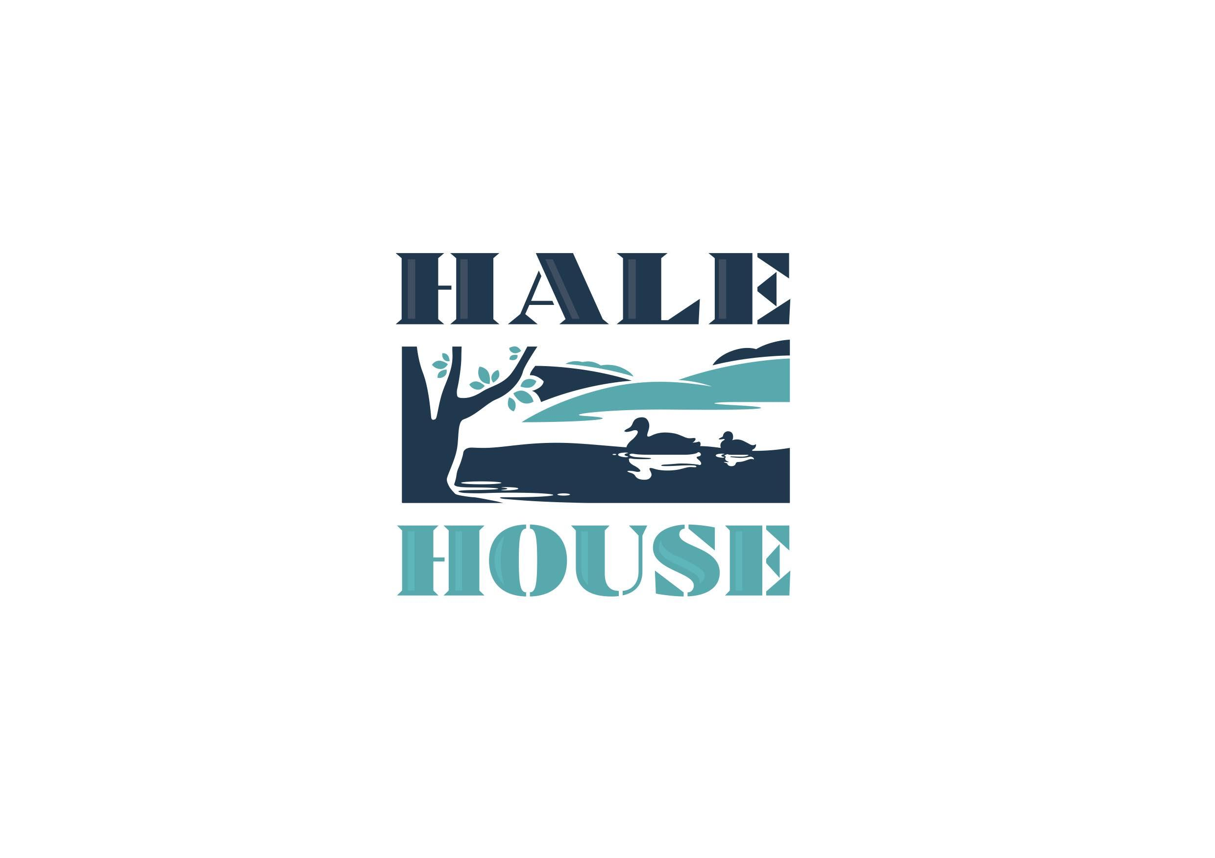

Accessibility Guide for Hale House Bed & Breakfast
susanna.geoghegan@btinternet.com, 01296 625742, www.halehousebnb.co.uk
Contact for accessibility enquiries: Susanna Geoghegan
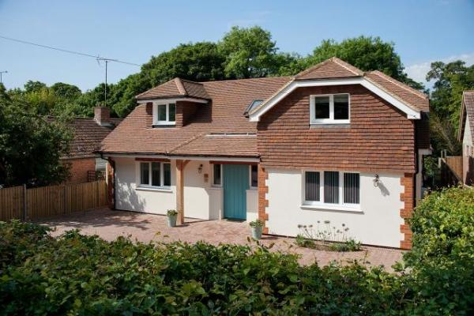

Welcome
Hale House is a modern eco-friendly boutique bed & breakfast with three letting en-suite bathrooms set in a quiet, beautiful rural setting on the outskirts of the market town of Wendover and the Chilterns. The house fulfills all current statutory disability building regulations and with physical disability in mind hence we have a downstairs bathroom and large adjacent bathroom.

At a Glance

Level Access
- There is level access from the main entrance to:
  - Dining Table
  - Lounge
  - Garden

Hearing
- Some staff have disability awareness training.

General
- Staff are available 24 hours a day.
- Some staff have disability awareness training.
- We have emergency evacuation procedures for disabled visitors.

Getting here
56 Hale Road
Wendover
Bucks
HP22 6NF

Travel by public transport
- You can get to Hale House Bed & Breakfast by bus and train.
- There is a bus stop in Wendover High Street and the main bus hub in the area is Aylesbury. We are happy to collect guests from the bus stop. The bus stop is 0.5 miles / 0.8 km from Hale House Bed & Breakfast.
- The nearest train station is Wendover. The train station is 0.8 miles / 1.3 km from Hale House Bed & Breakfast.
- We are happy to collect guests from the local bus stop or train station

Travel by taxi
- You can get a taxi with Wendover Taxi Service by calling 01296 350196. The taxi company has a wheelchair accessible vehicle.
- We have a transfer service for visitors. Wheelchair users can use the transfer service.

Parking
- We have a car park. The parking is less than 50 metres from the main entrance. Parking is free.
- There is a drop-off point at the main entrance. The drop-off point has a dropped kerb.
- From the car park to the entrance, there is level access. There is a permanent ramp.
- The route is 2000mm wide, or more.
- We have a transport service, to take visitors from the car park to the main entrance. The car park is immediately in front of the house
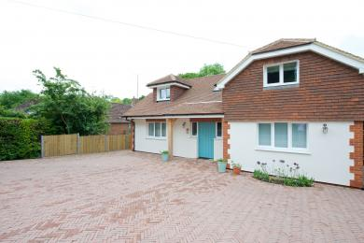
Front drive, parking and clear access

Arrival

Path to main entrance
- From the street to the main entrance, there is level access.
- The path is 3000mm wide, or more.
- The path is sloped.

Main entrance
- The main entrance has level access.
- The door is 960mm wide.
- The main door is side hung and manual.

Getting around inside

Place to eat and drink

Breakfast room
- From the main entrance to the dining area, there is level access. The route is 790mm wide, or more. The door is 790mm wide.
- To get to a table, there are no steps.
- If you need table service, staff can help you.
- The route through the dining area is 800mm wide, or more.
- There is no background music.
- We cater for sugar free (diabetic), vegetarian, gluten free (celiacs), lactose free (dairy free), nut free, low fat, low potassium, low sodium, no gastric content, high fibre and vegan specific diets.

Lounge
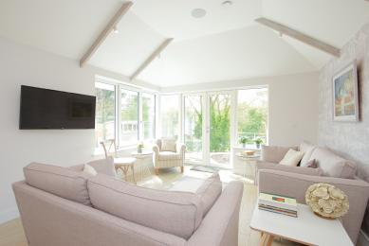
- From the main entrance to this area, there is level access.

Getting around outside

Garden
- From the main entrance to this area, there is level access.
- The access to the garden for a guest with a mobility problem is to exit by the front door and then go down a side path which is all on the level to the back garden where there is a shallow ramp to a seating area

Customer care support

Emergency evacuation procedures
- We have emergency evacuation procedures for disabled visitors.

Customer care support
- Some staff have disability awareness training.
- Staff are available 24 hours a day.

Guide last updated: 18 January 2019

