Accessibility Guide for Great Wood
james.latus@forestryengland.uk, 01278732319, https://www.forestryengland.uk/great-wood
Contact for accessibility enquiries: James Latus
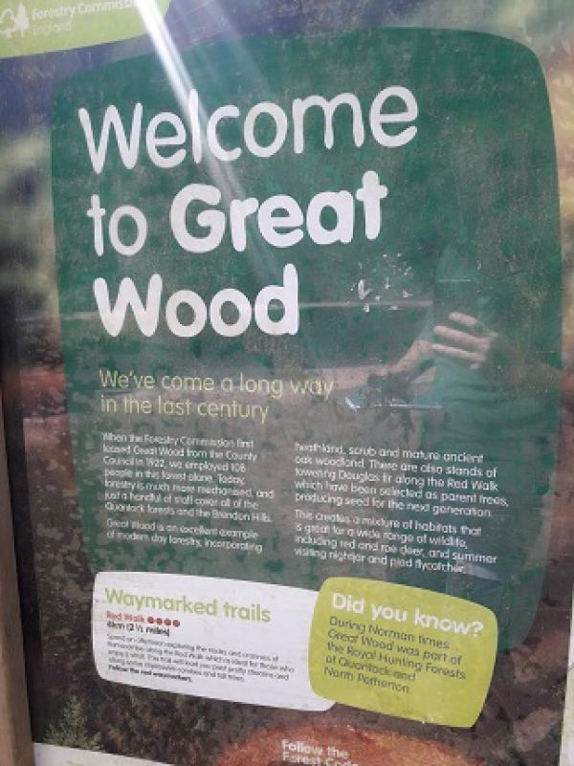

Welcome
Enjoy a leisurely stroll along our Red Walking Route, go on a long-distance horse ride or discover the forest by bike. There is a family picnic area with wheelchair access plenty of picnic tables and there are also deidicated surfaces for BBQ's. Our 2 mile Red Walk lets you explore the majestic Douglas fir idealfor families. If you bring a bike we don't have way marked routes but there a plenty of bridleways and forest roads to explore on 2 wheels. With stunning wildlife to spot such as Red Deer, Ravens, Buzzards, Pied Flycatchers, Crossbills and lots more besides Great Wood really is a stunning venue to spot uniqe species. We also have an events room ideal groups and schools to use on your visit.

At a Glance

Level Access
- There is level access from the main entrance to:
  - Main Accessible Toilet
- There is level access from the car park to:
  - Ramscombe Picnic Area

General
- There is at least 1 public toilet for disabled visitors.
- Some staff have disability awareness training.

Getting here
Great Wood
Adscombe Lane
Adscombe
TA5 1HN

Travel by public transport
- Traveling to our beautiful woodland is by car only along a easily accessible forest road with dedicated car parking once on site.

Parking
- We have a car park. There are accessible parking spaces. The parking is less than 50 metres from the main entrance. Parking is not free.
- There is a drop-off point at the main entrance. The drop-off point does not have a dropped kerb.
- From the car park to the entrance, there is level access. The path is sloped.
- The route is 900mm wide, or more.
- There is a tarmac path leading you from our dedicated accesable parking straight into our picnic area and a dedicated flat parking space next to our accessible toilet facilities.
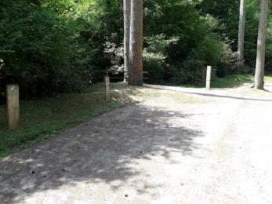
Parking For Picnic
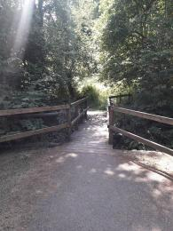
parking bridge

Arrival

Path to main entrance
- From the street to the main entrance, there is level access.
- The path is 900mm wide, or more.
- The path is sloped.

Main entrance
- The main entrance has level access.
- Access to the picnic area is via a tarmac path direct from our accessible parking spaces.
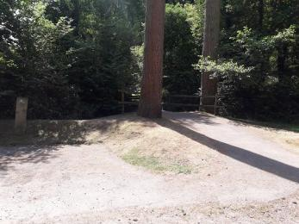
parking entrance

Getting around inside

Public toilet

Main Accessible Toilet
- There is a public toilet for disabled visitors.
- From the main entrance to the public toilet, there is level access. The route is 1400mm wide, or more.
- The toilet door is 830mm wide.
- The direction of transfer onto the toilet is to the left.
- There is 1900mm at the side of the toilet. There is 2000mm in front of the toilet. The toilet seat is 190mm high. The toilets have handrails.
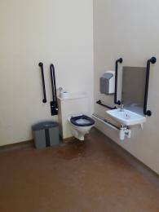
toilet
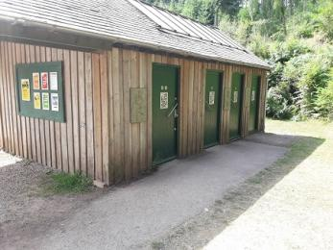
toilet block
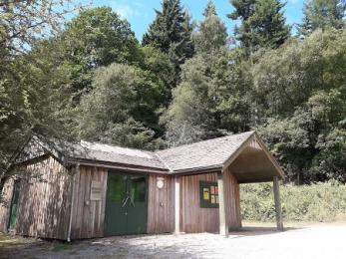
events room

Getting around outside

Designated Walking Trail

Red Route
- The trail is 3218metres long. Some of the trail has a loose surface. The trail is sloped. The trail has seats.
- The route is accessible by people in all terrain buggies such as Trampers and it is possible to push a wheelchair user around the route but this does involve considerable effort. Please note this is a multi-use trail.
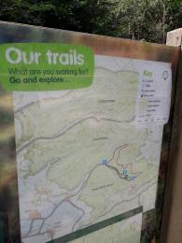
Route Map
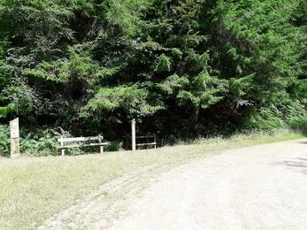
Red Route

Picnic Area

Ramscombe Picnic Area
- From the car park to the picnic area, there is level access. The path is 900mm wide, or more.
- The entrance is 1400mm wide.
- Some tables have space for wheelchair users. You can bring your own food to the picnic area.
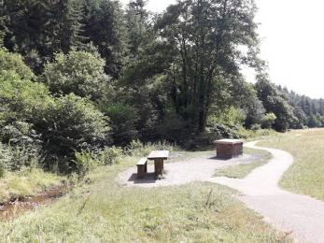
Ramscombe Picnic Area
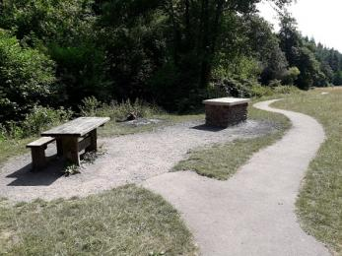
Close Ramscombe Picnic Area

Customer care support

Customer care support
- Some staff have disability awareness training.

Guide last updated: 24 January 2022

