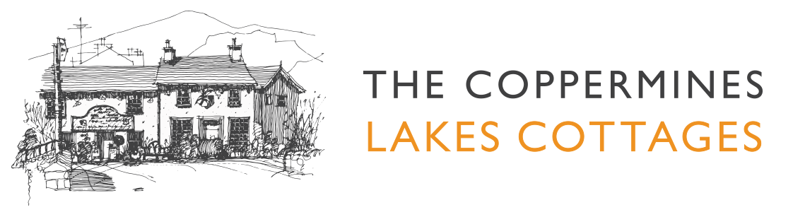

Accessibility Guide for The Mountain Cottages - Millrace
info@coppermines.co.uk, 015394 41765, www.coppermines.co.uk
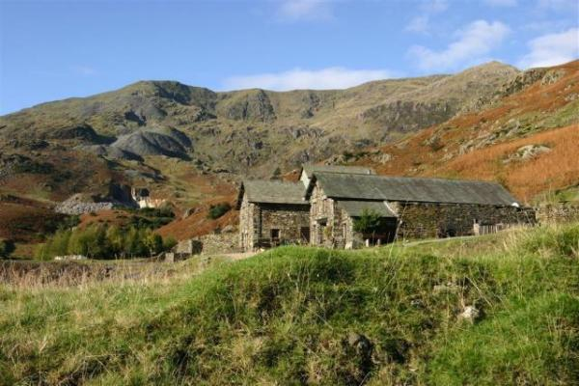

Welcome
At the Coppermines Lakes Cottages we want to make everyone's stay as enjoyable as possible. We aim to accurately describe our facilities and services to give you the confidence to book the right cottage for your specific requirements.

At a Glance

Level Access
- There is level access from the main entrance to:

Access with steps
- There are steps from the main entrance to:
  - Bedroom
  - Outside Hot Tub area

Visual
- Some parts of the venue have low lighting.
- We have information in large print.

Getting here
The Mountain Cottages - Millrace
The Coppermines Valley
Coniston
Cumbria
LA21 8HX

Travel by public transport
- You can get to The Mountain Cottages - Millrace by bus.
- The X12 bus from Barrow and the 505 bus from Windermere both stop at The Crown, in the centre of Coniston. Southlakeland Bus Timetables available at http://www.cumbria.gov.uk/buses. The bus stop is 1.2 miles / 1.9 km from The Mountain Cottages - Millrace.
- Please note that this cottage is situated within a mountain environment and as such, care and consideration must be given on approach to the cottage. The Mountain Cottages are accessible via a gravel road, 1 mile from the centre of Coniston. A taxi can be hired from Coniston to reach the cottages.

Travel by taxi
- You can get a taxi with Bluebird Tours by calling 07814 728390.

Parking
- We have a car park. The parking is less than 50 metres from the main entrance. Parking is free.
- There is a drop-off point at the main entrance. The drop-off point does not have a dropped kerb.
- From the car park to the entrance, there is level access. The area around the cottage has a level gravel surface.
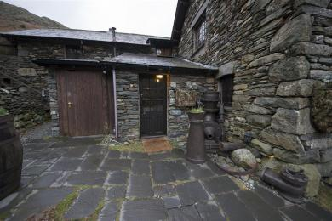
The Entrance to Millrace cottage is to the far left of the photo, down the side on a gravel path.

Arrival

Path to main entrance
- From the street to the main entrance, there is level access.

Main entrance
- The main entrance has level access.

Getting around inside

Visual Impairment - General Information
- Some parts of the venue have low lighting.

Bedrooms
- All bedrooms have windows.
- Bedrooms have ceiling lights, wall lights, bedside lamps and natural daylight.
- Lights are energy saving and traditional filament. All bedrooms are non-smoking.
- All bedrooms have fitted carpets.
- The bedroom nearest the main entrance has 13 steps.
- All bedrooms are ensuite.
- We have bathrooms with a separate shower.
- We have bathrooms with a bath and overhead shower.

Self catering kitchen
- We have an open plan kitchen.
- From the main entrance to the kitchen, there is level access.
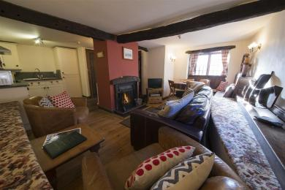
Open plan Kitchen Diner & Lounge

Lounge
- From the main entrance to the lounge, there is level access.

Getting around outside

Outside Hot Tub area
- From the main entrance to the area, there are 13 steps.
- The Hot Tub Area is reached via a wooden staircase. The Hot tub itself has high sides and there are no additional supports for entry or exit.
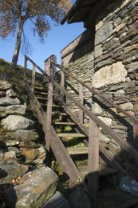
Hot Tub Steps
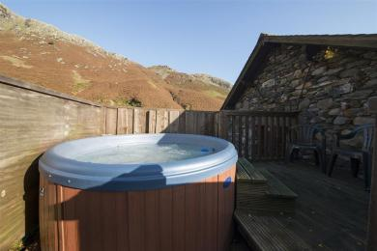
Hot Tub Area

Customer care support

Accessibility equipment
- For a list of more items, please go to http://www.southlakesmobilityshop.co.uk/.
- The nearest RADAR toilet is at the Coniston Tourist information Centre
- You can hire mobility equipment from South Lakes Mobility in Ulverston or Kendal by calling 01229 585 009. Wheelchairs may be able to be hired from Coniston Care Scheme by calling 015394 41868.

Customer care support
- We have information in large print.

Guide last updated: 18 January 2019

