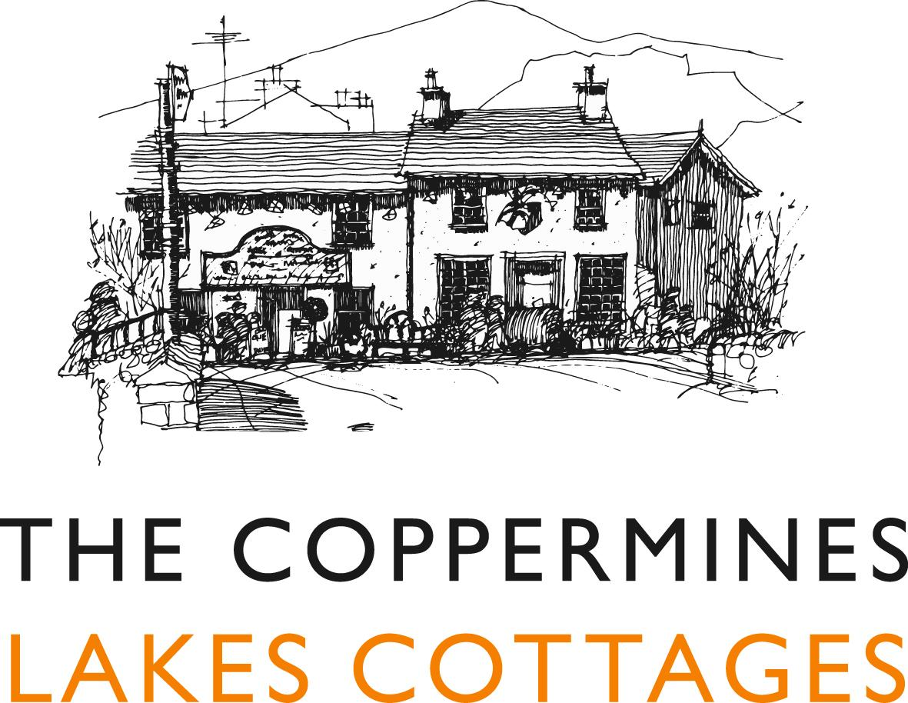

Accessibility Guide for Old Post Cottage
info@coppermines.co.uk, 015394 41765, www.coppermines.co.uk
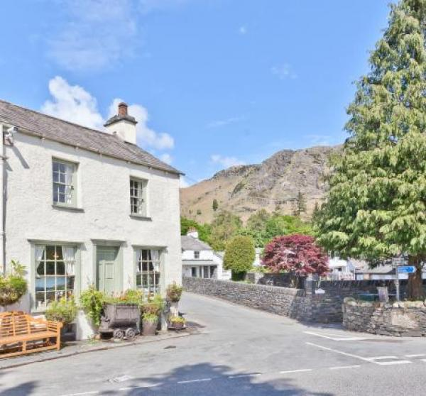

Welcome
At the Coppermines Lakes Cottages we want to make everyone's stay as enjoyable as possible. We aim to accurately describe our facilities and services to give you the confidence to book the right cottage for your specific requirements.

At a Glance

Level Access
- The main entrance has 3 steps and a handrail. There is no lift and no ramp.

Access with steps
- There are steps from the main entrance to:
  - Bedroom
  - Old Post Sitting Room
  - Outside Hot Tub area

Visual
- Some parts of the venue have low lighting.
- We have information in large print.

Getting here
Old Post Cottage
The Bridge
Coniston
LA21 8HJ

Travel by public transport
- You can get to Old Post Cottage by bus.
- The X12 bus from Barrow and the 505 bus from Windermere both stop at The Crown, in the centre of Coniston. Southlakeland Bus Timetables available at http://www.cumbria.gov.uk/buses. The bus stop is 0.1 miles / 0.2 km from Old Post Cottage .

Travel by taxi
- You can get a taxi with Bluebird Tours by calling 07814 728390.

Parking
- We have a car park. The parking is less than 50 metres from the main entrance. Parking is free.
- There is a drop-off point at the main entrance. The drop-off point does not have a dropped kerb.
- From the parking to the main entrance, there are 3 steps. There is no ramp and no lift.
- Parking area and area immediately around the main entrance is a gravel surface
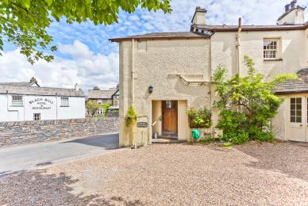
Old Post Cottage parking area in front of mail entrance - with gravel surface

Arrival

Path to main entrance
- From the street to the main entrance, there are 3 steps. There is no ramp and no lift.
- The path is sloped.

Main entrance
- The main entrance has 3 steps.
- This entrance has a handrail.
- The main door is side hung and manual.
- Parking and Entrance has a stone /shale surafce not suitable for wheelchairs
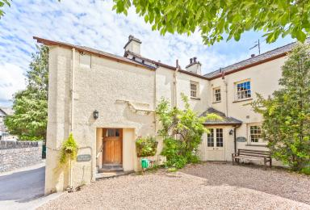
Old Post Cottage main entrance

Getting around inside

Visual Impairment - General Information
- Some parts of the venue have low lighting.

Bedrooms
- All bedrooms have windows.
- Bedrooms have ceiling lights, bedside lamps and natural daylight.
- Lights are energy saving and traditional filament. All bedrooms have fitted carpets.
- The bedroom nearest the main entrance has 16 steps.
- All bedrooms are ensuite.
- We have bathrooms with a separate shower.
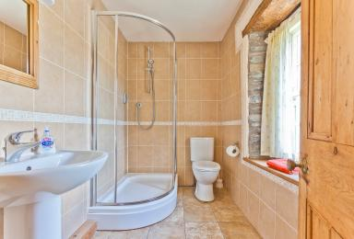
Old Post Cottage en suite shower room
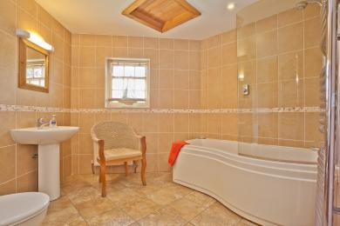
Old Post Cottage en suite bathroom
- We have bathrooms with a bath and overhead shower.

Self catering kitchen

Old Post Cottage kitchen
- We have a separate kitchen and dining room. The work surface is available at a height between 650mm and 900mm.
- The hob is available at a height between 650mm and 900mm.
- The sink is available at a height between 650mm and 900mm.
- The oven is available at a height between 650mm and 900mm.
- From the main entrance to the dining room, there are 2 steps. There is no lift and no ramp.
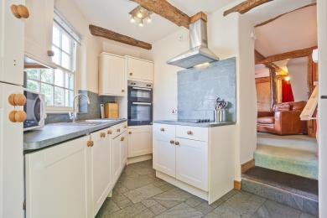
Old Post kitchen showing steps to sitting and dining room

Lounge

Old Post Sitting Room
- From the main entrance to the lounge, there are 2 steps. There is no lift and no ramp.
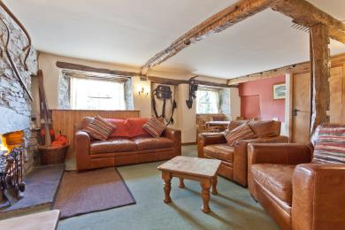
Ols Post Sitting and Dining Room

Getting around outside

Outside Hot Tub area
- From the main entrance to the area, there are 4 steps.
- The Hot tub has high sides and there are no additional supports for entry or exit.
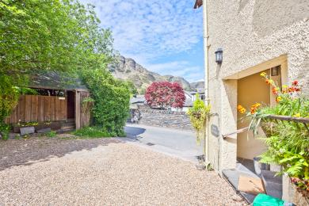
Old Post Cottage main entrance and hot tub across the gravelled driveway

Customer care support

Accessibility equipment
- For a list of more items, please go to https://lakesmobility.co.uk/.
- The nearest RADAR toilet is at the Coniston Tourist information Centre
- You can hire mobility equipment from South Lakes Mobility in Ulverston or Kendal by calling 01229 585 009. by calling 015394 41868.

Customer care support
- We have information in large print.

Guide last updated: 25 January 2024

