Accessibility Guide for Wanderlust Camper Co self-drive campervan hire
info@wanderlustcamperco.com, 08453889958, www.wanderlustcamperco.com
Contact for accessibility enquiries: Annah Todman
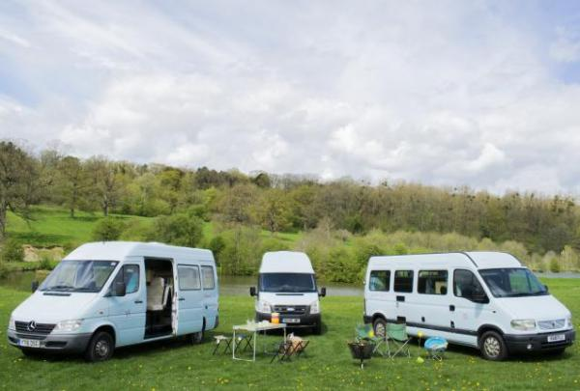

Welcome
Experience our campervans with their own individual personality for self-drive camping breaks.
Comfortable & unique home-on-wheels for adventures, festivals or events.
All our campervans have flexible living and sleeping arrangements.
Our campervans are created with flexibility, comfort and ease in mind.
​
No special licence required - all fall within the car category.
High-tops mean no pop-tops to put up and
it's day-time to night-time in just a few minutes!
Watch the video: A tour around Sally, Amelia and Lula the campervans for hire

At a Glance

Access with steps
- There are steps from the main entrance to:
  - Access to campervans

Getting here
2 Dowles Cottages
Dymock
GL18 2AF

Travel by public transport
- You can get to Wanderlust Camper Co self-drive campervan hire by bus and train.
- There is a bus stop in our village, just 2 minutes walk away. The route is serviced by the number 132 from Stagecoach - between Gloucester and Ledbury. The bus stop is 0.5 miles / 0.8 km from Wanderlust Camper Co self-drive campervan hire.
- The nearest train station is Ledbury Train Station. The train station is 4 miles / 6.4 km from Wanderlust Camper Co self-drive campervan hire.
- Stagecoach provide a service through Dymock from Gloucester and Ledbury. Number 132

Travel by taxi
- We have a transfer service for visitors. We can collect from Gloucester or Ledbury by arrangement

Parking
- We have a car park. The parking is less than 50 metres from the main entrance. Parking is free.
- There is a drop-off point at the main entrance. The drop-off point has a dropped kerb.
- We have a large, gravel driveway
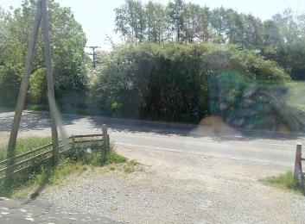
View from driveway to road

Arrival

Path to main entrance
- From the street to the main entrance, there is level access.
- The path is 3000mm wide, or more.

Main entrance
- The main entrance has level access.
- Handovers for our campervans are on our level, gravelled driveway that is accessed through a large open driveway from the road. For the purposes of this guide, the details we are including is for driveway, the main entrance to our residence is not required by guests

Getting around inside

Site facilities
- You can park next to your tent and caravan.
- Our campervans do not have bathrooms or shower facilities. It is recommended that guests select a campsite with the appropriate facilities for their requirements.

Access to campervans
- From the main entrance to this area, there is 1 step. There is no lift and no ramp.
- All our campervans come with a one-step access step to get in to the campervans. Some campervans have a higher step than others to access the campervan

Getting around outside

Campsite outside area
- Outdoor areas will depend entirely on the facilities available at selected campsite

Customer care support

Accessibility equipment
- Dogs are welcome in Lula, where a safety harness belt clip is provided for the safety of the dog and passengers. Facilities for dogs will be entirely dependent upon the campsite selected. We recommend confirming details with the campsite.

Customer care support
- We recommend guests contact campsites in advance to discuss customer care support for assistance whilst on a break. Areas to consider would be disability awareness training, Next GenerationText Service, availability of staff with British Sign Language training, the availability of staff over 24 hours and whether they can make their visitor information available in different formats.

Guide last updated: 18 January 2019

