Accessibility Guide for Seascape
info@coquetcottages.co.uk, 01665 710700, https://www.coquetcottages.co.uk/northumberland-holiday-cottages/seascape/
Contact for accessibility enquiries: Reservations Team
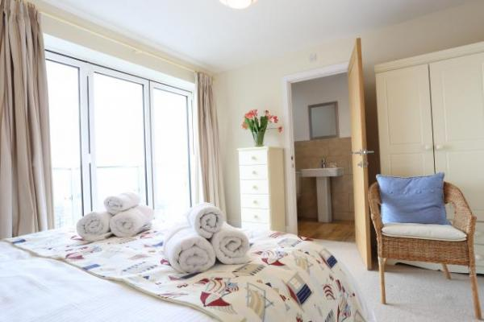

Welcome
Seascape is a stunning seaside holiday home in charming Amble. With unspoilt views of the sea, this gorgeous coastal retreat sleeps 4 guests in 2 bedrooms and welcomes 2 dogs too.
Seascape is not entirely suitable for those with limited mobility and not suitable at all for wheelchair users.

At a Glance

Access with steps
- There are steps from the main entrance to:
  - Bedroom

Bedrooms
- We have non-allergic bedding.

Hearing
- The (bedroom) TVs have subtitles.

Getting here
1 Bay View
Amble
NE65 0AZ

Travel by public transport
- You can get to Seascape by train.
- The nearest train station is Alnmouth Train Station. The train station is 6 miles / 9.7 km from Seascape.
- You can catch a taxi from Alnmouth Train Station to Seascape or you can get the bus from Alnmouth Train Station to Amble and walk to Seascape.

Travel by taxi
- You can get a taxi with Alnmouth Station Taxis by calling 07760 751667. The taxi company has a wheelchair accessible vehicle.

Parking
- We have a car park. The parking is less than 50 metres from the main entrance. Parking is free.
- There is a drop-off point at the main entrance. The drop-off point does not have a dropped kerb.
- From the parking to the main entrance, there are 2 steps. There is no ramp and no lift.
- The car parking space is less than 2 metres from the front door. The parking space is on a very slight incline.
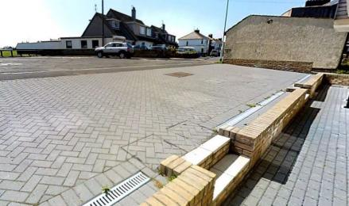
Seascape Parking Area

Arrival

Path to main entrance
- From the street to the main entrance, there is level access.
- There is a permanent ramp.
- The path is 1000mm wide, or more.
- The path is sloped.

Main entrance
- The main entrance has 0 steps.
- The main door is side hung and automatic.

Getting around inside

Bedrooms
- All bedrooms have windows.
- Bedrooms have bedside lamps, spot lights and natural daylight.
- Lights are LED, energy saving and traditional filament. TVs have subtitles.
- All bedrooms are non-smoking.
- We have non-allergic bedding.
- All bedrooms have fitted carpets.
- All wooden floors downstairs.
- The bedroom nearest the main entrance has 13 steps.
- We have bathrooms with a separate shower.
- We have bathrooms with a bath and overhead shower. The walls and the fittings have high colour contrast.

Washer in kitchen
- We have an iron and ironing board.

Self catering kitchen

Kitchen in the cottage
- We have an open plan kitchen.
- The table and plates have high colour contrast.
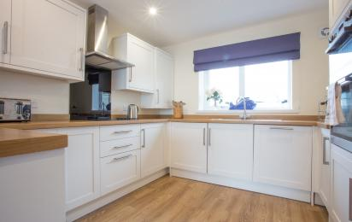
Seascape Kitchen

Lounge

Lounge in the cottage
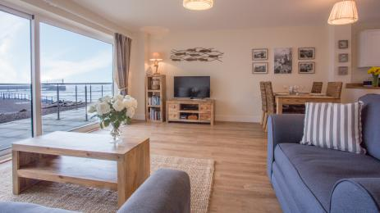
Seascape Lounge

Getting around outside

Terrace

Terrace from the cottage
- You can only access the terrace from inside the property.

Customer care support

Accessibility equipment
- For a list of more items, please go to http://www.redcross.org.uk/Where-we-work/HealthandSupport?loc=ne65+0xp&r=50&s....
- The promenade in front of the cottage or the Little Shore Beach. Dogs are only permitted on the beach between October and April.
- You can hire mobility equipment from Red Cross Newcastle by calling 0191 2737961.

Guide last updated: 9 April 2021

