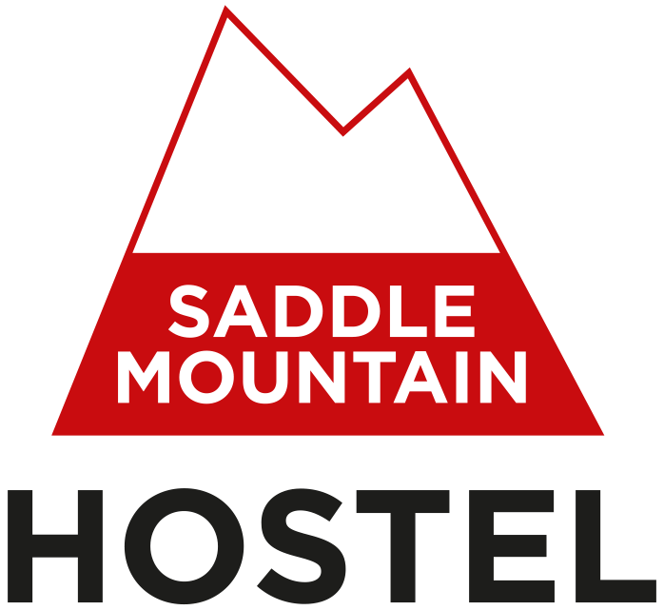

Accessibility Guide for Saddle Mountain Hostel
info@saddlemountainhostel.co.uk, 01809501412, saddlemountainhostel.co.uk
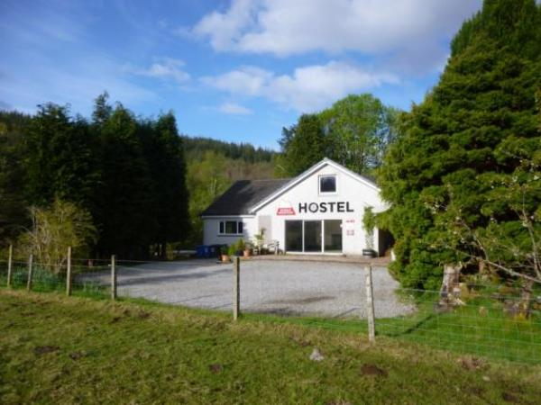

Welcome
Saddle Mountain Hostel is a small and friendly 4-star hostel. We are centrally located in the Great Glen in the village of Invergarry, a short drive south along the A82 from Loch Ness, between Fort William and Inverness.
The hostel is spacious and comfortable. We have 5 bed rooms, with a mix of dorm rooms and private rooms sleeping up to 24 people. Our facilities include a large self-catering kitchen, a separate dining room, a visitors' lounge, toilets, showers and a drying room.
All of the hostel is on the ground floor of the building.

At a Glance

Level Access
- There is level access from the main entrance to:
  - Reception
  - Lounge

Level access bedrooms
- From the main entrance to the bedroom, there is level access.
- The route to the bedroom is 750mm wide, or more.

General
- All staff have disability awareness training.

Getting here
Saddle Mountain Hostel
Mandally Road
Invergarry
PH35 4HP

Travel by public transport
- You can get to Saddle Mountain Hostel by bus.
- You can get to Invergarry by bus from Inverness, Fort William, Glasgow and the Isle of Skye.
The nearest bus stops are by the junction of the A82 and the A87. They are approximately 750 metres (0.35 miles) from the hostel.
From the bus stops, follow the A82 in the direction of Fort William (there is a pavement) until you get to a junction with a minor road, signposted Mandally, approximately 500 metres. Turn right onto this road (no pavement) and follow for 250 metres. Saddle Mountain Hostel is the third building on the right. Once you have turned into the hostel grounds there is a slight descent and rise to reach the hostel building.

Travel by taxi
- You can get a taxi with Great Glen Travel by calling 01809501222.

Parking
- We have a car park. The parking is less than 50 metres from the main entrance. Parking is free.
- The main car parking area is outside the hostel building on a gravel surface. There is one small step up to the patio in front of the hostel. There is a permanent ramp to the hostel entrance.
There is overflow parking at the entrance to the hostel grounds on a gravel surface. There is a small rise to reach the main parking and hostel building.
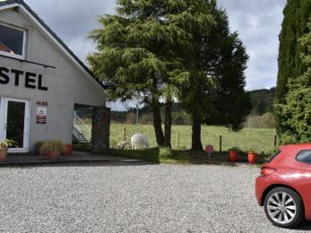
Main car park outside the front of Saddle Mountain Hostel

Arrival

Path to main entrance
- The path is sloped.

Main entrance
- The main entrance has level access.
- There is a permanent ramp.
- The door is 750mm wide.
- The main door is side hung and manual.
- When you arrive, we can help carry your luggage.
- There is one small step up from the car park to the patio in front of the hostel.
There is a covered path to the hostel entrance which is 1400 mm wide at its narrowest.
The ramp at the front door is 730 mm wide at its narrowest.
There are benches close to the front door. These can be moved, if required.
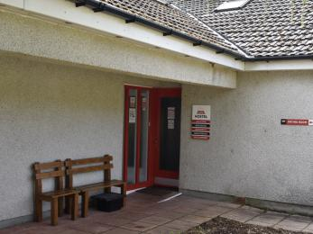
Saddle Mountain Hostel entrance

Getting around inside

Reception
- From the main entrance to reception, there is level access.
- The reception area desk is 1110 mm high. There is also seating and space around a coffee table that can be used for guest registration if required.
All rooms are accessed from the reception area. With the exception of the lounge all the doors are a contrasting colour to the walls and door frames.
We give all our guests a quick tour of the building to show them where everything is.
The reception area is carpeted.
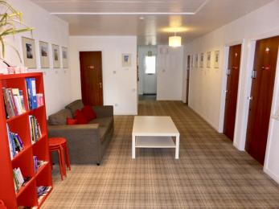
Reception area

Bedrooms
- All bedrooms have windows.
- Bedrooms have ceiling lights, wall lights, bedside lamps and natural daylight.
- Lights are fluorescent tube, LED and energy saving. All bedrooms are non-smoking.
- All bedrooms have fitted carpets.
- From the main entrance to this area, there is level access.
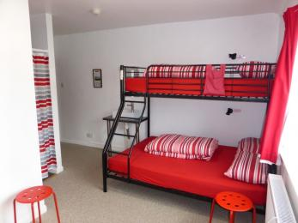
Room 1
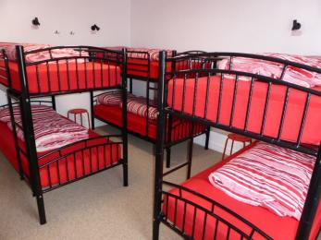
Room 2
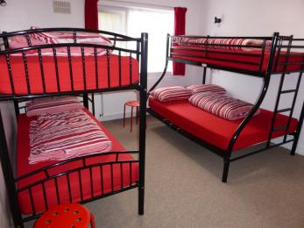
Room 3
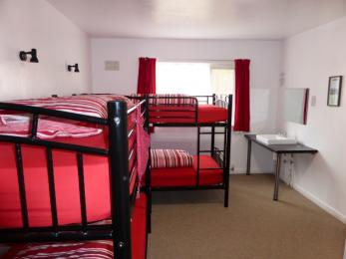
Room 4
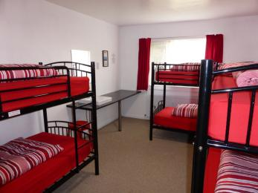
Room 5

Self catering kitchen

Kitchen
- We have a separate kitchen and dining room. From the main entrance to the kitchen, there is level access.
- The route is 1000mm wide, or more.
- The door is 750mm wide.
- The work surface is available with clear underspace and available at a height between 650mm and 900mm.
- From the main entrance to the dining room, there is level access. The route is 1800mm wide, or more. The door is 750mm wide.
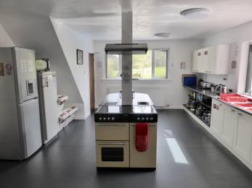
Kitchen
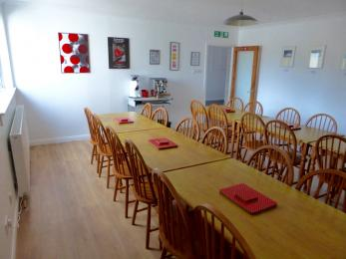
Dining Room

Lounge

Lounge
- From the main entrance to the lounge, there is level access. The route is 1400mm wide, or more. The door is 750mm wide.
- There are low coffee tables in the lounge which can be removed if required.
The sofas and armchairs in the lounge can be rearranged if required.
There is a TV in the lounge which can be set up to show subtitles.
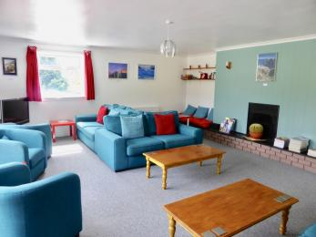
Lounge

Getting around outside

Garden
- Access to the outside of the hostel building is through the front door.
There are steps or a sloping path to our lower garden.
There is a patio area outside the hostel lounge.
There is a gravel path on one side of the hostel building.

Customer care support

Customer care support
- All staff have disability awareness training.
- Gregor and Helen have completed the VisitScotland accessible tourism training programme.
Our reception is open between 7.30 and 10am and 4.30 and 10pm. The hostel is closed daily between 11am and 4pm. We are available whenever guests are in the building.

Guide last updated: 18 January 2019

