Accessibility Guide for Mere Brook House
lorna@merebrookhouse.co.uk, 01513345474, http://www.merebrookhouse.co.uk/
Contact for accessibility enquiries: Lorna Tyson. Sarah Atherton.
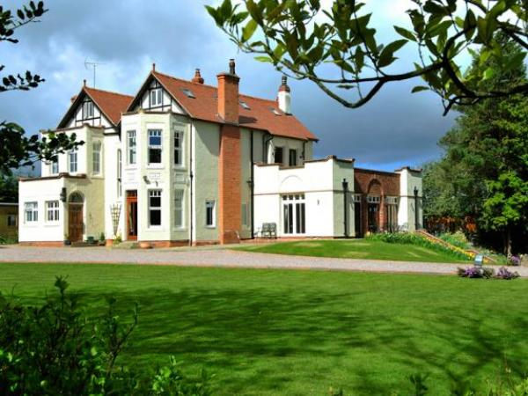

Welcome
Mere Brook House, owned by Lorna & Donald Tyson, is a 5 Star Gold B&B situated on the edge of the picturesque village of Thornton Hough, nestled between the cities of Liverpool & Chester. It offers high class B&B accommodation in 8 bedrooms & has facilities for events such as weddings, celebrations & business meetings.
Whether you're staying on the Wirral for business or leisure, we offer a warm welcome, with comfortable surroundings in which to relax. We are situated just over a mile from junction 4 of the M53, making it accessible from all parts of the Wirral, Liverpool & Chester.

At a Glance

Level Access
- The main entrance has level access with a ramp. The ramp is permanent.
- There is level access from the main entrance to:
  - Bedroom: Flora & Blossom
  - Lounge
  - Patio area

Bedrooms
- We have non-allergic bedding.

Level access bedrooms
- From the main entrance to the bedroom, there is level access.
- The route to the bedroom is 750mm wide, or more.
- The bedroom door is 750mm wide, or more.
- There is unobstructed floor space 1200mm by 900mm, or more.
- The bathroom has a level access shower.

Hearing
- The (bedroom) TVs have subtitles.
- Some staff have disability awareness training.

Visual
- The walls and the doors have high colour contrast.
- Some parts of the venue have low lighting.
- We have information in large print.

General
- Some staff have disability awareness training.

Getting here
Thornton Common Road
Thornton Hough
Wirral
CH63 0LU

Travel by public transport
- You can get to Mere Brook House by bus and train.
- The nearest bus stop is on the same road as Mere Brook House, about half a mile away. The bus stop is 0.5 miles / 0.8 km from Mere Brook House.
- The nearest train station is Bromborough. The train station is 1.2 miles / 1.9 km from Mere Brook House.
- Bromborough station is on the Liverpool/Chester line and has limited accessibility for wheelchair users. Up to date information is available on the Merseyrail website.

Travel by taxi
- We can often provide lifts by prior arrangement.

Parking
- We have a car park. There are accessible parking spaces. Parking is free.
- There is a drop-off point at the main entrance. The drop-off point has a dropped kerb.
- From the car park to the entrance, there is level access. There is a permanent ramp.
- The route is 1500mm wide, or more.
- There is no need to transport visitors from the car park to the main entrance as there is ample parking next to the main entrance.
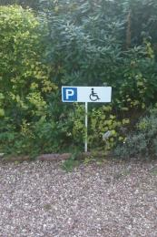
Car parking space
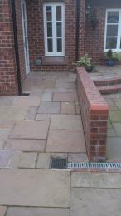
Ramp to Coach House accommodation
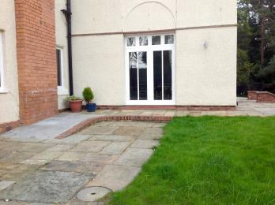
Ramp to Main House accommodation

Arrival

Main entrance
- The main entrance has level access.
- There is a permanent ramp.
- The door is 2000mm wide.
- The main door is side hung and manual.
- There are two wide doors with level access to the main building and one to the coach house which is also level access via a ramp.
Ramp to main house

Getting around inside

Visual Impairment - General Information
- We have high colour contrast between walls and doorframes.
- Some parts of the venue have low lighting.

Bedrooms
- All bedrooms have windows.
- Bedrooms have ceiling lights, wall lights, floor standing lights, bedside lamps, desk or table lamps and natural daylight.
- Lights are LED and energy saving. TVs have subtitles.
- All bedrooms are non-smoking.
- We have non-allergic bedding.
- All bedrooms have fitted carpets.
- We can give details of our cleaning products on request
- We can move the bedroom furniture, to improve accessibility.
- From the main entrance to this area, there is level access.

Accessible bedrooms

Accessible bedroom Flora & Blossom
- From the main entrance to the bedroom, there is level access. There is a ramp. The ramp is Permanent.
- The route to the bedroom is 1000mm wide, or more. The bedroom door is 819mm wide. There is 1346mm at the side of the bed. The bed is 635mm high. There is 0mm under the bed.
- The bedroom is flexible (either double or twin). The bathroom is ensuite. The bathroom door is 850mm wide.
- The bathroom has a separate shower. The shower has a seat. The shower has a handrail.
- The bathroom has a level access shower. There is a shower chair available. The level access shower has handrails.
- The toilets have handrails. The direction of transfer onto the toilet is to the left and right. There is 1117mm at the side of the toilet.
- There is 1600mm in front of the toilet. The toilet seat is 406mm high.
- The basin is 838mm high. There is space under the basin, with no pedestal or boxing.
- We have a seat that can be fixed to the toilet to raise it and a frame that can be used around the toilet.
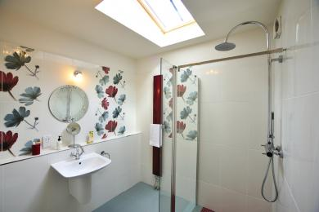
en-suite bathroom in accessible bathroom
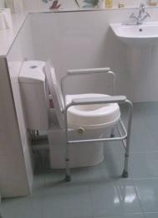
different aids for toilet
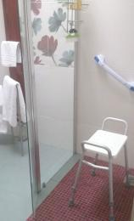
shower seat and grab rail

Lounge
- From the main entrance to this area, there is level access. There is a permanent ramp. The route is 914mm wide, or more.
- The door is 914mm wide.

Getting around outside

Patio area
- From the main entrance to this area, there is level access. The route is 1500mm wide, or more. The entrance is 965mm wide.

Customer care support

Accessibility equipment
- A raised toilet seat, grab rails and a frame surround with arms to place around the toilet. We can also offer guests the use of a zimmer frame if required.
- We're set in four acres so there is plenty of space for dogs.
- We have an area to charge mobility scooters and battery powered wheelchairs.

Emergency evacuation procedures
- We have emergency evacuation procedures for disabled visitors.

Customer care support
- Some staff have disability awareness training.
- We have information in large print.

Guide last updated: 10 March 2020

